Paper 1 (2000)

- Which pair includes a vector quantity and a scalar quantity?
  - displacement; acceleration
  - force; kinetic energy
  - power; speed
  - work; potential energy

- A micrometer, reading to ± 0.01 mm, gives the following results when used to measure diameter d of a uniform wire:

1.02 mm 1.02 mm 1.01 mm 1.02 mm 1.02 mm

When the wire is removed and the jaws are closed, a reading of -0.02 mm is obtained.

Which of the following gives the value of d with a precision appropriate to the micrometer?

A 1.0 mm B 1.00 mm C 1.038 mm D 1.04 mm

- A ball is released from rest above a horizontal surface and bounces several times. The graph shows how, for this ball, a quantity y varies with time.

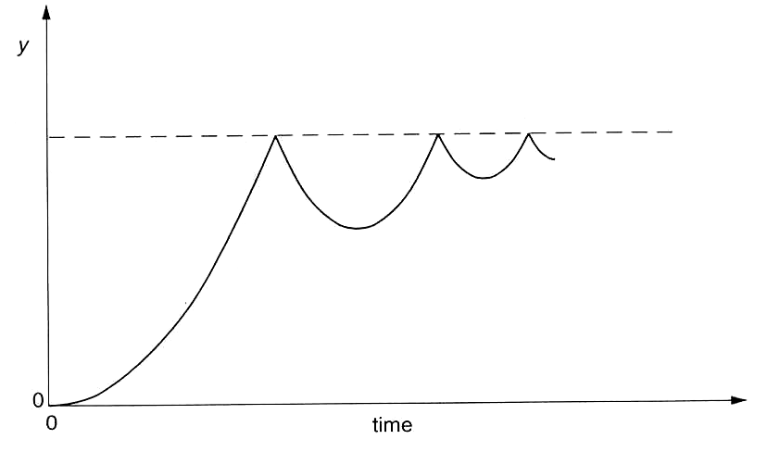

What is the quantity y?

  - acceleration
  - displacement
  - kinetic energy
  - velocity
- Two satellites in space collide inelastically.

What happens to the kinetic energy and momentum?

 | kinetic energy | momentum
A  B  C  D | conserved  conserved  reduced  reduced | conserved  reduced  conserved  reduced

- The diagram shows the jib of a tower crane. Only three forces act on the jib: the tension T provided by a supporting cable; the weight W of the jib; and a force P (not shown) acting at point X.

The jib is in equilibrium.

Which triangle of forces is correct?

- Two charged plates are 0.020m apart, producing a uniform electric field. The potential energy E_{P} of an electron in the field varies with displacement x from one of the plates as shown.

What is the magnitude of the force on the electron?

  - 3.0 x l0⁻¹⁸N
  - 7.5 x10⁻¹⁷N
  - 3.8 x10⁻¹⁵N
  - 7.5 x10⁻¹⁵N

- Outside a uniform sphere of mass M, the gravitational field strength is the same as that of a point mass M at the centre of the sphere.

The Earth may be taken to be a uniform sphere of radius r. The gravitational field strength at its surface is g.

What is the gravitational field strength at a height h above the ground?

A $\frac{{\text{gr}}^{2}}{{\left(r+h\right)}^{2}}$ B $\frac{\text{gr}}{\left(r+h\right)}$ C $\frac{g\left(r−h\right)}{r}$ D ${\frac{g\left(r−h\right)}{r^{2}}}^{2}$

- Which quantity is not necessarily the same for satellites that are in geostationary orbits around the Earth?

  - angular velocity
  - centripetal acceleration
  - kinetic energy
  - orbital period

- A mass hanging from a spring suspended from the ceiling is pulled down and released. The mass then oscillates vertically with simple harmonic motion of period T. The graph shows its distance from the ceiling varies with time t.

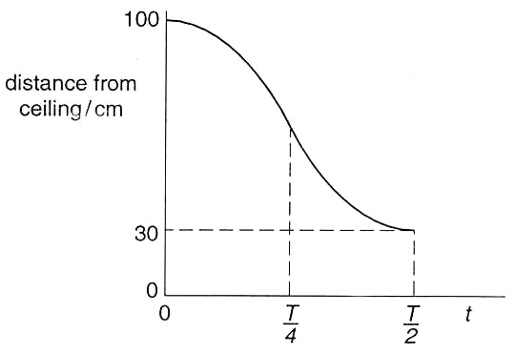

What can be deduced from this graph?

  - The amplitude of the oscillation is 70 cm.
  - The kinetic energy is a maximum at $t=\frac{T}{2}$.
  - The restoring force on the mass increases between t = 0 and t = $\frac{T}{4}$.
  - The speed is a maximum at $t=\frac{T}{4}$.

- A ray of light travels from air to glass as shown.

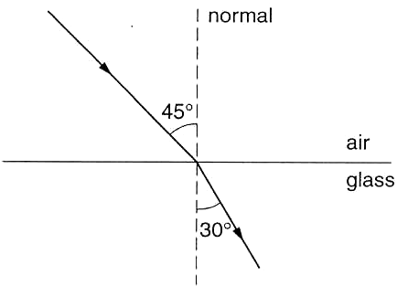

The speed of light in air is 3.00 x l0⁸ms⁻¹. What is the speed of light in the glass?

  - 2.0 x l0⁸ ms⁻¹
  - 2.l2 x l0⁸ ms⁻¹
  - 3.00 x l0⁸ ms⁻¹
  - 4.24 x 10⁸ ms⁻¹

- A diffraction grating has a spacing of 1.6 x 10⁻⁶ m. A beam of light is incident normally on the grating. The first order maximum makes an angle of 20º with the undeviated beam.

What is the wavelength of the incident light?

A 2l0 nm B 270 nm C 420 nm D 550 nm

- Which of the following gives three regions of the electromagnetic spectrum in order of increasing wavelength?

  - gamma rays, microwaves, visible radiation
  - radio waves, ultraviolet, X-rays
  - ultraviolet, infra-red, microwaves
  - visible radiation, gamma rays, radio waves

- An isolated conducting sphere P has the charge distribution shown.

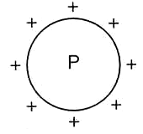

A similar sphere Q, connected to earth by a long wire, is brought close to P.

Which diagram shows the final distribution of charge on the two spheres?

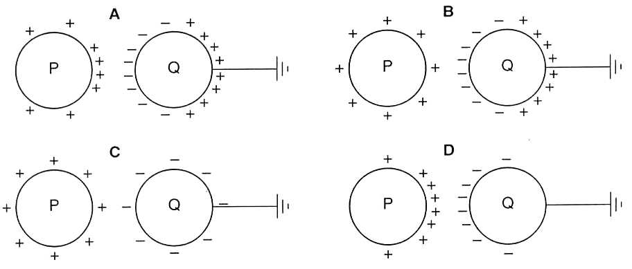

- Two squares, X and Y are cut from the same sheet of metal of thickness t. The lengths of the sides of X and Y are l and 2l respectively.

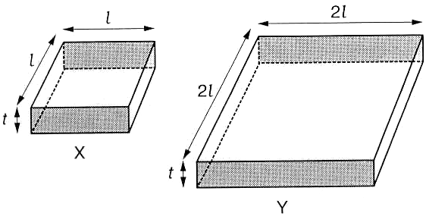

What is the ratio $\frac{R_{X}}{R_{Y}}$ of the resistances between the opposite shaded faces of X and of Y?
A $\frac{1}{4}$ B $\frac{1}{2}$ C $\frac{1}{1}$ D $\frac{2}{1}$

- Four resistors are connected as shown.

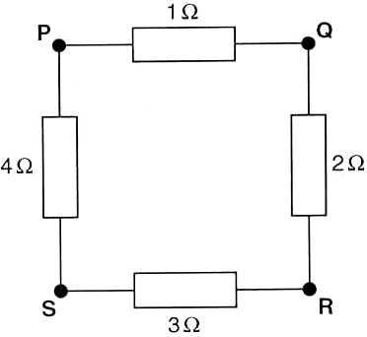

Between which two points is the resistance of the combination a maximum?

A P and Q B Q and S C R and S D S and P

- Which statement describes the electric potential difference between two points in a wire that carries a current?

  - the force required to move a unit positive charge between the points
  - the ratio of the energy dissipated between the points to the current
  - the ratio of the power dissipated between the points to the current
  - the ratio of the power dissipated between the points to the charge moved

- Which graph correctly relates the electric field strength or electric potential in the field of a point charge, with distance r from the charge?

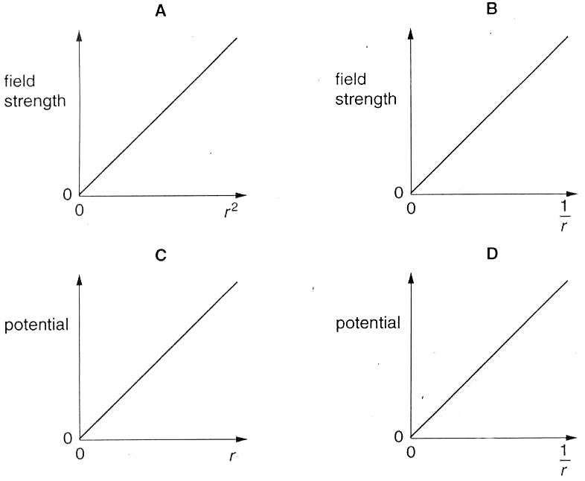

- Four students are asked to draw graphs to show how the p.d. V across a capacitor depends on its charge Q. They are also asked to shade the area that represents the increase in energy stored in the capacitor when the charge is increased from Q₁ to Q₂.

Which graph is correct?

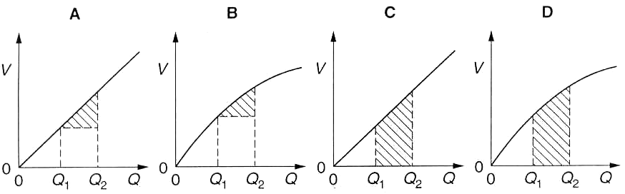

- The diagram shows a flat surface with lines OX and OY at right angles to each other.

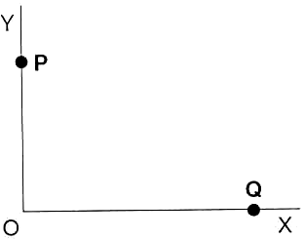

Which current in a straight conductor will produce a magnetic field at O in the direction OX?

  - at P into the plane of the diagram
  - at P out of the plane of the diagram
  - at Q into the plane of the diagram
  - at Q out of the plane of the diagram

- A flat circular coil of 120 turns, each of area 0.070 m², is placed with its axis parallel to a uniform magnetic field. The flux density of the field is changed steadily from 80 mT to 20 mT over a period of 4.0 s.

What is the e.m.f. induced in the coil during this time?

A 0 B l30 mV C l70mV D 500 mV

- A capacitor is to be used to provide smoothing for a half-wave rectifier.

In which circuit is the capacitor correctly connected?

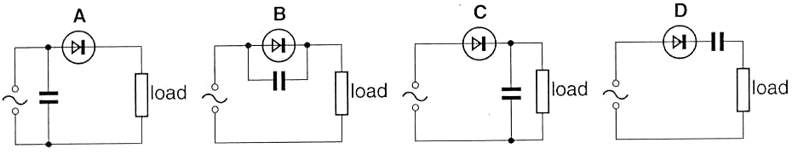

- A student observes the Brownian motion of smoke particles in air.

Which statement explains the movement of the smoke particles?

  - Smoke particles are more dense than air molecules.
  - There are convection currents in the air.
  - The smoke particles are bombarded by moving air molecules.
  - The smoke particles collide with one another.

- Which diagram shows the force-extension graph for a brittle material that is loaded to breaking point?

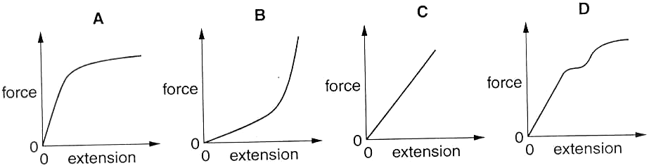

- The table lists the approximate range and response time of different types of thermometer.

Which set of properties belongs to a liquid-in-glass thermometer?

thermometer | range/K | response time
A | 3-1750 | medium
B | 30-1750 | short
C | 75-1550 | long
D | 240-630 | medium

- In a heating experiment, energy is supplied at a constant rate to a liquid in a beaker of negligible heat capacity. The temperature of the liquid rises at 4.0 K per minute just before it begins to boil. After 40 minutes all the liquid has boiled away.

For this liquid, what is the ratio $\frac{\text{specific heat capacity}}{\text{specific latent heat of vaporisation}}$?

A $\frac{1}{\text{10}}K^{−1}$ B $\frac{1}{\text{40}}K^{−1}$ C $\frac{1}{\text{160}}K^{−1}$ D $\frac{1}{\text{640}}K^{−1}$

- In the diagram the volume of bulb X is twice that of bulb Y. The system is filled with an ideal gas and a steady state is established with the bulbs held at 200 K and 400 K.

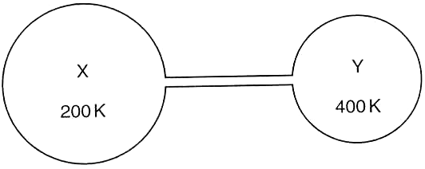

There are x moles of gas in X.

How many moles of gas are in Y?

A $\frac{x}{4}$ B $\frac{x}{2}$ C $x$ D $2x$

- A charged particle is projected horizontally at P into a uniform vertical field. The particle follows the path shown.

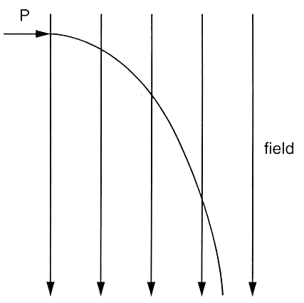

Ignoring gravitational effects, what describes a possible state of charge of the particle and the nature of the field?

 | charge | field
A  B  C  D | negative  negative  positive  positive | electric  magnetic  electric  magnetic

- An electron has mass m_{e} and speed 0.02 c, where c is the speed of light in free space.

What is the de Broglie wavelength of this electron, expressed in terms of the Planck constant h?

A $\frac{h}{(0\text{.}\text{02}c)}$ B $\frac{(0\text{.}\text{02}c)}{h}$ C $\frac{h}{(0\text{.}\text{02}c)m_{e}}$ D $\frac{(0\text{.}\text{02}c)m_{e}}{h}$

- A thin gold foil is bombarded with α-particles as shown.

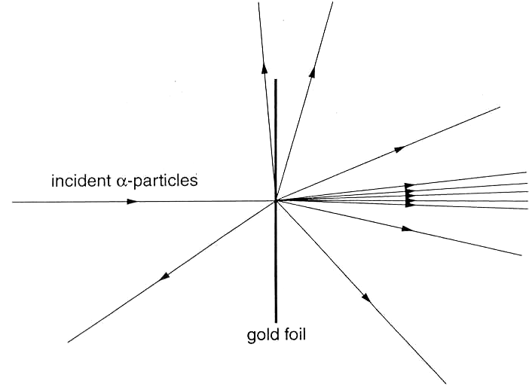

The results of this experiment provide information about the
  - binding energy of a gold nucleus.
  - energy levels of electrons in gold atoms.
  - size of a gold nucleus.
  - structure of a gold nucleus.

- A radioactive source produces 10⁶ α-particles per second. When all the ions produced in air by these α -particles are collected, the ionisation current is about 0.01 μA.

If the charge on an ion is about 10⁻¹⁹C, what is the best estimate of the average number of ions produced by each α-particle?

A 10⁵ B 10⁶ C 10⁷ D 10⁸

