1998

1 Part of an arch made of stone is shown in Fig. 1.1.

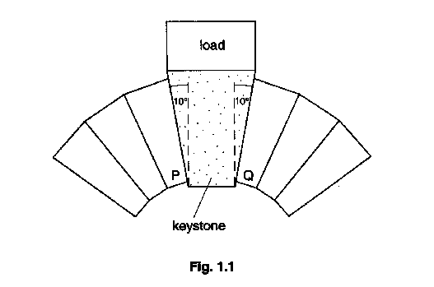
The central stone is known as a keystone and has a weight of 600 N. The keystone is supporting a load of 4600 N. The sides of the keystone make an angle of 10º to the vertical. The two stones P and Q, which are next to the keystone, exert forces at right angles to the sides of the keystone.

(a) On Fig. 1.1, draw and label arrows to show the following four forces.

W, the weight of the keystone
L, the force the load exerts on the keystone
P, the force stone P exerts on the keystone
Q, the force stone Q exerts on the keystone [4]

(b) In Fig. 1.2, the vector labelled L represents, to a scale of 1 cm : 1000 N, the force the load exerts on the keystone. Complete a vector triangle to the same scale to represent the equilibrium of the four forces listed in (a). [4]
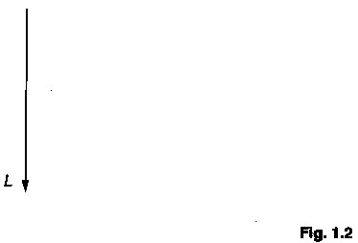

(c) Use your vector triangle to determine the value of the force P. [2]

2 The mass of the Earth is 5.98 x 10²⁴ kg and its mean radius is 6.37 x 10⁶ m.

(a) Use Newton's law of gravitation to calculate the gravitational force acting on a 1.00 kg mass on the surface of the Earth. Assume that the Earth acts as a point mass.
[3]
(b) State the value of the Earth's gravitational field strength at its surface.
[1]

(c) What is meant by the gravitational potential at a point in a gravitational field? [2]

(d) Calculate the difference in the gravitational potential between the surface of the Earth and a point 800 m above the surface. [3]

3 An object, a letter F, is placed in between two plane mirrors P and Q, as shown in Fig. 3.1.

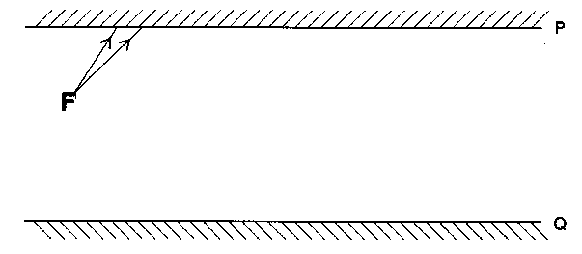

(a) On Fig. 3.1, two rays leaving a point on F are shown. On Fig. 3.1, continue the paths of the two rays to show their reflection by mirror R Draw the image of F correctly situated. State whether it is a real or a virtual image. [3]

(b) Continue the two rays drawn in (a) until they are reflected by mirror Q. Using these rays, construct the image of F in mirror Q. Draw an eye in a suitable place to see this image. [3]

4 (a) Describe, in terms of a simple electron model, the difference between an electrical conductor and an electrical insulator. [2]

(b) State
(i) two metals which are conductors
(ii) one non-metal which is a conductor
(iii) one solid which is an insulator [3]

(c) Air is normally an insulator. However, it can be made to conduct under certain conditions.
(i) Suggest one condition that could cause air to conduct electricity.
(ii) Suggest one hazard which might be associated with the conduction of electricity in air. [2]

(d) In a cathode-ray tube, there is a current of 150 μA in the vacuum between the cathode and the anode. Calculate

(i) the time taken for a charge of 3.0 C to be transferred,
(ii) the number of electrons emitted per second from the cathode. [4]

5 Electrical power of 4400 kW is supplied to an industrial consumer at a considerable distance from a generating station. This is represented in Fig. 5.1.
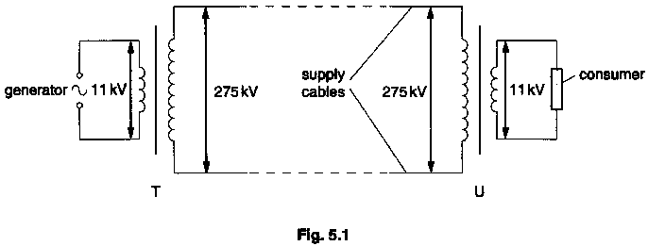

In order to do this, the electricity supply company makes use of a circuit containing two transformers, T and U. The transformers can be considered to be ideal and the supply cables to have negligible resistance.

(a) The power is generated at 11 kV r.m.s. and is supplied to the consumer at 11 kV r.m.s. Calculate the r.m.s. current supplied to the consumer. [2]

(b) There is a potential difference of 275 kV r.m.s. between the supply cables. Calculate

(i) the ratio N_{s}/N_{p} required for each transformer,

(ii) the current in the supply cables. [3]

(c) Explain why, when the resistance of the supply cables cannot be neglected, this arrangement is preferable to a system which generates and transmits the power at the same voltage of 11 kV r.m.s. [2]

(d) (i) Explain the distinction between the r.m.s. value and the peak value of an alternating current.

(ii) Find the peak value of the current in (a). [3]

6 (a) By considering differences in structure, state how the density change which takes place when a solid changes to a liquid compares with the density change when a liquid changes to a gas. [3]

(b) State one similarity and one difference between evaporation and boiling. [2]

(c) What is meant by the internal energy of a system? [2]

(d) Use the first law of thermodynamics to calculate the difference between the internal
energy of 1.00 kg of water at 100 ºC and 1.00 kg of steam at 100 ºC at a pressure of
1.01 x 10⁵ Pa. [A mass of 1.00kg of steam at this pressure and temperature occupies
1.67 m³ and the specific latent heat of vaporisation of water is 2.26 x 10⁶ J kg⁻¹.]
[4]

7 A collision takes place between an α-particle travelling at 3.0 x 10⁷m s⁻¹ and a stationary nitrogen nucleus. It results in the following nuclear reaction.

$${}_{7}^{\text{14}}{}\text{N }+{}_{2}^{4}{}\text{He }→{}_{8}^{\text{17}}{}\text{O }+{}_{1}^{2}{}H$$
The masses of the nuclei involved are listed below.

$${}_{7}^{\text{14}}{}\text{N }$$ | 13.9993 u
${}_{2}^{4}{}\text{He}$(α-particle) | 4.0015 u
$${}_{8}^{\text{17}}{}O$$ | 16.9947 u
$${}_{1}^{2}{}H$$ | 1.0073 u

The particles move in a straight line, as shown in Fig. 7.1. The speed of the proton after the collision is 6. x 10⁷ m s⁻¹.
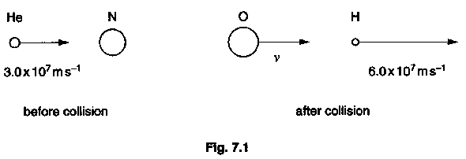
(a) State the number and type of particles which form an a-particle. [2]

(b) Calculate the small change in mass, in kilograms, which takes place in this nuclear reaction. [3]

(c) Use your answer to (b) to calculate the minimum kinetic energy needed by the α-particle to cause the nuclear reaction. [2]

(d) Use the principle of conservation of momentum to calculate v, the velocity of the oxygen nucleus after the collision. [4]

8 Most countries have building regulations which contain instructions about limiting heat transfer. In countries which are cold in the winter, these instructions are designed to reduce the amount of heating required. In tropical countries, the same principles can be used to reduce the need for air conditioning. The instructions apply to domestic and public buildings and are enforced in order to reduce the amount of energy required to keep buildings at a comfortable temperature. This has the effect of reducing the amount of fossil fuel which needs to be burnt and, hence, of reducing the emission of greenhouse gases into the atmosphere.

In order to calculate heat gains or losses, a thermal transmittance coefficient or U-value is measured for each type of building material. The U-value is the rate of heat transfer, in watts, through one square metre of a structure when the air temperatures on each side of the structure differ by 1 kelvin. The following U-values will be needed in answering this question.
U-value for bricks 100 mm thick =8.2W m⁻² K⁻¹
U-value for thermal insulation 50 mm thick = 1.4W m⁻² K⁻¹

Answer the following questions using the information given.

(a) What is stated in the passage as an advantage of enforcing regulations which limit heat transfer to and from buildings? [1]

(b) Explain why it is that the same physical theory can be applied to a situation where a house is to be kept warm in cold weather and to one where a house is to be kept cool in hot weather. [3]

(c) Using the definition given in the passage, write down an equation relating the rate R of heat transfer to the difference in temperature ΔT between the two surfaces of the material, the surface area A of the material and the U-value U of the material. [1]

(d) Calculate the rate of heat transfer flow through a brick wall 100 mm thick and of dimensions 3.0 m x 5.0 m when the temperature on the inside is 20ºC and on the outside is 0 ⁰C. [2]

(e) A composite wall is constructed from two 100 mm brick walls separated from one another by 50 mm of thermal insulation, as shown in Fig. 8.1.

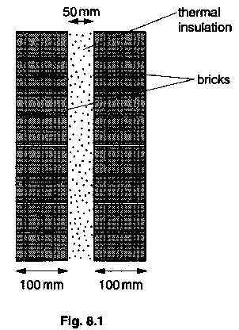

In order to calculate the rate of heat transfer through such a wall, a composite U-value, U_{c}, has to be used. U_{c} is given in terms of the U-values of the individual materials by the equation

$$\frac{1}{U_{c}}=\frac{1}{U_{1}}+\frac{1}{U_{2}}+\text{.}\text{.}\text{.}\text{.}\text{.}\text{.}$$

Use the equation to find

(i) U_{c} for the composite wall shown in Fig. 8.1,

(ii) the rate of heat transfer through a wall of dimensions 3.0 m x 5.0 m when the temperature on the inside is 20 ºC and on the outside is 0 ºC. [5]

(f) On Fig. 8.2, sketch a graph to show how the rate of heat transfer through a wall, such Use as that shown in Fig. 8.1, varies with the thickness of the insulation. Label the vertical axis with suitable values. [4]

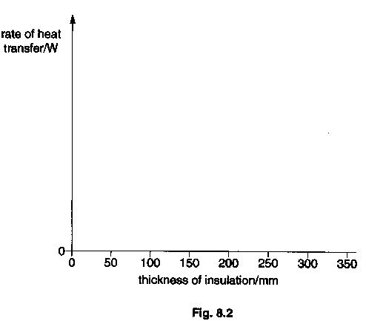

(g) Suggest a factor which will also affect heat losses from a room, in addition to loss by conduction which has already been considered. Indicate how the effect of this factor may be minimized. [2]

Quality of Language [4]

