1998

1 The graph relates to the motion of a falling body.

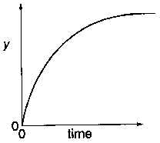

What could y represent on the vertical axis?

A distance when air resistance is negligible

B distance when air resistance is not negligible

C speed when air resistance is negligible

D speed when air resistance is not negligible

2 Two instruments are used on the Earth to measure the mass of an object. A spring balance reads 600 g and a lever balance requires six 100 g discs to balance.

If these measurements were to be repeated on the Moon, where the gravitational field is 1/6 of its value on Earth, which results would be expected?

reading on number of 100 g discs required
spring balance for balance on lever balance

A 600 g 6

B 600 g 1

C 100 g 6

D 100 g 1

3 The base units of the SI system include those of

mass, kg; length, m; time, s; electric current, A.

Which base units would be needed to express the SI unit of potential difference (the volt)?

A m and A only

B s and A only

C m, s and A only

D kg, m, s and A

4 A ball of weight W slides along a smooth horizontal surface until it falls off the edge at time T

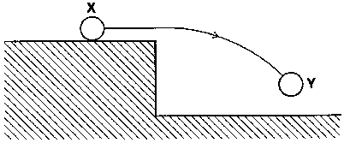

Which graph represents how the resultant vertical force F, acting on the ball, varies with time t as the ball moves from position X to position Y?
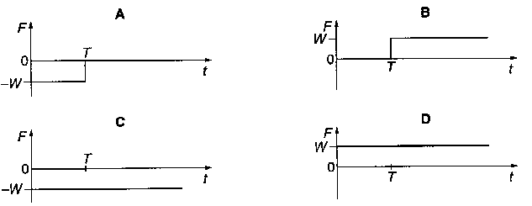

5 A heavy uniform plank of length L is supported by two forces F₁ and F₂ at points distant L/8 and L/4 from its ends as shown.

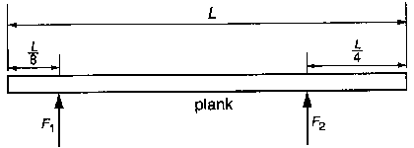

What is the value of F₁/F₂?

A 2/5 B 3/5 C 2/3 D 3/2

6 The engine of an inter-city train; travelling at 50 m s⁻¹ delivers a power of 2 MW. What is the tractive force exerted by the engine?

A 4 x 10⁴ N B 1 x l0⁵ N C 4 x 10⁷ N D 1 x l0⁸ N

7 Two point masses m₁ and m₂ are a distance r apart.

What is the magnitude of the gravitational field strength caused by m₁ at m₂?

A $\frac{{\text{Gm}}_{1}m_{2}}{r}$ B $\frac{{\text{Gm}}_{1}m_{2}}{r^{2}}$ C $\frac{{\text{Gm}}_{1}}{r^{2}}$ D $\frac{{\text{Gm}}_{2}}{r^{2}}$

8 A communications satellite which takes 24 hours to orbit the Earth is replaced by a new satellite which has twice the mass of the old one.

The new satellite also has an orbit time of 24 hours.

What is the value of $\frac{\text{radius of orbit of new satellite}}{\text{radius of orbit of old satellite}} ?$

A ½ B $\frac{1}{1}$ C $\frac{\sqrt{2}}{1}$ D $\frac{2}{1}$

9 The graph shows the way the potential energy of a body varies with its displacement from a point Z.

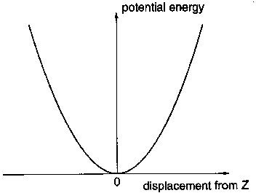

Which feature of the graph means that the force on the body is directed towards Z?

A The graph is approximately linear for large displacements.

B The graph passes through the origin.

C The potential energy increases as the body moves further from Z.

D The value of the potential energy is always positive.

10 The same progressive wave is represented by the following graphs.

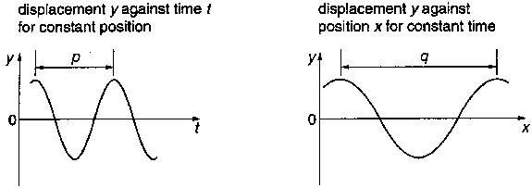
Which of the following gives the speed of the wave?

A pq B p/q C q/p D 1/(pq)

11 In the diagram, T represents a transmitter of microwaves and P represents a metal plate.

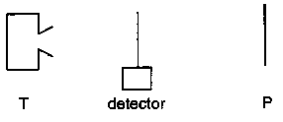

The detector is connected to a galvanometer. The distance TP is much greater than the wavelength of the microwaves.

As the detector is moved between T and P, what happens to the galvanometer reading?

A It decreases steadily.
B It reaches a maximum at R
C It reaches a maximum midway between T and R
D It increases and decreases regularly.

12 Light of wavelength 600 nm falls on a pair of slits, forming fringes 3.00 mm apart on a screen. What would the fringe spacing become if the wavelength were 300 nm?

A 0.75 mm B 1.50 mm C 3.00 mm D 6.00 mm

13 An uncharged capacitor is connected between earth Z and a terminal W. A positively charged rod is brought close to W.
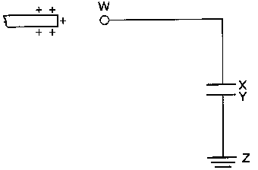

Which of the following describes the movement of charge?

A Electrons move from W to X and from Y to Z.

B Electrons move from W to X but not from Y to Z.

C Electrons move from X to W and from Z to Y.

D Electrons move from X to W but not from Z to Y

14 The diagram shows the relation between the direct current I in a certain conductor and the potential difference V across it. When V< 1.8 V, the current is negligible.
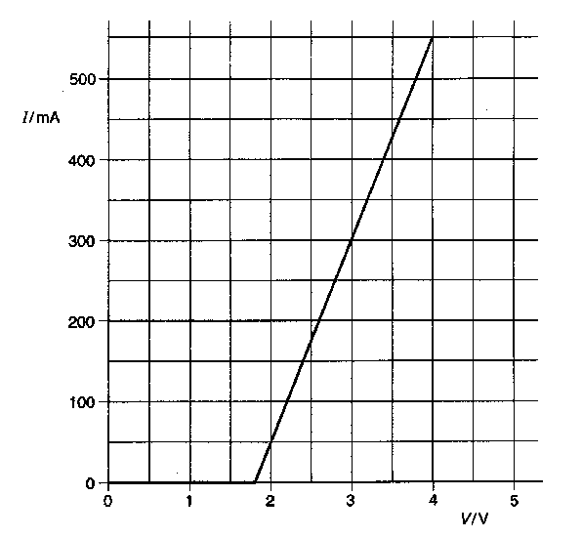

Which statement about the conductor is correct?

A It does not obey Ohm's law but when V> 1.8 V its resistance is 4 Ω.

B It does not obey Ohm's law but when V =3 V its resistance is 10 Ω.

C It obeys Ohm's law when V> 1.8 V and when V = 3 V its resistance is 10 Ω.

D It obeys Ohm's law when V> 1.8 V but its resistance is not constant.

15 A lamp is connected to a power supply of negligible internal resistance.

Which circuit could not be used as a practical means to vary the voltage across the lamp?
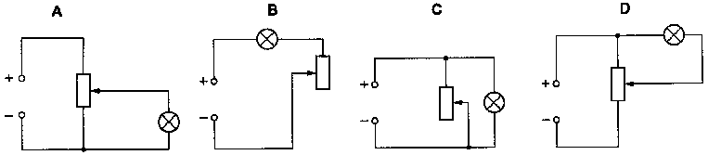

16 Two large horizontal metal plates are separated by 4 mm. The lower plate is at a potential of - 6 V.

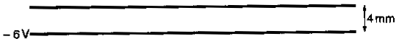
What potential should be applied to the upper plate to create an electric field of strength 4000 V m⁻¹ upwards in the space between the plates?

A +22 V B +10 V C -1O V D –22 V

17 The diagrams show two ways of connecting two identical capacitors of capacitance C in circuits each with a supply of p.d. V.

What is the value $\frac{\text{total electrical energy in the capacitors in circuit 1}}{\text{total electrical energy in the capacitors in circuit 2}} ?$

A 1/4 B 1/2 C 2/1 D 4/1

18 The diagram shows a wire, carrying a current I, placed between the poles of a magnet.

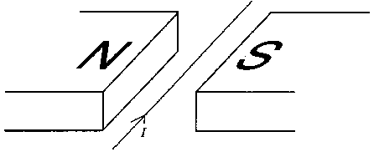

In which direction does the force on the wire act?

A downwards
B upwards
C towards the N pole of the magnet
D towards the S pole of the magnet

19 When a coil is rotated in a magnetic field, the induced e.m.f. E varies as shown.

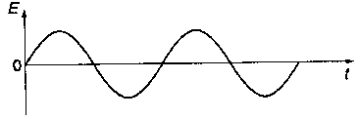

Which of the following graphs, drawn to the same scale, would be obtained if the speed of rotation of the coil were doubled?

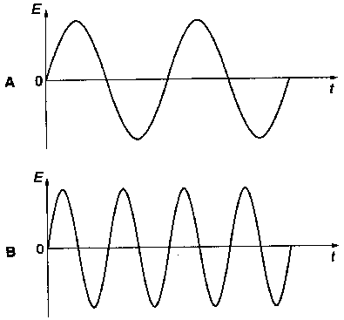
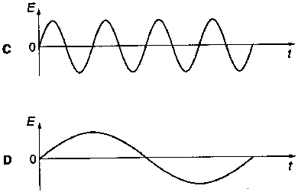

20 Some students were given the following instructions.

‘Design a circuit to give a full-wave rectified output from a low-voltage alternating supply. The positive output must be connected to a red terminal and the negative output to a black terminal.’

Which circuit satisfies these design instructions?
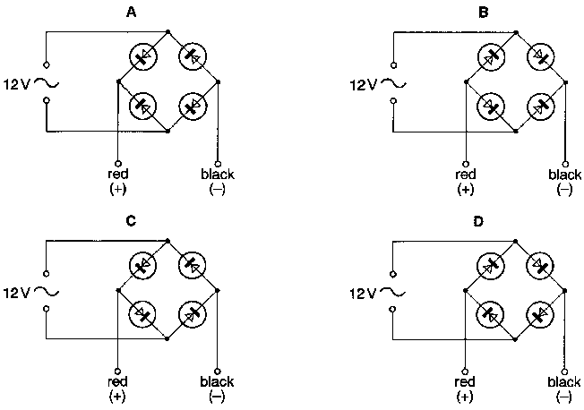

21 In a Brownian motion experiment involving smoke particles in air, heavy particles settle quickly but very small particles remain suspended for long periods of time.

Which statement explains why the small smoke particles do not settle?

A Air pressure has a greater effect on smaller particles.

B Random molecular bombardment by air molecules keeps the particles suspended.

C The Earth's gravitational field does not act on very small particles.

D The small smoke particles have the same density as the air.

22 A specimen of polymeric material stretches and contracts as the tensile force applied is first increased and then decreased, as shown.
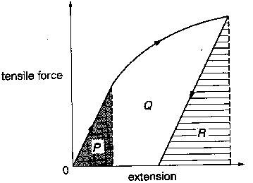

Which area represents the net work done during the stretching and contracting cycle?

A R

B P + Q

C P + Q + R

D P + Q - R

23 The temperature is to be measured in each of two different situations:

1 recording the temperature of approximately 3 cm³ of water in an insulated container;

2 monitoring the temperature of a large sphere of copper at approximately 1300 K, cooling at approximately 20 K s⁻¹.

What are the most suitable types of thermometer for these situations?

1 2
A resistance liquid-in-glass
B resistance resistance
C thermocouple resistance
D thermocouple thermocouple

24 The graph shows the variation of temperature change Δθ with time t for 1 kg of a substance, initially solid at room temperature. The substance is heated at a uniform rate of 2000 J min⁻¹.
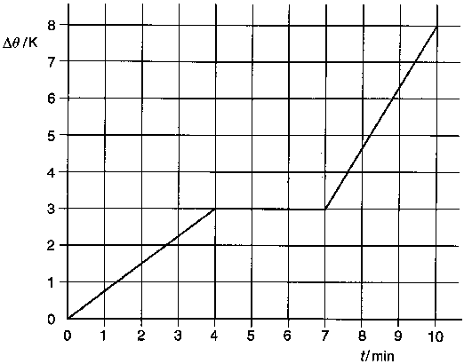

What can be deduced from this graph?

A After 4 mm of heating, the substance is all liquid.
B After 10 mm of heating the substance is all gaseous.
C The specific heat capacity of the substance is greater when liquid than when solid.
D The specific latent heat of fusion of the substance is 6000 J kg⁻¹.

25 In the derivation of the formula $p=\frac{1}{3}\frac{\text{Nm}}{V}<c^{2}>$ for an ideal gas, which of the following is not an essential assumption?

A All collisions are elastic.
B The average kinetic energy of a molecule is proportional to the temperature of the gas.
C The molecules are in continuous random motion.
D There are no intermolecular forces of attraction.

26 In very cold weather, ice can form on the surface of puddles of water because the air temperature is below that of the water.

If the ice layer is found to be thickening at its lower surface, then the transfer of energy must mostly be by

A conduction away from the ice through the air.
B convection away from the ice through the water.
C conduction from the lower to the upper surface of the ice.
D conduction from the upper to the lower surface of the ice.

27 Four particles independently move at the same speed in a direction perpendicular to the same magnetic field.

Which particle is deflected the most?

A a copper ion
B a helium nucleus
C an electron
D a proton

28 In experiments on the photoelectric effect, different metals were illuminated with light from various monochromatic sources of different frequencies and variable intensities. It was found that, for a given metal, frequency and intensity, electrons were emitted with a spread of kinetic energies up to a maximum value.

On what does this maximum kinetic energy depend?

 | metal | frequency of light | intensity of light

A

B

C

D

29 The sketch graph shows how the binding energy per nucleon varies with the nucleon number for naturally occurring nuclides.
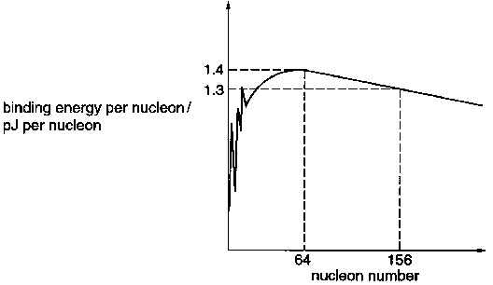

What is the total binding energy of the nuclide ${}_{\text{64}}^{\text{156}}{}\text{Gd}$ ?

A 83 pJ B 90 pJ C 203 pJ D 218 pJ

30 A source contains initially N_{o} nuclei of a radioactive nuclide.

How many of these nuclei have decayed after a time interval of three half-lives?

A N_{o}/8 B N_{o}/3 C 2N_{o}/3 D 7N_{o}/8

