1997

Section A

Answer any four questions from this section.

You should take approximately 1 hour 50 minutes answering this section.

1 The following data concern a tennis ball at a given instant just before it is struck by a tennis racket;
horizontal momentum of tennis ball = 2.4 N s,

kinetic energy of tennis ball = 45J.

(a) Why is it correct to give the direction of the momentum but not of the kinetic energy?
[1]
(b) Write down in terms of the mass m and the velocity v of a body, expressions for
(i) the momentum,
(ii) the kinetic energy. [2]

(c) Use your answer to (b) to help you to calculate the mass and the velocity of the tennis ball. [4]

(d) When the racket hits the ball it strikes it with a constant force of 60 N in a direction opposite to its momentum, bringing it to rest momentarily. Calculate
(i) the time the tennis ball takes to stop,
(ii) the distance the tennis ball travels while stopping. [4]

(e) The force of 60 N then continues to act on the tennis ball for a further 0.060 s. Calculate
(i) the new momentum of the ball,
(ii) the new velocity of the ball. [3]

(f) Calculate the increase in kinetic energy of the ball for the whole time that the force is applied to it and hence deduce the mean power being delivered to the ball while it is in contact with the racket. [4]

(g) Suggest why, in practice, it is impossible for a constant force to be applied to the ball.
[2]

2 The following astronomical data are required in answering this question.

Mass of the Earth 5.98 x 10²⁴kg
Mass of the Moon 7.35 x 10²²kg
Radius of the Earth (assumed constant) 6.378 x 106 m
Distance from the centre of the Earth to the
centre of the Moon (assumed constant) 3.84 x 10⁸m.

(a) The metre was originally defined so that the distance along the Earth's surface from the equator to the North pole was 10 000 km. What percentage error is there between this original definition of the metre and the modern definition, which was used when quoting the radius of the Earth? [3]

(b) Use Newton's law of gravitation to calculate the gravitational force which the Earth exerts on the Moon. [3]

(c) Calculate the acceleration of the Moon due to the force in (b). State the direction of this acceleration and explain why this acceleration does not increase the speed of the Moon. [4]

(d) Use your answer to (c) to deduce the angular velocity of the Moon about the Earth and the period of it in its orbit. [4]

(e) Show that the period T of a satellite orbiting the Earth in a circle of radius r is given by

$$T=\sqrt{\frac{4 π^{2} r^{3}}{\text{GM}}}$$

where G is the gravitational constant and M is the mass of the Earth. [4]

(f) Use the equation in (e) to find the radius of the orbit of a geostationary satellite. [2]

3 (a) Explain, using clearly labelled sketches where appropriate, the meaning of the following terms when applied to wave motion.
(i) displacement,
(ii) amplitude,
(iii) wavelength,
(iv) phase difference between two waves,
(v) coherence of two waves,
(vi) diffraction. [9]

(b) A diffraction grating with 250 lines per millimetre is placed in front of a monochromatic source of red light. A screen placed 200 cm beyond the grating has red light images measured at certain positions on a scale on the screen, as shown in Fig. 3.1.

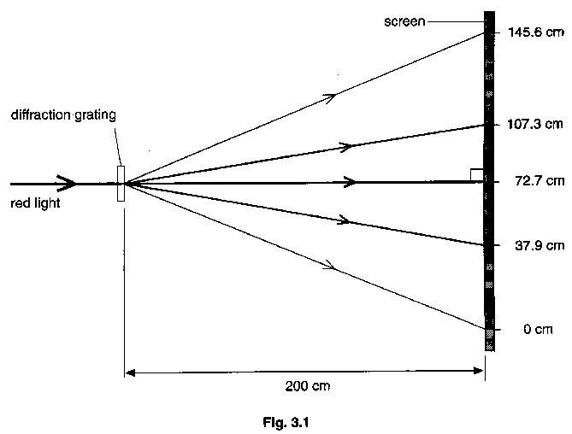

(i) Use the first order spectrum to deduce a value for the wavelength of the red light.
(ii) Make a check, using the second order spectrum, to show that your calculation is correct. [6]

(c) How would the pattern obtained be different if blue light were used in place of red light? You are not expected to make any calculations when answering this part of the question. [3]

(d) What main problem would arise if the experiment were repeated with infra-red radiation? Suggest how this problem could be overcome. [2]

4 (a) Name a material commonly used as (i) the conductor, (ii) the insulator, in household electrical wiring. [2]

(b) A metal, such as silver, conducts electricity approximately 10²⁰ times more readily than an insulator of the same dimensions, such as sulphur. Explain this qualitatively using a simple electron model. [3]

(c) A car headlamp is marked 12 V, 72W. It is switched on for a 20 minute journey. Calculate

(i) the current in the lamp,
(ii) the charge which passes through the lamp during the journey,
(iii) the energy supplied to the lamp during the journey,
(iv) the working resistance of the lamp. [6]

(d) Two of the headlamps referred to in part (c) are connected into the circuit shown in Fig. 4.1, in which one source of e.m.f. (the generator of the car) is placed in parallel with the car battery and the two lamps. Both lamps are on and are working normally.

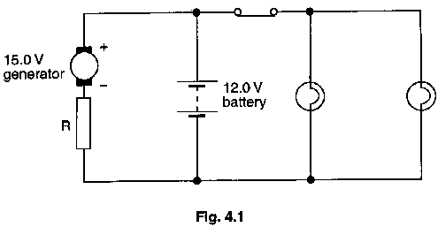

The battery has an e.m.f. of 12.0 V and negligible internal resistance: the generator has an e.m.f. of 15.0 V and negligible internal resistance. The generator is in series with a variable resistor R.

(i) The value of R is adjusted so that there is no current in the battery when the lamps are on.

Calculate
1. the current in the generator,
2. the value of the resistance of R. [5]

(ii) Calculate the current in the battery when both lamps are switched off, the value of R remaining the same as in (i). [2]

(e) Suggest two advantages which the circuit, as shown in Fig. 4.1, has over a single power source. [2]

5 (a) Distinguish between the structure of crystalline and non-crystalline solids, making reference to appropriate examples. [3]

(b) Define the terms stress and strain as applied to a wire being stretched. [2]

(c) Explain the difference between elastic and plastic deformation of a material. [2]

(d) A wire, made of a ductile material of density 7.6 x 10³ kg m⁻³, has an area of cross section 2.5 x 10⁻⁷m² and initial length 2.00m. It is stretched by applying a tensile force to it. The force increases to 48 N, at which value the extension increases from 8.0 mm to 88 mm, as shown in Fig. 5.1. Once the extension has reached 88 mm the force is removed and the wire is then seen to have been permanently stretched by 80 mm.
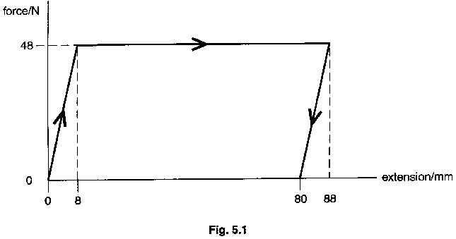

Calculate
(i) the mass of the wire, [2]
(ii) the strain in the wire when the extension is 8.0 mm, [2]
(iii) the work done on the wire [4]
1. while the extension increases from zero to 8.0 mm,
2. while the extension increases from 8.0 mm to 88 mm.
(iv) Discuss how the work done which you calculated in the two parts of (iii), is transformed to different forms of energy. [2]
(v) The specific heat capacity of the material of the wire is 450 J kg⁻¹ K⁻¹. Estimate the rise in the temperature of the wire when the extension increases from zero to 88 mm. [3]

6 (a) Define electric field strength and state an SI unit of electric field strength. [21]

(b) State the equation for the force F acting on a charge Q travelling with velocity v in, and at right angles to, a magnetic field of field strength B. [1]

(c) Outline Millikan's experiment and summarize the experimental evidence it provides for the quantisation of charge. [6]

(d) A part of a mass spectrometer is illustrated in Fig. 6.1. The whole arrangement is in a vacuum. Negative ions of mass 2.84 x 10⁻²⁶kg and charge -1.60 x 10⁻¹⁹C, are generated at S, which is at a potential of -3000 V. The ions are accelerated in a narrow beam towards H, which is a hole in a hollow metal container. The container is kept at zero potential.

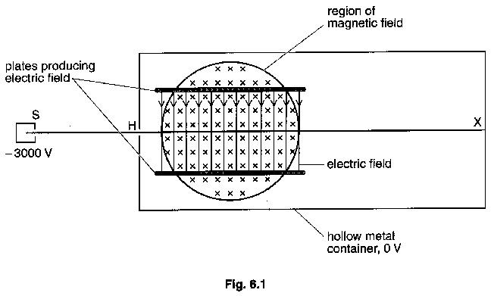

Once inside the container the negative ions enter a region in which there is an electric field of field strength E, and a magnetic field of flux density 0.83 T. When in these fields the negative ions continue in a straight line with constant velocity.

(i) Calculate the velocity of the ions when they reach H. [4]
(ii) Explain, using a sketch, how it is possible for the ions not to be deflected in the fields. [2]
(iii) Calculate the electric field strength E. [3]
(iv) The electric field is then switched off. State, without calculation, what would happen to the path of the negative ions. [2]

Section B

Answer any two questions from this section.

One question is set on each of the seven optional topics, namely,

Option A, Astronomy and Cosmology,
Option C, The Physics of Materials,
Option E, Electronics
Option F, The Physics of Fluids
Option M, Medical Physics
Option P, Environmental Physics and
Option T, Telecommunications.

You should take approximately 40 minutes answering this section.

Option A

Astronomy and Cosmology

7 (a) What is meant by a light year? Calculate its value. [2]

(b) Give an approximate value for the diameter of the Universe. [1]

(c) Electromagnetic radiation is the major source of information about stars. Give a description of the deductions which can be made from the following observations.
(i) The sky is dark at night (Olbers' Paradox).
(ii) The wavelength of the electromagnetic radiation at which maximum power occurs is different for different stars.
(iii) The hydrogen line spectrum from some stars is redder than expected. [9]

(d) State two advantages and one disadvantage of making astronomical observations from a satellite. [3]

Option C

The Physics of Materials

8 (a) The microstructure of a metal affects its mechanical properties.

(i) Explain what is meant by microstructure of a metal.
(ii) State two mechanical properties which are usually affected by differences in microstructure.
(iii) Describe three techniques which are used to change the microstructure of steel.
[10]

(b) (i) What is meant by metal fatigue? Describe a situation which may lead to fatigue in steel.
(ii) How may a fatigue failure be
1. prevented,
2. detected once it has happened? [5]

Option E

Electronics

9 Fig. 9.1 shows an operational amplifier (op-amp) in a circuit. The op-amp in this question may be considered to be ideal.

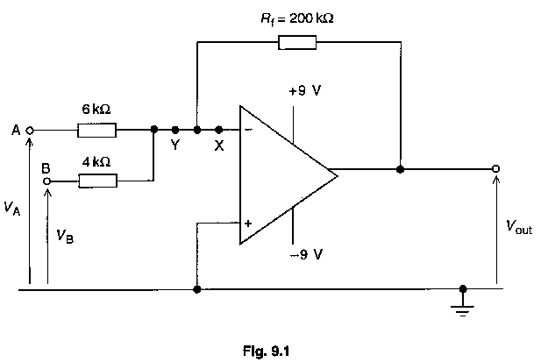

(a) For the ideal op-amp, what can be stated about
(i) the potential at X,
(ii) the current in the wire at X,
(iii) the maximum and the minimum output potentials? [3]

(b) The potential at A is fixed at +1.8 V and the potential at B is initially -0.4 V. Calculate
(i) the input current at A,
(ii) the current at Y,
(iii) the current in the feedback resistor of value R_{f} = 200 kΩ,
(iv) the output potential. [7]

(c) The potential at B is now varied in the way shown in Fig. 9.2: the potential at A remains fixed at +1.8 V. Sketch the shape of the output potential. [5]

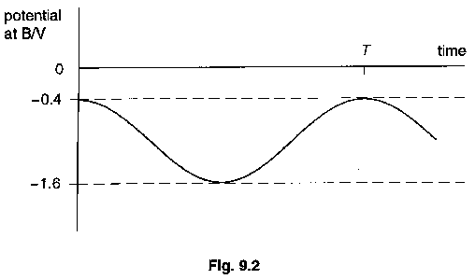

Option F

The Physics of Fluids

10 (a) A cuboid with dimensions 25cm x 20cm x 15cm has mass 4.0 kg and is floating in water of density 1000 kg m⁻³ so that its largest faces are horizontal as shown in Fig. 10.1.

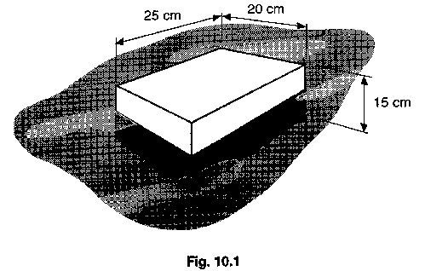

Calculate
(i) the upthrust on the cuboid,
(ii) the fraction of the cuboid which is beneath the water surface,
(iii) the position of the centre of buoyancy of the cuboid. [5]

(b) Making reference to the cuboid in (a), describe how the relative positions of the metacentre and the center of mass determine the stability of the cuboid. [3]

(c) The drag force F on an object of mass 0.42 kg falling with velocity v through a viscous fluid under laminar conditions is given by

F = kv

where k is a constant having the value 26 N m⁻¹ s.

(i) Explain the meaning of the terms viscous and laminar.
(ii) Calculate the terminal velocity of the object falling under gravity.
(iii) Calculate the acceleration of the object when it is falling with velocity 0.l4ms-¹.
[7]

Option M

Medical Physics

11 (a) Outline the physical principles of the following techniques to obtain diagnostic information about the internal structure of a human body.
(i) X-rays, [4]
(ii) magnetic resonance. [5]

(b) State one disadvantage of each of the methods of imaging described in (a). [2]

(c) Explain the principle of one method of producing ultrasonic waves. [4]

Option P

Environmental Physics

12 (a) The solar constant has a value which varies from 1420 Wm⁻² in December to 1330 Wm⁻² in June.

(i) Explain what is meant by the term solar constant.
(ii) Suggest why the solar constant is different in December from June.
(iii) Explain why the mean temperature in England is lower than the mean temperature in the West Indies, although the solar constant is the same in both places. (The West Indies are closer to the equator than England.)
(iv) State two factors, apart from those already mentioned, which affect the amount of power which a place receives from the Sun at any particular time. [8]

(b) (i) A power station uses steam at a temperature of 650 ºC to operate its turbines. On one day in summer the temperature of its cooling water is 23 ºC and on one day in winter the cooling water temperature is only 2 ºC. Calculate the maximum theoretical efficiencies on the two days.

(ii) The actual efficiency of the power station on the winter day is 34%. When the electrical power output of the power station is 600 MW, calculate the power input and the power wasted. [7]

Option T

Telecommunications

13 (a) A high quality transmission of an audio signal requires that the transmission system should be able to transmit all frequencies up to 10 000 Hz. The signal is to be transmitted using a digital fibre optic system which operates in the infra-red waveband of the electromagnetic spectrum at a frequency of 3 x 10¹⁴Hz. The audio signal is sampled once every millionth of a second and uses an 8-bit analogue to digital converter.

Making use of the above information where appropriate,
(i) state the advantages of transmitting data in digital form, [3]
(ii) explain the principle of analogue to digital conversion, [5]
(iii) explain the advantage of using high frequency electromagnetic radiation. [4]

(b) A signal at one point in an optic fibre has a mean power of 8.3 x 10⁻² W. At a point 5.0 km further along the fibre the mean power is 7.4 x 10⁻³W. Calculate the signal attenuation in dB per unit length of the fibre. [3]

