1997

1 A stuntman on a motorcycle plans to ride up a ramp in order to jump over a number of cars, as illustrated in Fig. 1.1.

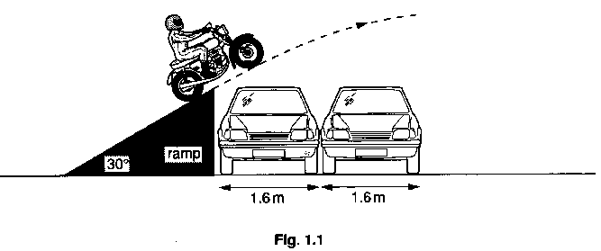

The speed of the motorcycle as it leaves the ramp is 14 m s⁻¹. Neglect air resistance throughout this question.

(a) On Fig. 1.2, the line OA represents the velocity of the motorcycle just as it leaves the ramp.

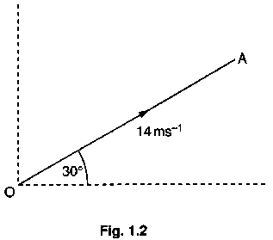
(i) Explain why OA represents the velocity of the motorcycle and not just its speed.

(ii) What is the scale used in Fig. 1.2?
(iii) On Fig. 1.2, construct lines to determine the horizontal and the vertical components of the velocity of the motorcycle. Determine
1. the horizontal component of the velocity,
2. the vertical component of the velocity. [4]

(b) Calculate the time interval between leaving the end of the ramp and reaching maximum height. [2]

(c) The cars are each of width 1.6 m and the same height as the ramp. Estimate the maximum number of cars which the motorcyclist can jump for the take-off speed of l4ms⁻¹. [3]

2 Fig. 2.1 illustrates a mass which can be made to vibrate vertically between two springs.

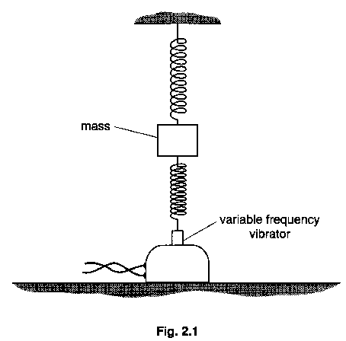

The vibrator itself has constant amplitude. As the frequency is varied, the amplitude of vibration of the mass is seen to change as shown in Fig. 2.2.

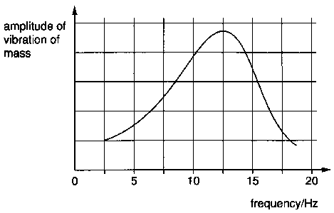
(a) Name the phenomenon which is illustrated in Fig. 2.2. [11]

(b) For the mass vibrating at maximum amplitude, calculate
(i) the angular frequency,
(ii) the period. [4]

(c) A light piece of card is fixed to the mass with its plane horizontal. On Fig. 2.2, draw a line to show the variation with frequency of the amplitude of vibration of the mass.
[2]

(d) State one situation in which the phenomenon illustrated in Fig. 2.2 is used to advantage. [1]

3 Fig. 3.1 illustrates the pattern of the magnetic flux due to a current in a solenoid.

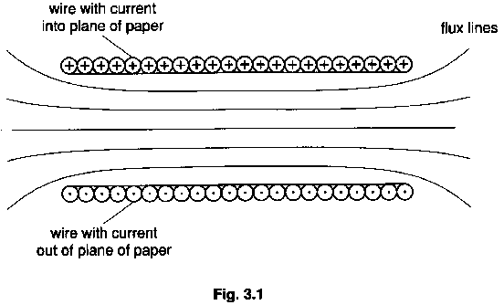

(a) On Fig.3.1,
(i) draw arrows to show the direction of the magnetic field in the solenoid,
(ii) draw a line to represent a current-carrying conductor in the magnetic field which does not experience a force due to the magnetic field. Label the conductor C. [2]

(b) The coils of wire on an electromagnet are usually wound on a ferrous core. State two
properties of the core which are important in its use in an electromagnet. [2]

(c) In a transformer, the core on which the primary and secondary coils are wound is laminated, i.e. the core is made up of a large number of strips, rather than being solid. This reduces energy losses due to currents induced in the core. Explain

(i) how these currents arise in the core,
(ii) why laminating the core reduces energy losses due to the currents. [5]

4 An ideal gas has volume 0.50 m³ at pressure 1.01 x 10⁵ Pa and temperature 17 ⁰C.

(a) (i) Define pressure.
(ii) State a unit, other than pascal, for pressure. [2]

(b) Calculate, for this gas, the number of
(i) moles,
(ii) molecules. [5]

(c) Each molecule may be considered to be a sphere of radius 1.2 x 10⁻¹⁰ m. Calculate

(i) the volume of one molecule of the gas,
(ii) the volume of all the molecules. [2]

(d) (i) State the assumption made in the kinetic theory of gases for the volume of the molecules of an ideal gas.
(ii) Comment on your answer to (c)(ii) with reference to this assumption. [3]

5 A student sets up the apparatus illustrated in Fig. 5.1 in order to demonstrate Brownian motion.

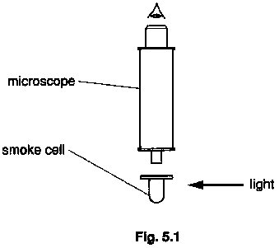

(a) State

(i) the evidence provided by the experiment for the movement of gas molecules,
(ii) the nature of the movement of gas molecules. [3]

(b) State and explain the effect on the observations made if larger smoke particles are used. [2]

6 Electromagnetic radiation is incident normally on the surface of a metal. Electrons are emitted from the surface and these are attracted to a positively charged electrode, as shown in Fig. 6.1.

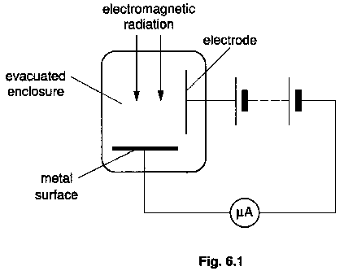

(a) Name the effect which gives rise to the emission of the electrons. [1]

(b) State a word equation, based on the principle of conservation of energy, which describes this effect. [2]

(c) The current recorded on the microammeter is 2.1 μA. Calculate the number of electrons emitted per second from the surface. [2]

(d) The incident radiation has wavelength 240 nm. Calculate the energy of a photon incident on the surface. [2]

(e) The intensity of the incident radiation is 8.2 x 10³ W m⁻². The area of the surface is 2.0 cm². Calculate

(i) the power of the radiation incident on the surface,
(ii) the number of photons incident per second on the surface.
(iii) Hence determine the ratio

number of electrons emitted per second
number of photons incident per second [4]

(f) Comment on your answer to (e)(iii). [1]

7 Uranium nuclei when bombarded by neutrons may undergo nuclear reactions. One such reaction is

$${}_{\text{92}}^{\text{235}}{}\text{U }+{}_{0}^{1}{}\text{n }→{}_{\text{56}}^{\text{144}}{}\text{Ba }+{}_{\text{36}}^{\text{90}}{}\text{Kr }+$$

(a) (i) Complete the equation for this nuclear reaction.

(ii) Name this type of nuclear reaction. [2]

(b) The binding energy per nucleon of Uranium-235 is approximately 7.5 MeV and that of Barium-144 and Krypton-90 is approximately 8.5 MeV.

(i) Estimate the energy change in this nuclear reaction.
(ii) Suggest two forms of energy into which the energy in (i) is transformed during a reaction of this type. [5]

8 (a) What is meant by the random nature of radioactive decay? [1]

(b) The thickness of a sheet of aluminium foil is to be monitored using β-radiation as illustrated in Fig. 8.1.

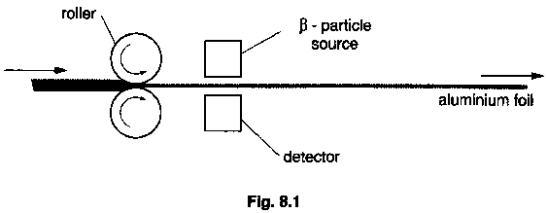

The separation of the rollers is controlled by the output from the detector with the intention of maintaining a constant foil thickness.

(i) State what would happen to the separation of the rollers if the output from the detector were to increase.
(ii) Suggest why a γ-radiation source would not be satisfactory for monitoring changes in thickness of the foil.
(iii) A β-particle source of half-life 14 days is installed in the monitor and then used for a working day of 8.0 hours.

1. Calculate the ratio

activity of source at end of working day
activity of source at start of working day

2. Estimate the percentage change in foil thickness during one working day if no allowance is made for radioactive decay. State whether the change is an increase or a decrease. [7]

9 With increasing levels of noise in the environment, it is recognized that measures need to be taken to reduce noise, particularly in the home and working environment. Noise near busy roads or airports is of great concern, and the level of noise insulation provided by windows must be considered.

Double-glazed windows consist of two glass sheets separated by a layer of air as illustrated in Fig. 9.1.

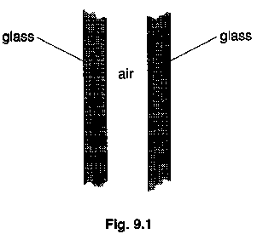

For glass of thickness 6.0 mm and an air-gap of 12 mm, the window would be specified as 6-12-6 double glazing. The table of Fig. 9.2 shows how sound insulation varies with frequency for two double-glazed windows and also for a single sheet of glass of thickness 6.0 mm. Higher values of sound insulation represent more noise reduction. A change of less than 3 units is not detectable by the human ear.

frequency/Hz | sound insulation/arbitrary units
frequency/Hz | 6-12-6 | 6-200-6 | 6 mm
100 | 21 | 32 | 22
125 | 27 | 35 | 22
160 | 27 | 38 | 23
200 | 23 | 40 | 24
250 | 25 | 42 | 25
315 | 28 | 43 | 26
400 | 29 | 45 | 27
500 | 31 | 46 | 29
630 | 32 | 47 | 30
800 | 33 | 48 | 31
1000 | 34 | 49 | 31

(a) On Fig. 9.3, plot a graph to show how sound insulation varies with frequency for 6-200-6 double glazing. [3]

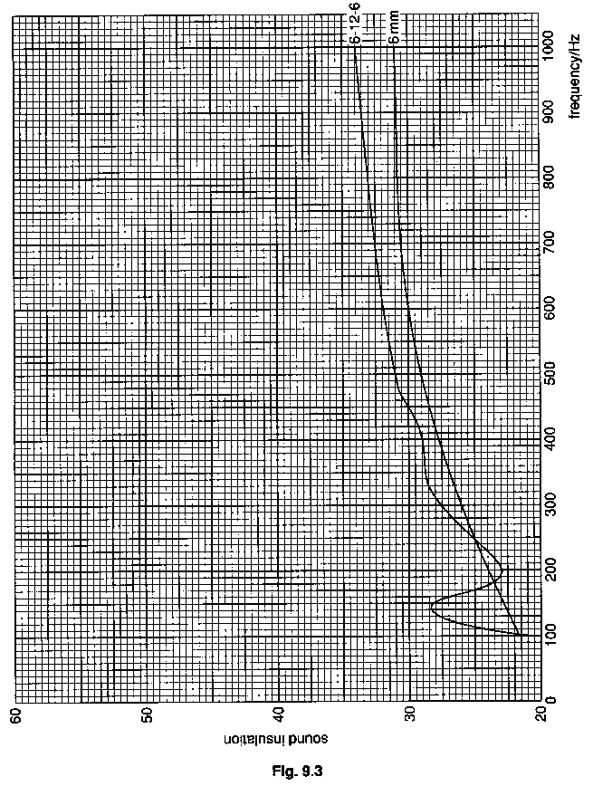

(b) 6-12-6 double glazing is sometimes sold for thermal insulation. A salesman claims that it is also effective for sound insulation.

(i) State and explain two reasons why 6-12-6 double glazing is more effective as a thermal insulator than a single sheet of 6 mm glass.
(ii) 6-200-6 double glazing is not as effective as 6-12-6 double glazing for thermal insulation. Suggest a reason for this difference.
(iii) Use Fig. 9.3 to comment on whether the salesman's claim is justified. [9]

(c) In a television advertisement for double glazing, the effectiveness of the sound insulation of windows was demonstrated by using machinery which produced noise at about 1 kHz. Comment on whether the demonstration could be misleading for a potential customer who wishes to insulate against the low-frequency rumbling noise of traffic. [3]

(d) The noise insulation provided by a window may be measured by comparing the sound intensity I_{o} incident on the window with the sound intensity I_{T} which has been transmitted (see Fig. 9.4).

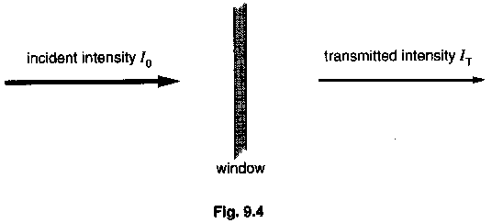

The sound insulation, measured in decibels (dB), is given by

sound insulation = -10 lg(I_{T}/I_{o}) dB.

Fig. 9.5 shows the variation with frequency of the sound insulation provided by a sheet of glass of thickness 6 mm.

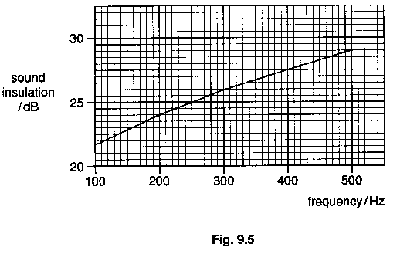

(i) State whether the glass sheet provides better sound insulation at high or at low frequencies.
(ii) From Fig. 9.5, read off the value of sound insulation for a frequency of 350 Hz.
(iii) Calculate the ratio I_{T}/I_{o} at a frequency of 350Hz. [5]

