1997

1 If p is the momentum of an object of mass m, the expression $\frac{p^{2}}{m}$ has base units identical to

A energy.
B force.
C power.
D velocity

2 The trace shown appeared on an oscilloscope screen with the time-base set to 2.0 ms cm⁻¹.

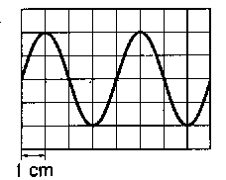

What was the frequency of the signal?

A 40Hz B 125Hz C 250Hz D 500Hz

3 A small steel ball falls freely under gravity after being released from rest. Which graph best represents the variation of the height h of the ball with time t?

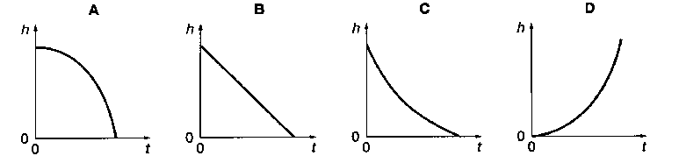

4 A mass accelerates uniformly when the resultant force acting on it

A is zero.
B is constant but not zero.
C increases uniformly with respect to time.
D is proportional to the displacement of the mass from a fixed point.

5 Diagram 1 shows two parallel forces F acting on a bar of length l pivoted at P. The forces give rise to a couple of torque M.

In diagram 2, the lines of action of the forces are moved a distance l/4 to the left.

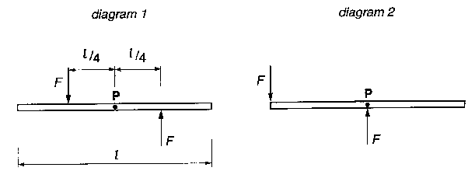

What is now the torque of the couple?

A 0 B M/2 C M D 2M

6 A boat moving at constant speed v through still water experiences a total frictional drag F. What is the power developed by the boat?

A ½ Fv B Fv C ½ Fv² D Fv²

7 The diagram shows two points X and Y at distances L and 2L, respectively, from the centre of the Earth. The gravitational potential at X is -8 kJ kg⁻¹.

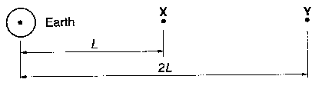

What is the gain in gravitational potential energy of a 1 kg mass when it is moved from X to Y?

A -kJ B -2kJ C +4kJ D +8kJ

8 The maximum safe speed of a car rounding an unbanked corner is 20 m s⁻¹ when the road is dry. The maximum frictional force between the road surface and the wheels of the car is halved when the road is wet.

What is the maximum safe speed for the car to round the corner when the road is wet?

A $\frac{\text{20}}{4}$ m s⁻¹ B $\frac{\text{20}}{2\sqrt{2}}$ m s⁻¹ C $\frac{\text{20}}{2}$ m s ⁻¹ D $\frac{\text{20}}{\sqrt{2}}$ m s⁻¹

9 Which graph correctly shows the variation with time t of kinetic energy E_{k} of an object undergoing simple harmonic motion of period T?
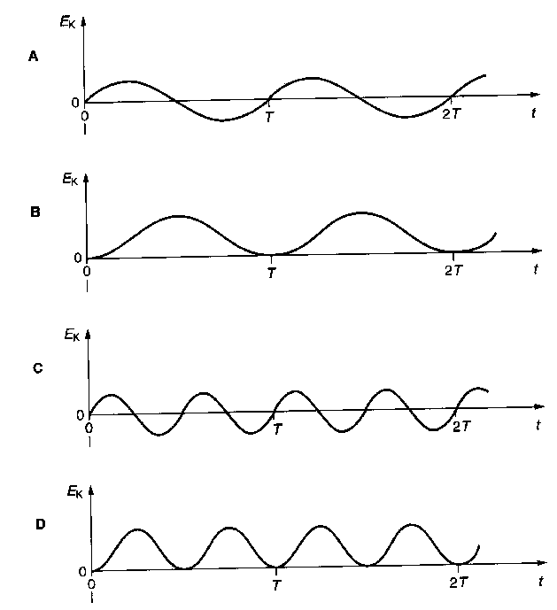

10 What happens to the speed, frequency and wavelength of light when it enters glass from air?
speed frequency wavelength
A decreases increases unchanged
B increases unchanged increases
C unchanged decreases decreases
D decreases unchanged decreases

11 Water waves of wavelength 4 m are produced by two generators, S₁ and S₂, as shown. Each generator, when operated by itself, produces waves which have an amplitude A at P, which is 3m from S₁ and 5 m from S₂.

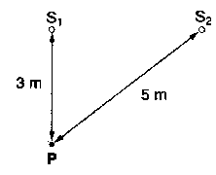

When the generators are operated in phase, what is the amplitude of oscillation at P?

A 0 B ½ A C A D 2A

12 A wire is stretched over two supports, Q and R, a distance 4x apart. Three light pieces of paper rest on the wire, as shown.

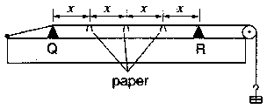

When the wire is made to vibrate at one particular frequency, the middle piece of paper stays on, but the others fall off the wire.

What is the wavelength of the vibration produced on the wire?

A 2x B 3x C 4x D 8x

13 Which statement describes the electrical potential difference between two points in a wire carrying a current?
A the force required to move a unit positive charge between the points
B the ratio of the energy dissipated between the points to the current
C the ratio of the power dissipated between the points to the current
D the ratio of the power dissipated between the points to the charge moved

14 The resistance of a thermistor decreases significantly as its temperature increases.

Which graph best represents the way in which the current I in the thermistor depends upon the potential difference V across it?

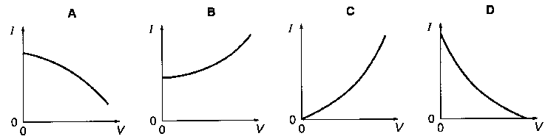

15 In the circuit shown, there is a current of 3 A in the 2 Ω resistor.

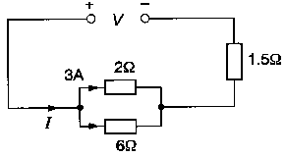

What are the values of the current I delivered by, and the voltage V across, the power supply?

I/A V/V
A 3 10.5
B 4 9
C 4 12
D 12 18

16 Two large plane parallel conducting plates are situated 40 mm apart as shown. The potential difference between the plates is V

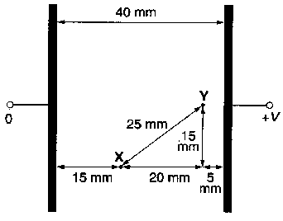

What is the potential difference between point X and point Y?

A $\frac{\text{15}}{\text{40}}$ V B $\frac{\text{20}}{\text{40}}$ V C $\frac{\text{25}}{\text{40}}$ V D $\frac{\text{40}}{\text{40}}$ V

17 A positive charge and a negative charge of equal magnitude are placed a short distance apart. Which diagram best represents the associated electric field?

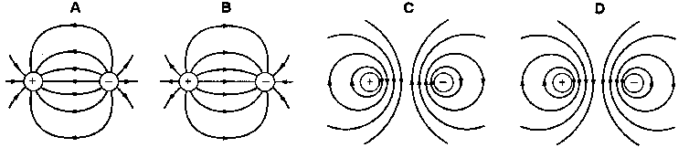

18 A capacitor is charged to a voltage V and then discharged through a small d.c. motor. As the capacitor discharges, the motor raises a mass through a height h. The experiment is repeated for several values of V

A constant fraction of the capacitor energy is converted to gain of gravitational potential energy. Which graph would be expected to give a straight line?

A h against V²
B h against V
C h against $\sqrt{V}$

D h against 1/$\sqrt{V}$

19 Hot air from a hair-dryer contains many positively charged ions. The motion of these ions constitutes an electric current.

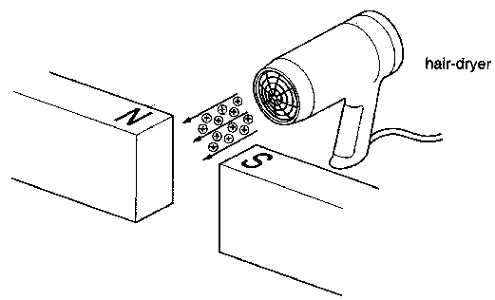

The hot air is directed between the poles of a strong magnet, as shown.

What happens to the ions?

They are deflected

A towards the north pole N.
B towards the south pole S.
C downwards.
D upwards.

20 An a.c. supply is connected to a resistor. When the peak value of the e.m.f. of the supply is V_{o} and the frequency is f, the mean power dissipated in the resistor is P. The supply frequency is then changed to 2f, the peak value of the e.m.f. remaining as V_{o}.

What is now the mean power in the resistor?

A P B $\sqrt{2}$P C 2P D 4P

21 The diagram shows an iron-cored transformer assumed to be 100% efficient. The ratio of the secondary turns to the primary turns is 1:20.

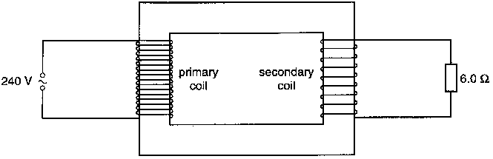

A 240 V, a.c. supply is connected to the primary coil and a 6.0 Ω resistor is connected to the

What is the current in the primary coil?

A 0.10 A B 0.14 A C 2.OA D 40 A

22 A long narrow tube contains salt water of density 1020 kg m⁻³ to a depth of 1.00 m. The tube is then inclined at 30º to the horizontal, as shown.

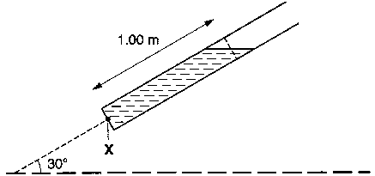

If atmospheric pressure is 100 kPa, what is the pressure at point X inside the tube?

A 5.00 kPa B 95.0 kPa C l05 kPa D 110 kPa

23 Which diagram shows the force-extension graph for a brittle material which is stressed up to breaking point?

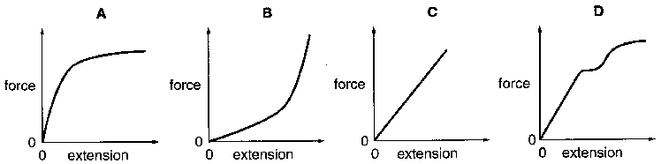

24 An electric kettle contains 1.5 kg of water at 100ºC and is powered by a 2.0 kW electric element.

It the thermostat of the kettle fails to operate; approximately how long will the kettle take to boil dry? [Take the specific latent heat of vaporisation of water as 2000 kJ kg⁻¹.]

A 500 s B 1000 s C 1500 s D 3000 s

25 The pressure p of a gas occupying a volume V and containing N molecules of mass m and mean square speed <c²> is given by

$$p=\frac{1}{3}\frac{\text{Nm}}{V} <c^{2}>$$

The density of argon at a pressure of 1.00 x 10⁵ Pa and at a temperature of 300 K is 1.60 kg m⁻³.

What is the root mean square speed of argon molecules at this temperature?

A 216ms-¹ B 250 ms-¹ C 306 ms-¹ D 433 ms-¹

26 Two metal spheres of different radii are in thermal contact in a vacuum as shown.

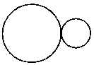
The spheres are at the same temperature. Which statement must be correct?

A Each sphere has the same internal energy.
B There is no net transfer of thermal energy between the spheres.
C Both spheres radiate electromagnetic energy at the same rate.
D The larger sphere has a greater mean internal energy per atom than the smaller sphere.

27 In a cathode-ray oscilloscope tube, the electron beam passes through a region where there are electric and magnetic fields directed vertically downwards as shown.

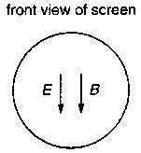

The deflections of the spot from the centre of the screen produced by the electric field E and the magnetic field B acting separately are equal in magnitude.

Which diagram shows a possible position of the spot on the screen when both fields are operating together?

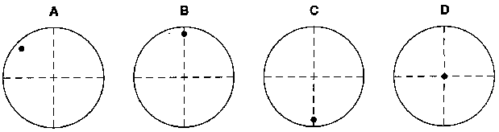

28 An atom emits a spectral line of wavelength λ when an electron makes a transition between levels of energy E₁ and E₂.

Which expression correctly relates λ, E₁ and E₂?

A $λ=\frac{h}{c}\left(E_{1}−E_{2}\right)$
B $λ=\text{ch}\left(E_{1}−E_{2}\right)$
C $λ=\frac{c}{h\left(E_{1}−E_{2}\right)}$
D $λ=\frac{\text{ch}}{E_{1}−E_{2}}$

29 A high energy α-particle collides with a ${}_{7}^{\text{14}}{}N$ nucleus to produce a ${}_{8}^{\text{17}}{}O$. What could be the other products of this collision?

A a γ photon alone
B a γ photon and a β particle
C a γ photon and a neutron
D a γ photon and a proton

30 A newly prepared radioactive nuclide has a decay constant λ of 10⁻⁶ s⁻¹. What is the approximate half-life of the nuclide?
A 1 hour
B 1 day
C 1 week
D 1 month

