Paper-3/1995
Section A
Answer four questions from this section.

1. (a) An object accelerates uniformly in a straight line from a velocity u to velocity v in time t, as shown in Fig. 1.1.
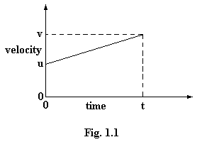
(i) Write down an expression for the acceleration a in terms of u, v and t .
(ii) Use Fig. 1.1 and your answer to (i) to show that s, the distance traveled, is given by
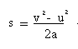

[4]

(b) A cylinder of length 1.20 m, area of cross-section 8.30 x 10⁻⁵ m², and mass 0.777 kg falls from rest so that its base drops from a height of 2.30 m above the ground, as shown in Fig. 1.2.
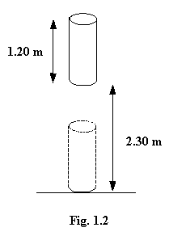

(i) Calculate, ignoring air resistance,
1. the speed of the cylinder just before it hits the ground,
2. the kinetic energy of the cylinder just before it hits the ground [4]
(ii) On hitting the ground, the cylinder may be considered to behave perfectly elastically and to obey Hooke’s law. Under these conditions it undergoes a maximum contraction of 1.6 x 10⁻³ m. Calculate
1. The maximum strain in the cylinder,
2. the maximum elastic potential energy stored in the cylinder,
3. the average force the cylinder exerts on the ground,
4. the maximum force it exerts on the ground,
5. the Young modulus of the material of the cylinder, assuming that the area of cross-section of the cylinder does not change. [9]
(iii) If the collision with the ground is not perfectly elastic, suggest qualitatively, with reasons, how your answers to (b) (ii) 2 and 4 might be different. [3]

2. (a) Describe qualitatively how it is that a body which is traveling in a circle with uniform speed has acceleration. Show on a diagram the direction of this acceleration in relation to the direction in which the body is traveling. [4]
(b) State the equation for the force of attraction F between two point charges of equal magnitude, +q and -q, when placed a distance r apart in a vacuum. [2]
(c) There is a sub-atomic particle of the same mass as the electron but with a positive charge equal in magnitude to the charge of the electron. This particle is called a positron. Calculate the force between an electron and a positron when they are separated by a distance of 1.3 x 10⁻¹⁰ m. [3]
(d) It is possible for an electron and a positron to move in a circular orbit as shown in Fig. 2.1. This system is called positronium and it is very unstable.
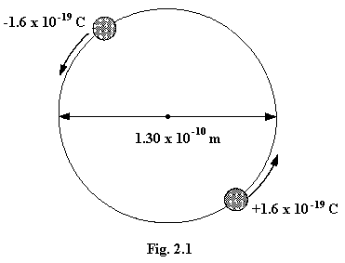

Using your answer to part (c) calculate
(i) the acceleration of the electron (mass 9.11 x 10⁻³¹ kg),
(ii) the radius of the orbit of the electron,
(iii) the speed of the electron in its orbit,
(iv) the time taken for one revolution of the electron. [8]

(e) Suggest, with reason, what will happen to the two particles in (d) if their total energy is reduced. [3]

3. (a) In the preparation of tide tables for coastal reports and harbours, use is made of a graph of depth of water against time at a particular place. One such graph is shown n Fig. 3.1.

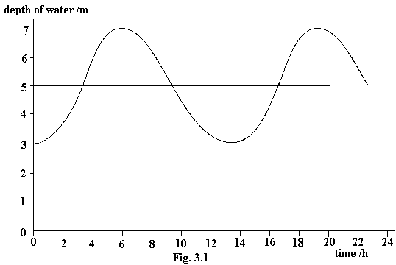

(i) Describe the steps you would take to obtain such a graph practically for a particular harbour. [5]
(ii) What is the period of this oscillation? [1]
(iii) What is the amplitude of this oscillation? [1]

(b) In some harbours, the rise and fall of the water level is simple harmonic. What does simple harmonic mean? [3]

(c) In one harbour, the equation for the depth h of the water is
$$h=5\text{.}0+3\text{.}0\text{sin}\frac{2πt}{\text{45600}} ,$$
where h is given in metres and t is the time in seconds. (The angle 2πt/45600 is in radians.)
For this harbour, calculate
(i) the maximum depth of water, [1]
(ii) the minimum depth of water, [1]
(iii) the time interval between high- and low-water, [2]
(iv) two values of t at which the water is 5.0 m deep, [2]
(v) the length of time for each tide during which the depth of water is more than 7.0 m. [4]

4. (a) Define potential difference [1]
(b) If the equation V = IR is used to define resistance why is it not then possible to use the same equation to define potential difference? [2]
(c) One element of an electric cooker has an I - V characteristic as shown in Fig. 4.1.

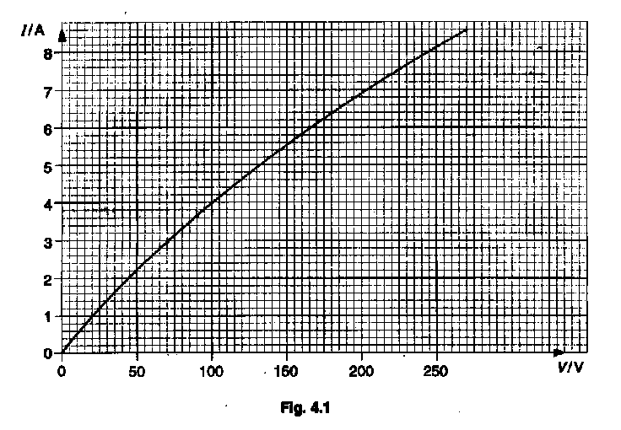

(i) Explain how the characteristic shows that the resistance of the element increases with potential difference. [3]
(ii) Explain in terms of the movement of charged particles why the resistance in-creases with potential difference [3]
(iii) Use the graph to estimate the potential difference which should be applied to the element if it is to have a resistance of 30 Ω. [3]
(iv) What will be the current in the element when it has a resistance of 30 Ω? [1]
(v) What will be the power of the element when it has a resistance of 30 Ω? [1]

(d) Why is it not sensible to control the power to a heating element, such as the one for the electric cooker in (c), by the use of either of the circuits in Fig. 4.2? [4]

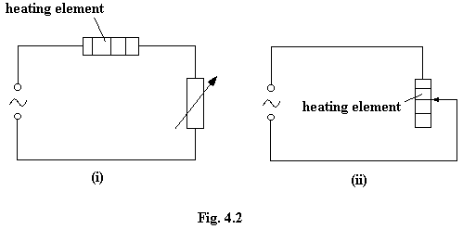
(e) Suggest a more suitable means of controlling the average power output of the heating element over a period of time. [2]

5. (a) What is meant, in molecular terms, by the internal energy of a gas? [2]
(b) State qualitatively and explain in molecular terms, what happens to the internal energy of a fixed mass of an ideal gas when, separately,
(i) the temperature of the gas is raised,
(ii) the volume is decreased at constant temperature,
(iii) the gas as a whole is moving at a certain speed. [6]

(c) The quantity of gas in an engine is 5.2 x 10⁻³ mol. It has volume 5.0 x 10⁻⁵ m³ and pressure 6.0 x 10⁵ Pa. Assume the gas to be ideal.

(i) Calculate the temperature of the gas. [3]
(ii) The gas is then heated at constant volume, so raising its temperature by 800 K. This is done by supplying 85 J of energy to the gas. Calculate
1. the molar heat capacity of the gas at constant volume,
2. the final pressure of the gas [5]

(iii) During the power stroke of the engine, the gas expands, doing 62 J of work, but no thermal energy enters or leaves the gas.
1. State the first law of thermodynamics.
2. By applying the law to this process, find the change in the internal energy of the gas during the power stroke. [4]

6. (a) Describe, using a sketch, a simple model for the nuclear atom.
(b) In the α-particle scattering experiment, α-particles, traveling in a vacuum, are incident on a gold foil. Draw sketch diagrams to illustrate the path of an α-particle, the original path of which
(i) is directly towards the nucleus of a gold atom,
(ii) passes close to the nucleus of a gold atom,
(iii) passes some distance from the nucleus. [3]
(c) Describe and explain how the α-particle scattering experiment which you have illustrated in part (b) gives evidence for the existence and small size of the nucleus [4]
(d) The structure of the nucleus was clarified further by the experiment illustrated in Fig. 6.1.

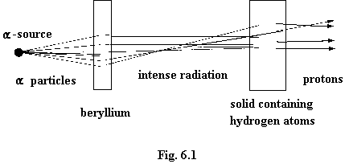

α-particles were fired at a piece of beryllium and an intense radiation was found to be emitted from the beryllium. When this radiation enters a solid containing many hydrogen atoms, many protons were knocked forward from the solid. The initial reaction in the beryllium in now known to be
$${}_{2}^{4}{}\text{He }+{}_{4}^{9}{}\text{Be}→{}_{0}^{1}{}\text{n }+{}_{6}^{\text{12}}{}C$$

(i) In the equation what symbol is used to represent the α-particle?
(ii) What information does the symbol give about the α-particle?
(iii) Suggest, with a reason, which particle is responsible for knocking a proton out of the solid containing the hydrogen atoms.
(iv) The intense radiation was originally thought to be γ-rays. Why does the existence of the knocked-forward protons make this impossible? [6]

(e) The masses of the particles referred to in part (d) are as follows.

$${}_{2}^{4}{}\text{He}$$ | + | $${}_{4}^{9}{}\text{Be}$$ | → | $${}_{0}^{1}{}n$$ | + | $${}_{6}^{\text{12}}{}C$$
4.00260 u |  | 9.01212 u |  | 1.00867 u |  | 12.00000 u

(i) Calculate the loss of mass which appears to take place in the reaction.
(ii) Hence find the energy equivalence of this mass. [4]

Section B

Answer two questions from this section.

Option C

Communications

10. (a) A certain inductor has an inductance of 3.0 henries. What is meant by the phrase in italics? [2]

(b) In an experiment, the inductor is placed in the circuit shown in Fig. 10.1.

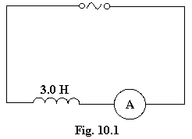

The sinusoidal a.c. supply gives a voltage of constant amplitude but a frequency which can be varied. The current is measured for different frequencies. When the frequency is 100 Hz the r.m.s. value of the current is found to be 2.6 mA. Assuming the resistance of the circuit is negligible,

(i) calculate the reactance of the inductor when the frequency is 100 Hz,
(ii) calculate the r.m.s. value of the p.d. of the supply,
(iii) calculate the r.m.s. current in the circuit when the frequency is 25 Hz,
(iv) sketch a graph to show how the current will vary with the frequency,
(v) draw a sketch to show the phase relationship of the current and the p.d in the circuit. [9]

(c) The inductor in (a) is to be used in conjunction with a capacitor to give a resonant frequency of 2.0 Hz in a low frequency oscillator.

(i) Derive an expression for resonant frequency in terms of capacitance and inductance.

(ii) Use your expression to calculate the capacitance of the capacitor. [4]

11. Write an article on the synthesis of waveforms. Your answer should include several diagrams
It should

(a) start with the basic principle of adding together sine waves to get more complex wave patterns, [4]

(b) go on to consider the significance of such synthesis, for example with modulated signals and digital signals, [8]

(c) conclude with brief reference to practical applications in such items as electronic organs or speech synthesis [3]

12. (a) State two advantages which can be gained by transmitting a signal digitally rather than in analogue form. [2]
(b) Explain the following disadvantages of digital signals and state how they are overcome.
(i) An analogue signal, reconstructed after digital transmission, has a stepped shape rather than that of the original smooth analogue signal .
(ii) A digital signal requires a high bandwidth for transmission. [4]
(c) An analogue signal, as shown in Fig. 12.1, is to be converted into digital form and transmitted along an optic fibre.
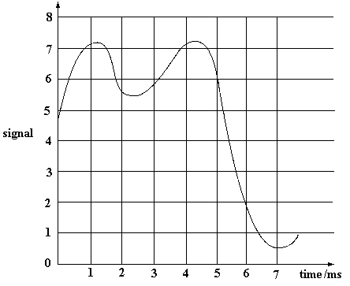
Assuming that it is digitised into three-bit words at times 0, 1, 2..........7 ms, what digital signal needs to be transmitted? Explain how you have obtained the three-bit digital word at t = 0. [5]

(d) A digital signal of initial power 70 mW is transmitted along a fibre of length 3000 m. If the absorption coefficient a is 4.2 x 10⁻⁴ m⁻¹, calculate the power received at the end of the fibre.

(The power falls exponentially as given by the equation P = P₀e^{-ax}.) [2]

(e) Draw sketches to show how the shape of a typical digital signal changes between the input and the output fibre considered in (d) [2]

Option M
Medical Physics

13. (a) With the aid of a labelled diagram, give a description of the way in which X-rays are produced. [5]
(b) How can
(i) the sharpness,
(ii) the contrast,
be controlled in X-ray imaging? [6]

14. (a) In Fig. 14.1, the forces shown are acting to keep the forearm of a person stationary. W is the weight of the forearm acting through its centre of gravity and F is the force exerted by a ligament on a bone in the arm. The pivot is near the elbow. The ratio W/F is called the mechanical advantage of the lever.

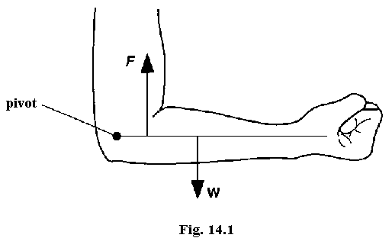
(i) Find the mechanical advantage of the forearm shown in Fig. 14.1 by making suitable measurements of distance on the diagram. [4]
(ii) What force must be exerted by the ligament if W = 23 N? [2]
(iii) The muscular-skeletal system of the arm is in fact more complex than this. Describe two ways in which the analysis in (i) and (ii) is simplified as regards mechanical functions. [4]

(b) The following is a passage taken from a book about animal movement.

‘Short limbed animals will have limbs with relatively high mechanical advantage and be able to exert large forces. However, the distance that the end of a limb moves is proportional to its length, so rapid movement requires a long limb. Consequently, a compromise must be made between speed and strength. For example, the foreleg of a racehorse has a mechanical advantage of 0.08. The mole, which is a burrowing animal, has a foreleg with a mechanical advantage of 0.25. Hence, it cannot move as quickly, but it has the strength needed for burrowing.’

Answer the following questions about the passage, using diagrams to illustrate your answer where possible.
(i) In terms of limb structure, explain how a mole has a high mechanical advantage but a racehorse has a low mechanical advantage. [3]
(ii) Explain why the distance that the end of a limb moves is proportional to its length. [2]

15. Tables of sound intensities, such as the one which is given here, are often published in textbooks dealing with human hearing.

sound | intensity  / W m⁻² | intensity level  / dB
(Rupture of ear-drum) | 10⁴ | 160
Jet engine | 10 | 130
(Threshold of pain) | 1 | 120
Loud thunder | 10⁻¹ | 110
Heavy street traffic | 10⁻⁴ | 80
Normal conversation | 10⁻⁶ | 60
Whisper | 10⁻¹⁰ | 20
(Threshold of hearing) | 10⁻¹² | 0

(a) What is meant by the term intensity? [1]
(b) By inspection of the table deduce
(i) the intensity of the sound from a motor cycle when the intensity level is 100 dB. [1]
(ii) the intensity level of bird song with an intensity of 10⁻⁸ W m⁻². [1]
(c) The ear of a particular person collects sound from an effective area of 15 cm². What power of sound is the ear detecting when at the threshold of hearing? [2]
(d) Explain how the power of the sound entering a person’s ear is used to maintain resonant frequency oscillations in the inner ear. [4]
(e) State three factors which make obtaining data for a table such as this, very difficult.
[3]
(f) Suggest additional information which needs to be given in order to make use of the values given in the table. [3]

