1995

1 Which expression does not have the second (s) as its base unit?
A $\frac{1}{\text{frequency}}$
B capacitance x resistance
C $\sqrt{\text{length }÷\text{ acceleration}}$
D mass ÷ spring constant

2. When comparing systematic and random errors, the following pairs of properties of errors in an experimental measurement may be contrasted:

P₁:error can possibly be eliminated  P₂:error cannot possibly be eliminated | Q₁:error is of constant sign and magnitude  Q₂:error is of varying sign and magnitude
R₁:error will be reduced by averaging repeated measurements
R₂:error will be not reduced by averaging repeated measurements

Which properties apply to random errors?
A P₁, Q₁, R₂
B P₁, Q₂, R₂
C P₂, Q₂, R₁
D P₂, Q₁, R₁

3. A parachutist steps from an aircraft, falls without air resistance for 2 s and then opens his parachute.
Which graph best represents how a, his vertical acceleration, varies with time t during the first 5 s of his descent?
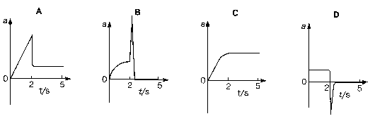

4. A ball of weight W slides along a smooth horizontal surface until it falls off the edge at time T.

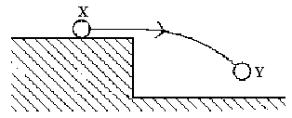

Which graph represents how the resultant vertical force F, acting on the ball, varies with time t as the ball moves from position X to position Y?
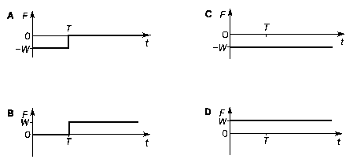

5. A heavy uniform beam of length l is supported by two vertical cords as shown.

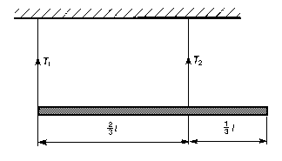

What is the ratio $\frac{T_{2}}{T_{1}}$ of the tensions in these cords?
A 1/3 B ½ C 2/1 D 3/1

6. The resultant force F on a body moving in a straight line varies with displacement x from a fixed point as shown in the graph.
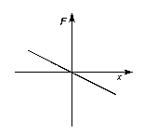

Which graph represents the variation with x of the potential energy E_{p} of the body?

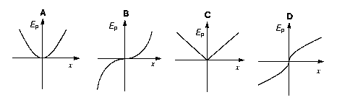

7. In a tape cassette, the tape leaves one spool at a constant speed v and at a variable distance r from the centre.

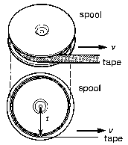
The angular velocity of the spool
A is proportional to .
B is proportional to .
C is proportional to r.
D does not depend on r.

8. The acceleration of free fall on the surface of the Earth is 6 times its value on the surface of the Moon. The mean density of the Earth is 5/3 times the mean density of the moon.
If r_{E} is the radius of the Earth and r_{M} the radius of the moon, what is the value of $\frac{r_{E}}{r_{M}}$?
A 1.9 B 3.6 C 6.0 D 10

9. A pendulum swings with the time period of 1 s at a place where the acceleration of free fall is g. If it were swung at another place where the acceleration of free fall is g', what would be the value of its new time period?

A $\left(\frac{g'}{g}\right) s$ B $\left(\frac{g}{g'}\right) s$ C $\sqrt{\left(\frac{g'}{g}\right)} s$ D $\sqrt{\left(\frac{g}{g'}\right)} s$

10. A source of sound of frequency 2500 Hz is placed several metres from a plane reflecting wall in a large chamber containing gas. A microphone, connected to a cathode-ray oscilloscope, is used to detect nodes and antinodes along the line XY between the source and the wall.

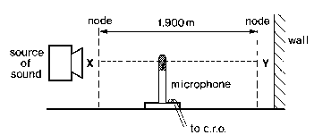

The microphone is moved from one node through 20 antinodes to another node, a distance of 1.900 m.

What is the speed of sound in the gas?

A 238 m/s B 250 m/s C 330 m/s D 475 m/s

11. Which group of electromagnetic waves is arranged in order of increasing frequency?

lowest highest

A gamma rays, ultra-violet rays, radio waves
B microwaves, ultra-violet rays, X-rays
C radio waves, visible light, infra-red radiation
D visible light, infra-red radiation, microwaves

12. In the Young’s slits arrangement shown, a pattern of equally-spaced, parallel fringes appears on a screen placed at S.

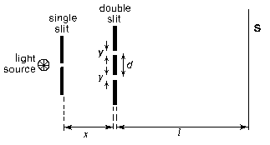

Which quantity, if increased, would cause the separation of the fringes to increase?

A x B y C d D l

13. An insulated charged rod R is to be used to give a permanent charge to a conducting sphere S, by induction.

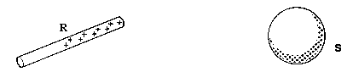

What is the required sequence of events?

A Move R close to S; connect S to earth; remove R; remove earth connection from S.

B Move R close to S; connect S to earth; remove earth connection from S; remove R.

C Move R to make contact with S; remove R.

D Move R to make contact with S; connect S to earth; remove R; remove earth connection from S.

14. A cell of internal resistance r is connected to a load of resistance R.
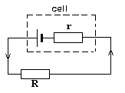
Energy is dissipated in the load, but some thermal energy is also wasted in the cell.

The efficiency of such an arrangement is found from the expression

$$\frac{\text{energy dissipated in the load}}{\text{energy dissipated in the complete circuit}} \text{.}$$

Which of the following gives the efficiency in this case?

A r/R B R/r C r/(R + r) D R/(R + r)

15. The diagram shows three resistors of resistance 4Ω, 10Ω, and 6Ω connected in series. A potential difference of 10 V is maintained across them, with point Q being earthed.
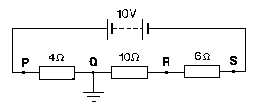

Which graph represents the change in potential along the resistor network?

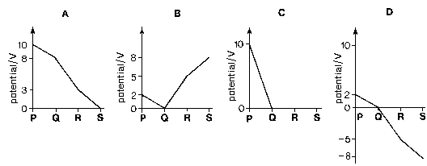

16. A point charge q is situated at X between two parallel plates which have a potential difference V and carry charges +Q and -Q.

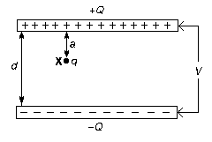

What is the electric field strength at X ?

A V/d B Vq/d C $\frac{Q}{4π ε_{o} a^{2}}$ D $\frac{\text{qQ}}{4π ε_{o} a^{2}}$

17. The diagram shows an earthed conducting sphere held close to a positively-charged dome.

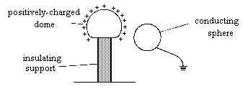

What are the charge and potential of the conducting sphere?

charge potential
A uncharged zero
B uncharged negative
C negative zero
D negative negative

18. A horizontal power cable carries a steady current in an east-to-west direction, i.e. into the plane of the diagram.

Which arrow shows the direction of the force on the cable caused by the Earth’s magnetic field, in a region where this field is at 70º to the horizontal?

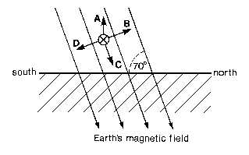

19. The diagram represents an aircraft of length l, wingspan x, flying horizontally at speed v in a region where the Earth’s magnetic field, of uniform flux density B, is inclined at an angle θ to the Earth’s surface.

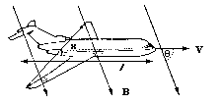

Which expression gives the magnitude of the e.m.f. generated between the wingtips by electromagnetic induction?

A Blvsinθ B Blv C Bxv D Bxvsinθ

20. The diagram shows three circuits used to rectify an alternating current. A cathode-ray oscilloscope (c.r.o) with fixed settings of time-base and y-gain is connected in turn as shown and produces a different trace in each case.

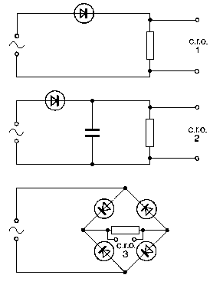

Which set of diagrams shows these traces most accurately?

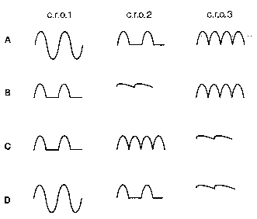

21. The circuit shown includes an ideal operational amplifier.

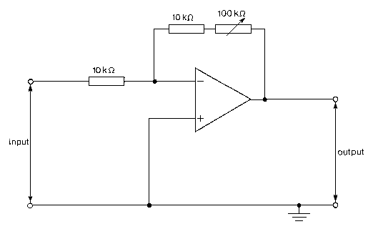

Which of the following gives the minimum and maximum values of the voltage gain of the circuit?

A 0.09 and 1.0 B 0.1 and 1.0 C 1.0 and 10 D 1.0 and 11

22. The density of liquid air is 700 times the density of gaseous air at standard temperature and pressure.

Using these data, what is the approximate value of

$$\frac{\text{mean separation of liquid air molecules}}{\text{mean separation of gaseous air molecules}} ?$$

A 700/1 B 700^{1/3} /1 C 1/700^{1/3} D 1/700³

23. Which thermodynamic temperature is equivalent to 501.85 ºC?

A 775.00 K B 774.85 K C 228.85 K D 228.70 K

24. A metal ball-bearing of specific heat capacity c, moving with speed v, is brought to rest. All its kinetic energy is converted into thermal energy which it absorbs, causing a temperature rise Δθ.

What was the value of v?

A ½ cΔθ B 2cΔθ C $\sqrt{cΔθ}$ D $\sqrt{2cΔθ}$

25. A fixed mass of ideal gas undergoes changes of pressure and volume starting at L, as shown.

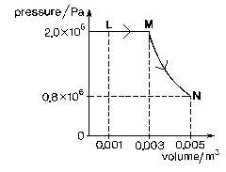
Which graph shows how temperature (measured in kelvin) changes with volume?

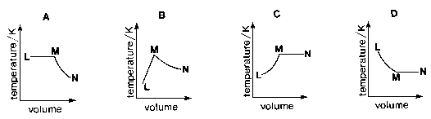

26. Thermal conduction in metals differs from thermal conduction in insulators. The reason for this is that, in metals, heat can be transported by
A electrons.
B lattice vibrations.
C photons.
D positive ions.

27. The diagram shows a velocity selector used in a mass spectrometer.

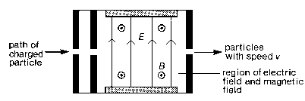

The charged plates give a uniform electric field of strength E. In the same region there is a uniform magnetic field of strength B, at right angles to the electric field.

Particles carrying charge Q and having speed v pass through undeviated, because the forces on them due to the electric fields are equal in magnitude but opposite in direction.

What is the speed v of the particles leaving the selector?

A B/E B E/B C BQ/E D EQ/B

28. An energy level diagram for an atom is shown drawn to scale. The electron transitions give rise to the emission of a spectrum of lines of wavelength λ₁, λ₂, λ₃, λ₄, λ₅.

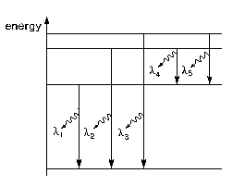

Which statement is correct?
A It can be deduced from the energy lever diagram that λ₁ > λ₂.
B It can be deduced from the energy level diagram that λ₃ = λ₁ + λ₅.
C Of the five wavelengths, λ₄ is the shortest.
D The transition corresponding to wavelength λ₃ represents the ionisation of the atom.

29 Which statement correctly describes the nucleon?
A a neutron or a proton
B a neutron, proton or an electron
C any atomic nucleus
D a radioactive atomic nucleus

30 In a cancer therapy unit, patients are given treatment from a certain radioactive source. This source has a half-life of 4 years. A particular treatment requires 10 minutes of irradiation when the source is first used.

How much time is required for this treatment, using the same source, 2 years later?

A 7 minutes
B 10 minutes
C 14 minutes
D 20 minutes

