1994/2

1. (a) (i) Define linear momentum.

(ii) State whether linear momentum is a vector or a scalar quantity. [2]

(b) State the principle of conservation of momentum. [1]

(c) The principle can be applied in different types of interaction. These are illustrated by the following examples.

(i) Inelastic collision: a piece of plasticine of mass 0.20 kg falls to the ground and hits the ground with a velocity of 8.0 ms⁻¹ vertically downward. It does not bounce but sticks to the ground. Calculate the momentum of the plasticine just before it hits the ground.

State the transfers of momentum and of kinetic energy of the plasticine which occur as a result of the collision. [3]

(ii) elastic collision: a neutron of mass 1.00 u traveling with velocity 6.50 x 10⁵ ms⁻¹ collides head on with a stationary carbon atom of mass 12.00 u. The carbon atom moves off in the same direction with velocity 1.00 x 10⁵ ms⁻¹. Calculate the velocity of the neutron after the collision. State what happens to the kinetic energy as a result of this collision. [3]

(iii) There is a third type of interaction: this happens when two strong magnets are held stationary with the north pole of one pushed against the north pole of the other. On letting go, the magnets spring apart. It is apparent that the kinetic energy of the magnets has increased. Explain how the law of conservation of momentum applies in this case. [2]

2. (a) Define the term gravitational field strength. [1]

(b) State the numerical value and unit of the gravitational field strength of the Earth at its surface. [2]

(c) Why is it incorrect to call g(=9.8 ms⁻²) ‘gravity’? [2]

(d) This part of the question is about the rotation of the Moon in a circular orbit around the Earth. You will need to use the following astronomical data.

Radius of the Moon’s orbit = 3.84 x 10⁸ m
Mass of the Moon = 7.35 x 10²² kg
Time for the Moon to complete
one orbit around the Earth = 2.36 x 10⁶ s

Calculate

(i) the speed of the Moon in its orbit around the Earth,

(ii) the acceleration of the Moon,

(iii) the force the Earth exerts on the Moon,

(iv) the gravitational field strength of the Earth at the Moon. [6]

3. (a) A filament lamp is marked 240 V 60 W. Calculate

(i) the current trough the lamp when it is working normally [1]

(ii) the resistance of the lamp when it is working normally [1]

(iii) The resistance of the lamp is found to be less when it is not lit than when it is working normally. Sketch the current-voltage characteristic of the filament lamp on the axes in Fig. 3.1.
[3]
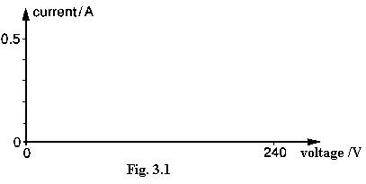

(b) A lighting circuit includes four lamps connected as shown in Fig 3.2. The resistance of each lamp should be 120 Ω when it is not lit.

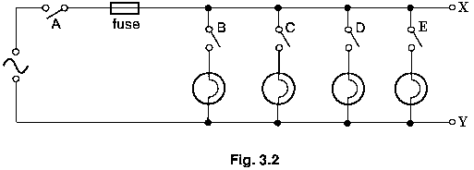
A fault is discovered in the circuit, so switch A is turned off and the fuse is removed for safety. A resistance meter is connected between the points X and Y and the following readings are obtained for different switch positions.

Switches Resistance meter
reading/Ω
A B C D E

off off off off off 14 600 000
off off off off on 120
off off off on on 60
off off on on on 40
off on on on on 0.2

(i) If there were no fault in the circuit, what would the resistance meter read when switched B, C, D and E are on and A is off?

(ii) Why does the resistance meter not read infinity when all the switches are off?

(iii) Suggest what the fault in the circuit may be. [5]

4. The three graphs in Fig. 4.1 are load-extension graphs for strands of three different materials X, Y and Z. Each strand is of cross-sectional area 1.0 mm².
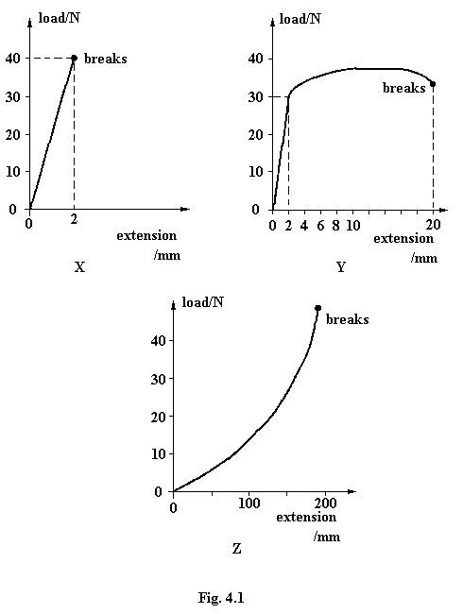
(a) Which material is
(i) ductile,

(ii) brittle,

(iii) polymeric? [2]

(b) Name a possible substance for each of the three materials.

X Y Z [3]

................... .................... ................

(c) (i) Deduce the strain energy stored in the strand of material Y for an extension of 2.0 mm. [2]

(ii) Estimate how much additional work would have to be done on this strand in order to break it. [2]

5. A fixed mass of gas in a heat pump undergoes a cycle of changes of pressure, volume and temperature as illustrated in the graph, Fig. 5.1. The gas is assumed to be ideal.

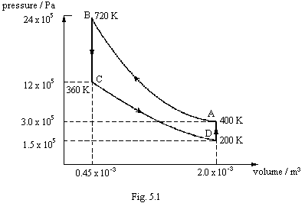

The table below shows the increase in internal energy which takes place during each of the changes A to B, B to C and C to D. It also shows that in both of sections A to B and C to D, no heat is supplied to the gas.

 | Increase in  internal  energy /j | Heat supplied  to gas  /j | Work done  on gas  /j
A to B  B to C  C to D  D to A | 1200  -1350  -600 | 0  0

(a) Using the first law of thermodynamics and necessary data from the graph, complete the table. You will find it helpful to proceed in the following order.

(i) work done on gas for A to B and B to C
(ii) work done on gas for B to C and D to A
(iii) heat supplied to gas for B to C
(iv) increase in internal energy for D to A
(v) heat supplied to gas for D to A [6]

(b) Calculate P, the coefficient of performance of the heat pump, given that

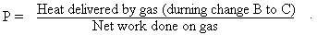

[1]

6. Fig. 6.1 shows a typical arrangement for a domestic hot-water tank. The water can be heated by an immersion heater and the tank has lagging around the walls and over the top.
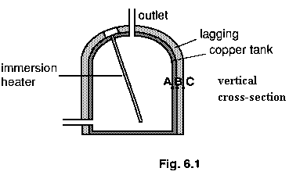
(a) Why is convection important in heating the water? [1]

(b) Why is the bottom not lagged? [2]

(c) Sketch a graph on the axes below to show how the temperature is likely to vary along the line of points ABC shown in Fig. 6.1. Assume the tank is flat in this region. [3]

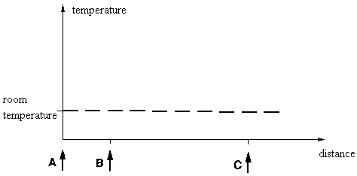

7. (a) What is meant by

(i) the decay constant λ of a radioactive material,

(ii) the half-life t_{1/2}? [2]

(b) The decay constant and the half-life are related by the equation

$$λ=\frac{0\text{.}\text{693}}{t_{12}}$$

The half-life of ${}_{\text{27}}^{\text{60}}{}\text{Co}$ is 5.26 years.

(i) What of the numbers 27 and 60 represent?

27.................................................................................................

60.................................................................................................. [2]

(ii) Calculate the decay constant of ${}_{\text{27}}^{\text{60}}{}\text{Co}$. [1]

(iii) Calculate the activity of 1.00 gram of ${}_{\text{27}}^{\text{60}}{}\text{Co}$. [3]
(60 grams of${}_{\text{27}}^{\text{60}}{}\text{Co}$ contain 6.02 x 10²³ atoms.)

9. When a car has a brake test, two sets of measurements are made:

1. the maximum braking force on the wheels produced by operating the foot brake,

2. the maximum braking force produced by operating the hand brake.

Typical data for a car of mass 900 kg are as follows.

 | maximum, braking force /N
1. foot brake | 6700
2. hand brake | 2000

In order to determine whether or not the brakes are satisfactory, the data are applied to a chart (called a nomogram) like the one shown in Fig. 8.1. This chart has three vertical lines, marked with scales.

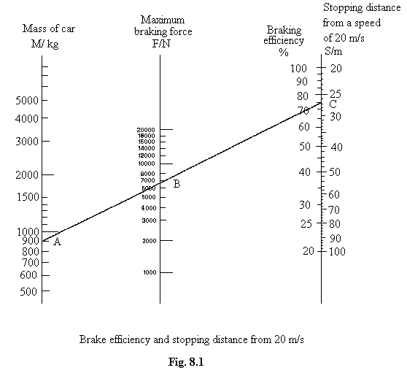

The central vertical line is for the maximum braking force.
The left line is for the mass of the car.
The right hand line is for the braking efficiency and also for the stopping distance from an initial speed of 20 ms⁻¹. The braking efficiency E is defined by the equation

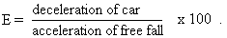

As an example of the use of this chart for the car of mass 900 kg, the figures in the table show a maximum braking force for the foot brake of 6700 N. The point A corresponding to the mass and the point B corresponding to the braking force are joined to give a straight, sloping line. This line is extended to cut the braking efficiency scale at the point C, and shows that in this particular case the stopping distance S from a speed of 20 ms⁻¹ is about 27 m.

(a) Read from the chart the braking efficiency corresponding to point C. [1]

(b) Using the definition of braking efficiency given above, find the deceleration corresponding to this value of braking efficiency. Give your answer in ms⁻². [2]

(c) Show, by calculation from the equations of motion, that the deceleration you obtained in (b) gives a stopping distance of 27 m to 2 sig. fig. from an initial speed of 20 ms⁻¹.
[3]

(d) (i) Draw a line on the chart to represent the results of the hand brake test on the car of mass 900 kg. [1]

(ii) Using the hand brake alone,

1. what would be the stopping distance from a speed of 20 ms⁻¹, [1]

2. what is the braking efficiency? [1]

(e) Now consider a car of mass 1300 kg. Read from the chart in Fig. 8.1 corresponding pairs of values of the maximum braking force and stopping distance from 20 ms⁻¹, and tabulate them below. [3]

Maximum braking force /N | Stopping distance from 20 ms⁻¹ /m

Plot a graph of these values on the following grid. [3]

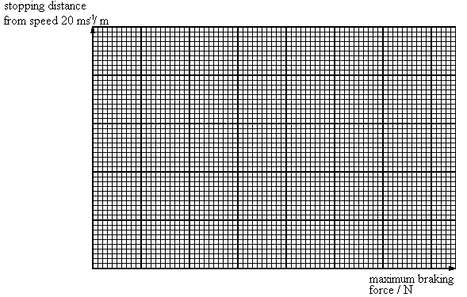

(f) Using the chart to estimate the braking efficiency for the car of mass 1300 kg if the maximum braking force were 14 000 N. Comment on your answer. [3]

