1994

1. Which pair includes a vector quantity and a scalar quantity?

A displacement; acceleration
B power; speed
C work; potential energy
D force; kinetic energy

2. A student attempts to measure the diameter of a steel ball by using a metre rule to measure four similar balls in a row.

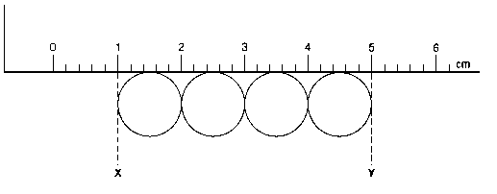

The positions on the scale are estimated to be

X (1.0 ± 0.2) cm
Y (5.0 ± 0.2) cm

What is the diameter of a steel ball together with its associated uncertainty?

A (1.0 ± 0.05) cm
B (1.0 ± 0.1) cm
C (1.0 ± 0.2) cm
D (1.0 ± 0.24) cm

3. In the absence of air resistance, a stone is thrown from P and follows a parabolic path in which the highest point reached is T.

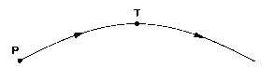

The vertical component of acceleration of the stone is

A zero at T.
B greatest at T.
C greatest at P.
D the same at p as at T.

4. A child (mass m) sits on a car seat which is accelerating horizontally at 0.50 g (where g is the acceleration of free fall).

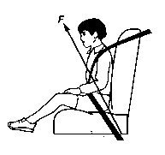

What is the magnitude of the total force F exerted by the car seat on the child?

A 0.50 mg B 1.0 mg C 1.1 mg D 1.5 mg

5. A racing car accelerates uniformly through three gear changes with the following average speeds:
20 m/s for 2.0 s
40 m/s for 2.0 s
60 m/s for 6.0 s

What is the overall average speed of the car?

A 12 m/s B 13.3 m/s C 40 m/s D 48 m/s

6. A bicycle dynamo is started at time zero. The total energy transformed by the dynamo during the first 5 seconds increases as shown in the graph.

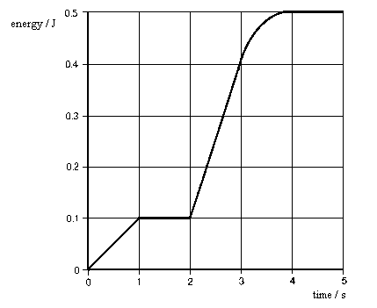

What is the maximum power generated at any instant during these first 5 seconds?

A 0.10 W B 0.13 W C 0.30 W D 0.50 W

7. A satellite of mass 50 kg moves from a point where the gravitational potential due to the Earth is -20 MJ/kg to another point where the gravitational potential is -60 MJ/kg.

During this change of position, it has moved

A closer to the Earth and lost 2000 MJ of potential energy.
B closer to the Earth and lost 40 MJ of potential energy.
C further form the Earth and gained 2000 MJ of potential energy.
D further form the Earth and gained 40 MJ of potential energy.

8. A body moving in a circular path of radius r has tangential acceleration a_{t}, and centripetal acceleration a_{c}.

If the body is moving at constant speed v, what are the magnitudes of a_{t} and a_{c}?

tangential centripetal
acceleration a_{t} acceleration a_{c}
A r v² 0
B v²/r 0
C 0 r v²
D 0 v²/r

9. The three oscillating bodies, represented as P, Q, and R in the diagrams, each show simple harmonic motion.

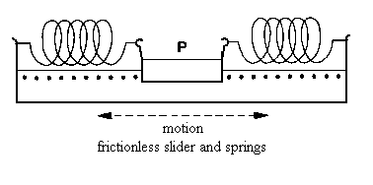 | 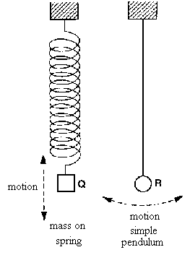

In which of these systems will the period increase if the mass of the body increases?

A P only B Q only C P and Q only D Q and R only

10. Which effect provides direst experimental evidence that light is a transverse, rather than a longitudinal, wave motion?

A Light can be diffracted.
B Two coherent light waves can be made to interfere.
C The intensity of light from a point source falls off inversely as the square of the distance from the source.
D Light can be polarized.

11. A narrow beam of monochromatic light falls at normal incidence on a diffraction grating. Third-order diffracted beams are formed at angles of 45^{o.}

What is the highest order of diffracted beam produced by this grating?

A 3rd B 4th C 5th D 6th

12. What is the approximate range of frequencies of infra-red radiation?

A 1 x 10³ Hz to 1 x 10⁹ Hz
B 1 x 10⁹ Hz to 3 x 10¹¹ Hz
C 3 x 10¹¹ Hz to 4 x 10¹⁴ Hz
D 4 x 10¹⁴ Hz to 7 x 10¹⁴ Hz

13. In a system used for spraying cars, a car body is positively charged. Neutral droplets of paint are then attracted to the car because the positive car body induces charge on the droplets of paint.

Which diagram best shows the charge pattern?
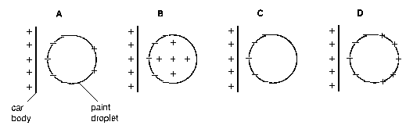

14. The resistors P, Q, and R in the circuit have equal resistance.
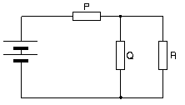
The battery, of negligible internal resistance, supplies a total power of 12 W.
What is the power dissipated by heating in resistor R?

A 2 W B 3 W C 4 W D 6 W

15. An oil droplet has a charge -q and is situated between two parallel horizontal metal plates as shown in the diagram.
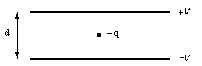

The separation of the plates is d. The droplet is observed to be stationary when the upper plate is at potential +V and the lower at potential -V.
For this to occur, the weight of the droplet is equal in magnitude to

A Vq/d B 2Vq/d C Vd/q D 2Vd/q

16. Two capacitors are connected in series as shown in the diagram.

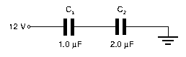
What is the charge carried by each of these capacitors?

 | charge on C₁/μC | charge on C₂/μC
A  B  C  D | 4.0  4.0  8.0  8.0 | 4.0  8.0  4.0  8.0

17. A plotting compass is placed near a solenoid.

When there is no current in the solenoid, the compass needle points due north as shown.
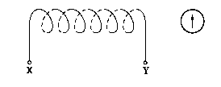
When there is a current from X to Y, the magnetic field of the solenoid at the compass is equal in magnitude to the Earth’s magnetic field at that point.

In which direction does the plotting compass set?
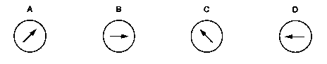

18. Large alternating currents in a cable can be measured by monitoring the e.m.f. induced in a small coil situated near the cable. This e.m.f. is induced by the varying magnetic field set up around the cable.

In which arrangement of coil and cable will the e.m.f. induced be a maximum?

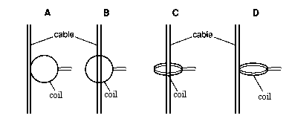

19. Some students were given the following instructions:

‘Design a circuit to give a full-wave rectified output from a low-voltage alternating supply. The positive output must be connected to a red terminal and the negative output to a black terminal.’

Which circuit satisfies these design instructions?

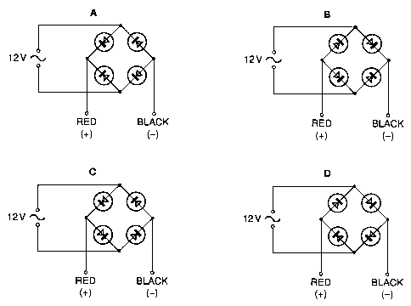

20. A combination of logic gates has the truth table below.

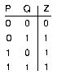

Which combination has this truth table?

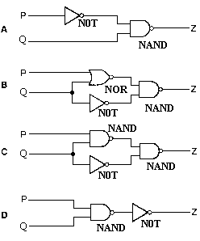

21. Which statement concerning the evaporation and boiling of a liquid is true?
A Boiling always occurs at a higher temperature than evaporation.
B Evaporation and boiling are unaffected by changes in the surface area of the liquid.
C Evaporation occurs at any temperature whereas the boiling point depends on the external pressure.
D evaporation results in the loss of the most energetic molecules from a liquid whereas in boiling, all molecules have the same energy.

22. The graph shows the relationship between load F and extension x for a certain spring.

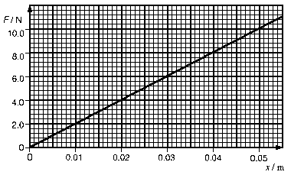
A load of 6. 0 N is placed on the spring.

What additional strain energy will be stored in the spring if it is then extended a further 0.01 m?

A 0.010 J B 0.060 J C 0.070 J D 0.160 J

23. The table lists the approximate range, accuracy and response time of different types of thermometers.

Thermometer | range/K | accuracy | response time
A  B  C  D | 3-1750  30-1750  75-1550  230-630 | very good  average  good  poor | long  short  long  medium

Which set of properties belongs to a thermocouple?
24. An air gun pellet, mass m and specific heat capacity c, hits a steel plate at speed v. During the impact, 50% of the pellet’s kinetic energy is converted to thermal energy in the pellet.

What is the rise in the temperature of the pellet?

A v²/2c B v²/4c C mv²/2c D mv²/4c

25. The simple kinetic theory of gases may be used to derive the expression relating the pressure P to the density ρ of a gas.

P = 1/3 ρ <c²>

In this expression what does <c²> represent?

A the average of the squares of the speeds of the gas molecules
B the most probable value of the squares of the speeds of the gas molecules
C the root-mean-square speed of the gas molecules
D the square of the average speed of the gas molecules

26. In designing a method for measuring the thermal conductivity of polystyrene, care must be taken to choose a specimen of appropriate dimensions as well as to decide whether or not the specimen requires lagging.

Which of the following would be the correct choice?

Cross-sectional thickness lagging
area of specimen of specimen required

A small thin no
B small thick yes
C large thin no
D large thick yes

27. An alternating p.d. is applied across the y-plates of a cathode-ray (c.r.o.) and produces the trace shown below.

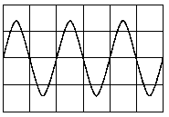

If the peak voltage of the alternating p.d is 2.8 V and its frequency is 50 Hz, what are the time-base and Y-gain settings of the c.r.o.?

time-base setting Y-gain
A 10 μs/cm 2.0 V/cm
B 20 μs/cm 1.0 V/cm
C 10 ms/cm 2.0 V/cm
D 20 ms/cm 1.0 V/cm

28. White light from a tungsten filament lamp is passed through sodium vapour and viewed through a diffraction grating.

Which of the following best describes the spectrum which would be seen?
A coloured lines on a black background
B coloured lines on a white background
C dark lines on a coloured background
D dark lines on a white background

29. Which sketch graph best represents the variation of binding energy per nucleon with nucleon number?

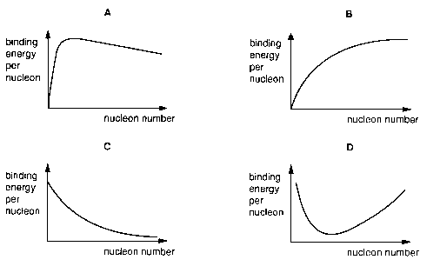

30. A radioactive source contains the nuclide ${}_{\text{74}}^{\text{187}}{}W$which has a half-life of 24 hours.
In the absence of this source, a constant average count-rate of 10 m/s is recorded.

Immediately after the source is placed in a fixed position near the counter, the average count-rate rises to 90 s⁻¹.

What average count-rate is expected with the source still in place 24 hours later?

A 30 s⁻¹ B 40 s⁻¹ C 45 s⁻¹ D 50 s⁻¹

