Paper-3/1993

Section A

Attempt four questions from this section.

1. The graph, Fig.1.1, shows how the velocity v of an athlete varies with time t during a 100 m race. The race starts at time t = 0.

(a) It takes a short time for the athlete’s velocity to increase above zero.

(i) By reference to the graph deduce a value for this time.

(ii) Give a reason for this delay. [2]

(b) Use the graph to deduce

(i) the maximum velocity of the athlete,

(ii) the athlete’s maximum acceleration,

(iii) the distance the athlete travels between the times t = 4.0 s and t = 8.0 s. [7]

(c) Assuming that, say, 10 people with stop watches are available, outline what they would need to do in order to obtain such a graph experimentally. [6]

(d) Sketch the shape of the acceleration-time graph for this 100 m race. [3]

(e) suggest why the men’s olympic record for 200 m is less that twice the time for 100 m.
[2]
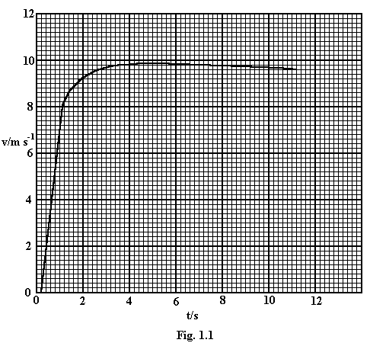

2. This question is about the superposition of waves.

(a) (i) What is mean by the term stationary wave [2]

(ii) Describe an experiment to show how a stationary wave may be set up. [3]

(b) (i) Explain the meaning of the term diffraction. [2]

(ii) How does the width of the aperture through which a wave is passing affect the diffraction of the wave? [2]

(c) A beam of red light from a laser is shone normally on to a diffraction grating. Bright light is seen emerging at certain angles as shown in Fig. 2.1 Use the principle of superposition to suggest a qualitative explanation of this effect. [2]

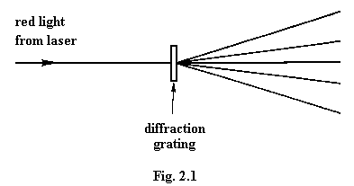

(d) A diffraction grating with a grating spacing of 2.20 x 10⁻⁶ m is used to examine the light from a glowing gas. It is found that the first order violet light emerges at an angle of 11.8º and the first order red light at an angle of 15.8º as shown in Fig. 2.2

(i) Calculate the wavelengths of these two colours. [3]

(ii) Describe and explain what will be observed at an angle of 54.8º. [3]

(iii) Without making any further calculations, draw a sketch similar to Fig. 2.2 showing the whole pattern observed. [3]
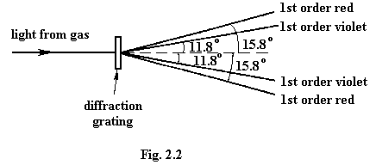

3. (a) (i) Define electric potential difference and state the SI unit in which it is measured.

(ii) Use you definition in (i) to show that P, the power dissipation in a resistor of resistance R is given by

$$P=\frac{V^{2}}{R}$$

where V is the potential difference across the resistor. [5]

(b) A battery of e.m.f. E and internal resistance r is connected in series with a resistor of resistance R, as shown in Fig. 3.1.

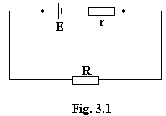

(i) Give expressions, in terms of E, r, and R for

(1) the current I in the circuit,

(2) the power P_{R} dissipated in the external resistor.

(ii) The battery generates total power P_{T}. Show that the fraction $\frac{P_{R}}{P_{T}}$is given by

$$\frac{P_{R}}{P_{T}}=\frac{R}{R+r}$$
[6]

(c) A car battery of e.m.f. 12 V and internal resistance 0.014 Ω delivers a current of 110 A when first connected to the started motor.

(i) Calculate

(1) the resistance of the starter motor,

(2) the fraction of the total power which is dissipated in the battery [5]

(ii) After prolonged use, the internal resistance of the battery may increase. State and explain how the performance of the battery is affected by an increase in the internal resistance. [4]

4. (a) What is meant by the term electric field strength? [2]

(b) Calculate the force exerted on a proton, which has a charge of +1.6 x 10⁻¹⁹ C, when it is in a uniform electric field of field strength 2.7 x 10⁵ N C⁻¹. [2]

(c) A proton is moved in a vacuum by a uniform electric field of 2.7 x 10⁵ N C⁻¹ from A to B, a distance of 0.0078 m. (Fig. 4.1.)

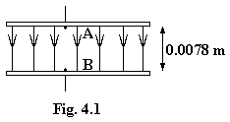

(i) How much work is done by the field on the proton? [2]

(ii) What is the gain in the kinetic energy of the proton? [1]

(iii) Calculate the difference in potential between A and B.

State whether A or B is at the higher potential. [3]

(d) In an electron microscope, an electron lens has two cylinders which are at potentials of +500 V and -100 V respectively. An electron beam passes at high speed into the lens from the left. A cross-section of the two cylinders is shown full scale in Fig. 4.2, together with dotted lines showing points of the same potential at different places within the cylinders. Use the diagram, where necessary measuring distances on it with a ruler, to

(i) find the potential difference between X and Y, [1]

(ii) find the loss in kinetic energy of an electron moving in a vacuum between X and Y, [2]

(iii) find the approximate value of the electric field strength at Z, [3]

(iv) sketch a graph showing how the potential varies along the axis of the lens, [2]
(v) sketch, on the same x-axis drawn in (iv), a graph showing how the speed of the electron varies as it passes from X to Y. [2]

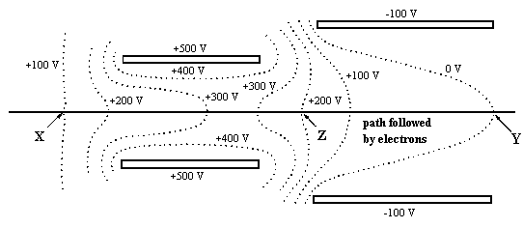

5. (a) Describe two mechanisms which enable thermal conduction to take place in a metal.
[4]

(b) Explain why only one of the mechanisms in (a) is responsible for thermal conduction in an insulator. [2]

(c) A saucepan has a flat copper base with an area of 0.031 m² and thickness 0.0040 m, and is in direct thermal contact with a hotplate. The two surfaces in contact are at the same temperature. The rate of heat flow through the base of the saucepan is 1500 W when water is boiling steadily at 100 ºC in the saucepan. Calculate the surface temperature of the hotplate. The thermal conductivity of copper is 390 W m⁻¹K⁻¹. [5]

(d) In practice, the surface temperature of the hotplate will be rather higher than you have calculated. Suggest reasons for this. [4]

(e) Discuss how the surface temperature of the hotplate described in (c) will change when the saucepan is removed. What will control its final temperature assuming that the power input to it remains unchanged? [5]

6. (a) Describe a laboratory demonstration which cannot be explained by the wave theory of light but which requires an explanation in which light has a particular nature. [4]

(b) For light of wavelength 5.62 x 10⁻⁷ m, calculate

(i) its frequency,

(ii) the energy of a photon,

(iii) the rate of emission of photons for a light power of 18.7 W [6]

(c) Figure 6.1 shows four energy levels A, B, C and D within an atom and an electron transition from level A to level C which results in the emission of a photon of light.

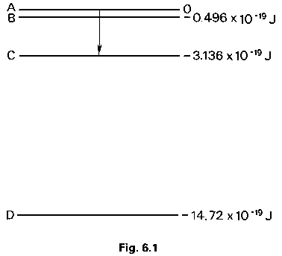

(i) Show on a copy of the diagram all the other possible transitions between these four levels which result in photon emission.

(ii) Calculate the wavelength of the light emitted as a result of the electron transition from A to C.

(iii) Which other transition may result in visible light being emitted?

(iv) When a transition takes place from level A, B or C to level D, in which part of the electromagnetic spectrum will the radiation occur? [6]

(d) Explain how Fig. 6.1 can be used to account for absorption spectra. [2]

(e) When the spectrum of gamma radiation from a nucleus is examined, it is found that it too has a line emission spectrum. Suggest what can be deduced from this observation.
[2]

Section B

Answer two questions from this Section.

Option C
Communications

10. (a) Outline one function of a capacitor in a circuit. [2]

(b) A capacitor is to be used in a circuit in which it should have a reactance of 630Ω. The circuit uses a frequency of 20 kHz.

(i) Calculate the capacitance of the capacitor.

(ii) Calculate the r.m.s. current to the capacitor if the r.m.s. potential difference across it is 18 V.

(iii) Illustrate on a sketch the phase relationship between the current and the potential difference.

(iv) Calculate the inductance of an inductor which would have the same reactance as this capacitor. [8]

(c) If the capacitor and inductor referred to in (b) are placed in parallel across a 20 kHz a.c. supply, resonance occurs.

(i) Explain what is meant by the term resonance.

(ii) Describe how you could demonstrate resonance with this combination of capacitor and inductor together with any other components you would require.
[5]

11. (a) Explain what is meant by the term modulation. [1]

(b) Two radio waves are shown diagramatically in Figs. 11.1 and 11.2. One of the diagrams shows amplitude modulation (AM) and the other frequency modulation (FM). Which is which? [1]

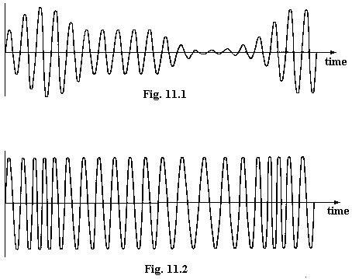

(c) Both diagrams, Figs. 11.1 and 11.2, show the basic radio wave having been modulated by the same audio signal. Sketch a graph to show how the audio signal varies with time. [4]

(d) State what bandwidth is required for a radio wave of frequency 500 kHz when amplitude modulated by audio frequencies of up to 15 kHz. Explain how you obtained your answer. [3]

(e) What would be the effect on an audio signal which included frequencies of up to 15 kHz if it were transmitted by an amplitude-modulated radio signal with a bandwidth considerably less than that which you have stated in (d)? [2]

(f) A typical FM radio wave requires a bandwidth which is significantly larger than that for AM. Explain why, nevertheless, FM is used and why many transmissions can be made in the VHF (very high frequency) range used by FM. [4]

12. (a) Explain what is meant by (i) an analogue signal, (ii) a digital signal. [2]

(b) Describe two advantages of using digital signals rather than analogue signals. [4]

(c) Using digital information, more than one message can be transmitted simultaneously along a single optical fibre. Explain the principle of a method used to do this. [3]

(d) Fig. 12.1 shows three types of optical fibre in common use. All three fibres are made of very pure glass. The features of the three fibres illustrated, which allow monochromatic light to pass in the ways shown, are as follows:

1. a very narrow core,

2. a wider core,

3. a core containing graded index glass, in which light travels more slowly at the centre than at the edges of the core.

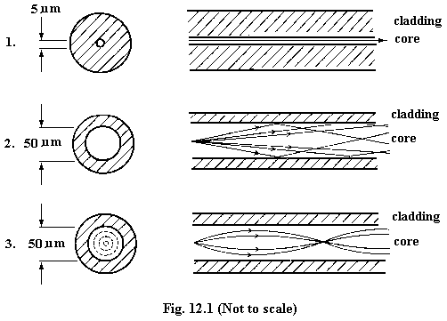

Answer the following questions about the optical fibres described.

(i) Why is very pure glass required?
(ii) What is the advantage in using a very narrow core?
(iii) What problem arises as a result of the multiple light paths shown in 2?
(iv) How is the problem in 2 partially overcome by using a fibre of the design shown in 3?
[6]

Option M

Medical Physics

13. A recent medical technique seeks to improve the vision of people who have had cataracts removed. A cataract operation involves the removal of the eye lens when it has become too opaque for light to travel through it. In the past the patient has required very strong spectacle lenses, which produce a distorted image, making seeing difficult, particularly when only one eye has been treated. The new technique uses a donor cornea, which is first frozen and then shaped. It can be stitched on to the patient's own cornea and becomes an extra, living, contact lens, replacing the original eye lens which has had to be removed.

Answer the following questions concerning this operation.

(a) Draw a ray diagram showing the formation of an image on the retina of a normal eye. (You are NOT expected to draw a full diagram of the structure of the eye. Apart from the light rays, show only the cornea, the lens and the retina.) [4]

(b) Draw a corresponding diagram to the one in (a) showing what will happen to the rays when the eye lens has been removed. Explain what the patient would see. [2]

(c) Illustrate how the patient can again see objects clearly in focus by use of the donated
cornea. [3]

(d) Why would the patient have a problem with visual accommodation after this operation? How would this problem be overcome? [4]

(e) Suggest two reasons why the donor cornea has to be frozen. [2]

14. (a) Describe the basic structure of the ear and explain how the ear responds to an incoming sound wave. [8]

(b) The average intensity of sound from a quiet conversation is 5.0 x 10⁻⁶ W m⁻²; the threshold intensity is 1.0 x 10 x ⁻¹² W m⁻².
Answer the following questions about this statement.
(i) What is meant by the term intensity when applied to a sound wave? [1]
(ii) What does the term threshold intensity mean? [1]
(iii) How would you measure the average intensity, given that you have a sound-level meter? [2]
(iv) What is the intensity level, in dB, of the quiet conversation? [3]

15. (a) Show that when a force F moves with velocity v in the direction of the force, the power supplied by the force is given by
power = Fv. [3]

(b) If a fluid is being pumped along a tube of cross-sectional area A with a constant velocity v, as shown in Fig. 15.1, the liquid flows from a region of high pressure P₁ to a region of low pressure P₂.

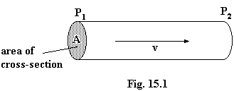

(i) What force is exerted on the fluid as a result of this pressure difference? [1]

(ii) Deduce the power supplied to the fluid in terms of the pressure difference and the volume rate of flow of fluid. [4]

(c) Calculate the power generated by the heart in order to maintain blood flow around the body of a healthy, resting person if the volume rate of flow of blood is 8.6x 10⁻⁵ m³ s⁻¹ and the pressure difference from the arterial to venous systems is 12.8 kPa. [2]

(d) The rate of energy usage of the heart referred to in (c) is likely to be several times the value you have just calculated. State two other uses for the input of energy to the heart in addition to the energy used in pumping blood. [2]

(e) Suggest what is likely to happen to the two values quoted in (c) and to your answer to (c) for a person whose arteries are narrowed, possibly by cholesterol. [3]

