Paper-3/1992

Section A
Attempt four questions from this Section.

1. (a) Define acceleration. Explain how it is possible for a body to be undergoing an acceleration although its speed remains constant. [4]
(b) A ball is placed at the top of a slope as shown in Fig. 1.1

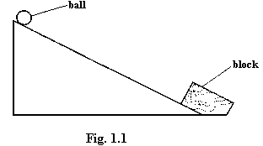

A block is fixed rigidly to the lower end of the slope. The ball of mass 0.70 kg is released at time t= 0 from the top of the incline and v, the velocity of the ball down the slope, is found to vary with t as shown in Fig. 1.2.

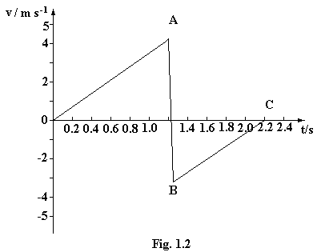
(i) Describe qualitatively the motion of the ball during the periods OA, AB and BC.
[7]
(ii) Calculate

(1) the acceleration of the ball down the incline,
(2) the length of the incline,
(3) the mean force experienced by the ball during impact with the block.
[7]
(iii) Discuss whether the collision between the block and the ball is elastic. [2]

2. (a) What do you understand by a progressive wave? Illustrate your answer by reference to a transverse progressive wave. [4]

(b) What conditions must be satisfied in order that two-source interference fringes may be observed? [5]

(c) A double slit with slit separation 0.800 mm is situated a distance 2.50 m from a thin jet of high speed smoke as shown in Fig. 2.1.

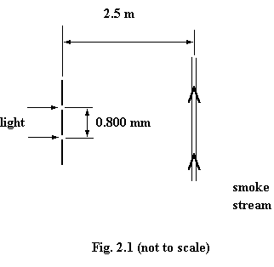

The double slit is illuminated with coherent light of wavelength 589 nm. Fringes are observed in the moving smoke. Calculate the separation of these fringes. [3]

(d) State with a reason the change, if any, that would be observed in the pattern of fringes if the following adjustments were made in the experimental arrangement. In each case, only the one adjustment is made and all the other arrangements are as initially in (c).

(i) The coherent light of wavelength 589 nm is replaced with coherent monochromatic red light.

(ii) The speed of the smoke stream is doubled.

(iii) The direction of the smoke stream is rotated through 45° as shown in Fig. 2.2.

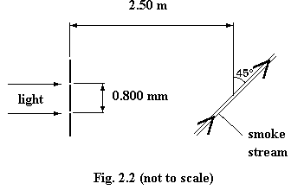

(iv) The smoke stream is replaced by a fixed screen. [8]

3. (a) Give an expression for P, the power dissipated in a resistor of resistance R, in terms of V, the potential difference across the resistor, and I, the current through the resistor. Hence show that P is given by the expression

P = V²/R. [3]

A certain electric hotplate, designed to operate on a 250 V supply, has two coils of nichrome wire of resistivity 9.8 x 10⁻⁷ Ωm. Each coil consists of 16 m of wire of cross-sectional area 0.20 mm².

(b) For one of the coils calculate
(i) its resistance,
(ii) the power dissipation when a 250 V supply is connected across the coil, assuming its resistance does not change with temperature. [4]
(c) Show, by means of diagrams, how these coils may be arranged so that the hotplate may be made to operate at three different powers. In each case, calculate the power rating.
[5]
(d) The hotplate is connected to the 250 V supply by means of cable of total resistance 3.0Ω.
(i) Calculate the power loss in the connecting cable when the hotplate is being used on its middle power rating.
(ii) Comment qualitatively on any change in power loss in the cable when the hotplate is operating at each of its other power ratings. [6]

(e) Different connecting cables are available for use with the hotplate. The maximum safe current which can be used in any one of the cables is 1A or 3A or 6A or 12A. State which is the most appropriate cable to use and briefly explain one possible danger of using cable with a lower maximum safe current. [2]

4. (a) (i) Distinguish between elastic and plastic deformation of a material.
(ii) Sketch a graph to show how the extension x of a copper wire varies with F, the applied load. Mark on your sketch the region where the wire obeys Hooke's law.
[6]
(b) (i) A force is required to cause an extension of a spring. Explain why this causes energy to be stored in the spring.
(ii) A spring of spring constant k undergoes an elastic change resulting in an extension x. Deduce that W, its strain energy, is given by

W = ½ kx². [7]

(c) A toy train, mass m, travels along a track at a speed v and is brought to rest by two spring buffers which are shown in Fig. 4.1.
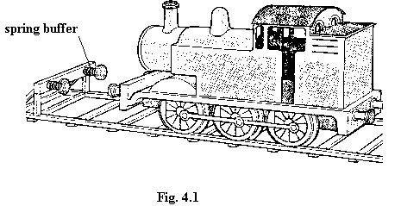
Each buffer has spring constant k.

(i) By considering the energy transfer, derive an expression to show how the maximum compression of the buffers varies with the initial speed of the train.

(ii) Calculate the maximum compression of the buffers for a train of mass m = 1.2 kg travelling with an initial speed v = 0.45 ms⁻¹ when the spring constant k of each buffer is 4.8 x 10³Nm⁻¹. [5]

State and explain a reason why, in practice, spring buffers of this design are not used. [2]

5. (a) Describe by means of a diagram and a simple equation the force due to

(i) an electric field,

(ii) a magnetic field,

acting on an electron moving at right angles to each field.

Hence explain how an electric field and a magnetic field may be used in the selection of the velocity of negatively charged particles. [9]

(b) Ions having charge +Q and mass M are accelerated from rest through a potential difference V. They then move into a region of space where there is a uniform magnetic field of flux density B, acting at right angles to the direction of travel of the ions, as shown in Fig. 5.1.

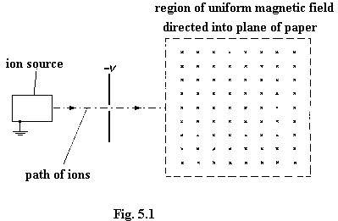

(i) Show that v, the speed with which the ions enter the magnetic field, is given by

$$v=\sqrt{\frac{2\text{QV}}{M}}$$
[3]

(ii) Hence derive an expression, in terms of M,Q,B and V, for the radius of the path of the ion in the magnetic field. [4]

(iii) Briefly describe and explain any change in the path in the magnetic field of an ion of twice the specific charge (i.e.) for which the ratio Q/M is doubled). [4]

6. (a) (i) Explain what is mean by the nucleon number and the nuclear binding energy of a nucleus.

(ii) Sketch a fully labelled graph to show the variation with nucleon number of the binding energy per nucleon.

Hence explain why fusion of nuclei having high nucleon numbers is not associated with a release of energy. [9]

(b) A rolling mill produces sheet aluminium, the thickness of which must be kept within certain limits. In order to achieve this, the thickness of the sheet is monitored as it leaves the final set of rollers. The monitor consists of a β-particle source and a detector placed as shown in Fig. 6.1.

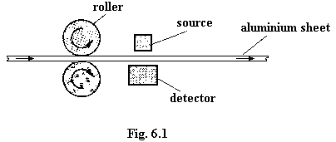

(i) Discuss the advisability, or otherwise, of using a β-emitting source which has

(1) a high activity, giving a count rate many times that of background,

(2) a short half-life. [6]

(ii) For sheets of aluminium about 1 mm thick, the β-particle count rate C/s⁻¹ is known to vary with thickness x/mm according to the expression

C = C_{o}e^{-0.62x},

Where C_{o} / s⁻¹ is the count rate when x = 0.

Calculate the ratio

maximum count rate
minimum count rate

when x = 1.00 mm and x varies by ±5.0%. [5]

Section B

Attempt two questions from this Section.

Option C

Communications

10. (a) (i) What do you understand by the term reactance?
(ii) The unit of reactance and of resistance is the ohm. In what way does a component having reactance differ from a resistor? [3]

(b) (i) Describe an experiment to investigate the dependence on frequency of the reactance of a capacitor. Sketch a graph to illustrate this dependence.
(ii) Sketch a second graph to illustrate the dependence on frequency of the reactance of an inductor.
(iii) Why, in practice, would it be difficult to obtain the graph in (ii) when using a coil of wire wound on an iron core? [6]

(c) (i) You are provided with a coil of inductance 0.025 mH and a variety of capacitors. Design a tuning circuit which could be used for radio reception in the frequency range 400 kHz to 1.0 MHz.

(ii) Discuss the effect on tuning if the coil has a large resistance. [6]

11. (a) (i) Explain the use of a dipole aerial as receiving antenna. Derive an expression, in terms of the length l of the dipole, for the frequency of the optimum signal received.
(ii) Briefly discuss the advantages of a dish reflector as a receiving antenna. [6]

(b) Describe the use of satellites in radio communication, pointing out any advantages this system may have over other means of long-range communication. [4]

(c) (i) What is meant by a geostationary satellite? Briefly explain the importance of such satellites in radio communication.

(ii) Assuming that the Earth is a uniform sphere of radius R, show that r, the radius of the geostationary orbit, is given by the expression

r³ω² = gR²,

where ω is the angular velocity of the satellite.
(iii) Why is it difficult to communicate between the poles of the Earth via a satellite link? [5]

12. (a) What is meant by a digital signal? [2]
(b) A person speaks into a microphone. Outline a means by which the output of the microphone may be converted into a digital signal. [4]

(c) During transmission, unwanted signals (noise) may distort the original transmitted signal. To avoid possible loss of signal, the signal is clipped. The clipped section of the signal is then amplified prior to onward transmission. The sequence is illustrated in Fig. 12.1.

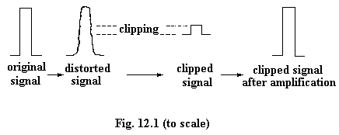

Draw a diagram of a circuit including an operational amplifier which could be used to amplify the clipped signal. Include possible component values on your circuit diagram.
[5]
(d) Briefly explain why it is much more difficult to reduce the effects of noise when transmitting an analogue signal than when transmitting in digital form. [4]

Option M

Medical Physics

13. (a) Explain the principles of one method of generation of ultrasonic waves for use in medical diagnosis.

(b) Compare the use of ultrasound with the use of X-rays in medical diagnosis. [10]

14. (a) The loudness of a sound as heard by an individual depends on the frequency and intensity of the sound.
(i) Define frequency and intensity.
(ii) Sketch a graph to show how the loudness of a sound, as heard by a person with normal hearing, depends on frequency when the intensity of the sound is constant. Point out any special features of the graph.
(iii) Describe the response of the ear to different intensities of sound with the frequency remaining constant. Hence define intensity level. [11

(b) A source emits sound energy uniformly in all directions. A sound-level meter records 92 dB when situated 2.5 m from the source. Given that I_{o}, the threshold intensity of hearing, is 1.0 x 10⁻¹² W m⁻², calculate the total sound power emitted by the source. [4]

15. (a) Briefly describe the possible uses of a lever. Illustrate your answer by reference to the muscular-skeletal system of one joint in the human body. [5]

(b) Describe an experiment to estimate the average rate of working over a period of approximately five minutes which can be achieved by a student’s leg muscles. [5]

(c) (i) On each beat of the heart, approximately 1 J of useful work is done, with an efficiency of about 15%. Estimate the power requirement of the heart for a resting person.

(ii) The basal metabolic rate of an adult is approximately 85 kW. Comment on the difference between this rate and your estimate obtained in (c) (i). [5]

