1992
1. Which of the following experimental techniques reduces the systematic error of the quantity being investigated?

A timing a large number of oscillations to find a period
B measuring several internodal distances on a standing wave to find the mean internodal distance
C measuring the diameter of a wire repeatedly and calculating the average
D adjusting an ammeter to remove its zero error before measuring a current
E plotting a series of voltage and current readings for an ohmic device on graph and using its gradient of find resistance

2. Which of the following quantities has a unit that can be expressed in terms of just two different SI base units?

A area B charge C current D force E resistance

3. The graph represents how displacement varies with time for a vehicle moving along a straight line.

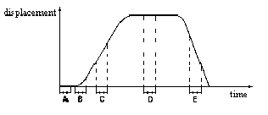

During which time interval does the acceleration of the vehicle have its greatest numerical value?

4. An ice-hockey puck slides along a horizontal, frictionless ice-rink surface. It collides inelastically with a wall at right angles to its path, and then rebounds along its original path.

Which graph shows the variation of the momentum p of the puck with time t?

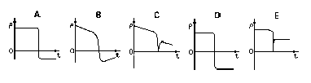

5. The diagram shows a diving-board held in position by two rods X and Y.
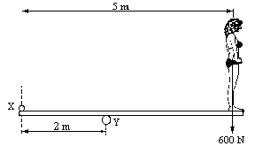

What additional forces do these rods exert on the board when the diver of weight 600 N stands on the right-hand end?

A 400 N 600 N
B 400 N 1000 N
C 600 N 1200 N
D 900 N 600 N
E 900 N 1500 N

6. A raindrop of mass m is falling vertically through the air with a steady speed v. It experiences a retarding force kv due to the air, where k is a constant. The acceleration of free fall is g.

Which expression gives the kinetic energy of the raindrop?

A $\frac{\text{mg}}{k}$ B $\frac{{\text{mg}}^{2}}{2k^{2}}$ C $\frac{m^{3}g^{2}}{k^{2}}$ D $\frac{m^{3}g^{2}}{2k^{2}}$ E $\frac{m^{3}g^{2}k^{2}}{2}$

7. The diagram represents a cyclist making a left turn on a rough road surface at constant speed v, as viewed from behind. The total mass of the bicycle and rider is m and their combined centre of gravity is at G.
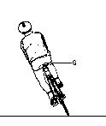
If R is the resultant force of the normal reaction and the frictional force, which vector diagram represents the directions of the forces acting on the bicycle and its rider?

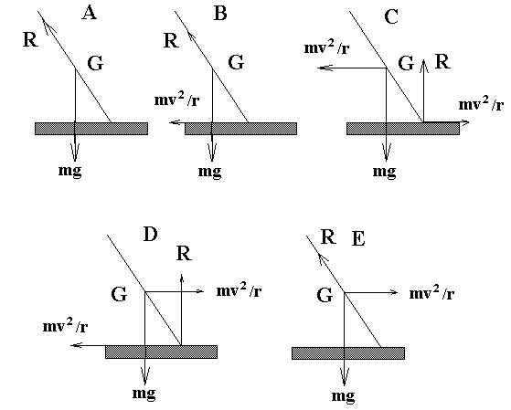

8. The acceleration of free fall on the surface of the Earth is about 6 times its value on the surface of the Moon. The mean density of the Earth is about 5/3 times the mean density of the Moon.
Using the data, what is the best value of the ratio of the radius of the Earth to the radius of the Moon?

A 1.9 B 3.2 C 3.6 D 6.0 E 10

9. In which of the following lists are all three quantities constant when a particle moves in undamped simple harmonic motion?

A acceleration force total energy
B amplitude angular frequency acceleration
C angular frequency acceleration force
D force total energy amplitude
E total energy amplitude angular frequency

10. The arrows on the diagrams represent the movement of the air molecules in a pipe in which a stationary longitudinal wave has been set up. The length of each arrow represents the amplitude of the motion, and the arrow head shows the direction of motion at a particular instant.

Which diagram shows a possible stationary wave in which there are two displacement nodes and two displacement antinodes.

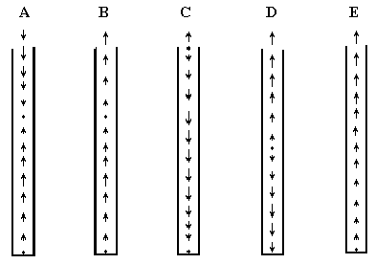

11. A diffraction grating is ruled with 600 lines per millimetre. When monochromatic light falls normally on the grating, the first-order diffracted beams are observed on the far side of the grating each making an angle of 15º with the normal to the grating.

What is the frequency of the light?

A 1.2 x 10¹³ Hz
B 4.7 x 10¹³ Hz
C 1.9 x 10¹⁴ Hz
D 3.6 x 10¹⁴ Hz
E 7.0 x 10¹⁴ Hz

12. An electromagnetic radiation has a frequency of 10⁸ Hz.

In which region of the spectrum would such radiation occur?

A infrared
B radio
C ultraviolet
D visible
E X-ray

13. Two parallel plates X and Y are mounted vertically and given equal and opposite charges. A light uncharged conducting sphere is suspended by an insulating thread from point P vertically above the mid-point O of the line joining the centre of the plates.
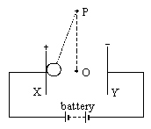

If the sphere is initially placed in contact with X as shown in the diagram, which statement best describes its subsequent motion?

A It remains in contact with plate X.
B It moves to plate Y and sticks to it.
C It moves back and forth continuously, touching each plate in turn.
D It moves to point O and quickly comes to rest there.
E It oscillates as a simple pendulum.

14. A current flows in a wire of circular cross-section with the free electrons traveling with a mean drift velocity v.

If an equal current flows in a wire of the same material but of twice the radius, what is the new mean drift velocity?

A v/4 B v/2 C v D 2 v E 4 v

15. A constant 60 V d.c. supply is connected across two resistors of resistance 400 kΩ and 200 kΩ.
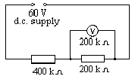

What is the reading of the voltmeter, also of resistance 200 kΩ, when connected across the second resistor as shown in the diagram?

A. 12 V B. 15 V C. 20 V D. 30 V E. 40 V

16. A thermocouple is connected across a galvanometer of resistance 30 Ω. One junction is immersed in water at 373 K and the other in ice at 273 K. The e.m.f. of the thermocouple is 90 μV for each 1 K difference in temperature between the junctions, and the thermocouple resistance is 6 Ω.

What current will flow in the galvanometer?
A 1.8 μA B 250 μA C 300 μA D 1.5 mA E 1.8 mA

17. Which circuit could be used to measure the capacitance of a capacitor using the reed switch S?

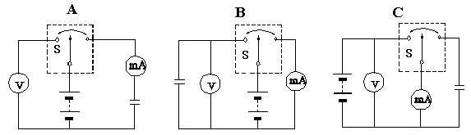

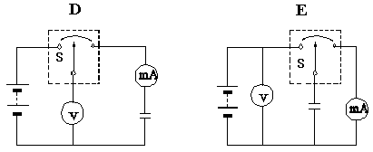

18. The diagram shows an earthed conducting sphere held close to a positively-charged dome.

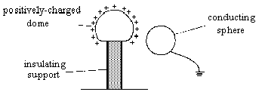

What are the charge and potential of the conducting sphere?

charge potential

A uncharged zero
B uncharged negative
C uncharged positive
D negative zero
E negative negative

19. A long, air-cored solenoid has N turns, is of length l, has cross-sectional area A, and carries current I. The uniform magnetic flux density near the middle of the solenoid is parallel to the axis and has the value .
What is the magnetic flux through the cross-section in this region?

A $μ_{o}\text{NI}$ B $\frac{μ_{o}\text{NI}}{A}$ C $μ_{o}\text{NIA}$ D $\frac{μ_{o}\text{NIA}}{l}$ E $\frac{μ_{o}\text{NI}}{\text{lA}}$

20. The diagram represents an aircraft of length l, wingspan x, flying horizontally at speed v in a region where the Earth’s magnetic field of uniform density B is inclined at an angle θ to the Earth’s surface.
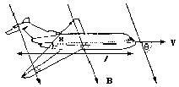

Which of the following gives the magnitude of the e.m.f. generated between the wingtips by electromagnetic induction?

A blxsinθ B Blv C Blvcosθ D Bxv E Bxvsinθ

21. The function of a mains transformer is to convert

A one direct voltage to another direct voltage of different magnitude.
B one alternating voltage to another alternating voltage of different magnitude.
C a high value alternating voltage to a low value direct voltage.
D a high value alternating current to a low value direct voltage.
E a low value alternating current to a high value direct current.

22. The diagram shows a combination of logic gates.

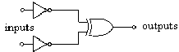

To what single gate is this combination equivalent?

A EX-NOR B EX-OR C NAND D NOR E OR

23. A sealed U-tube contains nitrogen in one arm and helium at pressure P in the other arm. The gases are separated by mercury of density ρ with dimensions as shown in the diagram. The acceleration of free fall is g.

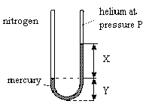

What is the pressure of the nitrogen?

A P B xρg C P- xρg D P + xρg E P + (x+y)ρg

24. A uniform strip of rubber, marked with equal divisions, is fixed at end P and pulled into tension by force F applied at end Q, as shown in the diagram.
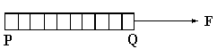
Which diagram shows the separation of the divisions when the elastic is extended to twice its original length?

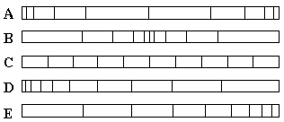

25. Cooling water enters the heat exchanger in the turbine hall of a nuclear power station at 6°C and leaves at 14°C. The specific heat capacity of water is 4200 J kg⁻¹ K⁻¹.
If the rate of heat removal by the water is 6.72 x 10⁹ J per minute, what is the rate of water flow?

A $\frac{6\text{.}\text{72}×{\text{10}}^{9}}{\text{4200}×8}\text{kg} s^{−1}$ B $\frac{6\text{.}\text{72}×{\text{10}}^{9}×\text{60}}{\text{4200}×8}\text{kg} s^{−1}$

C $\frac{6\text{.}\text{72}×{\text{10}}^{9}}{\text{4200}×8×\text{60}}\text{kg} s^{−1}$ D $\frac{\text{4200}×8}{6\text{.}\text{72}×{\text{10}}^{9}×\text{60}}\text{kg} s^{−1}$

E $\frac{\text{4200}×8×\text{60}}{6\text{.}\text{72}×{\text{10}}^{9}}\text{kg} s^{−1}$

26. What is the approximate number of atoms in a cubic metre of an ideal gas at a temperature of 27°C and a pressure of 1 x 10⁵ Pa?

A 1 x 10²¹ B 1 x 10²² C 6 x 10²³ D 2 x 10²⁵ E 3 x 10²⁶

27. The Y-input terminals of an oscilloscope are connected to a voltage supply of peak value 5.0 V and frequency 50 Hz. The time-base is set at 10 ms per division and the Y-gain at 5 V per division.

Assuming that all diagrams are drawn to scale, which trace will be obtained?
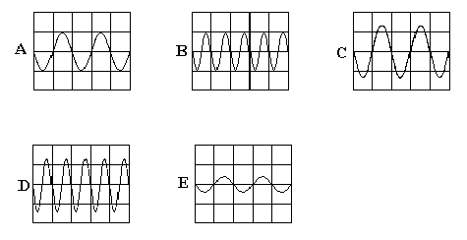

28. Thermal energy can be transferred by different processes, including (i) transfer in a fluid by a process which is a consequence of a change in density of the fluid, (ii) transfer in a non-metallic solid by the process of lattice vibrations.

Which terms are used for these processes?

process (i) process (ii)
A evaporation conduction
B evaporation radiation
C conduction radiation
D convection conduction
E convection radiation

29. Which curve shows the relationship between the energy E and the wavelength λ of a photon of electromagnetic radiation?

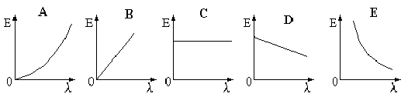

30. An ultraviolet radiation source causes the emission of photoelectrons from a zinc plate.

How would the maximum kinetic energy E_{K} of the photoelectrons and the number of photoelectrons emitted per second n be affected by substituting a more intense source of the same wavelength?

E_{K} n
A decreased increased
B unchanged unchanged
C unchanged increased
D increased unchanged
E increased increased

