1990

Section A

Answer four questions from this section.

1 . (a) Explain what is meant by the linear momentum of a body. Obtain a relation between p, the linear momentum of a body of mass m, and E_{K}, its kinetic energy. [3]

(b) A bullet is fired from a gun into a block which is suspended by thin threads from fixed points. The bullet remains in the block which swings upwards as shown in Fig. 1.1.

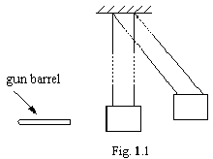

Explain how you would use this equipment to determine the velocity of the bullet. [7]

(c) A gun of effective barrel length 0.70 m and diameter 20 mm fires shot of mass 30 g with an exit velocity of 310 ms⁻¹. Assuming that the acceleration of the shot as it travels down the barrel is constant, calculate
(i) the acceleration of the shot,
(ii) the pressure in the barrel,
(iii) the average power supplied to the shot. [7]

(d) The butt of such a gun is sometimes fitted with a thick rubber pad as shown in Fig. 1.2.
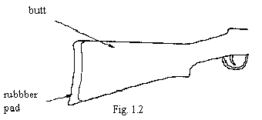

Describe and explain how this pad will affect the recoil of the gun, as experienced by the shooter. [3]

2. (a) (i) Define resistance.
(ii) Write down an equation which relates resistance and resistivity. Identify all the symbols in the equation. [3]

(b) Calculate the resistance per metre of a copper wire of diameter 0.05 mm and resistivity 1.7 x 10⁻⁸ Ω m. [2]

(c) The wire in (b) is to be used to construct an electromagnet in the form of a hollow solenoid by winding one layer of close-packed turns onto a plastic tube of length 200 mm and diameter 30 mm. The solenoid is connected in series with a switch and a battery of e.m.f. 6.0 V and negligible internal resistance, as shown in Fig. 2.1.

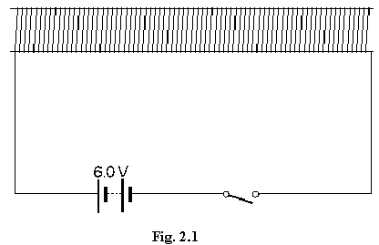

Calculate
(i) the resistance of the wire of the solenoid,
(ii) the maximum magnetic flux density produced by the electromagnet. [6]
(The magnetic flux density B at the centre of a solenoid is given by B = μ_{o} n I.)

(d) State and explain the effects on the maximum flux density of each of the following changes.
(i) The plastic tube is filled with iron filing.
(ii) The diameter of the tube is reduced but the number of turns of wire on the coil and the total length of wire in the circuit are not changed.
(iii) Twice the length of similar wire is used so that the coil consists of two close-packed layers. [9]

3. (a) (i) Explain what is meant by the internal energy of a system.
(ii) Use the molecular model of matter to explain why evaporation of a liquid is accompanied by cooling, unless heat is supplied to the liquid. [5]

(b) A thermally insulated vessel containing liquid water and water vapour is connected to a vacuum pump which removes water vapour continuously. When the temperature reaches 0°C, the vessel contains 110 g of liquid water. What mass of ice has been formed when no liquid remains? [5]
(Specific latent heat of fusion of water = 3.40 x 10⁵ J kg⁻¹,
Specific latent heat of vaporisation of water = 2.52 x 10⁶ J kg⁻¹.)

(c) Starting from the kinetic theory equation p = $13$<c²> and the ideal gas equation pV = NkT, deduce an expression, in terms of the thermodynamic temperature T, for the average translational kinetic energy of a monatomic molecule. [3]

(d) If two sufficiently energetic sodium atoms collide, an electron in one of them may be raised to a higher energy level.
(i) Explain why such a collision is called an inelastic collision.
(ii) Briefly explain why such inelastic collisions are not consistent with basic assumptions of the kinetic theory of gases.
(iii) If the energy required to raise the electron to the higher energy level is 3.35 x 10⁻¹⁹ J, estimate the temperature at which appreciable excitation by collision might take place. [7]

4. (a) (i) Describe, by means of a labelled diagram, the basic structure of a cathode-ray tube. [4]
(ii) What is meant by the term linear time base? [2]
(iii) A sinusoidal voltage is applied to the Y-plates of a cathode-ray oscilloscope and the Y-plate sensitivity is adjusted to 3.0 V cm⁻¹. With the time base set at 0.2 ms cm⁻¹, the trace of Fig. 4.1 is obtained.

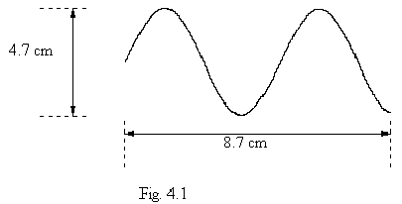

Deduce all you can about the voltage. [4]

(b) (i) Draw a diagram to show how four diodes may be used to produce a bridge rectifier for full-wave rectification of an alternating current. Indicate clearly the input and output terminals of the bridge and the direction of the current in each of the diodes during one half cycle of the alternating input. [4]

(ii) The output of a simple battery charger is a full-wave rectified sinusoidal voltage of r.m.s. value 2.0 V. The battery to be charged has e.m.f. 1.5 V and is connected as shown in Fig. 4.2. The battery receives charge only when the output voltage of the rectifier is greater than 1.5 V.

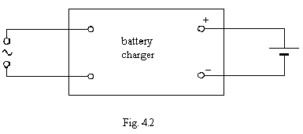

For what fraction of the total time is the battery being charged? [6]

5. (a) Distinguish between α-particles, β-particles and γ-ray photons, making reference, wherever appropriate, to charge, mass, speed and penetration. [6]

(b) A radioactive isotope of thallium, ²⁰⁷Th, is known to emit β-particles. It is suspected that the isotope also emits γ-radiation. You have available a ²⁰⁷Th source with an activity of approximately 10⁵ Bq. Devise an experiment, based on the different penetrating properties of β-particles and γ-ray photons, which could be used to confirm the emission of γ-radiation. [7]

(c) (i) Explain the meaning of the term radioactive decay constant.

(ii) ⁴⁰K, an isotope of potassium, has a half-life of 1.37 x 10⁹ years and decays to an isotope of argon which is stable. In a particular sample of Moon rock, the ratio of potassium atoms to argon atoms was found to be 1:7. Estimate the age of the rock, assuming that originally there was no argon present.

(iii) State one other assumption which you have made in your calculation. [7]

6. (a) (i) What do you understand by superposition? [2]

(ii) Explain how superposition contributes towards the effects observed when coherent monochromatic light passes through two very narrow parallel slits placed close together. [4]

(b) Parallel coherent light is incident upon two slits S₁ and S₂ as shown in Fig. 6.1.
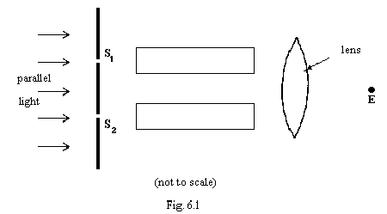

Light emerging from the slits passes through two identical evacuated tubes and is then superimposed and viewed in the region around E.

(i) Describe what will be observed near E if
(1) S₂ is covered,
(2) S₁ and S₂ are both uncovered and the path lengths from S₁ to E and from S₂ to E are identical. [5]

(ii) When gas is allowed to leak gradually into the tube in front of S₂, the intensity of the light at the point E is found to change periodically. Explain how this observation leads to the conclusion that the speed of light in the gas is different from that in a vacuum. You may assume that the frequency of the light is constant.
[4]

(iii) Light of wavelength 591 nm in a vacuum is observed to undergo 312 complete cycles in the variation of its intensity at E as the gas is introduced into the tube. The tube length is 62.0 cm. Obtain a numerical value for the ratio

speed of light in vacuum
speed of light in the gas. [5]

Section B

Answer two questions from this Section.
(Only one option is presented here)

Option C

COMMUNICATIONS

10. (a) A sinusoidal radio-frequency carrier wave of frequency f_{c} is to be amplitude modulated by a sinusoidal audio-frequency signal of frequency f_{s}.

(i) Explain the term amplitude modulated.

(ii) State the frequencies of the radio-frequency waves which are present in the transmitted signal.

(iii) Hence, or otherwise, explain what is meant by the term bandwidth. [5]

(b) Fig. 10.1 shows a block diagram of the various elements in a simple amplitude modulated radio receiver.
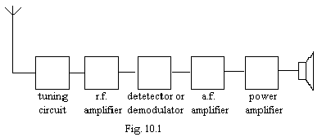

(i) Draw a circuit diagram of a simple tuning circuit. [2]

(ii) Why is it desirable to amplify the r.f. signal before de-modulation? [1]

(iii) List the elements shown in Fig. 10.1 for which the output power is greater than the input power. What is the source of this increased power? [3]

(iv) The frequency of the audio modulating signal is 5 kHz. What are the minimum possible bandwidths of

(1) the r.f. amplifier,
(2) the a.f. amplifier?
In each case, show how you arrived at your answer. [4]

11. (a) Distinguished between an analogue signal and a digital signal. [4]

(b) A three bit digital signal representing the analogue number 6 is shown in Fig. 11.1.

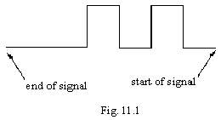

Sketch the signal representing the analogue number 3. [2]

(c) The code in (b) is to be used to transmit information about the analogue signal shown in Fig. 11.2

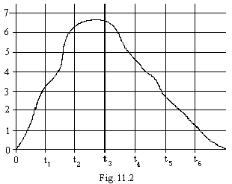

(i) Sketch the digital signal which would be transmitted when the analogue signal is sampled at time t₆.

(ii) The analogue signal is sampled and digitized at times t₁, t₂, t₃, t₅ and t₆. The digital signal is then transmitted and converted back into analogue form. Sketch a graph of the resulting analogue signal.

(iii) State two ways in which the accuracy of representation of the original analogue signal could be improved. [9]

12. (a) An ideal capacitor of capacitance C is connected in series with a variable frequency supply of constant peak e.m.f. and low output resistance, as shown in Fig. 12.1.
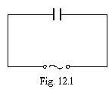

(i) Sketch a graph to show the variation with frequency of the current in the circuit.

(ii) The capacitor is replaced by a coil of inductance L and negligible resistance. Sketch a second graph to show the variation with frequency of the current in the coil. [4]

(b) The capacitor and coil are now connected in series across the supply, and identical loudspeakers, A and B, are connected across the capacitor and coil as shown in Fig. 12.2. The loudspeakers may be assumed not to affect the performances of the capacitor and coil.
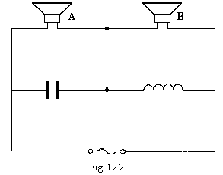

(i) Show that the potential difference across the coil is equal to that across the capacitor when f, the applied frequency, is given by the expression

$$f=\frac{1}{2π\sqrt{\text{LC}}}$$

[3]

(ii) Compare the amplitude of the voltage across the coil with that across the capacitor when
$$f\text{<<}\frac{1}{2π\sqrt{\text{LC}}}$$

[2]

(ii) Explain how the circuit may be used to separate high and low frequencies in an audio signal. [6]

