1990

1. (a) An object has mass of 2.3 kg. What is its weight? [1]

(b) When the object in (a) falls in air, the air resistance F is given by the equation

F = k v²

where v is the velocity of the object and k has the value 0.042 Ns²m⁻².

(i) Explain why the object eventually falls with uniform velocity (the terminal velocity).
[3]
(ii) Calculate the terminal velocity of the object. [2]

(c) Calculate the acceleration of the object when it is falling with a velocity of 12 ms⁻¹. [3]

2. Fig. 2.1 shows a planet P of mass m orbiting the Sun S of mass M in a circular path of radius r.

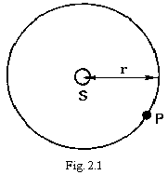

(a) Write down an expression, in terms of G,m,M and r, for the force exerted by the Sun on the planet. [1]

(b) Use this expression to find the angular velocity of the planet in its orbit. [2]

(c) Deduce the time taken to complete one orbit of the Sun. [2]

(d) The Earth is 1.50 x 10¹¹ m from the centre of the Sun and takes exactly one year to complete one orbit. The planet Jupiter takes 11.9 years to complete an orbit of the Sun. Calculate the radius of Jupiter's orbit. [4]

3. (a) Explain the term simple harmonic motion. [2]

(b) (i) State the defining equation for simple harmonic motion. [1]

(ii) Write down a solution to the equation giving the displacement x in terms of the amplitude of oscillation x_{o}, the angular frequency ω and the time t. [1]

(c) Given that the velocity v of a body of mass m undergoing simple harmonic motion is given by
v = ± ω √(x_{o}² - x²)

find the kinetic energy of the body in terms of its displacement x, and ω and x_{o}. [1]

(d) Sketch graphs, using the same horizontal axis, to show how the velocity and the kinetic energy vary with the displacement of a body undergoing simple harmonic motion. [3]

4. The light dependent resistor (LDR) in the circuit shown in Fig. 4.1 has a resistance of 10 MΩ when in the dark and a resistance of 1.0kΩ when in the light. The device X emits light (is ON) only when the potential difference between points B and C exceeds 5V. The LDR is shielded from the light from X.
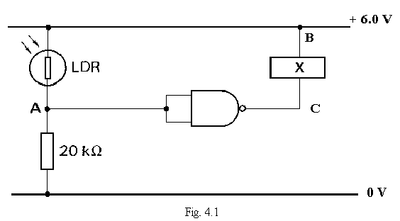

(a) Calculate the potentials at A when the LDR is (i) in the light, (ii) in the dark. [3]

(b) Complete the following table to show the conditions under which X is ON or OFF.

 | Logic state  of inputs  to NAND gate | Logic state  of output  from NAND gate | Device X  ON/OFF
LDR in LIGHT
LDR in DARK

(c) Suggest a practical use for this circuit. [2]

5. A resistor of resistance 2000 Ω is connected in series with a switch, a capacitor of capacitance 10.0 μF, and a battery of e.m.f. 20.0 V and negligible internal resistance, as shown in Fig. 5.1.

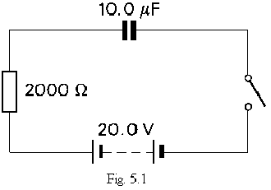
The capacitor is initially uncharged.

(a) Calculate the current in the circuit immediately after the switch is closed. [2]

(b) Calculate the final charge on the capacitor when the current is zero. [1]

(c) Calculate the time constant of the circuit. [1]

(d) The battery and switch are replaced by a voltage source which varies with time as shown in Fig. 5.2. The capacitor is uncharged at time t = 0.

(i) Sketch on Fig. 5.3 how the potential difference across the capacitor varies with time. [3]

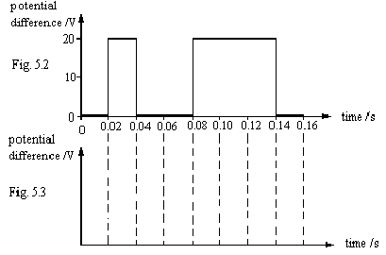

- The potential difference V across a capacitor whilst it is being charged is given by the general equation

$$V=V_{o}\left(1−e^{−\frac{t}{\text{CR}}}\right)$$

Calculate the potential difference across the capacitor when t = 0.04 s. [3]

6. (a) Describe the principal features of a thermocouple thermometer and state a suitable indicating instrument to use with it. [3]

(b) State why the thermodynamic scale of temperature is called an absolute scale. [2]

(c) Name types of thermometers that would be suitable for measuring each of the following:

(i) the boiling point of oxygen (about 90 K),

(ii) a rapidly changing temperature,

(iii) the temperature of a very small quantity of a liquid. [3]

Give a reason for your choice of thermometer in (ii). [1]

7 (a) What is meant by the term threshold frequency as applied to the photoelectric effect?
[1]

(b) Explain why the maximum possible kinetic energy of a photoelectron is independent of the intensity of the incident light. [2]

(c) Ultra-violet radiation of frequency 4.83 x 10¹⁵ Hz is incident on a metal surface and the resulting photoelectrons have a maximum kinetic energy of 1.28 x 10⁻¹⁸ J. Calculate

(i) the energy of a photon of this radiation,

(ii) the maximum kinetic energy of the photoelectrons produced by radiation of frequency 6.76 x 10¹⁵ Hz incident on the same metal surface. [6]

8. The electrical generator in a power station is driven by a steam turbine. The turbine absorbs thermal energy from a boiler and produces useful work. However, thermal energy must also be removed from the turbine by a cooling system as shown in Fig. 8.1.

The operating efficiency e of the turbine is defined by

e = useful work output
thermal energy input.

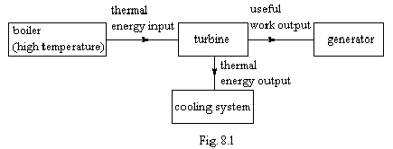

The efficiency of heat engines, of which the turbine is an example, can never exceed a certain value which is fixed by the temperatures of the boiler and the cooling system. This ideal efficiency e_{max} is given by the equation

e_{max} = (T₂ - T₁)/T₂

Where T₂ is the thermodynamic temperature of the boiler and T₁ is the thermodynamic temperature of the cooling system.
Further data for a particular power station situated at Newtown are given below.
Electrical power output 200 MW
Efficiency of electrical generator 100%
Operating efficiency of turbine 31%
Ideal efficiency of turbine 52%
Effective temperature of the cooling system 330 K
The cooling system uses water which enters at a temperature of 283 K
and leaves at 291 K.
Specific heat capacity of cooling water 4200 J kg⁻¹ K⁻¹

(a) Calculate the ideal efficiency if the boiler temperature is 100°C and the cooling system is at 27°C. [2]

(b) (i) Plot a graph of e_{max} against T₂ using data from the following table which refers to a constant value of T₁. [3]

T₂/K | e_{max}
333  373  450  600  750 | 0.048  0.15  0.30  0.47  0.58

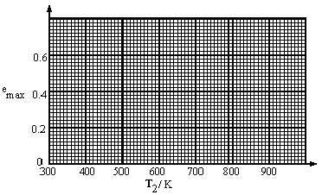
(ii) From your graph deduce the value of T₂ for which e_{max} = 0. [1]

(iii) Hence deduce the value of T₁. [1]

(iv) In principle the ideal efficiency could be increased by reducing the temperature of the cooling system. Why is this not a practicable method of increasing the efficiency? [1]

(c) For the power station at Newtown, calculate

(i) the effective boiler temperature,
(ii) the rate of input of thermal energy to the turbine,
(iii) the rate at which thermal energy is removed from the turbine,
(iv) the required rate of flow of water through the cooling system. [5]

(d) Suggest two reasons for the discrepancy between the ideal efficiency of the turbine and its operating efficiency. [2]

(e) A significant fraction of the electrical power produced in the U.K. by burning fossil fuels is used for domestic heating. Two suggestions for improvement are as follows.

(i) Burn the fossil fuel in the home instead of at the power station.

(ii) Use the thermal energy output from the turbine for domestic heating.

Comment critically on these suggestions.

Suggest one further way by which consumption of fossil fuel for domestic heating could be reduced.
[3]

