1990

1. A constant mass undergoes uniform acceleration when the resultant force acting on it

A is proportional to the displacement from a fixed point.
B is proportional to the velocity.
C is zero.
D is constant but not zero.
E increases uniformly with respect to time.

2. Two blocks, X and Y, of masses m and 2m respectively, are accelerated along a smooth horizontal surface by a force F applied to the block X, as shown in the diagram.

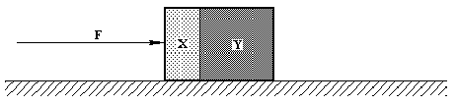

What is the magnitude of the force exerted by block Y on block X during this acceleration?

A 0 B F/3 C F/2 D 2F/3 E F

3. The e.m.f. E_{b} of a battery is given by E_{b} = P/I where P is the power dissipated when a current I flows. The e.m.f. E_{c} induced in a coil by a changing magnetic flux is equal to the rate of change of flux, E_{c} = dΦ/dt.
Which of the following is a unit for magnetic flux?

A m s⁻¹ A B m s⁻² A⁻¹ C kg m² s⁻² A D kg m s² A⁻¹

E kg m² s⁻² A⁻¹
4. A puck on a frictionless surface collides with a stationary puck. The pucks move as shown in the diagram.

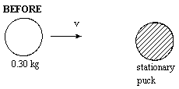
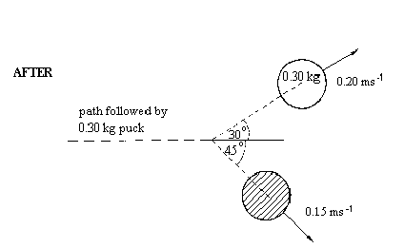

If the mass of the puck moving before the collision is 0.30 kg, what is the mass of the second puck

A 0.20 kg B 0.28 kg C 0.40 kg D 0.49 kg E 1.0 kg

5. A small ball of weight W is suspended by a light thread. When a strong wind blows horizontally exerting a constant force F on the ball, the thread makes an angle θ to the vertical as shown in the diagram.

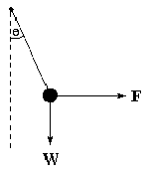

Which of the following equations correctly relates θ, F and W?

A cos θ = F/W
B cos θ = W/F
C sin θ = F/W
D tan θ = F/W
E tan θ = W/F

6. A linear accelerator sends a charged particle along the axis of a set of coaxial hollow metal cylinders as shown in the diagram.
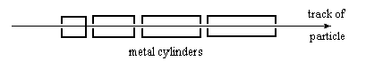

The particle travels at constant speed inside each cylinder. The particle crosses the gaps between the cylinders at equal time intervals, and at each gap its kinetic energy increases by a fixed amount. Which of the graphs best represents the way in which v, the velocity of the particle varies with d, the distance along its track?

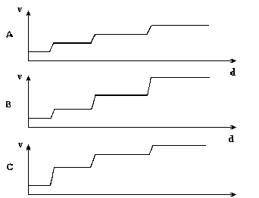

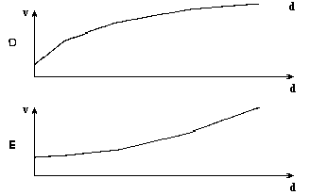

7. The diagram shows two bodies X and Y connected by a light cord passing over a light, free-running pulley. X starts from rest and moves on a smooth plane inclined at 30 º to the horizontal.
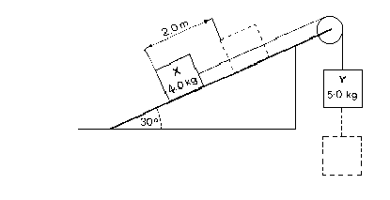
What will be the total kinetic energy of the system when X has traveled 2.0 m along the plane? (g = 9.8 m s⁻²).

A 20 J B 59 J C 64 J D 132 J E 137 J

8. When a satellite in on the surface of a planet, it experiences a gravitational force W. What is the gravitational force when the satellite is at a height R/50, where R is the radius of the planet?

A 1.02 W B 1.00 W C 0.98 W D 0.96 W E 0.00 W

9. When the aircraft Concorde is moving in a horizontal plane at a constant speed of 650 m/s, its turning circle has a radius of 80 km. What is the ratio of the centripetal force to the weight of the aircraft?

A 8.3 x 10⁻⁴ B 0.54 C 1.9 D 52 E 540

10. A body performing simple harmonic motion has a displacement x given by the equation x = 30 sin 50t, where t is the time in seconds. What is the frequency of oscillation?

A 0.020 Hz B 0.13 C 8.0 Hz D 30 Hz E 50 Hz

11. In a fairground shooting game a gun fires at a moving target. The gun fires by itself at random times. The player has to point the gun in a fixed direction, and the target moves from side to side with simple harmonic motion.

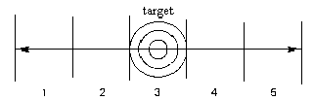

At which region should the player take a fixed aim to score the greatest number of hits?

A 3
B either 1 or 5
C either 2 or 4
D any of 1, 3, or 5
E any of 1, 2, 3, 4, or 5

12. The diagram shows two oscillations.

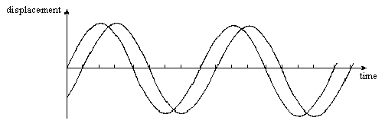

What is the phase difference between the two oscillations?

A π/4 rad B π/2 rad C 3/4 π rad D π rad E 3/2 π rad

13. Progressive waves of frequency 300 Hz are superimposed to produce a system of stationary waves in which adjacent nodes are 1.5 m apart. What is the speed of the progressive waves?

A 100 m/s B 200 m/s C 450 m/s D 900 m/s E 1800 m/s

14. The grating spacing d of a diffraction grating is the distance between successive slits and should be uniform across the grating.

The diagram shows the formation of the first order spectrum when parallel rays of monochromatic light fall perpendicularly on a substandard diffraction grating PQR. For the part of the grating between P and Q, the angle of deviation θ is constant and the diffracted rays emerge parallel. However, from Q to R, θ falls progressively as shown in the graph.

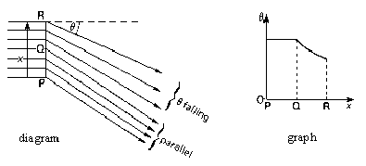

Which graph best shows how the grating interval d varies with x, the distance from P?

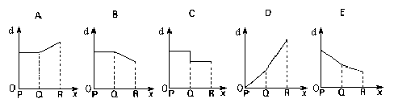

15. In the circuit shown, resistors X and Y, each of resistance R, are connected to a 6 V battery of negligible internal resistance. A voltmeter, also of resistance R, is connected across Y.
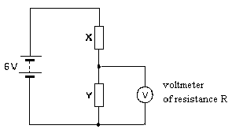

What is the reading of the voltmeter?

A zero B between zero and 3 V C 3 V

D between 3 V and 6 V E 6 V

16. Three resistors of resistance 1Ω, 2Ω, and 3Ω respectively are used to make the combinations X, Y, and Z shown in the diagrams.
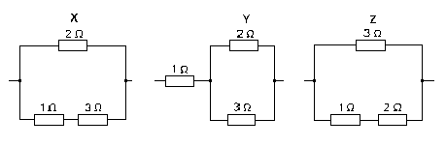
Which of the following gives the combinations in order of increasing resistance?

A XYZ B XZY C YXZ D ZXY E ZYX

17. A current flows in a wire of circular cross-section with the free electrons traveling at drift velocity v. What is the drift velocity for the same current in a wire of the same material but half the radius?

A v/4 B v/2 C v D 2 v E 4 v

18. A capacitor of capacitance 1.0 μF carries a charge of 15 mC. It is discharged through a 25 Ω resistor. What is the maximum current during the discharge?

A 0.60 A B 1.2 A C 300 A D 600 A E 1200 A

19. The charge on the uranium nucleus is 1.5 x 10⁻¹⁷ and the charge on the α-particle is 3.2 x 10⁻¹⁹ c. What is the electrostatic force between a uranium nucleus and an α-particle separated by 1.0 x 10⁻¹³ m?

A 4.3 x 10⁻³³ N B 4.3 x 10⁻²⁰ N C 4.3 x 10⁻¹³ N D 4.3 N

E 4.3 x 10¹⁰ N

20. The diagram shows three long straight wires P and Q and R normal to the plane of the paper. Wires P and R carry currents directed into the plane of the paper, and wire Q carries a current directed out of the paper. All three currents have the same magnitude.
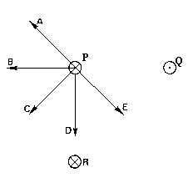

Which arrow best shows the direction of the resultant force on wire P?

21. The circuit diagram shows a full-wave rectifier with a smoothing capacitor.

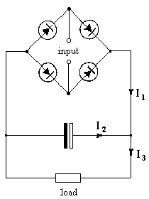
The currents I₁ and I₃ vary with time as shown below. Which of the graphs A-E best represents the variation with time of the current I₂?
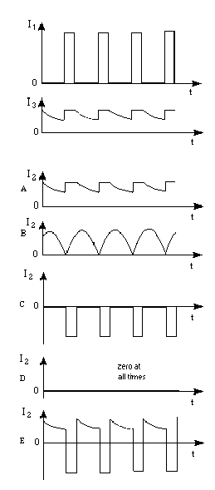

22. How does negative feedback affect the gain and bandwidth of an operational amplifier?
effect on gain effect on bandwidth
A increased unchanged
B increased decreased
C unchanged increased
D decreased increased
E decreased decreased

23. A uniform, vertical wire is stretched by hanging a mass from its lower end. Which of the following does not affect the strain in the wire?

A the stress
B its unstretched length
C its cross-sectional area
D the load applied
E the Young modulus of the metal

24. When one junction X of a thermocouple is placed in melting ice and the other junction Y in steam at 100 ºC, the e.m.f. is 6.0 mV. Junction Y is removed from the steam and is placed in a liquid bath at a constant temperature, junction X remaining in the ice. The e.m.f. is now -1.5 mV.

What is the temperature of the bath on the centigrade scale of this thermometer?

A -75º B -25º C 25º D 75º E 125º

25. What is the internal energy of a system?

A the maximum amount of work that can be extracted from the system
B the sum of kinetic energies and potential energies of the molecules
C the total amount of work which has been done on the system
D the thermal energy needed to raise the temperature of the system by one kelvin
E the thermal energy which remains in the system when it is cooled to absolute zero

26. A mass of an ideal gas of volume V at pressure p undergoes the cycle of changes shown in the graph.
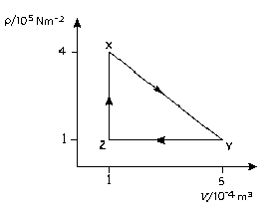
At which points is the gas coolest and hottest?

coolest hottest
A X Y
B Y X
C Y Z
D Z X
E Z Y

27. Two thermally conducting blocks are maintained at temperatures which differ by 20 K. The blocks are joined by two cylindrical bars each of length 0.40 m and made from a material of thermal conductivity 25 W m⁻¹ K⁻¹. The cross-sectional areas of the bars are 1.0 x 10⁻⁴ m² and 4.0 x 10⁻⁴ m² respectively. The remainder of the space between the blocks is filled with insulating material as shown in the diagram.
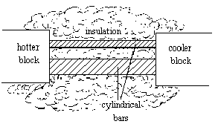
What is the rate of transfer of thermal energy between the two blocks?

A 0.13 W B 0.25 W C 0.31 W D 0.50 W E 0.63 W

28. An electron is projected with velocity v into a region where there exists a uniform electric field of strength E perpendicular to a uniform magnetic field of flux density B. If the electron velocity is to remain constant, v must be

A of magnitude B/E and parallel to B
B of magnitude E/B and parallel to E
C of any magnitude but at 45º to both E and B
D of magnitude B/E and perpendicular to both E and B.
E of magnitude E/B and perpendicular to both E and B.

29. When a clean metal in a vacuum is irradiated with monochromatic ultra-violet radiation, electrons are emitted. Which of the following will double if the intensity of the ultra-violet radiation is doubled?

A the maximum speed of the electrons
B the maximum kinetic energy of the electrons
C the rate of emission of the electrons
D the threshold frequency of the metal surface
E the work function of the metal surface

30. A radioactive source consists of 6.4 x 10¹¹ atoms of a nuclide of half-life 2 days. A second source consists of 8 x 10¹⁰ atoms of another nuclide of half-life 3 days. After how many days will the numbers of active atoms in the two sources be equal?

A 6 B 9 C 12 D 15 E 18

