
Support Material
GCE Modern Foreign Languages
OCR Advanced Subsidiary GCE in Persian: H195
Unit: F885

This Support Material booklet is designed to accompany the OCR Advanced Subsidiary GCE specification in Persian for teaching from September 2008.

Contents
Contents 2
Introduction 3
Persian H195: Listening, Reading and Writing 1: F885 5
Sample Lesson Plan: Persian H195 Listening, Reading and Writing 1: F885 7
Other forms of Support 9

Introduction

Background
A new structure of assessment for A Level has been introduced, for first teaching from September 2008. Some of the changes include:
- The introduction of stretch and challenge (including the new A* grade at A2) – to ensure that every young person has the opportunity to reach their full potential
- The reduction or removal of coursework components for many qualifications – to lessen the volume of marking for teachers
- A reduction in the number of units for many qualifications – to lessen the amount of assessment for learners
- Amendments to the content of specifications – to ensure that content is up-to-date and relevant.
OCR has produced an overview document, which summarises the changes to Persian. This can be found at www.ocr.org.uk, along with the new specification.
In order to help you plan effectively for the implementation of the new specification we have produced this Scheme of Work and Sample Lesson Plans for Persian. These Support Materials are designed for guidance only and play a secondary role to the Specification.

Our Ethos
All our Support Materials were produced ‘by teachers for teachers’ in order to capture real life current teaching practices and they are based around OCR’s revised specifications. The aim is for the support materials to inspire teachers and facilitate different ideas and teaching practices.

Each Scheme of Work and set of sample Lesson Plans is provided in:

- PDF format – for immediate use

- Word format – so that you can use it as a foundation to build upon and amend the content to suit your teaching style and students’ needs.

The Scheme of Work and sample Lesson plans provide examples of how to teach this unit and the teaching hours are suggestions only. Some or all of it may be applicable to your teaching.

The Specification is the document on which assessment is based and specifies what content and skills need to be covered in delivering the course. At all times, therefore, this Support Material booklet should be read in conjunction with the Specification. If clarification on a particular point is sought then that clarification should be found in the Specification itself.

A Guided Tour through the Scheme of Work

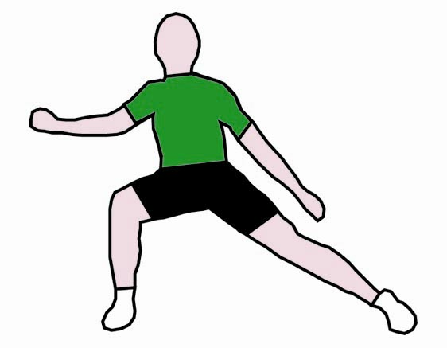
= Innovative Teaching Idea
All the teaching ideas contained in the SOW are innovative, but the icon is used to
Highlight exceptionally innovative ideas.

= Stretch & Challenge Activity
This icon is added at the end of text when there is an explicit opportunity to offer
Stretch and Challenge.

= ICT Opportunity
This icon is used to illustrate when an activity could be taught using ICT facilities.

Persian H195: Listening, Reading and Writing 1: F885
Suggested teaching time | 12 hours | Topic | Leisure Activities (aspects of cultural life: Cinema, Theatre, Music)
Topic outline |  | Suggested teaching and homework activities | Suggested resources | Points to note
Listening |  | - Listening to Iranian classical/folk/pop music and/or programmes and interviews on the subtopic.  - Watching Iranian films or listening to their reviews.  - Answering short questions in Persian based on the stimulus. Respond non-verbally and verbally. | - Relevant radio/television items  audio tapes/CDs/MP3s/video clips.  www.BBC Persian.com | - There is a wide selection of items available. Teachers need to make a careful selection and adapt their selection into teaching material in order to maximise the educational benefits to students.
Speaking |  | - Role play: interviewing an artist in Persian.  - Group work: carrying out surveys on students’ cultural interests in Persian.  - Setting up panels to discuss young people’s leisure activities in Persian. | - Interviews of artists or art experts available in the Persian speaking media and on cultural websites/initiating discussion by providing stimulus such as posters, postcards, drawing and photographs.  www.Jadidmedia.com | Useful to teach alongside:  - Ways of expressing likes and dislikes, opinion, agreement and tactful disagreement in Persian.  - Practising open and closed questions with students.
Reading  = Innovative teaching idea  = Stretch and challenge opportunity idea  = ICT opportunity |  | - Variety of exercises based on the relevant topic accompanied by manipulation of the language exercises: gap filling and sentence completion, and short extract for transfer of meaning. | - Newspaper/magazine cuttings/internet items on related cultural matters.  www.gooya.com
Writing  = Innovative teaching idea  = Stretch and challenge opportunity idea  = ICT opportunity |  | - Gist summary of articles.  - Writing discursive essays on topics such as: The influence of society or environment on the choice of leisure interests/evaluation of the role of leisure interests in one’s life. | - All previously studied material/students’ interests. | - Students need to learn analytical skills in writing.
Consolidation |  | - Creating a paper montage of cinema, theatre, music.  - Writing an article for the wall/school newspaper.  - Writing a film/play or music review.  - Staging parts of plays. | - Newspaper/magazine cuttings/images from the internet/drawing/sketches.  - Going to concerts, film screenings and plays. | - Producing a school newspaper/school play or a similar group activity is a highly motivating and useful exercise in team-building skills.
Consolidation |  | - Students to produce their own set of keywords and expressions for this topic. | - Articles studied/researched/vocabulary used in the class, etc. | - Needs to be assessed by teacher.
Consolidation |  | - Doing quizzes about Iranian musical instruments, Iranian directors and Iranian artists. | - Iranian media also available on the internet. | - Such activities add motivation to the learning process in the class.
Consolidation |  | - Exploring past papers. | - Past Papers. | - To be assessed according to the Mark Scheme.
Consolidation |  | - Independent reading/viewing of items and comprehension exercises. | - Newspaper/internet/radio/television.
Consolidation |  | - Visit a relevant exhibition.
Consolidation |  | - Watch more Iranian films.
= Innovative teaching idea
= Stretch and challenge opportunity idea
= ICT opportunity

Sample Lesson Plan: Persian H195 Listening, Reading and Writing 1: F885

Introduction to Iranian cinema or classical music as part of leisure time
OCR recognises that the teaching of this qualification will vary greatly from school to school and from teacher to teacher. With that in mind, this lesson plan is offered as a possible approach but will be subject to modifications by the individual teacher.

Lesson length is assumed to be one hour.

Learning objectives for the lesson
Objective 1 | Students to understand the key premises behind leisure activities.
Objective 2 | Students to be able to understand and respond in Persian in relation to Iranian cinema or classical music.
Objective 3 | Students to evaluate the advantages and disadvantages of leisure activities.

Recap of previous experience and prior knowledge
- Students to provide answers to questions on their Persian cultural interests. Questions on Iranian musical instruments or Iranian cinema to assess the level of knowledge and interests of the class.

Content
Time | Content
5 minutes | Warm-up activity to assess students’ interest and prior knowledge of Iranian cinema or classical Persian music.
10 minutes  Listening | Students to watch footage of a film/music DVD or listen to a CD and answer comprehension questions in Persian.
10 minutes  Speaking | Pupils to feed back on the film shown or piece of music heard. One pupil from the entire group to act as scribe and note down the discussion points that arise.
15 minutes  Reading and Writing | Teacher to set a written activity based on a text about cinema or music, with questions and answers in Persian requiring non-verbal (ticking/matching) or verbal answers in Persian and English (filling blanks, finding synonyms, etc).
15 minutes  Writing | Students to translate or summarise a selected passage on the topic of Iranian cinema or music.

Consolidation and Homework
Time | Content
5 minutes  Consolidation | Students to divide into 2 groups, one evaluating the advantages and the other the disadvantages of Iranian cinema or music as a leisure activity for the young generation in the UK.  One student to act as a scribe writing down on the board or flipchart the advantages and disadvantages in 2 different columns.
Homework | Students to use Excel/Word to produce charts on the advantages and disadvantages of Iranian cinema or music as a leisure activity for the young generation in the UK.

Other forms of Support
In order to help you implement these new specification effectively, OCR offers a comprehensive package of support. This includes:

OCR Training

Get Ready…introducing the new specifications
A series of FREE half-day training events are being run during Autumn 2007, to give you an overview of the new specifications.

Get Started…towards successful delivery of the new specifications
These full-day events will run from Spring 2008 and will look at the new specifications in more depth, with emphasis on first delivery.
Visit www.ocr.org.uk for more details.

Mill Wharf Training
Additional events are also available through our partner, Mill Wharf Training. It offers a range of courses on innovative teaching practice and whole-school issues - www.mill-wharf-training.co.uk.

e-Communities
Over 70 e-Communities offer you a fast, dynamic communication channel to make contact with other subject specialists. Our online mailing list covers a wide range of subjects and enables you to share knowledge and views via email.
Visit https://community.ocr.org.uk, choose your community and join the discussion!

Interchange
OCR Interchange has been developed to help you to carry out day to day administration functions online, quickly and easily. The site allows you to register and enter candidates online. In addition, you can gain immediate a free access to candidate information at you convenience. Sign up at https://interchange.ocr.org.uk

Published Resources
Published Resources
OCR offers centres a wealth of quality published support with a fantastic choice of ‘Official Publisher Partner’ and ‘Approved Publication’ resources, all endorsed by OCR for use with OCR specifications.

Publisher partners
OCR works in close collaboration with three Publisher Partners; Hodder, Heinemann and Oxford University Press (OUP) to ensure centres have access to:

- Better published support, available when you need it, tailored to OCR specifications
- Quality resources produced in consultation with OCR subject teams, which are linked to OCR’s teacher support materials
- More resources for specifications with lower candidate entries
- Materials that are subject to a thorough quality assurance process to achieve endorsement

Oxford University Press (OUP) is the publisher partner for OCR GCE Modern Foreign Languages

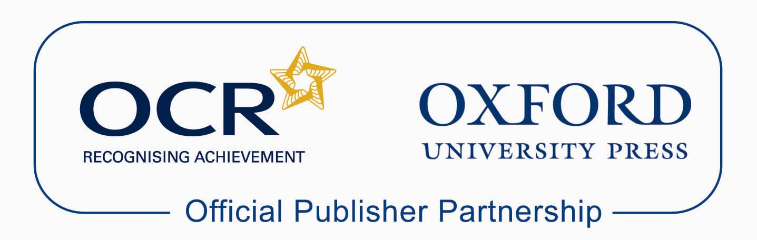

Approved publications
OCR still endorses other publisher materials, which undergo a thorough quality assurance process to achieve endorsement. By offering a choice of endorsed materials, centres can be assured of quality support for all OCR qualifications.

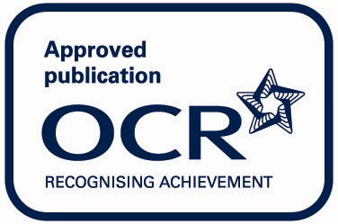

Endorsement
OCR endorses a range of publisher materials to provide quality support for centres delivering its qualifications. You can be confident that materials branded with OCR’s “Official Publishing Partner” or “Approved publication” logos have undergone a thorough quality assurance process to achieve endorsement. All responsibility for the content of the publisher’s materials rests with the publisher.

These endorsements do not mean that the materials are the only suitable resources available or necessary to achieve an OCR qualification. Any resource lists which are produced by OCR shall include a range of appropriate texts.

