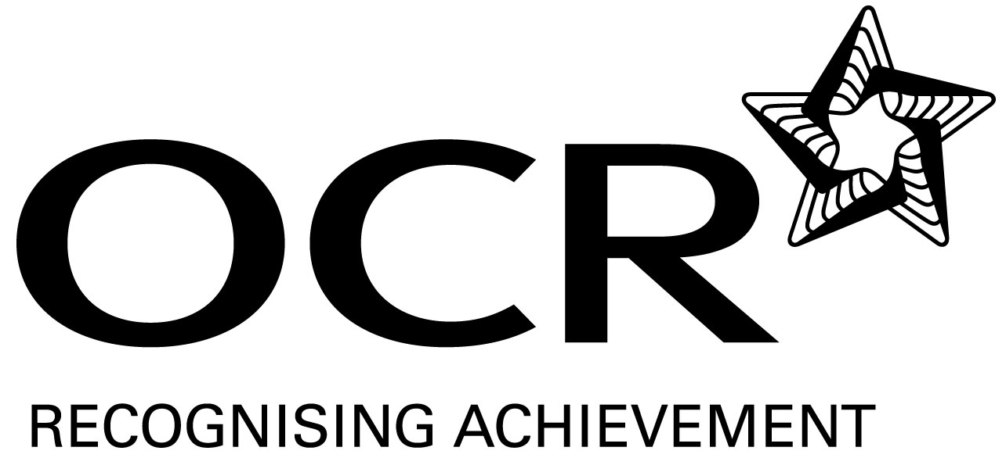
Support Material
GCE Modern Foreign Languages
OCR Advanced GCE in Persian: H595
Unit: F886

This Support Material booklet is designed to accompany the OCR Advanced GCE specification in Persian for teaching from September 2008.

Contents
Contents 2
Introduction 3
Persian H595: Listening, Reading and Writing 2: F886 5
Sample Lesson Plan: Persian H595 Listening, Reading and Writing 2: F886 9
Other forms of Support 11

Introduction

Background
A new structure of assessment for A Level has been introduced, for first teaching from September 2008. Some of the changes include:
- The introduction of stretch and challenge (including the new A* grade at A2) – to ensure that every young person has the opportunity to reach their full potential
- The reduction or removal of coursework components for many qualifications – to lessen the volume of marking for teachers
- A reduction in the number of units for many qualifications – to lessen the amount of assessment for learners
- Amendments to the content of specifications – to ensure that content is up-to-date and relevant.
OCR has produced an overview document, which summarises the changes to Persian. This can be found at www.ocr.org.uk, along with the new specification.
In order to help you plan effectively for the implementation of the new specification we have produced this Scheme of Work and Sample Lesson Plans for Persian. These Support Materials are designed for guidance only and play a secondary role to the Specification.

Our Ethos
All our Support Materials were produced ‘by teachers for teachers’ in order to capture real life current teaching practices and they are based around OCR’s revised specifications. The aim is for the support materials to inspire teachers and facilitate different ideas and teaching practices.

Each Scheme of Work and set of sample Lesson Plans is provided in:

- PDF format – for immediate use

- Word format – so that you can use it as a foundation to build upon and amend the content to suit your teaching style and students’ needs.

The Scheme of Work and sample Lesson plans provide examples of how to teach this unit and the teaching hours are suggestions only. Some or all of it may be applicable to your teaching.

The Specification is the document on which assessment is based and specifies what content and skills need to be covered in delivering the course. At all times, therefore, this Support Material booklet should be read in conjunction with the Specification. If clarification on a particular point is sought then that clarification should be found in the Specification itself.

A Guided Tour through the Scheme of Work

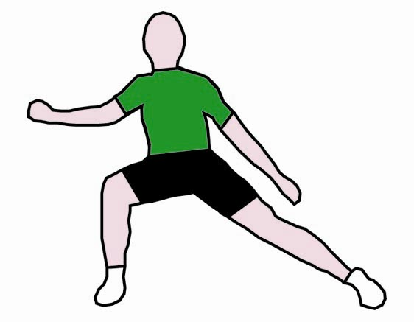
= Innovative Teaching Idea
All the teaching ideas contained in the SOW are innovative, but the icon is used to
Highlight exceptionally innovative ideas.

= Stretch & Challenge Activity
This icon is added at the end of text when there is an explicit opportunity to offer
Stretch and Challenge.

= ICT Opportunity
This icon is used to illustrate when an activity could be taught using ICT facilities.

Persian H595: Listening, Reading and Writing 2: F886
Suggested teaching time | 12 hours | Topic | Literature and the arts: trends, changes, influences and impacts on individuals and society.
Topic outline |  | Suggested teaching and homework activities | Suggested resources | Points to note
Literature and its development –
classical/modern
prose/verse
Listening |  | - Listening to audio tapes/DVDs of Persian poetry sung by famous vocalists such as Shajarian, Shahram Nazeri, Parisa, Shakila, etc, as stimulus for introduction or discussion. | - Tapes/DVDs on Persian classical poetry by Hafez, Rumi, Sa’di, etc, recited or sung by well-known artists. | - Taster lessons to introduce the beauty and wealth of Persian literature to the students.  - It will be interesting to explore the reasons why the verb ‘to read’ and ‘to sing’ is the same in Persian.
Speaking |  | - Role play: using the ‘Time Machine’, meet various writers and poets through the centuries and interview them about their life and work. | - History of literature.  - Biographies and works of writers/poets. | - Teacher’s role will be pivotal in the choice of important literary personalities studied/interviewed by the class.
Speaking  = Innovative teaching idea  = Stretch and challenge opportunity idea  = ICT opportunity |  | - Students to impersonate poets and writers, putting forward reasons why their contribution to Persian cultural heritage should be considered as the greatest. The class to vote on each performance.  - Group work: students to read out a famous play or story from Persian literature and act out key sections.  - Organising poetry recitals.  - One student to describe postcards of miniatures or Ghahveh Khanehie paintings based on a famous story from Shahnemeh studied in class. The other members of the class to guess the story and its personalities. | - Simplified versions of Persian literature.  - Anthology of Persian poetry.  - Bilingual editions of Persian poetry.  - Books on Persian painting and miniature.  - Shortened and simplified versions of the Shahnameh and stories of Masnavi.  - Rumi (Masnavi Ma’navi, Ketabeh Shams). | - Miniatures are the earliest and best examples of forms of art, enriching manuscripts of Persian literature.  - Naghashi Ghahveh Khanehi depict stories of Ferdowsi’s Shahnameh on the walls of old coffee houses.
Reading |  | - Reading selected significant passages and/or famous verses from prominent writers/poets and giving answers to questions in Persian.  - Organising story reading competitions. | - Hafez (Divan).  - Omar Khayyam (Rubaiyat).  - Sa’di (Golestan).  - Ferdowsi (Shahnameh).  www.bbcpersian.com  - Collection of modern short stories.  - Anthology of modern literature. | - Figures of speech: couplet, quatrain, ode and sonnet could be explained to the students.
Writing |  | - Write about role of literature, in particular poetry, in Persian cultural heritage. |  | - Naghali – the most traditional form of story reading in the Persian-speaking world – could be explained to the students.
Development of arts
architecture – calligraphy
carpets, miniatures, pottery, textiles, etc
Listening and Speaking |  | - Watching videos of Iranian arts and crafts prepared by the Cultural Heritage and Tourism Organisation of Iran or academic and research institutes. Answering questions in English and Persian. | - Iranian Cultural Heritage News Agency.  www.chnpress.com | - Out of the huge wealth of Persian art, the teacher needs to select points to develop and discuss in the class.
Listening and  Speaking  = Innovative teaching idea  = Stretch and challenge opportunity idea  = ICT opportunity |  | - Giving presentations on Persian art using PowerPoint or other forms of visual aid. Students to ask questions/answer written questions in English and Persian. | - Various histories of Persian or Islamic art.  - Publications from the Ministry of Tourism/Iranian Cultural Heritage Organisation.
Writing |  | - Development of calligraphy:  Showing its decorative and utilitarian role through the centuries.  - Group work: creating postcards or posters using the decorative form of calligraphy.  - Designing items with calligraphy. | - Encyclopaedia Iranica.  - Posters, postcards, desk diaries and art calendars.  www.farhangeiran.com | - Various forms of calligraphy: Naskh, Nasta’ligh, Shekasteh and Sols.  - Mentioning the decorative use of calligraphy on tile work, metalwork, woodwork, etc, would be useful.
Reading  Reading  = Innovative teaching idea  = Stretch and challenge opportunity idea  = ICT opportunity |  | - Reading articles about various forms of Persian art, answering questions in Persian:  - Textile: carpets, Kelims, Ghalamkar, etc.  - Architecture: Persepolis, Arqeh Bam, mosques of Isphafan, bridges  - old palaces, etc.  - Painting: miniatures, modern art.  - Metal work: Loristan bronze, Achamenid and Sassanid gold and silver objects, etc.  - Glasswork.  - Woodcraft: (Khatam) inlay, etc.  - Pottery/ceramic: Sialk, Marlik pottery, etc.  - With the help of a map of Iran, locate the origin of the various forms of art.  - Drawing maps of Iran or filling empty maps with various regional clothes, jewellery and artefacts.  - Organise quizzes based on acquisitions of the topic.  - Group work: doing projects on various forms of art, e.g. computer searches.  - Pair work: creating wall charts/paper montage on regional art. | - Publications about archaeological excavations.  - Iranian modern miniatures or pictures/postcards of old ones.  - Postcards of museums or examples of modern Iranian handicrafts.  - History of Persian architecture, museum catalogues, postcards, leaflets and guide books.  www.carpetmuseum.com  www.allmuseums.com  - Maps of Iran/Afghanistan/Tajikistan.  - Historic maps.  www.Iranartnews.com  www.jadidmedia.com | - Abgineh museum is the museum of Iranian glass work.  - Musee Mardom Shenassi (Ethnographic museum) has a fine collection of postcards.  - Combination of arts: engraving on metal, painting on wood, enamel, etc.
Writing |  | - Write about one or more forms of art such as architecture, calligraphy, carpets, textiles, pottery, and their role in Persian cultural heritage.
Consolidation |  | - Visiting the Jamil Gallery (Victoria and Albert museum).  - Visiting British Museum – Persian manuscript section and Islamic galleries. Teacher to set projects based on the visit.  - Attending cultural events/festivals organised by museums and cultural foundations such as the Iran Heritage Foundation, and then writing critical review. | - Museum catalogues/brochures, leaflets, postcards, etc.  - Videos, tapes, CDs, DVDs, etc.  - Speeches, exhibitions, film screenings, plays, etc.  www.iranheritage.org
= Innovative teaching idea
= Stretch and challenge opportunity idea
= ICT opportunity

Sample Lesson Plan: Persian H595 Listening, Reading and Writing 2: F886

An introduction to Literature and the arts
OCR recognises that the teaching of this qualification will vary greatly from school to school and from teacher to teacher. With that in mind, this lesson plan is offered as a possible approach but will be subject to modifications by the individual teacher.

Lesson length is assumed to be one hour.

Learning objectives for the lesson
Objective 1 | Students to understand the key premises behind cultural heritage.
Objective 2 | Students to learn how to communicate about Persian culture.
Objective 3 | Students to be able to evaluate own culture.

Recap of previous experience and prior knowledge
- Question and answer session regarding cultural heritage. Students to provide answers to questions on Persian cultural heritage.

Content
Time | Content
5 minutes | Warm up activity: assessing cultural heritage.
10 minutes  Listening | A class presentation on what constitutes culture: guided by the teacher who provides stimulus in terms of ideas (e.g. literature and its history) and also visual and audio cultural aids related to Persian arts and crafts (The collection will have pictures of Iranian old monuments, such as bas-relief, bridge mosque, palaces, and various forms of arts and crafts, such as Persian carpets, calligraphy, miniatures).
10 minutes  Speaking | Activities:  - Students to select a picture/postcard from among the collection presented by the teacher, which they regard as a symbol of Persian culture, and then talk about its importance to them.  - Students to be given postcards/photographs which they should not show but describe to the class who should guess the subject.
15 minutes  Reading | Teacher to provide a text on Persian culture with questions requiring non-verbal, English and Farsi verbal answers.
10 minutes  Writing | Students to transfer meaning of some sentences on Persian culture from Persian into English.

Consolidation and Homework
Time | Content
10 minutes  Consolidation | - Students to write a list of Persian cultural features to which they can relate and regard as part of their cultural heritage.  - Students to categorise various forms of art and crafts seen/mentioned in the session (e.g. buildings, textiles, metalwork, pottery).
Homework | - To write about own experience and knowledge of Persian cultural heritage as an article for the school newsletter.  OR  - To do an internet search for Persian culture/Iranian history and write own summary.  OR  - To prepare a presentation of 5-10 minutes on Persian cultural heritage for the following session.

Other forms of Support
In order to help you implement these new specification effectively, OCR offers a comprehensive package of support. This includes:

OCR Training

Get Ready…introducing the new specifications
A series of FREE half-day training events are being run during Autumn 2007, to give you an overview of the new specifications.

Get Started…towards successful delivery of the new specifications
These full-day events will run from Spring 2008 and will look at the new specifications in more depth, with emphasis on first delivery.
Visit www.ocr.org.uk for more details.

Mill Wharf Training
Additional events are also available through our partner, Mill Wharf Training. It offers a range of courses on innovative teaching practice and whole-school issues - www.mill-wharf-training.co.uk.

e-Communities
Over 70 e-Communities offer you a fast, dynamic communication channel to make contact with other subject specialists. Our online mailing list covers a wide range of subjects and enables you to share knowledge and views via email.
Visit https://community.ocr.org.uk, choose your community and join the discussion!

Interchange
OCR Interchange has been developed to help you to carry out day to day administration functions online, quickly and easily. The site allows you to register and enter candidates online. In addition, you can gain immediate a free access to candidate information at you convenience. Sign up at https://interchange.ocr.org.uk

Published Resources
Published Resources
OCR offers centres a wealth of quality published support with a fantastic choice of ‘Official Publisher Partner’ and ‘Approved Publication’ resources, all endorsed by OCR for use with OCR specifications.

Publisher partners
OCR works in close collaboration with three Publisher Partners; Hodder, Heinemann and Oxford University Press (OUP) to ensure centres have access to:

- Better published support, available when you need it, tailored to OCR specifications
- Quality resources produced in consultation with OCR subject teams, which are linked to OCR’s teacher support materials
- More resources for specifications with lower candidate entries
- Materials that are subject to a thorough quality assurance process to achieve endorsement

Oxford University Press (OUP) is the publisher partner for OCR GCE Modern Foreign Languages

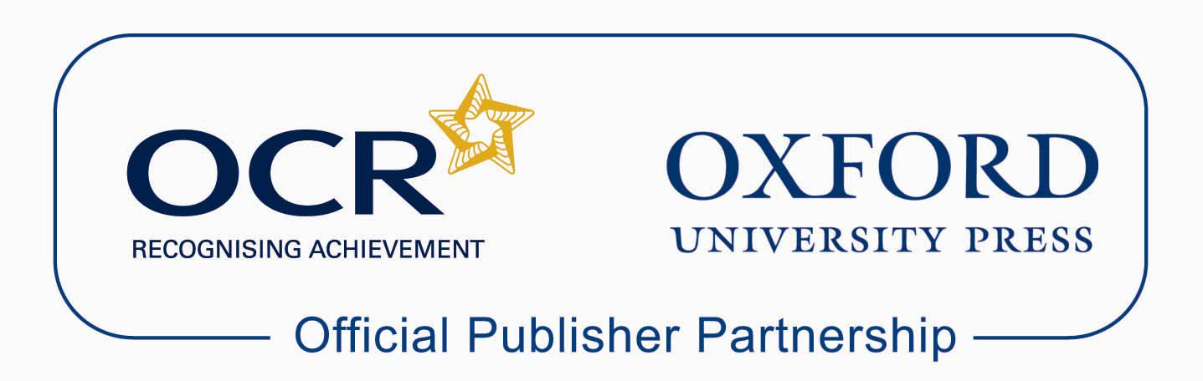

Approved publications
OCR still endorses other publisher materials, which undergo a thorough quality assurance process to achieve endorsement. By offering a choice of endorsed materials, centres can be assured of quality support for all OCR qualifications.

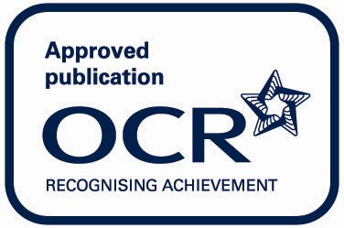

Endorsement
OCR endorses a range of publisher materials to provide quality support for centres delivering its qualifications. You can be confident that materials branded with OCR’s “Official Publishing Partner” or “Approved publication” logos have undergone a thorough quality assurance process to achieve endorsement. All responsibility for the content of the publisher’s materials rests with the publisher.

These endorsements do not mean that the materials are the only suitable resources available or necessary to achieve an OCR qualification. Any resource lists which are produced by OCR shall include a range of appropriate texts.

