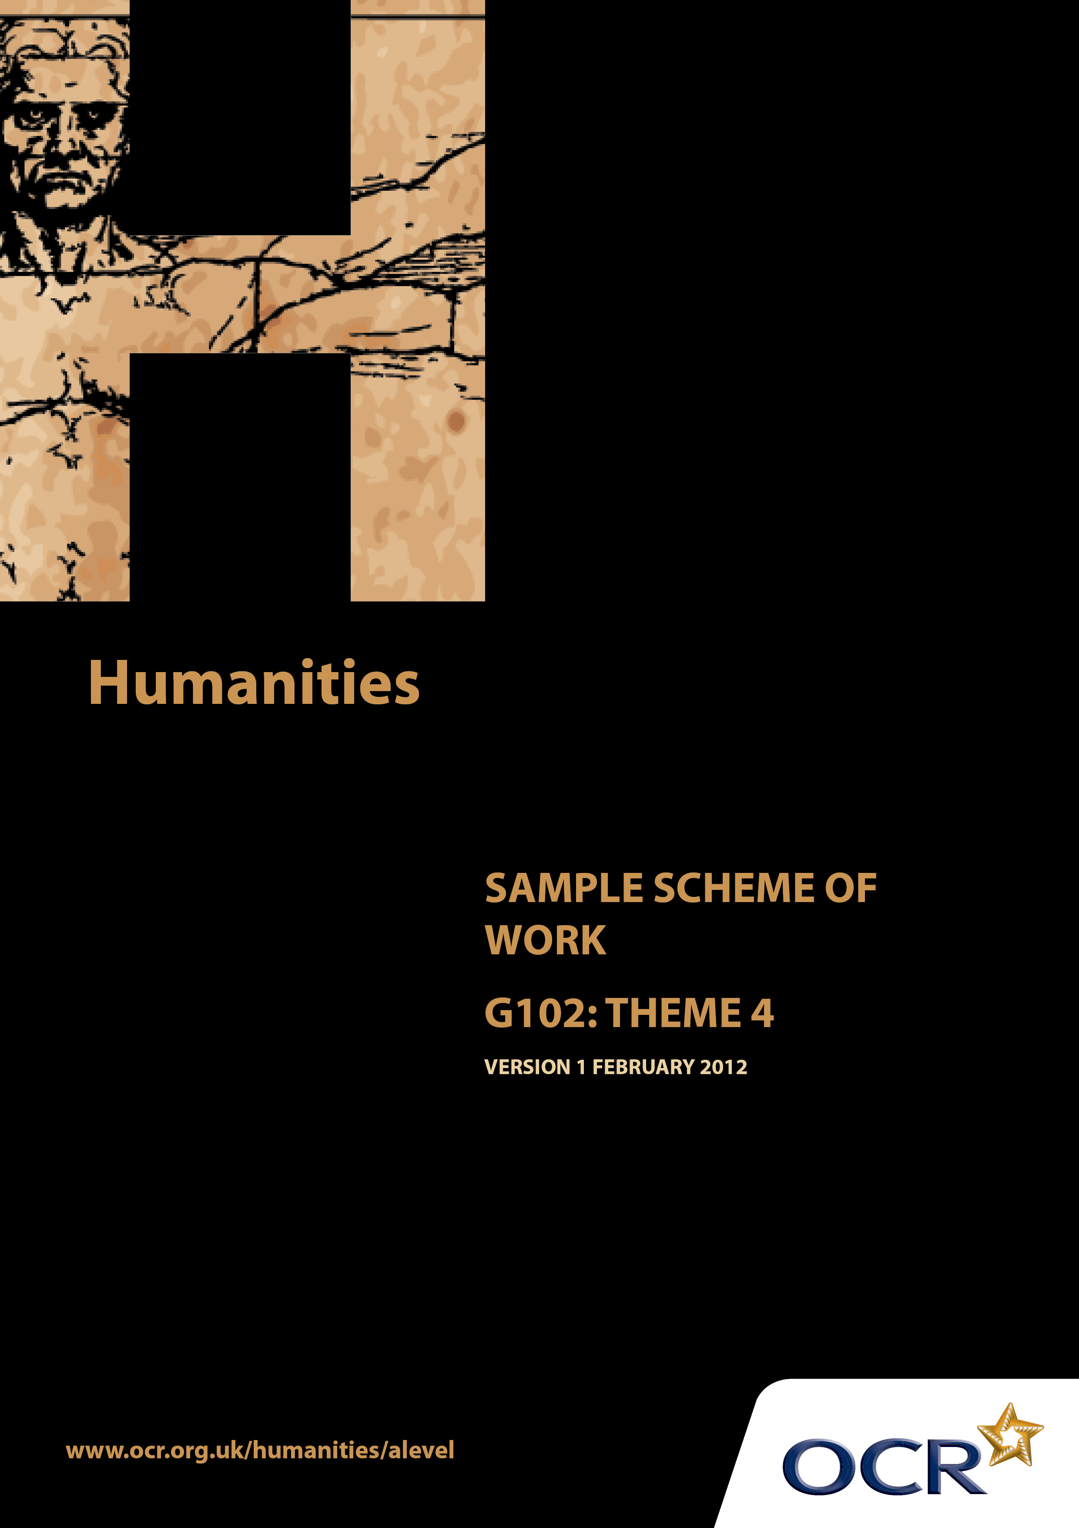
TWENTY FIRST CENTURY SCIENCE SUITE
SCHEMES OF WORK AND LESSON PLANS
B1: You and your genes
VERSION 1.1 JULY 2011
Introduction
OCR involves teachers in the development of new support materials to capture current teaching practices tailored to our new specifications. These support materials are designed to inspire teachers and facilitate different ideas and teaching practices. Each Scheme of Work is provided in Word format – so that you can use it as a foundation to build upon and amend the content to suit your teaching style and students’ needs.
The Scheme of Work provides examples of how to teach this unit and the teaching hours are suggestions only. Some or all of it may be applicable to your teaching.
The Specification is the document on which assessment is based and specifies what content and skills need to be covered in delivering the course. At all times, therefore, this Support Material booklet should be read in conjunction with the Specification. If clarification on a particular point is sought then that clarification should be found in the Specification itself.

Sample Scheme of Work
GCE Humanities
G102: People, community and power Theme 4: Communication and Social Interaction

Suggested Teaching Time: 15 Hours

Aims of the whole unit

The idea of a “natural” fit between an ethnically homogeneous nation and a national territory is a recent notion in historical terms. The concept of the nation state, with a shared national culture, arose in the 18thand 19 ^{th} centuries. In contemporary societies religious and ethnic diversity is regarded as the norm. Both of these situations are the result of complex historical processes which are explored in this unit.

Content of this theme

This final theme focuses on changing patters of social interaction with particular reference to the media and pressure groups. The effects of modern communications on the interaction between citizen and state are explored, as well as tensions between principles such as the right to individual privacy versus the right to freedom of the press.

Teaching this unit

Conceptually this unit is based on an understanding of changes taking place through a period of time. There are links between this unit and unit G101 which will need to be made apparent to candidates to promote coherence in learning. A wide range of skills will be needed to study this unit.

The unit will particularly develop skills 3, 4, 5, 6, 7 and 8 listed on page 4. As assessment will be through questions based on previously unseen sources it will be especially important for candidates to become confident in analysing and evaluating source material in the light of subject specific knowledge.

The function of expanded content

The specification is arranged around key ideas which appear in the ‘Key concepts, ideas and terms’ column. This gives the emphasis and focus of what candidates need to learn. The expanded content is designed to provide material suitable for teaching the concepts, and it also forms the context in which the concepts will be examined.

Topic outline | Suggested teaching and homework activities | Suggested resources | Points to note
Conflicting rights and freedoms in social interaction in an international context  Striking a balance between competing interests in society  Non-harm  Precautionary principle  Freedom of the press  Freedom of information  Right to a fair trial  Right to privacy | JS Mill and the principle of non-harm and the precautionary principle. Recap from theme 3 if needed.  - Class discussion of main ideas in Mill’s work.  - Homework: Essay. How are these ideas relevant to social interaction, and particularly new technologies?  In groups, students role play situations/ethical dilemmas where Mill’s principles conflict with other demands.  Role plays/Mock trials/class debate concerning  Human Rights, freedom of speech/worship/privacy  superinjunctions, Work on rights and possible conflicts between them could be a productive  focus  e.g. a celebrity who wants journalists prevented from following him/her in the hope of a photo v. The journalist’s right to do their job freely.  Possible topics could include;  -Naomi Campbell court case  Relevant homeworks could be researching the legal frameworks or writing speeches for presentation  to the class in a mock trial. | http://plato.stanford.edu/entries/mill/  http://www.utilitarian.net/jsmill/  The above website contains information on other useful sources.  http://www.who.int/peh-emf/meetings/southkorea/Leeka_Kheifets_principle_.pdf  Although refers to health issues, there is a good definition of the precautionary principle.  Possible coverage of high profile court cases/trials where information has not been admitted (e.g Joanna Yeates)  Freedom of Information Act 200  http://www.legislation.gov.uk/ukpga/2000/36/contents  Human Rights Act 1998  http://www.legislation.gov.uk/ukpga/1998/42/contents  European Court of Human Rights  http://www.echr.coe.int/ECHR/homepage_en  Media coverage of high profile cases such as Wikileaks, Occupy London movement, Ryan Giggs superinjunction, could provide suitable materials for use in class. | Links to other themes/topics within  the specification. Could incorporate  some consideration of Locke and  von Humboldt.  “On Liberty” by J.S.Mill can be found  here.  http://www.bartleby.com/130/  .  International dimension could include Occupy Wall Street movement, Wikileaks,

Topic outline | Suggested teaching and homework activities | Suggested resources | Points to note
Civil Liberties  National Security | Civil liberties vs. state surveillance and national security  - Define ‘in the national/public interest’.  - Students could research Wartime posters (e.g. Careless Talk costs Lives etc) and explain how ‘the national interest’ can be dependent upon factors such as hostilities, political ideologies etc.  - Students then list situations where it may be considered better not to know e.g. could cause panic/panic buying/mass exodus.  - Internationally students could look at Chinese protest movements, Arab Spring – reactions of different countries and the international community, Egypt, Syria, Libya | Resources on Civil Liberties and other rights -  http://www.liberty-human-rights.org.uk/index.php  The Media Centre page on Liberty’s website has plenty of useful resources which could be used in class.  http://www.historylearningsite.co.uk/civil_liberties.htm

Topic outline | Suggested teaching and homework activities | Suggested resources | Points to note
Means of social control in an international context  Public opinion  Self-regulation  Regulation | Public opinion e.g. adverse reactions to offensive  material/violence in films  - Students undertake a survey on what people consider to be ‘offensive’. Results displayed in class.  - Hwk: write a brief report , including analysis of the statistics and explaining the findings. (good opportunity to consider sample size and composition, variables, questionnaire construction etc)  Self regulation: Press Complaints Commission  - Homework: research the role of the PCC and other similar bodies internationally.  - Students could write a selection of complaints letters for homework. Make sure a range of areas of complaint are covered. These are then shared with the class, ensuring each student gets a letter they didn’t write. They then have to adjudicate on them, explaining their decisions.  Legal controls:  Privacy law/use of injunctions to prevent publication  Homework: Essay. Should the Internet, especially  social networking media (Twitter,  Facebook etc) be monitored and  policed? How does this work in an international context?  Law on Defamation  Law on obscenity - famous literary trials e.g. Lady Chatterley, The Romans in Britain  -class discussion on the issues surrounding famous trials. Would these trials/controversies arise now? Are we less accepting of these things now? | http://www.lawteacher.net/human-rights/essays/freedom-of-press-and-privacy.php  www.britishcouncil.org/governance-foe-booklet.doc  Students need to formulate a definition of what a pressure group is.  http://www.historylearningsite.co.uk/what_are_pressure_groups.htm  Useful website for a range of media issues.  http://www.understandmedia.com/ | Consideration of what constitutes  ‘offensive material’., how the media  (e.g TV, films, DVD) deals with this.  Film classification – how do these  match up with video game  classification?  How effective is the 9pm watershed?  Possible discussion of why we can  see gruesome images on the 6pm  news, but drama programmes seem  to have tighter restrictions.  Many of the weblinks listed have  lesson plans and resources which could be used or adapted  for teaching this qualification.

Topic outline | Suggested teaching and homework activities | Suggested resources | Points to note
Censorship | Direct Censorship:  D notices  - Define what these are, giving examples, if possible.  - Homework: In what circumstances justifiable is it for a free, democratic society to use state censorship?  - Role play: Students act as the Government who have to consider issuing a D-notice for a given situation or range of situations. | Useful material on censorship:  http://www.understandmedia.com/ml-basics/11-censorship-vs-media-literacy  Details of the Lady Chatterley Trial 1960:  http://yourarchives.nationalarchives.gov.uk/index.php?title=The_Chatterley_Trial_1960  Obscene publications guidelines:  http://www.inbrief.co.uk/media-law/freedom-of-expression.htm  Ofcom guidance:  http://stakeholders.ofcom.org.uk/broadcasting/broadcast-codes/broadcast-code/harmoffence/  Lesson plans and resources available from the BFI on regulation and censorship.  http://www.bfi.org.uk/education/teaching/tvcitizenship/plans/regulation.html  Information on D notices (now called DA-Notices – Defence Advisory Notices:  http://www.dnotice.org.uk/  http://www.legislation.gov.uk/ukpga/1996/31/contents  http://www.lawyers-media.com/guide/  (Use the links on the left hand side to access relevant documents).  http://www.website-law.co.uk/resources/website-libel.html  http://www.pcc.org.uk/assets/111/Teachers__Resource_Pack.pdf | International context: Important to consider with both Superinjunctions and D-notices that they can apply globally in  certain circumstances.  In other cases, searching for a  website in another country can  produce the censored material  which can be freely and legally read.

Topic outline | Suggested teaching and homework activities | Suggested resources | Points to note
Changing patterns of technology and social interaction  How advances in technology have affected human behaviour in an international context  Citizen journalist  Public interest | Recent changes in behaviour related to communication technology:  - Mobile technologies and changing behaviour in public space - Discussion of situations/places where the use of mobile phones is not permitted(e.g. quiet coaches on trains, meetings, examination rooms, classrooms etc) or socially acceptable (e.g. dinner table, religious services, etc) or safe (e.g. while driving, walking along the street , cyberbullying etc)  - Changing relationship between journalist and audience -Students could consider the role of social networking media in political /news events e.g. Arab spring  - Rise of citizen journalists: issues of who checks content for accuracy, quality, legality. Availability of information vs. reliability  - Identify how blogs, Twitter and Facebook accounts are monitored. Could also include moderated forums/lists. Who does this? Do they have any training or is it voluntary? Does it depend on the personal viewpoints of a few people?  - Homework: Research how a range of social networking media monitor and control content.  Role of communication technology in relation to:  - News e.g. 24 hour TV news -Students compile a list of advantages and disadvantages of rolling news (e.g. instant knowledge, excitement, people are up to date and well informed, can be repetitive and boring if nothing happens, unscripted and some presenters are poor at ‘thinking on the hoof’, unexpected language/behaviour from interviewees etc). | http://www.thenewatlantis.com/publications/our-cell-phones-ourselves  http://www.oneupmagazine.co.uk/index.php?page=1&article=175  Article on cyberbullying.  http://www.slideshare.net/mariaahmed/the-changing-relationship-between-journalists-and-their-audience  Useful Powerpoint with links. | Several of the issues in this topic  outline could be covered whilst  teaching the previous one. There is  some overlap in public interest and  use of technology by pressure  groups which could be linked.  Could be linked to Regulation in the  previous section.

Topic outline | Suggested teaching and homework activities | Suggested resources | Points to note
- Pressure groups | - Investigative work e.g. exposing negative/criminal behaviour  - Students study news articles of famous exposes – MPs expenses, behaviour of sports teams (cricket betting scandal, rugby tours, footballers’ affairs etc).  - Hwk: Each candidate produces a written document in which they explore what criteria they believe should be used to determine what the public should be told about the behaviour of public figures, and giving reason for their views.  Promoting views/opinions -Students list the ways in which people canexpress their views and opinions (e.g speeches, letters, leaflets, blogs, websites, articles etc)  Disseminating political propaganda  Advertising:  - Define ‘political propaganda’ and ‘advertising’. What are the different features of each?  - Students could look at election campaign adverts from previous elections and identify which features of propaganda/advertising each contains.  - Political adverts from the USA could be considered since this is not widely practised in the UK. Students could consider why this is the case?  - Hwk; Essay.What do political adverts contribute to the political arena? How far is the use of propaganda/advertising in the public interest ?  Use of technology by pressure groups e.g. internet to disseminate information  Impact of pressure groups  - Define ‘Pressure Group’  - Students to research what pressure groups there are, and categorise them.  - Homework: Choose one pressure group to research. How effectively has that group used technology to get their message across? | Newspaper articles on the Twitter controversy would be helpful for this.  The following books may be useful-  Computer Mediated Communication. Thurlow, Lengel and Tomic. Google e-book. (Sage 2004).  The News and Public Opinion: Media Effects on Civic Life. McCombs, Kiousis, Holbert, Wanta (2011)  A Private Sphere: Democracy in a Digital Age. Papacharissi (2010) | Promoting views/opinions could be  Linked to work on freedom of  speech/information in previous  section.

