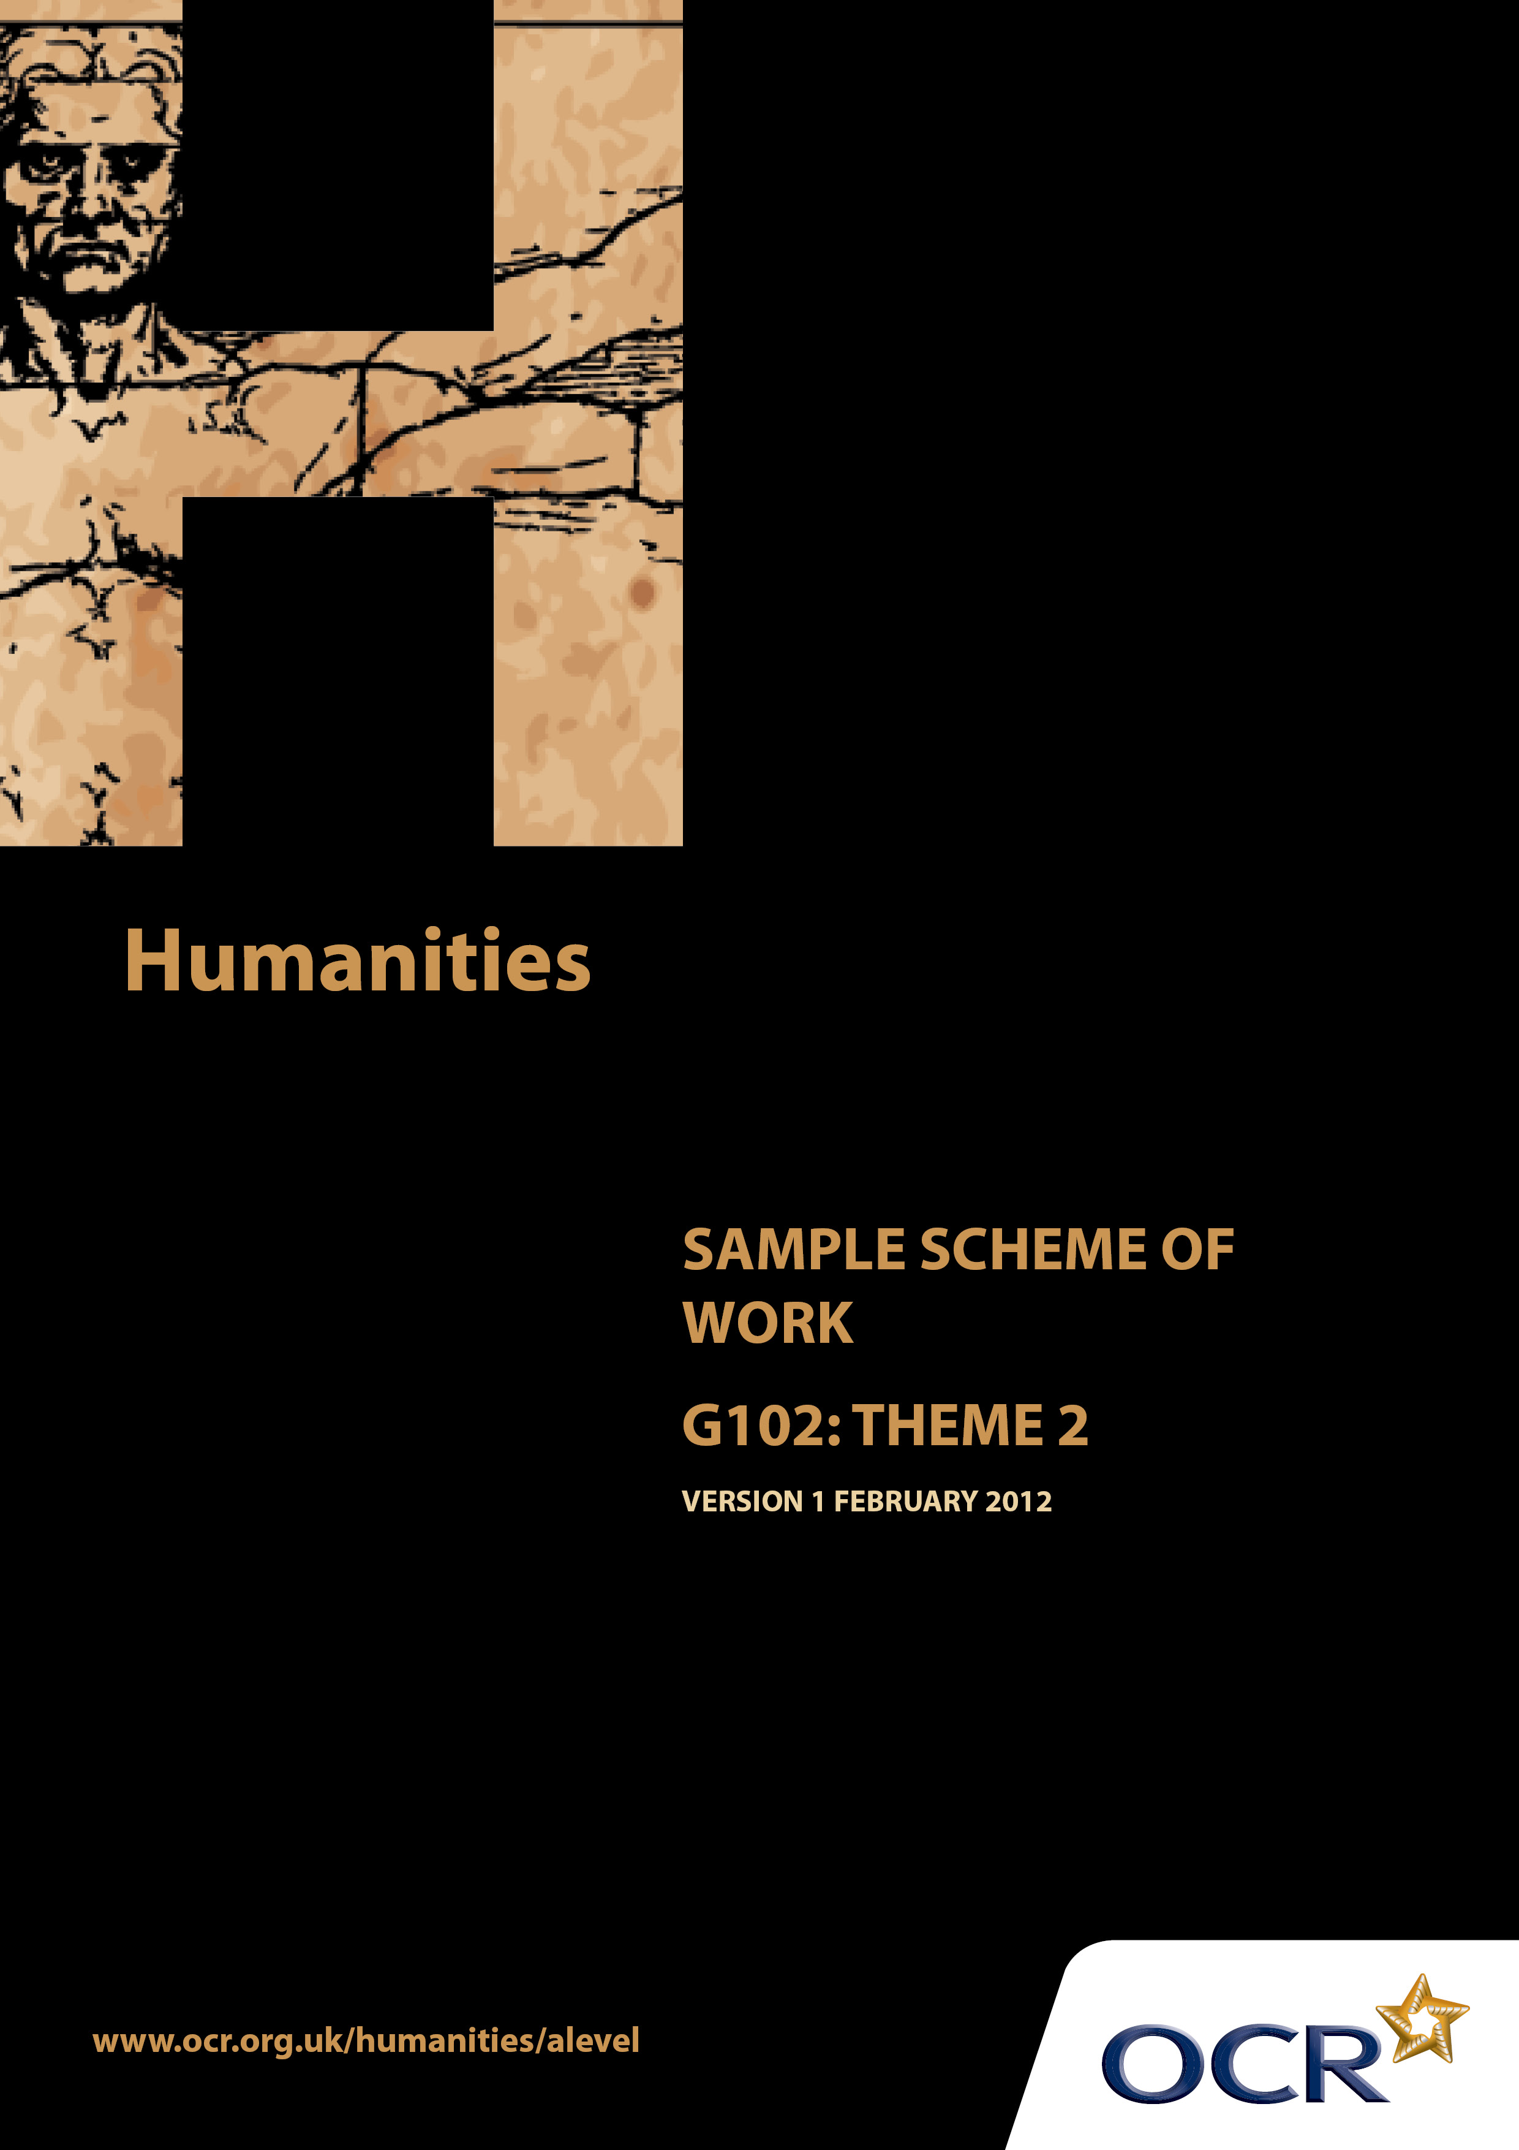
TWENTY FIRST CENTURY SCIENCE SUITE
SCHEMES OF WORK AND LESSON PLANS
B1: You and your genes
VERSION 1.1 JULY 2011
Introduction
OCR involves teachers in the development of new support materials to capture current teaching practices tailored to our new specifications. These support materials are designed to inspire teachers and facilitate different ideas and teaching practices. Each Scheme of Work is provided in Word format – so that you can use it as a foundation to build upon and amend the content to suit your teaching style and students’ needs.
The Scheme of Work provides examples of how to teach this unit and the teaching hours are suggestions only. Some or all of it may be applicable to your teaching.
The Specification is the document on which assessment is based and specifies what content and skills need to be covered in delivering the course. At all times, therefore, this Support Material booklet should be read in conjunction with the Specification. If clarification on a particular point is sought then that clarification should be found in the Specification itself.

Sample Scheme of Work
GCE Humanities
G102: People, community and power
Theme 2: Social movements, democracy and power

Suggested Teaching Time: 15 Hours

Aims of the whole unit

The idea of a “natural” fit between an ethnically homogeneous nation and a national territory is a recent notion in historical terms. The concept of the nation state, with a shared national culture, arose in the 18thand 19 ^{th} centuries. In contemporary societies religious and ethnic diversity is regarded as the norm. Both of these situations are the result of complex historical processes which are explored in this unit.

Content of this theme

This second theme traces the rise and progress of the social movements which have spread and deepened democracy, starting with universal suffrage and the rise of the trade union movement. The theme then considers prejudice and discrimination more widely, before turning to the struggles against authoritarian regimes and the gradual spread of democracy.

Teaching this unit

Conceptually this unit is based on an understanding of changes taking place through a period of time. There are links between this unit and unit G101 which will need to be made apparent to candidates to promote coherence in learning. A wide range of skills will be needed to study this unit.

The unit will particularly develop skills 3, 4, 5, 6, 7 and 8 listed on page 4. As assessment will be through questions based on previously unseen sources it will be especially important for candidates to become confident in analysing and evaluating source material in the light of subject specific knowledge.

The function of expanded content

The specification is arranged around key ideas which appear in the ‘Key concepts, ideas and terms’ column. This gives the emphasis and focus of what candidates need to learn. The expanded content is designed to provide material suitable for teaching the concepts, and it also forms the context in which the concepts will be examined.

Topic outline | Suggested teaching and homework activities | Suggested resources | Points to note
Introduction | Students could be provided with the essential information relevant to this unit/theme. This could include a brief summary of the strands within the theme, an overview of assessment, homework requirements and a reading list (if required).  Teachers will need to think carefully about the amount of detail students are provided with (or develop themselves) in relation to each area/example of protest movements. It is important that teaching concentrates on using sources wherever possible to illustrate the topics under consideration and does not seek to overload students with too much factual detail.  A possible introductory research activity and way of helping students to enhance their factual knowledge would be for students to develop a set of ‘Summary Sheets’ on each key feature of industrialisation and urbanisation. These could be single-side A4 summaries of the key features.  The teacher introduces this theme with a consideration of who, why and how people vote today. Consideration could be given to the influence of the EU in deciding who can vote e.g. the prison population. | ‘Summary sheets’ could include the following topics  Universal Suffrage 1832-1918  NUWSS  Suffragette Movement  New Trade Unions 1850-1875  New Unionism 1880s-1914  The rise of the Labour Party 1880s-1924  Civil Rights  2nd wave feminism  Civil Rights Movement  Gay/Lesbian Movement  Disability Rights Movement  Useful websites:  http://www.historytoday.com  http://www.thehistorychannel.co.uk/site/home  http://www.screenonline.org.uk  http://www.britishpathenews.com | Teachers will need to explain the focus of study as acquiring skills. The skills development document gives more guidance on teaching this area. Although acquiring knowledge and understanding of content is essential, the focus of the examination will be on applying skills to unseen material within the contextual area rather than demonstrating familiarity with the specific resources identified in this scheme of work.  It is hoped that much of the teaching of this theme can be done through sources.  Summary sheets would be just that – a summary of the main points relating to the events, inventions or individuals  .

Topic outline | Suggested teaching and homework activities | Suggested resources | Points to note
Struggles against prejudice and discrimination in the law and society  How people come together to institute change  Universal suffrage: fight against restrictions on the vote by property, literacy, gender, and age  - Suffragettes  - Workers movements | Students consider other movements that try to attempt to institute change in politics and working conditions today, before understanding that it was very different in the past 200 years.  In groups, students research and produce a presentation on one of the following case studies, including a timeline for each:  Aims, action and impact of first wave feminism and the Suffragettes  Students use source material to consider the extent to which the Suffragette Movements was successful in gaining the vote for women.  - Background detail, with particular focus on the lack of legal and political rights for women into the late 19th century.  - The emergence of new suffrage-oriented organisations – esp. NUWSS and the WSPU.  - The significance of the role of key individuals – especially Millicent Fawcett and the Pankhursts.  - The main activities of the Suffragettes up to 1914  - War work and the vote in 1918 and 1928  Aims, action and impact of workers’ movements e.g. Chartists  Students use source material to consider the extent to which the Movement was successful.  - Demands of the Chartisits  - Reasons for the emergence of the Movement  - The 3 Petitions | Votes for Women 1860-1928 Dr P Bartley  Edexcel GCE History Unit 2 C2 Britain c.1860-1930: The Changing Position of Women & Suffrage Question – R Rees  Heinemann Advanced History: The Extension of the Franchise: 1832-1931 – B Whitfield  http://www.nationalarchives.gov.uk/education/britain1906to1918/  http://webarchive.nationalarchives.gov.uk/20080910231102/http://learningcurve.gov.uk/britain1906to1918/g3/gallery3.htm

Topic outline | Suggested teaching and homework activities | Suggested resources | Points to note
- Trades unions | Formation, aims, action and impact of Trades Unions  Students use source material to consider the extent to which unions were successful.  - The nature and function of trade unions in the late 19th Century.  - An overview of the development of trade unionism since1850, including the New Model Unions.  - Features of the New Unions in the late 1880s.  - The strikes in the late 1880s  - Implications of various court rulings and laws for trade unions 1867-1909  - The emergence of the Labour Party | Edexcel GCE History Unit 2 B1 Britain, 1830-85: Representation and Reform – D Wilkinson & R Rees  Heinemann Advanced History: The Extension of the Franchise: 1832-1931 – B Whitfield  Chartism – E Evans  http://www.spartacus.schoolnet.co.uk/chartism.htm  http://www.chartists.net/  http://www.nationalarchives.gov.uk/education/politics/g7/  Textbooks on the history of Trades Unions are rare.  United We Stand: A History of Britain's Trade Unions – A J Reid  http://www.spartacus.schoolnet.co.uk/TU.htm  http://www.unionhistory.info/  http://www.unionancestors.co.uk/Timeline.htm  http://www.pcs.org.uk/en/resources/trade-union-history-resource-guide/

Topic outline | Suggested teaching and homework activities | Suggested resources | Points to note
Social movements which succeeded in bringing about change  Discrimination  Prejudice  Civil rights  Feminism | Students examine the extent to which discrimination and prejudice have been reduced over time in respect of each of the following movements.  As a starter activity, students formulate definitions of discrimination and prejudice  The civil rights movement in the US  Students use source material to consider the extent to which the Movement was successful over time in seeking equality  - Role of African-Americans in WW2  - Supreme Court decisions in 1950s  - Montgomery Bus Boycott 1955  - Non violence protest movement  - Martin Luther King  - Civil Rights legislation  2nd wave feminist/women’s movements  Students use source material to consider the extent to which women have achieved equality  - The effects of WW2 on women  - Domesticity, reinforced through advertising  - Women’s Liberation Movement  - Contraception  - Legislation (Divorce Reform , Abortion, Equal Pay, Sex Discrimination) | OCR A Level History B: Race and American Society 1865-1970s – A Pickering  Civil Rights in the USA 1945-68 – V Saunders  Civil Rights in the USA 1863-1980 - V Saunders  African-American Civil Rights in the USA Advanced TopicMaster – D McGill  http://www.infoplease.com/spot/civilrightstimeline1.html  http://www.spartacus.schoolnet.co.uk/USAcivilrights.htm  http://besthistorysites.net/index.php/american-history/1900/civil-rights  http://www.historylearningsite.co.uk/civil1.htm  Dear Sisters: Dispatches from the Women's Liberation Movement – R Baxandall & L Gordon  http://www.guardian.co.uk/lifeandstyle/2010/feb/26/forty-years-womens-liberation  http://www.nationalarchives.gov.uk/education/topics/sixties-britain.htm

Topic outline | Suggested teaching and homework activities | Suggested resources | Points to note
 | Gay/lesbian movement  Students use source material to compare the relative success of the gay and lesbian movement in the US with that in the UK  They might also use source material to debate evidence of attitudes towards gays and lesbians and the extent to which equality of opportunity has been achieved over time  - Establishment of the Mattachine Society and the Daughters of Bilitis, founding the first Gay and lesbian organisations in the 1950s.  - Stonewall riots in 1969 establishes a protest movement for equal gay rights and acceptance  - Harvey Milk becomes the first openly gay city commissioner in the United States in 1976  - The “Don't Ask, Don't Tell” policy is introduced by U.S. military in 1993, permitting gays to serve in the military  - Vermont becomes the first state in the US in 2000 to legally recognize civil unions between gay or lesbian couples  Disability rights movement  Students use source material to compare the relative success of the disability rights movement in the US with that in the UK | Images  http://www.google.co.uk/search?q=%E2%80%A2%09Women%E2%80%99s+Liberation+Movement&hl=en&rls=com.microsoft:en-gb:IE-SearchBox&prmd=imvnsb&tbm=isch&tbo=u&source=univ&sa=X&ei=hULGTsWnA8mmhAeC7djrDw&ved=0CE8QsAQ&biw=1280&bih=881  Film clip  http://www.bbc.co.uk/learningzone/clips/what-was-the-womens-liberation-movement/3735.html  The Gay Rights Movement (American social movements) - J Galas  http://www.infoplease.com/ipa/A0761909.html  http://www.religioustolerance.org/hom_agen.html | Little information on the gay/lesbian movements is available in textbooks, so teachers will be dependent on materials obtained on the web, some of which is shown opposite

Topic outline | Suggested teaching and homework activities | Suggested resources | Points to note
 | They might also use source material to debate evidence of attitudes towards people with disabilities  - Effects of Hitler’s policies towards the disabled and the Civil Rights Movement in the US, stimulate and renew demands for equal opportunities for the disabled after WW2  - President Kennedy addresses Congress in 1960 for the reduction of the number of persons confined to residential institutions  - Ed Roberts and the Rolling Quads attend the University of California in Berkeley in 1967  - The first International Special Olympics Games were held in 1968 in Chicago  - Independent living centres for the disabled grow rapidly in US during the early 1970s  - 1981 was the International Year of Disabled Persons with ceremonies before the United Nations General Assembly  - Legislation e.g. Americans with Disabilities Act (1990), the Disability Discrimination Act (UK 1995), | http://lgbthistorymonth.org.uk/  http://www.schools-out.org.uk/  Disability and Social Policy in Britain since 1750: a History of Exclusion by Anne Borsay 2004  http://www.leeds.ac.uk/disability-studies/archiveuk/Hurst/Disability%20Rights.pdf  http://www.museumofdisability.org/  http://www.widernet.org/egranary/gdrl  http://www.bfi.org.uk/education/teaching/disability/thinking/  http://www.communitycare.co.uk/static-pages/articles/disability-rights-40-years-on/

Topic outline | Suggested teaching and homework activities | Suggested resources | Points to note
Democracy v authoritarian regimes  Authoritarian regimes | Teachers introduce this topic by examining the issue of democracy and how widespread it is in the world today. The use of a map to indicate in which countries democracy exists would be useful.  Brainstorming exercise on what different types of democracies exist leading to a definition of the term. Whole class work on classifying different types of democracies and the country in which they exist. The map used earlier could then be colour coded to classify the democracies of the world.  Extension work could be undertaken on possible reasons for these differences.  Students turn their attention to the opposite of democracy i.e. authoritarianism. Following research, students are able to define an authoritarian state.  In groups students then research and categorise the key characteristics of an authoritarian state as listed in the specification. There is a wealth of examples both historical and recent to illustrate the following:  - concentration of power in elites;  - control of state (the police, army, judiciary) and the media;  - token elections;  - outlawing of opposition parties, trade unions and other political groups;  - use of surveillance and repression (including internal exile, assassination, disappearances, torture, arbitrary arrest and imprisonment). | Outline maps of the world  www.cyberlearning-world.com/lessons/authoritarian.vs.democracy.ppt  http://www.humanrights.asia/news/ahrc-news/AHRC-ART-117-2010  http://www.stanford.edu/group/polisci/faculty/magaloni/magkritchonepartyannrev.pdf  Freedom (various authors) published by Amnesty international and Mainstream Publishing 2009

Topic outline | Suggested teaching and homework activities | Suggested resources | Points to note
 | Students research the authoritarian states that have struggled to retain power since 1945 and produce in groups a brief outline of why and where that has occurred, as a lead into next section. | http://www.voanews.com/english/news/Report-Authoritarian-Regimes-Continue-to-Suppress-World-Freedom-113519114.html

Topic outline | Suggested teaching and homework activities | Suggested resources | Points to note
Growing opposition to authoritarian regimes from the 20th Century onwards  Human Rights  Dissidents  Political prisoners | Students will identify the NGOs that have supported dissidents and political prisoners in authoritarian regimes, e.g. Amnesty International.  They will also consider the trends of increased numbers of NGOs supporting Human Rights (link to theme 3)  In groups students research one each of the following case studies of movements opposing authoritarian regimes:  --Dissidents in the Soviet Union  --Solidarity and the Catholic Church in Poland  --The Mother’s Movements in Latin America e.g. Argentina  Students will then consider the case study of the Arab Spring uprising of 2011 and the extent to which  Impact of new digital technologies in opposing authoritarian regimes played a defining role (link to theme 4) | http://www.becker-posner-blog.com/2011/02/abrupt-change-of-authoritarian-regimes-becker.html  This is a blog maintained by the University of Chicago Law School. It may be blocked on some systems.  http://www.bbc.co.uk/news/world-asia-china-15835725  http://thaipoliticalprisoners.wordpress.com/  http://www.hoover.org/publications/hoover-digest/article/6561  http://gulaghistory.org/nps/onlineexhibit/dissidents/movement.php  Film clip: http://www.youtube.com/watch?v=IXbmZMQaz5U  http://www.gdansk-life.com/poland/solidarity  http://www.rovinginsight.org/library/index.php?menu=The_days_of_Solidarity  http://mujereslibres.blogspot.com/2010/10/argentinas-mothers-of-plaza-de-mayo.html  http://www.nonviolent-conflict.org/index.php/movements-and-campaigns/movements-and-campaigns-summaries?sobi2Task=sobi2Details&sobi2Id=28  Eugeny Morozow ‘The Internet in Society: Empowering and Censoring Citizens  http://carnegieendowment.org/2001/07/16/internet-and-state-control-in-authoritarian-regimes-china-cuba-and-counterrevolution/8ge  http://blogs.discovermagazine.com/80beats/2011/08/30/for-authoritarian-regimes-turning-off-the-internet-is-a-fatal-mistake-study-says/  http://socialcapital.wordpress.com/2011/01/26/twitter-facebook-and-youtubes-role-in-tunisia-uprising/

