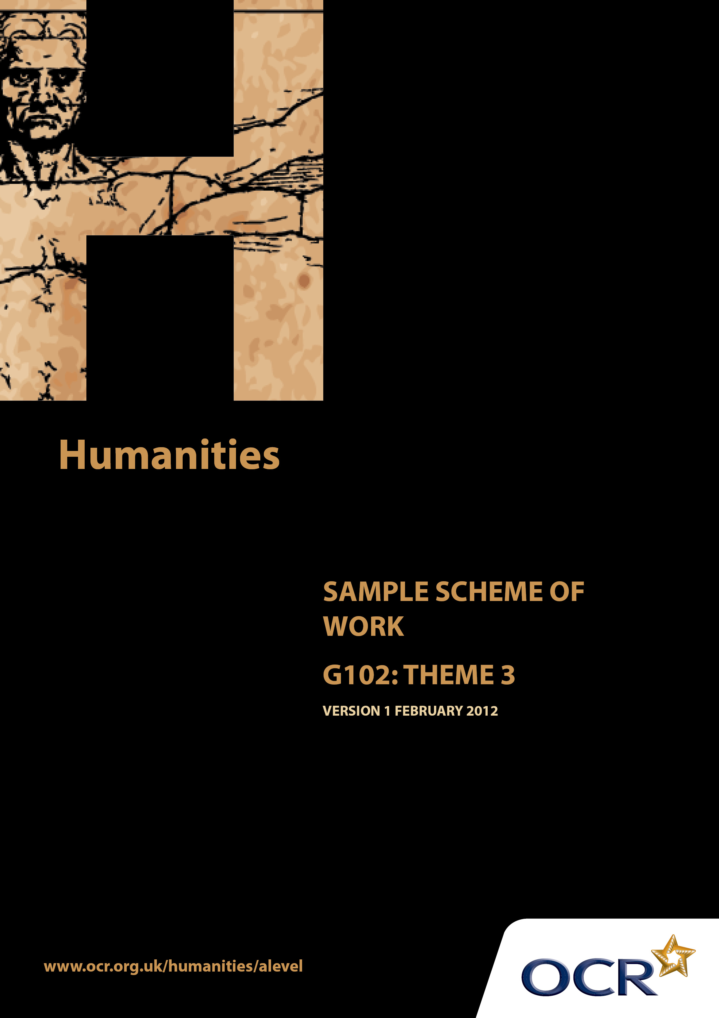
TWENTY FIRST CENTURY SCIENCE SUITE
SCHEMES OF WORK AND LESSON PLANS
B1: You and your genes
VERSION 1.1 JULY 2011
Introduction
OCR involves teachers in the development of new support materials to capture current teaching practices tailored to our new specifications. These support materials are designed to inspire teachers and facilitate different ideas and teaching practices. Each Scheme of Work is provided in Word format – so that you can use it as a foundation to build upon and amend the content to suit your teaching style and students’ needs.
The Scheme of Work provides examples of how to teach this unit and the teaching hours are suggestions only. Some or all of it may be applicable to your teaching.
The Specification is the document on which assessment is based and specifies what content and skills need to be covered in delivering the course. At all times, therefore, this Support Material booklet should be read in conjunction with the Specification. If clarification on a particular point is sought then that clarification should be found in the Specification itself.

Sample Scheme of Work
GCE Humanities
G102: People, community and power
Theme 3: Rights, responsibilities and justice in democratic societies

Suggested Teaching Time: 15 Hours

Aims of the whole unit

The idea of a “natural” fit between an ethnically homogeneous nation and a national territory is a recent notion in historical terms. The concept of the nation state, with a shared national culture, arose in the 18thand 19 ^{th} centuries. In contemporary societies religious and ethnic diversity is regarded as the norm. Both of these situations are the result of complex historical processes which are explored in this unit.

Content of this theme

This third theme explores the nature of contemporary democracy, and the balancing of rights and responsibilities in modern democratic societies, focussing on the United Kingdom. The theme continues by considering citizens’ and governmental responsibilities as the backdrop for a examination of socio-economic inequalities and equality before the law.

Teaching this unit

Conceptually this unit is based on an understanding of changes taking place through a period of time. There are links between this unit and unit G101 which will need to be made apparent to candidates to promote coherence in learning. A wide range of skills will be needed to study this unit.

The unit will particularly develop skills 3, 4, 5, 6, 7 and 8 listed on page 4. As assessment will be through questions based on previously unseen sources it will be especially important for candidates to become confident in analysing and evaluating source material in the light of subject specific knowledge.

The function of expanded content

The specification is arranged around key ideas which appear in the ‘Key concepts, ideas and terms’ column. This gives the emphasis and focus of what candidates need to learn. The expanded content is designed to provide material suitable for teaching the concepts, and it also forms the context in which the concepts will be examined.

Topic outline | Suggested teaching and homework activities | Suggested resources | Points to note
Introduction to the Theme  Upholding rights in a democratic society | Students could be provided with the essential information relevant to this unit/theme. This could include a brief summary of the strands within the theme, an overview of assessment, homework requirements and a reading list (if required).  Starter: Invite students to write down one of their human rights on a post-it note. Do the rest of the class agree that each of these are rights?  What are rights? Where do they come from? Brief consideration of different views. Origin of rights could be researched by splitting students into groups based on time periods and presented to the class, using the National Archives website.  Examine different examples of human rights legislation. What are the main shared points? Are they all genuine rights?  Explain the origin and history of European human rights law and its link to British Law.  Use case studies to explore the implications of the European legislation. (worksheet 1)  Discussion activity-should the human rights act be revoked?  Homework: Students write a balanced argument in preparation for class debate. | Summary information about:  UN Declaration of Human Rights, Human Rights Act 1998, European Convention on Human Rights, European Court of Human Rights - effect on UK Law  http://www.nationalarchives.gov.uk /humanrights/  Gives a helpful historical perspective on human rights beginning with the Magna Carta.  http://www.un.org/events/humanrights/  Gives a summary of the key points of the UN declaration. .You may need to paste this link into Google.  http://en.wikipedia.org/wiki/ European_Convention_on_Human_Rights  Gives a summary article by article  http://en.wikipedia.org/wiki/ Human_Rights_Act_1998  Gives a clear account of the 1998 Human Rights Act as well as some cases  http://www.yourrights.org.uk/ the liberty website also Provides useful summaries in relation to British Law  Worksheets 1 & 2 | Teachers will need to explain the focus of study as acquiring skills. The skills development document gives more guidance on teaching this area. Although acquiring knowledge and understanding of content is essential, the focus of the examination will be on applying skills to unseen material within the contextual area rather than demonstrating familiarity with the specific resources identified in this scheme of work.  Students do not necessarily need a detailed philosophy of human rights but a brief awareness of the main views may help them to see context. (see worksheet 2)

Topic outline | Suggested teaching and homework activities | Suggested resources | Points to note
Different Types of democracy  Direct Democracy – small scale societies or organisations, referenda in large scale societies  Representative Democracy – e.g. Parliamentary and Presidential systems | Teacher issues notes on the two types of democracy: direct and representative, and explains their history. Where might direct democracy still be used?  Research activity on representative democracy. Half the class research UK Parliamentary system and half look at US presidential system, exploring for example:  - How are laws made?  - How are elections run?  Students present findings. The next lesson could start with a quick quiz to check learning.  ‘It has been said that democracy is the worst form of government except all the others that have been tried.’ (Winston Churchill)  Use quote on board from Churchill to stimulate discussion. How far is this the case?  Explain Plato’s simile of the ship. How far is this a good criticism of democracy? (worksheet 3)  Homework: Produce a reasoned case arguing for or against representative democracy | http://www.historylearningsite.co.uk/ democracy.htm  Provides a very basic guide to the differences between direct and representative democracy in a British context.  http://www.bbc.co.uk/history/ancient/ greeks/greekdemocracy  Gives an account of the direct democracy of the Greeks. If link is troublesome you can click through to Greek Democracy – The democratic experiment by Professor Paul Cartledge  http://www.idebate.org/debatabase/  Search A-Z topic database index for Democracy  Gives the pros and cons of arguments concerning democracy  http://direct-democracy.geschichte-schweiz.ch/  An interesting article on how a form of direct democracy is still used in Switzerland today  http://www.electoral-reform.org.uk/voting-systems/ Gives an overview of the UK system and various alternative voting options  Worksheet 3  http://www.positech.co.uk/democracy/  There are 2 excellent games that simulate running the country. The demo is free and a full version can be downloaded. They are realistic and interactive and could support various parts of the topic

Topic outline | Suggested teaching and homework activities | Suggested resources | Points to note
Citizens’ and government’s responsibilities  Citizens’ responsibilities including  - Voting  - Jury service  - Acting within the law  - Payment of taxes  Government responsibilities including  - Raising taxes to provide services  - Providing accessible justice  - Handling international relations | Ask students to imagine that they are shipwrecked on an island and have to set up a society from scratch. What laws might they have? What rights would they expect? What responsibilities would each individual have? Each small group could produce a poster about how they have set up their society that would provide a backdrop to this topic  Look at the duty to vote- video clip stimulus. What are the arguments that are used for not voting?  Class discussion: How far are they convincing? Should voting be compulsory?  Jury trial: watch extracts of 12 angry men. Consider the advantages and disadvantages of trial by jury  Homework: Consider Jury Service. Research and present. What is the law on jury service? What are the advantages and disadvantages?  Government taxation and services. How is money raised and spent? How fairly is this done? Discussion should form a nice link into the next topic. Students discuss the figures. What surprises them most?  Taxes – Use case studies. These could be compiled from the news. Which of these individuals have failed to do their duty? If a citizen disagrees with government defence policy is it right to withhold taxes? Is acting within the law a duty regardless of situation? | http://www.youtube.com/watch?v =2pxJ-pda3uM&feature=related  http://www.youtube.com/watch?v =zruGBWLk9s8&feature=related  youtube clips from campaigns to encourage people to vote.  Film: 12 Angry men  www.sixthformlaw.info  Considers advantages and disadvantages of jury trial and contains a number of pages on juries that can be accessed by a search of the site  http://www.hm-treasury.gov.uk/budget2010_graphics.htm  Provides an overview of how money is raised and how it is spent. Other interesting taxation and public spending material on this site.  http://www.youtube.com/watch? v=H2pVngostcs&feature=related  The ‘ethicsonline’ channel features author Joe Jenkins attempt to withhold taxes as an objection to the war in Iraq. First 10 minutes particularly helpful

Topic outline | Suggested teaching and homework activities | Suggested resources | Points to note
Socio-economic inequalities  Contrasting views on taxes and universal welfare:  social democratic libertarian/neoliberal  Rawls’ veil of ignorance and idea of fairness  J S Mill’s idea of non-harm | Discussion tasks to act as stimulus: ‘Wayne Rooney deserves to keep all the money he has earned.’ ‘Frank Gallagher (character from ‘Shameless’) needs government money to support him.’ This should set the context of taxation and welfare quite nicely  Outline of the contrasting views of Robert Nozick and John Rawls on welfare. (worksheet 4)  Review desert island activity in the light of Rawls veil of ignorance. Consider Rawls ideas of fairness and equality of opportunity. How far can this be achieved in practice?  The discussion could be updated with reference to the NHS or the American context of Obama’s health bill vs. Tea Party critics  Homework: Students consider the ideas expressed in this topic, and then prepare arguments for class debate on the question ‘Should taxation be increased or decreased? Why?’  Introduce Mill’s principle of non-harm. This could be linked to the Hart-Devlin debate (see below) Produce a venn diagram showing overlap of liberty and harm. What should governments allow? Use worksheet 5.  Give background to Hart –Devlin debate on homosexuality  Outline the two contrasting approaches to legalisation of homosexuality: legal moralism (Devlin) and legal positivism (Hart)  Research task – what arguments were used?  Homework: Write an article arguing for a new law to be introduced or an existing law to be changed based on Mill’s ideas. This leads into theme 4. | http://www.woldww.net/classes/Political_Ideas/ Notes%20on%20Rawls%20and%20Nozick.html  Basic notes on the distinction between Rawls and Nozick. Students can find out about Wilt Chamberlain (Nozick’s original case study) by searching on youtube + Wikipedia  www.sixthformlaw.info  Select law and justice for good outline of Rawls ideas  http://bigthink.com/ideas/40323  A video presentation explaining Nozick’s libertarian argument  Exploring Ethics by Jones, Haywood & Cardinal is a pack of resources for ethical debate. The activity ‘Planet Thera’ is designed to replicate Rawls idea of the veil of ignorance  http://www.lawteacher.net/criminal-law/essays/mills-harm-principle.php  An essay outlining and assessing Mill’s non-harm principle  Worksheets 4 and 5 | Rawls argues that justice is whatever we would agree to from behind the ‘veil of ignorance,’ ie not knowing what our own situation or place in life would be.  Mill is a libertarian in the sense that the government should only legislate or intervene if harm is caused to another individual through an act.  Note that the discussion of homosexuality is not to do with morality. Hart is arguing that regardless of questions of morality, homosexuality should not be illegal as the law’s business is merely to prevent harm  Legal moralism – law enforces society’s moral standards vs Legal Positivism – laws are human creations for greater good

