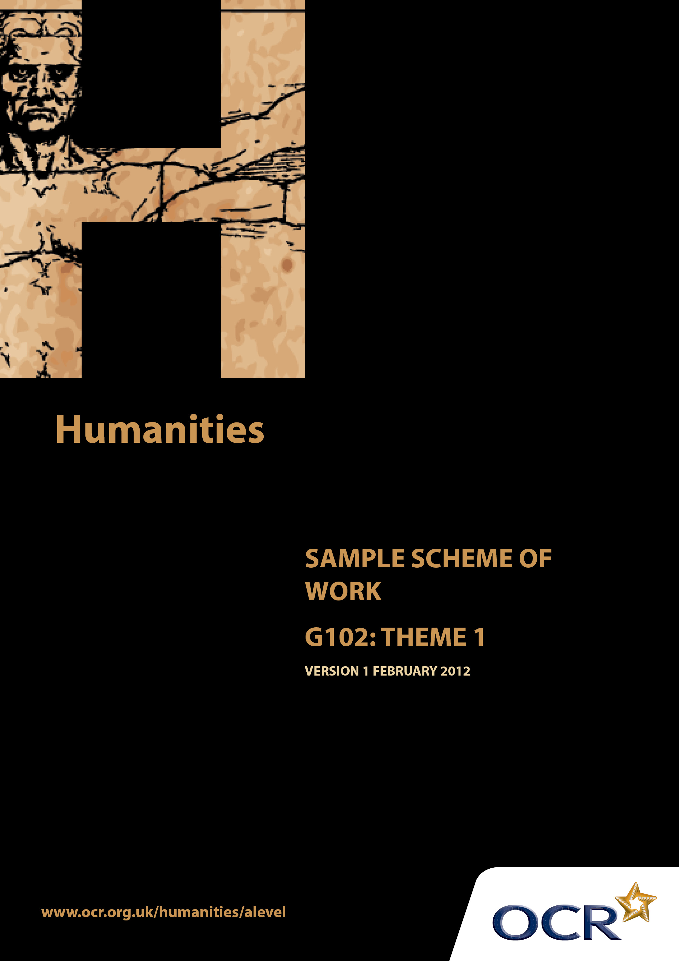
TWENTY FIRST CENTURY SCIENCE SUITE
SCHEMES OF WORK AND LESSON PLANS
B1: You and your genes
VERSION 1.1 JULY 2011
Introduction
OCR involves teachers in the development of new support materials to capture current teaching practices tailored to our new specifications. These support materials are designed to inspire teachers and facilitate different ideas and teaching practices. Each Scheme of Work is provided in Word format – so that you can use it as a foundation to build upon and amend the content to suit your teaching style and students’ needs.
The Scheme of Work provides examples of how to teach this unit and the teaching hours are suggestions only. Some or all of it may be applicable to your teaching.
The Specification is the document on which assessment is based and specifies what content and skills need to be covered in delivering the course. At all times, therefore, this Support Material booklet should be read in conjunction with the Specification. If clarification on a particular point is sought then that clarification should be found in the Specification itself.

Sample Scheme of Work
GCE Humanities
G102: People, community and power. Theme 1: Conflict and coexistence

Suggested Teaching Time: 15 Hours

Aims of the whole unit

The idea of a “natural” fit between an ethnically homogeneous nation and a national territory is a recent notion in historical terms. The concept of the nation state, with a shared national culture, arose in the 18thand 19 ^{th} centuries. In contemporary societies religious and ethnic diversity is regarded as the norm. Both of these situations are the result of complex historical processes which are explored in this unit.

Content of this theme

This theme covers the origins of nation states, and the processes which have shaped the national boundaries which we see today. This leads to consideration of the phenomenon of nationalism, and the ways in which conflicts between these nation states can be resolved. The final section of this theme considers the diverse nature of current society, historically rooted as it is, and the ways in which peace can be fostered between different groups.

Teaching this unit

Conceptually this unit is based on an understanding of changes taking place through a period of time. There are links between this unit and unit G101 which will need to be made apparent to candidates to promote coherence in learning. A wide range of skills will be needed to study this unit.

The unit will particularly develop skills 3, 4, 5, 6, 7 and 8 listed on page 4. As assessment will be through questions based on previously unseen sources it will be especially important for candidates to become confident in analysing and evaluating source material in the light of subject specific knowledge.

The function of expanded content

The specification is arranged around key ideas which appear in the ‘Key concepts, ideas and terms’ column. This gives the emphasis and focus of what candidates need to learn. The expanded content is designed to provide material suitable for teaching the concepts, and it also forms the context in which the concepts will be examined.

Topic outline | Suggested teaching and homework activities | Suggested resources | Points to note
Introduction to the Theme  How nation states emerged and their relationship with conflict.  The origins of the political concepts we use today.  - Nation State  - Republic  - Self-determination  - Monarchy | Students could be provided with the essential information relevant to this unit/theme. This could include a brief summary of the strands within the theme, an overview of assessment, homework requirements and a reading list (if required).  Teachers will need to think carefully about the amount of detail students are provided with (or develop themselves) in relation to each area/example of concepts or processes. It is important that teaching concentrates on using sources wherever possible to illustrate the topics under consideration and does not seek to overload students with too much factual detail.  Students need to have a clear understanding of the 4 key concepts. Students could work in small groups to discuss and produce definitions.  Teacher provides A4 hand-out with definitions of 4 key concepts extracted from sources. Students identify similarities and differences compared to the definitions they have produced.  Question for class discussion – Is it possible to produce definitive statements about these types of concepts?  Focus question: To what extent is it true that the modern nation-state was born out of the ideas that fuelled the French and American Revolutions? Whole class discussion could highlight key ideas underpinning the Revolutions, contributing to a summary sheet based on the resource. | Re Nation State  http://www.thenationstate.co.uk/index.html  Re Ideas leading to nation state  http://www.historyhaven.com  You may need to type this link in and then click through to the relevant time period – site addresses can change  Re Self-determination  http://legalsutra.org/1172/self-determination/  This site is blocked by some systems  Re Republic  www.civiced.org/papers/political.html  Re Monarchy  www.britannica.com/EBchecked/topic/388855/monarchy/272133/Monarchy-in-the-modern-era?anchor=ref953937  Teacher resource suitable for use in preparing summary sheet  http://www.historyhaven.com  You may need to type this link in and then click through to the relevant time period – site addresses can change | Teachers will need to explain the focus of study as acquiring skills. The skills development document gives more guidance on teaching this area. Although acquiring knowledge and understanding of content is essential, the focus of the examination will be on applying skills to unseen material within the contextual area rather than demonstrating familiarity with the specific resources identified in this scheme of work.  It is hoped that much of the teaching of this theme can be done through sources.

Topic outline | Suggested teaching and homework activities | Suggested resources | Points to note
 | Students in discussion could identify the most important idea in their view. This would encourage them to start prioritising ideas and this would in turn force them to argue and defend their choices thus helping them to develop a vital skill.  Homework: Students write individual essays in response to the question posed.  The impact of revolution on the role of the Monarch. Teacher provides simple A4 hand-out containing key facts and figures and talks through this with students showing how the hand-out could be used as a starting point for the next exercise.  Teacher provides a 20 Point ‘True or False’ quiz sheet on the events/impact of events in Europe on the UK. Students produce a timeline with key events and effects.  The emergence of Constitutional Monarchy. Teacher provides simple A4 hand-out containing key facts. Students could note the powers of the monarch before and after the reform.  Essay preparation: Does the nation-state really exist? Teacher presents students with the 4 key arguments which the article uses to challenge received wisdom. Students review all the information so far gathered in the light of these claims.  Homework: Students produce an essay for homework to argue for or against the thesis. | New Political Ideas and Revolutions  http://www.bbc.co.uk/history/british/empire_seapower/revolution_01.shtml#two  This online article is a review of the impact of the French Revolution on UK politics leading to reform not revolution.  A4 Teacher produced hand-out from online article  20 Point ‘True or False Quiz’  http://www.royal.gov.uk/MonarchUK/HowtheMonarchyworks/History%20and%20background.aspx  http://www.lancs.ac.uk/fass/sociology/papers/walby-mythofthenationstate.pdf  - There are more nations than states.  - Several key examples of supposed nation-states at their most developed were actually Empires.  - There are diverse and significant organisations in addition to nation-states, including the European Union (EU) and some organised religions.  - Despite the popular myth of the nation state having sole control, sovereignty, over a certain territory, there are in fact many overlaps. This means that the economic, political and cultural aspects of nation-states often go beyond the neat boundaries that are sometimes given to them.  Student-friendly markschemes could be used. | Sections on French and American Revolutions  From the online article, use Template for Change (first section) and later sections Revolutionary Activities and Parliamentary Reform for data to produce hand-out  Section 2 presents a clear resume of development of and role of monarch in constitutional monarchy.  Could be used as is.  The article goes on to develop these points with detailed examples.  Peer assessment against the marking criteria may be a useful tool.

Topic outline | Suggested teaching and homework activities | Suggested resources | Points to note
Why the processes of nation state formation can result from or result in conflict.  - Unification  - Decolonisation  - Secession  - Sovereignty  - Nationalism | Students need to have a clear understanding of the 5 key concepts. Students could work in small groups to discuss and produce definitions based on the listed resources. Each group researches a different concept.  Whole class discussion to agree definitions and produce a joint A4 hand-out with definitions extracted from sources.  Students could be divided into 5 pairs/groups to work on case studies based around each of the concepts. The focus will be to identify and evaluate the positive and negative impact each of the concepts has on the process of state formation. The resources identified are merely a starting point. Further group research should be undertaken using these sources as a jumping off point.  Students are to present their findings to the rest of the group in an innovative way using film, ICT, report, animation. | Unification  Basic review of German process  http://www.sparknotes.com/history/european/1871/section4.rhtml  Basic review of Italian process  http://www.sparknotes.com/history/european/1871/section3.rhtml  Decolonisation  UN declaration 1960  http://untreaty.un.org/cod/avl/ha/dicc/dicc.html  Secession  Guardian article on who should be allowed to vote in referendum on secession from the UK  http://www.guardian.co.uk/politics/2011/may/20/scottish-independence-all-vote-stick-together  Sovereignty  First page definition of term  http://www.alaindebenoist.com/pdf/what_is_sovereignty.pdf  Nationalism  A brief introduction  http://regentsprep.org/regents/global/themes/nationalism/index.cfm  Unification/Secession  http://www.npr.org/2011/03/17/134602534/a-divided-italy-prepares-for-unification-anniversary  http://tamilnation.co/selfdetermination/fourthworld/treanor.htm#Introduction  http://www.guardian.co.uk/politics/2011/may/20/scottish-independence-all-vote-stick-together  Decolonisation  http://www.bbc.co.uk/history/british/modern/endofempire_overview_01.shtml | There are political and social tensions around the key concepts identified in this section. They not only facilitate the formation of nation-states but also have the potential to fragment existing states leading to conflict and civil war.

Topic outline | Suggested teaching and homework activities | Suggested resources | Points to note
 | This source argues that there is an optimum geographical and population size for states and major advantages to be gained for secession into smaller geographical units.  Students review all the information so far gathered in the light of these claims.  Homework: Students produce an essay to argue for or against the thesis that there is an optimum size for states.. | http://www.let.leidenuniv.nl/history/migration/chapter8.html  Sovereignty  http://www.alaindebenoist.com/pdf/what_is_sovereignty.pdf  http://www.euromove.org.uk/index.php?id=6505  Nationalism  http://plato.stanford.edu/entries/nationalism/  http://reality.gn.apc.org/polemic/antina.htm  http://www.utne.com/Politics/Argument-for-Secession-Kirkpatrick-Sale.aspx?page=2

Topic outline | Suggested teaching and homework activities | Suggested resources | Points to note
Fostering peace between and within nation states.  The organisations that have grown up to foster peace and co-operation.  - Supra-national institutions  - United Nations  - European Community | Students need to have a clear understanding of the key concept of supra-national institutions before they look at concrete examples.  Teacher Resource: Simplified A4 hand-out teacher with definition from resource. Students could work individually to answer question ‘What is a Supra- national institution (SNI)?”  Using a selection of slides from the resource teacher could lead group discussion to achieve an understanding of what an SNI is.  Focus question: What is the contribution of SNI to fostering co-operation and peace?  Use a teacher resume of the two resources showing how the SNI has taken over some of the powers and functions previously exercised by nation-states. Students could produce an analysis of the potential advantages and disadvantages of this process leading to a personal conclusion with arguments to justify their point of view.  What is the impact of SNIs on nation-states? Using the example provided students could research other cases where nation-states are being pressured to change their ways. Possibly produce a collage to demonstrate the range of issues identified. | http://www.eclac.org/brasil/noticias/paginas/2/22962/BEST-SUPRANATIONAL%20INSTITUTIONS%20AND%20REGIONAL%20INTEGRATION.pdf  List of 10 SNI financial institutions.  http://www.aciforex.org/gb/useful-links.cfm?cat=Supranational_Institutions  This link goes to a 36 slide presentation  http://www.eclac.org/brasil/noticias/paginas/2/22962/Best%20-%20Supranational%20Institutions.pdf  http://www.un.org/en/peacekeeping/operations/success.shtml  http://www.civitas.org.uk/eufacts/OS/OS11.htm  Example of a state being put under pressure to change their ways  http://www.lifesitenews.com/news/polish-abortion-laws-targeted-by-supranational-institutions/ | Detailed 45 page PDF. Pages 2 and 3 Section1. 1 What do we mean? Especially useful  UN produced commentary on peacekeeping successes  Policing as an SNI in the EU

Topic outline | Suggested teaching and homework activities | Suggested resources | Points to note
The United Nations | The origins of the United Nations Organisation  How and why was the UN brought into existence? Teacher produced resource on the reasons and events leading to the establishment of the UN. Students could produce their own timeline and an explanation of why many countries were prepared to support politically and financially an organisation which could seriously limit their own national sovereignty.  What did the UN set out to achieve? Students could use the websites to do their own research on what the UN set out to do and how they set themselves up to do it. They should limit the scope of their research to these two points and avoid moving into an analysis of success/failure. The individual research could be combined into two collective documents listing aims and methods.  How successful has the UN been in achieving its aims? Teacher resource: extract a hand-out of successes and failures clearly attributing sources. Students to decide individually whether the UN should be seen as a resounding success or a miserable failure? Students produce a short statement to support their view with reference to the evidence and an analysis of the reliability of the sources used. | http://www.un.org/en/index.shtml  http://www.un.org/en/aboutun/history/index.shtml  http://www.bbc.co.uk/history/worldwars/wwone/league_nations_01.shtml  Comparison of League of Nations and UN particularly focussing on the peacekeeping role.  http://www.historylearningsite.co.uk/united_nations1.htm  Wide ranging brief analysis of many areas of the UN. Also a straightforward description of UN organisation.  http://mirror.undp.org/liberia/challenge.PDF  A short review of the UNs successes and failures.  http://www.un.org/en/peacekeeping/operations/success.shtml  UN commentary on peacekeeping successes.  http://dilipchandra12.hubpages.com/hub/Successes-and-Failures-of-the-United-Nations  List of successes and failures. | The UN home page with links to all information and publications  Very brief chronology of events leading to establishment of UN. “Milestones” section has useful timeline of key events in more detail.

Topic outline | Suggested teaching and homework activities | Suggested resources | Points to note
The European Community | The origins of the European Community  How and why was the European Community brought into existence? Teacher produced resource on the reasons and events leading to the establishment of the EC. Students could produce their own timeline and an explanation of why many countries were prepared to join politically and financially an organisation which would seriously limit their own national sovereignty.  How successful has the EC been in achieving its aims? Teacher resource: extract a hand-out of successes and failures clearly attributing sources. Students to decide individually whether the EC should be seen as a resounding success or a miserable failure? Students produce a short statement to support their view with reference to the evidence and an analysis of the reliability of the sources used. | http://europa.eu/about-eu/eu-history/index_en.htm  Short history of the EC.  http://www.dadalos-europe.org/int/grundkurs4/eu-struktur_3.htm  Deals with the structure of EC institutions at various levels.  http://www.civitas.org.uk/eufacts/OS/OS3.htm  Review of the EC to the present day  http://news.bbc.co.uk/1/hi/world/europe/3583801.stm  A timeline of the EC to 2007  http://www.historylearningsite.co.uk/  Search this site using European Union. Wide ranging brief analysis of many areas of the EC.  http://ec.europa.eu/publications/booklets/eu_documentation/05/txt_en_3-2.pdf  Statistics on how citizens view the EC.  http://ec.europa.eu/public_opinion/archives/ebs/ebs_251_en.pdf  Detailed document on EC success and failure
Origins of diversity within modern nation states.  - Diversity  - Devolution  - Secularism  - Multiculturalism | Students need to have a clear understanding of the 4 key concepts. As before students could work in small groups to discuss and produce definitions based on information in resources. | https://qmro.qmul.ac.uk/jspui/handle/123456789/587  Outlines the issues raised by social diversity for a nation-state  http://www.historylearningsite.co.uk/devolution.htm  Good straightforward introduction to devolution  http://www.bbc.co.uk/religion/religions/atheism/types/secularism.shtml  Good statement of what secularism is and what it wants  http://news.bbc.co.uk/1/hi/uk/3600791.stm  A number of definitions by individuals about what multiculturalism is

Topic outline | Suggested teaching and homework activities | Suggested resources | Points to note
Diversity – examples of historical processes leading to diversity | How have nation-states with their emphasis on homogeneity become diverse societies?  Students could be divided into groups to work on the three case studies indicated in the specification. The focus would be to identify the how and why diversity has become part of the nation-state. The resources identified are merely a starting point. Further group research should be undertaken using these sources as a jumping off point.  The end product should be a report presented by each group. This should lead to whole group discussion to attempt to achieve a conclusion on the original question posed. | Slavery (e.g. the USA)  http://www.slaveryinamerica.org/history/overview.htm  Detailed site on the history of the slave trade and the US  http://innercity.org/holt/slavechron.html  A timeline of events about US slavery  Settler Migrations (e.g. South Africa)  Two short accounts of the struggle between British and Boers leading great trek  http://myweb.tiscali.co.uk/kenanderson/histemp/boersouthafrica1.html  http://www.southafrica-travel.net/history/eh_menu.htm  Post-war labour shortages (e.g. UK)  Two brief surveys of post war immigration  http://www.nationalarchives.gov.uk/pathways/citizenship/brave_new_world/immigration.htm  http://www.migrationwatchuk.org/Briefingpaper/document/48

Topic outline | Suggested teaching and homework activities | Suggested resources | Points to note
Ideas which have been used to foster peaceful co-existence and reduce conflict  Devolution | How and why was devolved government introduced in the UK? Teacher produced resource on the reasons and events leading to the establishment of devolution. Students could produce their own timeline and an explanation of why the UK was prepared to weaken its national sovereignty. Individual students could conclude by making a judgement that devolution was/was not a sensible way forward for the long term future of the UK. | http://news.bbc.co.uk/1/hi/uk_politics/election_2010/first_time_voter/8589835.stm  BBC claims this is a beginner’s guide. Could be the basis of teacher resource.  http://www.direct.gov.uk/en/Governmentcitizensandrights/UKgovernment/Devolvedgovernment/DG_073306  Student resources  UK government view  http://www.scotland.gov.uk/About/18060/11550  Scottish government historical view  http://www.guardian.co.uk/uk/2011/oct/11/devolution-english-voters  English reaction to devolution
Secularism | How does secularism foster peaceful co-existence and reduce conflict? Students should already have a working definition of the term. Using the details of the French attitude towards distancing religion and the state they should identify what the potential problems can be if religion has a powerful role in government.  There is a vocal body of opinion in Britain that believes that the French approach to the separation of religion and the state should be replicated here. Students should research the validity of these demands and come to a conclusion as to whether they are necessary or desirable. A mock parliamentary debate could be organised to decide the issue. | http://h2g2.com/dna/h2g2/A2903663  Survey of the French secular state with the historical reasons for it  http:// http://www.secularism.org.uk/what-is-secularism.html  The secular view  http://www.anglican-mainstream.net/  The religious view  http://www.ekklesia.co.uk/content/news_syndication/article_051114faith.shtml  Report of results of a BBC opinion poll on religion. Is it really an issue?

Topic outline | Suggested teaching and homework activities | Suggested resources | Points to note
Multi-culturalism | Can multi-culturalism exist within a nation-state? Teacher resource identifying the major issues outlined in the source especially in relation to the UK. Students use the resource to make a preliminary judgement yes or no.  Using the three sources students could examine the views expressed on multi-culturalism and evaluate which, if any, carry the most weight. They could prepare a report on their conclusion which would be shared with the whole group leading to an individual and/or a collective answer to the question. | http://unesdoc.unesco.org/images/0013/001387/138796e.pdf  Detailed survey of what multiculturalism is and its impact on nation states. Section on Britain  http://www.bbc.co.uk/news/uk-politics-12371994  PM speech ‘State Multiculturalism has failed’ 2010  http://news.bbc.co.uk/1/hi/uk/3600791.stm  So what is multiculturalism? Definitions from the great and the good  http://www.guardian.co.uk/commentisfree/2011/apr/26/multiculturalism-debate-british-values-culture  A response to the PM

