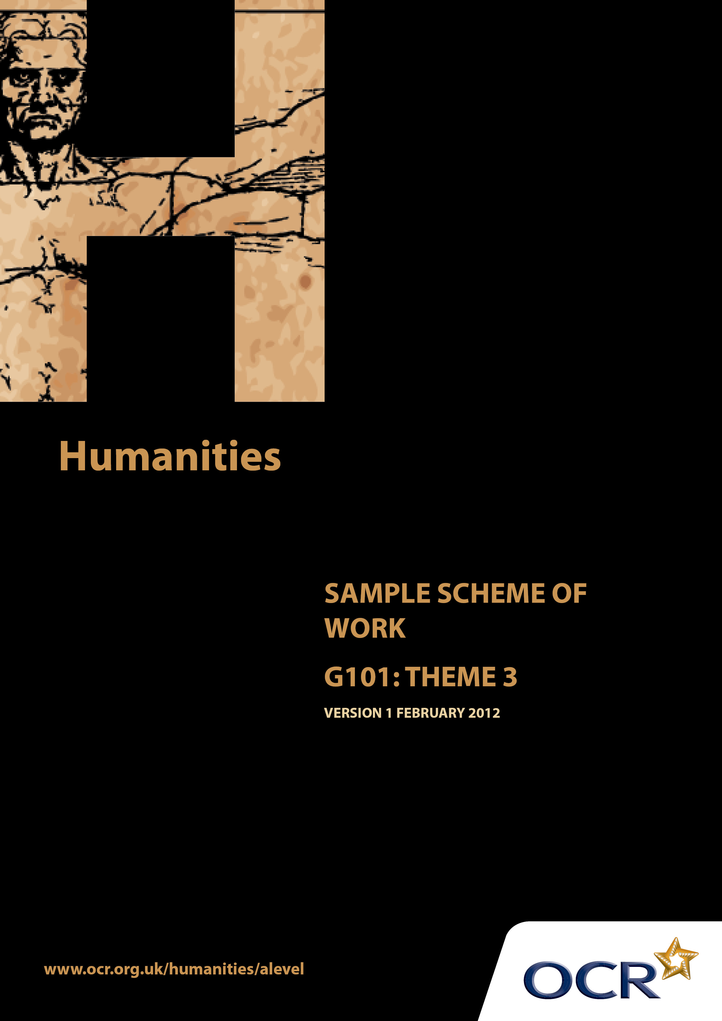
TWENTY FIRST CENTURY SCIENCE SUITE
SCHEMES OF WORK AND LESSON PLANS
B1: You and your genes
VERSION 1.1 JULY 2011
Introduction
OCR involves teachers in the development of new support materials to capture current teaching practices tailored to our new specifications. These support materials are designed to inspire teachers and facilitate different ideas and teaching practices. Each Scheme of Work is provided in Word format – so that you can use it as a foundation to build upon and amend the content to suit your teaching style and students’ needs.
The Scheme of Work provides examples of how to teach this unit and the teaching hours are suggestions only. Some or all of it may be applicable to your teaching.
The Specification is the document on which assessment is based and specifies what content and skills need to be covered in delivering the course. At all times, therefore, this Support Material booklet should be read in conjunction with the Specification. If clarification on a particular point is sought then that clarification should be found in the Specification itself.

Sample Scheme of Work
GCE Humanities
G101: Human Society and the natural world. Theme 3: Natural Resource Depletion, Ecological Damage and Environmental Crisis

Suggested Teaching Time: 15 Hours

Aims of the whole unit

This unit is about the way human society and the natural world inter-relate. It explores: changes that human society has made to the natural world; ways that environment has influenced man; attempts to recognise the importance of the natural world and to act appropriately in order to retain the natural heritage.

Content of this theme
By the mid 20th century there was an increasing understanding of the impact of human society on the natural world. Doom laden predictions alongside optimism linked to advances in science and technology led to a range of viewpoints and actions. Environmental awareness on an international scale has led to written publications, international conferences, national and international conservation movements. There is also interest at a local level. Opposing views champion progress with less regard for the natural environment with science and technology acting as the medium to facilitate change and ameliorate damage.

Teaching this unit

Conceptually this unit is based on an understanding of changes taking place through a period of time. It also involves some degree of spatial awareness with studies ranging in scale from local to global. There are links between this unit and unit G102 which will need to be made apparent to candidates to promote coherence in learning.

The unit will particularly develop skills 3, 4, 5, 6, 7 and 8 listed on page 4. As assessment will be through questions based on previously unseen sources, it will be especially important for candidates to become confident in analysing and evaluating source material in the light of subject specific knowledge.

The function of expanded content

The specification is arranged around key ideas which appear in the ‘Key concepts, ideas and terms’ column. This gives the emphasis and focus of what candidates need to learn. The expanded content is designed to provide material suitable for teaching the concepts, and it also forms the context in which the concepts will be examined.

Topic outline | Suggested teaching and homework activities | Suggested resources | Points to note
Introduction to the Theme  Changing attitudes to the natural world  Increasing awareness of the environment has changed human perspectives and approaches over the last 200 years. | Students could be provided with the essential information relevant to this unit/theme. This could include a brief summary of the strands within the theme, an overview of assessment, homework requirements and a reading list (if required).  Produce a ‘road map’ through time of how and why perceptions of the environment have changed over time. Students to be provided with, and research themselves, a variety of articles, websites and texts that demonstrate the key changes outlined below. Students to use a variety of images and key words on their road maps, share findings: e.g.  19th Century: Understanding of species diversity increases: London Zoological Society is founded in 1826, London Zoo open in 1928. Reactions to the growth of cities, industrialisation, worsening water and air pollution. Introduction of the British Alkali Act of 1863 to regulate hydrochloric acid gases from soda ash production to the River Pollutions Act of 1876 due to chemical and human waste disposal into waterways. Growth of individuals and societies interested in environmental conservation such as William Morris and John Ruskin: the first green socialists. In 1889 the RSPB was formed to counter the large scale extermination of birdlife for plumage in women’s hats. Wild Birds Protection Act 1880.  Early 20th century: National Parks and access to the Countryside Act of 1949 saw the protection and conservation of natural and semi-natural areas of the UK as well as the designation of a national network of SSSI’s (Sites of Special Scientific Interest). Town and Country Planning legislation was introduced/greenbelts in 1947 (and earlier). | Useful texts:  Neil Carter (2007) The Politics of the Environment: Ideas, Activism, Policies. Cambridge University Press.  Extracts from this books can be found on http://books.google.co.uk  Andrew Dobson (1991) The Green Reader, London. Routledge.  Zoological Society of London conservation: www.zsl.org/conservation  History of the RSPB: www.rspb.org.uk  History of Conservation in the UK: www.naturenet.net  Greenbelts: article Q&A England’s Green belt www.bbc.co.uk | Teachers will need to explain the focus of study as acquiring skills. The skills development document gives more guidance on teaching this area. Although acquiring knowledge and understanding of content is essential, the focus of the examination will be on applying skills to unseen material within the contextual area rather than demonstrating familiarity with the specific resources identified in this scheme of work.  General shifts over time include:  - Industrialisation to environmental regeneration/conservation.  - Environmental exploitation to environmental protection.  - Recognition/perception of risk to the natural world through human activities:  Include and use local changes and projects through time.

Topic outline | Suggested teaching and homework activities | Suggested resources | Points to note
 | Late 20th Century:  Introduction of the key term ‘sustainability’: Global awareness to reduce carbon emissions: The World Summit in Rio in 1992 , the Brundtland report and Kyoto Protocol global targets are set (see Theme 4 Sustainability). Capitalist driven backlash to environmental movements; unwillingness to compromise aspects of lifestyle,’ throw away’ society environmental movements, campaigns, NGO activity, political will. Different views between LEDC’s and MEDC’s. Shift from environmental exploitation to conservation: e.g. Draining the Fens for farming and its consequence for wetland birds habitats: The Great Fen Project. Or could refer to Trophy Hunting in Africa. | Great Fen Project: www.greatfen.org.uk  Article: Exploitation or Conservation: can hunting tourism industry in Africa be sustainable? www.environmentmagazine.org.

Topic outline | Suggested teaching and homework activities | Suggested resources | Points to note
Population and resources balance | Identify world population increase, growth and prediction figures. Think about how this data is collected, collated and calculated. (see specific section of suggested website). Consider how valid and reliable such ‘global’ data is.  Balancing resources and populations is an increasing challenge at different scales: global, national, regional and local. Examine the article: How can population growth and resources be brought into balance? Identify the problems, impacts and possible solutions.  Have a carousel activity of different evidence and sources at different scales to assess the documentation and trends of population and resources. e.g. UN population and resource trends (wall chart of data), governmental demographic policies such as China’s one child policy, Singapore’s 3+ policy, UK’s ageing population, France encourages a third child. NGO work e.g Oxfam, Water Aid, Greenpeace.  Malthus Model of population growth and food supply: understand this model (positive and negative checks). Compare with Boserup’s theory. Based on the evidence from the carousel activity, to what extent have these two theories/models already been proved correct? | Population counter:  www.worldometers.info This site is good – scroll down the front page to world ‘population clock: sources and methodology’.  Article: How can population growth and resources be brought into balance?  www.millennium-project.org  Population, environment and development 2001 wall chart: www.un.org/esa/population/publications  http://environment.about.com  Compare country statistics at www.cia.gov  Good summary of population policies in China and France: www.s-cool.co.uk/a-level/geograpgy/populationgrowth  Article: Combating environmental degradation: www.ifad.org  NGO’s: www.wateraid.org/uk  www.oxfam.org.uk  www.greenpeace.org.uk/  Clear understanding of Malthus and Boserup’s theories and evidence found on:  www.s-Cool.co.uk  Click to the A-level geography population section | Homocentrist view is that the environment and nature exists primarily to serve human needs. Students need to develop an understanding of how this view can affect the relationship between human society and the natural world.  See glossary definitions for:  Optimum population:  Over population:  Under population:

Topic outline | Suggested teaching and homework activities | Suggested resources | Points to note
Carrying capacity of natural systems. | Understand the term ‘Carrying Capacity’. Students can research a variety of different environments and compare the carrying capacity of chosen species within them e.g. Tropical Rainforest, Savanna, Arctic/Antarctic, Temperate, (UK), Mediterranean, Desert. Does the human race have a carrying capacity?  Students define and exemplify renewable and non-renewable resource. Determine which resources are ‘finite’ and ‘diminishing’ (in particular food and fuel). | Use Google to investigate different environments and/or species.
Predictions of environmental apocalypse | Environmental Apocalypse: understand the meaning of this term.  Watch the film ‘A crude awakening’ to draw together the use of fossil fuels, finite resources and projections for the future for society and the environment. | Summary of what Environmental Apocalypse is: www.oppapers.com/essays/Environmental-Apocalypse  You may need to paste this link into Google  Film: A Crude Awakening: The Oil Crash. (extracts are available on Youtube)

Topic outline | Suggested teaching and homework activities | Suggested resources | Points to note
Environmental destruction | As a result of the human interaction with the natural world, the environment is being destroyed. Students to complete independent research on one of the issues below and present their findings and conclusions to the rest of the group in a format of their choice(report, power point, video, news reel , essay etc).  The research should include a variety of source types: official statistics, images, cartoons, articles from magazines, newspapers, websites. As part of the presentation students need to produce a source bibliography and consider the provenance. Areas from specification:  - famine, despite the absence of global food shortages  - water, land and air pollution.  - depletion of fish stocks  - destruction of habitats  - loss of biodiversity  - species extinction and decline (statistic from UN reports)  - deforestation  - desertification  - climate change and the collapse of basic environmental services.  Once each presentation has been completed have a discussion/debate to consider: Can human society avert a catastrophe for itself? Write a structured essay, link in the mark scheme criteria for the G101 exam and use the sources as evidence. | Suggested case studies  Impact of predicted disruption of the North Atlantic ocean currents and weather systems  Essay: Mathew Hart (2003)‘The Greenland Pump’ in Granta 83, pp.77-94  Short Story: Maarten ‘t Hart (2003) ‘Midsummer in April’ Granta 83 pp.  Industrial fishing and the depletion of fish stocks: Mark Kurlanski (1999) Cod: A Biography of the Fish that Changed the World London: Vintage Books  Threats to key species e.g. bees  http://invasivespeciesireland.com/news/unep-report-highlights-threats-to-bees/ | Students only need to know ONE example of environmental destruction in detail.  Use the sample assessment material as guidance for exam technique and mark scheme levels.

Topic outline | Suggested teaching and homework activities | Suggested resources | Points to note
Understanding whether there is justification for forecasts of ultimate doom for human society. | Weighing up research outcomes – forecasting pessimism and optimism: Students consider whether they are a pessimist or optimist.  Draw an image of a glass half full of water: have a discussion regarding the characteristics of a person of each term, draw on examples from the students’ own experiences and label all ideas around the glass diagram.  Read the article ‘Pessimism vs Optimism’ and add notes to the glass diagram. How does a pessimist view an optimist and visa versa? | Article: Pessimism vs Optimism by Jeremy Dean, World of Psychology.  http://psycentral.com

Topic outline | Suggested teaching and homework activities | Suggested resources | Points to note
Attitudes to risk | Read the article to understand and set the scene of the psychological view of risk perception.  How do people perceive and accommodate known risks in their lives. Go to the HSE website and download a risk assessment template. Determine the risks for a working environment such as an office and complete the template. Compare with the example office risk assessment on the HSE website.  Highlight and understand the technological responses and health and safety legislation (Health and Safety at Work Act 1974) that is used in the UK/EU to reduce risks and hazards.  Containment measures: are measures put in place to reduce risk and hazards – they can be practical solutions of storage for fuels to hard engineered structures used to reduce environmental damage from an oil spill.  Refer to an up to date oil spill disaster: the causes, the social, environmental, political and economic impacts, hazards and risks e.g. BP Gulf of Mexico spill. Use Youtube clips of the news, newspaper articles etc: consider the different views, sensationalism, audience and language of the various articles.  Other ways of dealing with risk and hazards is to rationalise, ignore or misperceive the risk: such as ignoring evidence of damaging change, living in dangerous places by using technology to reduce risk.  Choose one known environmental hazard and assess and evaluate the different perception to it e.g. flood plains (a local area of development on a flood plain or prone to frequent flooding compared to Bangladesh), earthquake zones (San Francisco compared to Philippines). | Article: The Psychology of Risk Perception. Are We Doomed Because We Get Risk wrong? By David Ropeik (2010) www.psychologytoday.com  Health and Safety Executive (HSE): risk assessment s: www.hse.gov.uk/  A variety of completed RA’s are available premises such as a butchers, charity shop, convenience store, office, travel agent, estate agent, dry cleaners, hairdressing etc.  UK Laws and Legislation in the workplace:  www.hse.gov/legislation  EU Health and Safety directives:  http://osha.europa.eu/en/legislation/index  You may need to paste this link into Google  Search Youtube and Google for news articles and clips from a variety of media sources. E.g. BP Oil Spill in the Gulf of Mexico 2010. | The Kyoto Protocol is examined in Unit 4: Sustainability.

Topic outline | Suggested teaching and homework activities | Suggested resources | Points to note
Strategic planning at different scales. | Understand that there are strategies to cope with environmental risk at different scales such as:  Global environmental strategies: International agreements (eg The Kyoto Protocol: an international agreement to cut greenhouse gas emissions).  National political strategies e.g. China’s one child policy (to limit population growth), Antarctica Treaty (to have a zone free from nuclear waste and testing, to promote scientific cooperation and to not have territorial sovereignty).  Regional protection strategies eg North Sea coastal protection or river flood protection management (refer to a locally known area).  Produce a case study for each scale, citing sources as evidence. Analyse and evaluate the relative strategies. | Kyoto Protocol: www.unfccc.int/kyoto  News Article: China’s once-child policy – success or failure? www.bbc.co.uk  Antarctica Treaty: www.antarctica.ac.uk  Refer to the Local Council website, leaflets and literature for your chosen location. | Consider which examples lead to optimism: such as successful clean up operations, implementation of international agreements, reforestation, protecting species in zoos.  Consider which examples lead to pessimism: such as extinction of hundreds of species, permanent desertification; technology limited to rich e. g clean drinkable water on tap 24/7  Additional Sources:  Photo-essay Edward Burtynsky (2003) ‘The Evidence of Man’ in Granta 83 pp.95-127  Film: Al Gore (2006) An Inconvenient Truth
Responses to an increasing awareness of environmental issues.  Fostering values and practices that encourage awareness of the natural world. | Awareness of the natural world can be achieved through:  Political parties: The Green Party. Produce a manifesto document for the Green party. Use their website to research their core values, how and where they are represented in politics, and examples of how and where they have encouraged ecological awareness.  Work of individuals e.g. David Attenborough, Jonathan Porritt. Produce a summary autobiography about one of these people in terms of the impact they have to make society gain in environmental awareness. Use a variety of sources: iplayer programmes, websites, news and journal articles, extracts from biographies. | The Green Party: www.greenparty.org.uk  Jonathon Porritt blog: www.jonathonporritt.com/  David Attenborough:  BBC The Frozen Planet, The Blue Planet, Planet Earth, The Life of Mammals.

Topic outline | Suggested teaching and homework activities | Suggested resources | Points to note
Environmental activism. | Work of small, local groups (e.g. local environmental groups). Local community environmental activism: what is there in your local area? Where?, Why?, Who?, How?  This could be an opportunity to invite a guest speaker to present in your school/college, or for students to go to the local site on an organised visit. Students to prepare questions, interviews, participant observation. Maps, photos, sketch maps, notes, questionnaires used to record and present the information.  Work of organisations such as NGO’s e.g. WWF, Greenpeace, Friends of the Earth. Students need to have knowledge of one NGO of their choice which needs to include:  - Scale and size – International, national, local  - Funding – government, voluntary  - Purpose / benefits  - Specialist or general focus  - Campaign technique / publicity  - Participation of specialists / non- specialists.  Students could work in small groups to prepare the criteria above for their chosen environmental NGO, to present at a government meeting for funding of a grant. After all the presentations have a discussion and assessment to determine which NGO will receive the grant for the following year. | Use the local library, council and environmental agency sources.  Friends of the Earth: www.foe.co.uk  Greenpeace: www.greenpeace.org.uk  WWF: www.wwf.org.uk | To persuade others to bring about environmental change. It can take many forms such as writing letters, campaigning, petitioning, rallies, strikes, protests.  Search the web for a list of all environmental non-governmental organisations.

Topic outline | Suggested teaching and homework activities | Suggested resources | Points to note
Environmental protection.  Environmental conservation. | Ways of promoting protection in the countryside in the UK. For each of the following protection methods students to research and understand the following:  - location – national, regional and local context.  - funding – government, grants, fund raising, campaigns etc.  - which biodiversity/species is being protected and why.  - How is environmental awareness being increased – advertising, open days, events, education programmes etc.  National Parks e.g. Brecon Beacons.  Areas of Outstanding Natural Beauty (AONB) e.g. Mourne.  Nature reserves e.g. Kinder Scout  Sites of Special Scientific Interest e.g. Allscott setting ponds. | National Parks UK: www.nationalparks.gov.uk  Areas of Outstanding Natural Beauty (AONB): www.aonb.org.uk/  Nature Reserves:  www.naturalengland.org.uk  Search for a local SSSI: www.sssi.naturalengland.org.uk | Use examples that are local and /or well known to the students.

