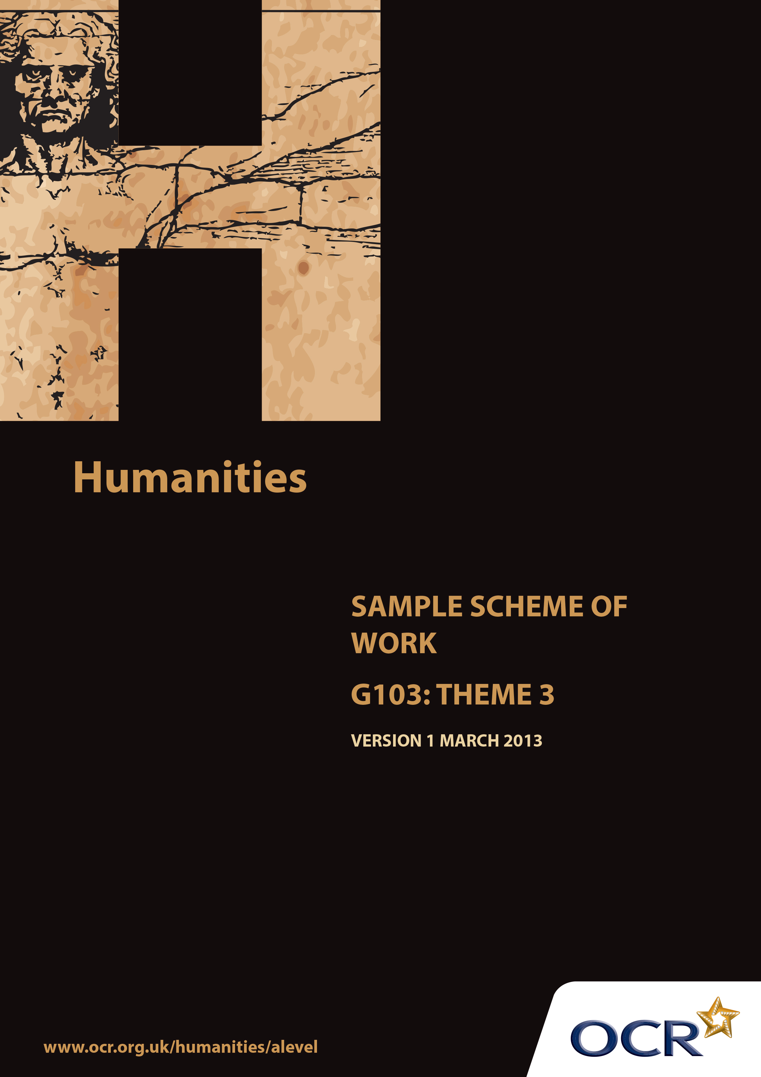
TWENTY FIRST CENTURY SCIENCE SUITE
SCHEMES OF WORK AND LESSON PLANS
B1: You and your genes
VERSION 1.1 JULY 2011
Introduction
OCR involves teachers in the development of new support materials to capture current teaching practices tailored to our new specifications. These support materials are designed to inspire teachers and facilitate different ideas and teaching practices. Each Scheme of Work is provided in Word format – so that you can use it as a foundation to build upon and amend the content to suit your teaching style and students’ needs.
The Scheme of Work provides examples of how to teach this unit and the teaching hours are suggestions only. Some or all of it may be applicable to your teaching.
The Specification is the document on which assessment is based and specifies what content and skills need to be covered in delivering the course. At all times, therefore, this Support Material booklet should be read in conjunction with the Specification. If clarification on a particular point is sought then that clarification should be found in the Specification itself.

Sample Scheme of Work
GCE Humanities
G103: International and Global Controversies Theme 3: Power, Control and Conflict

Suggested Teaching Time: 15 Hours

Aims of the whole unit

This unit is about analysing the nature of recent global controversies, reviewing evidence from across a range of disciplines which challenges or supports particular views. The focus is international, with a time frame of the last 25 years.

The unit will develop:
- Candidates’ intellectual curiosity about current global issues
- The skills and attributes of working independently
- The ability to consider different sides of controversies objectively and to select and analyse relevant evidence from across a range of academic disciplines
- The ability to construct a reasoned argument and reach independent substantiated conclusions
- Essay writing skills to present arguments and findings in a clear, coherent way.

Content of this theme

This theme focuses on some of the most prominent political and economic controversies of recent times: free trade and intervention in conflicts. In order to approach them in a balanced and rational way, a foundation is required in some key concepts: trade and markets, sovereignty, ethics and justice. Once students are familiar with these, they can use them to build on their skills of research and analysis of arguments in order to evaluate these appropriately and propose ways of proceeding in each case.

Teaching this unit

All the topics can be studied with reference to the following key questions:
- What is the current situation?
- Why is this happening?
- What, if any, action needs to be taken?

The unit will contribute especially to the development of Skills 3, 4, 5, 6 and 7 and the written aspects of Skill 9 listed on page 7.

Sample Scheme of Work
GCE Humanities
G103: International and Global Controversies Theme 3: Power, Control and Conflict

The function of expanded content

The specification responds to the key questions, and the expanded content provides resources and prompts for the students to develop the skills of academic curiosity, independent working, objective analysis from across the range of academic disciplines, reasoned argument and essay writing using those key questions. The structure is iterative, repeating these skills for each part of the theme and across themes to give students the opportunity to absorb and retain the required knowledge, and to practice the skills through deliberately organised rehearsal using targeted feedback.

Topic outline | Suggested teaching and  homework activities | Suggested resources | Points to note
International trade and its regulation. What is happening? | The first step is to establish the operation of free trade as part of classical economic theory. This might be done through a game such as the ‘Limiting Trade’ lesson in the suggested resources, or the showing and discussion of a video such as the Open University’s Open Learn ‘Principle of Comparative Advantage’. Teachers may find it helpful to show or give access to some of the other 1-minute videos in this series.  The concepts of trade and market failure / intervention are best supported through selective use of appropriate economics textbooks, such as Section 3 of OCR AS Economics. | EdecWeb Economics Lesson, ‘Limiting Trade’: http://ecedweb.unomaha.edu/lessons/feoga.htm  Open University, OpenLearn, ‘Principle of Comparative Advantage’, http://www.open.edu/openlearn/history-the-arts/culture/philosophy/concepts/60-second-adventures-economics-the-principle-comparative-advantage  Colin Bamford and Susan Grant, OCR AS Economics (2008) | The content of this sub-theme requires some specific and direct teaching of the relevant economic theory before moving on to exploring and responding to debates, so the suggested activities aim to build this knowledge first.
International trade and its regulation. Why is it happening? | Having established the enabling conceptual framework and knowledge base, students can now use the skills they have built up to research, present and evaluate competing arguments. This can be done as preparation for a formal debate, or perhaps as allocated presentations on each side of the debate. Again, some seed sources for whole-class work, or to get groups underway may well be helpful here.  A lesson for preparation followed by a lesson to present or debate would be appropriate here. | Actionaid, ‘What’s wrong with free trade?’: http://www.actionaid.org.uk/101015/free_trade.html  The Telegraph, ‘The Future is Free Trade’, 13 February 2013: http://www.telegraph.co.uk/comment/telegraph-view/9867830/The-future-is-free-trade.html  The Economist, Debates, ‘Fair Trade’: http://www.economist.com/debate/overview/172
International trade and its regulation – what (if anything) should be done about it. | Begin by establishing a starting framework of knowledge about the WTO and its role. The BBC article provides a useful resource for this. The remaining sources are drawn from a variety of audiovisual and written formats, and can be evaluated against the evidence previously collected in order to reach judgements and proposals. | Background to the WTO:  BBC, ‘Profile: The World Trade Organisation’, 15 February 2012: http://news.bbc.co.uk/1/hi/world/europe/country_profiles/2429503.stm  Arguments for the WTO:  Journeyman Pictures: ‘The World Trade Organisation’, http://www.youtube.com/watch?v=1Xp75Egtvi8  WTO, ‘WTO at Fifteen’, http://www.youtube.com/watch?v=7iywG3_EG1c  WTO, ’10 Benefits of the WTO Trading System’: http://www.wto.org/english/thewto_e/whatis_e/10ben_e/10b00_e.htm  Arguments against the WTO:  John Pilger, ‘The New Rulers of the World’ (2001): http://johnpilger.com/videos/the-new-rulers-of-the-world -- this documentary is also very useful for the globalisation topic within Theme 2.  Press Action, ‘Roots of Occupy: The Battle in Seattle, 1999’, 18 April 2012: http://www.pressaction.com/news/weblog/full_article/mickeyz04182012/ -- contains a number of useful links for the organisations and arguments behind the protest movement. | This final two lessons for the sub-theme incorporates all three questions in asking students to evaluate alternative solutions to the problem of free trade and its regulation from two very different perspectives. These are rooted in the 1999 Seattle protests against the WTO, but remain very relevant to the continuing choice to be made between the exponents of international free trade and those who are discontented with its consequences.
The nature and operation of international political influence and control. What is happening? | Begin by direct teaching of the idea of the nation and that of sovereignty. One could start with students’ own definitions of a country, a nation and ideas of sovereignty (the Queen as sovereign, etc). Then move on to some selected materials and resources from an appropriate politics textbook, such as sections 2.1 to 2.5 of the A2 OCR textbook listed in the suggested resources.  Having done this, it would be appropriate to spend at least one lesson introducing some key ideas from ethics, particularly consequentialist and duty-based (deontological) approaches. The BBC’s Introduction to Ethics provides some useful resources. Michael Sandel’s ideas on justice are also useful here, especially his interview with Prospect magazine. | Jon Sutherland and Diane Canwell, OCR A2 Political Ideas and Concepts: Student Book (Heinemann, 2009)  BBC, Ethics Guide, ‘Introduction to Ethics’: http://www.bbc.co.uk/ethics/introduction/  Nigel Warburton, ‘Interview: Michael Sandel on Justice’, Prospect Magazine January 21 2011: http://www.prospectmagazine.co.uk/magazine/interview-michael-sandel-on-justice-bbc4-justice-citizens-guide/  Justice: A Citizen’s Guide to the 21st Century: http://www.open.edu/openlearn/whats-on/ou-on-the-bbc-justice-citizens-guide-the-21st-century (a useful documentary by Sandel outlining his justice-based introduction to ethics -- check this link for when the programme is next available on the BBC) | As with the previous topic, some direct teaching of the key concepts is necessary before a development of the wider debate. Here, the essential ideas are the concept of sovereignty and also the contrasting ethical approaches used by different sides of the debate.
The nature and operation of international political influence and control. Why is it happening and what (if anything) should be done about it. | The initial concepts can then be applied to a specific case study, preferably a recent one. Here is a potential sequence:  - If required, show a recent or contemporary news report in order to establish overall context.  - Use some sources such as those in the suggested resources to establish the debate, reading them together in class.  - Evaluate the arguments against the concepts of sovereignty and justice (including consequentialist and deontological approaches to justice) previously established.  - Students then research the case study themselves, finding further arguments on each side (exemplifying both justifications and the effectiveness of intervention) and evaluate them in the same way.  - Students present their findings along with their own supported judgements on whether intervention would be justified or effective.  Homework (using this case study): Write an essay answering the question: ‘Would intervention in Syria be justified?’ using the framework and feedback from previous essay writing. | Seumas Milne, ‘Intervention in Syria risks blowback and regional war’, The Guardian, 19 December 2012: http://www.guardian.co.uk/commentisfree/2012/dec/19/intervention-syria-al-qaida-blowback  Anne-Marie Slaughter, ‘Syrian Intervention is justifiable, and just’, Washington Post, 9 June 2012: http://www.washingtonpost.com/opinions/syrian-intervention-is-justifiable-and-just/2012/06/08/gJQARHGjOV_story.html  Speakers’ Corner Trust, ‘The Ethics of Intervention – Human Rights, National Sovereignty and the Balance of Risk’: http://www.speakerscornertrust.org/5166/the-ethics-of-intervention-human-rights-national-sovereignty-and-the-balance-of-risk/ (generalises the debate helpfully using a number of examples) | The specification lists a number of possible justifications and reasons for the effectiveness of interventions, as well as a number of examples of recent interventions. Having established the key ideas from political philosophy and ethics, an effective way of identifying, analysing and evaluating these may be to research a specific, familiar case study and use it to list and assess the arguments on each side. When choosing a case study, the most useful approach would be to select one that is as current in the news as possible, which will restrict the amount of historical instruction required. For this reason, the sample resources here are all from the debate over whether to intervene in the conflict in Syria.
Exam practice | Some directed teaching about exam technique and timing could take place at this stage (analysing questions, mapping answers with key facts and sequencing, timing writing) and students can also produce revision notes for all topics in the theme. A timed mock examination with a selection of questions targeting different parts of the theme could then follow.

