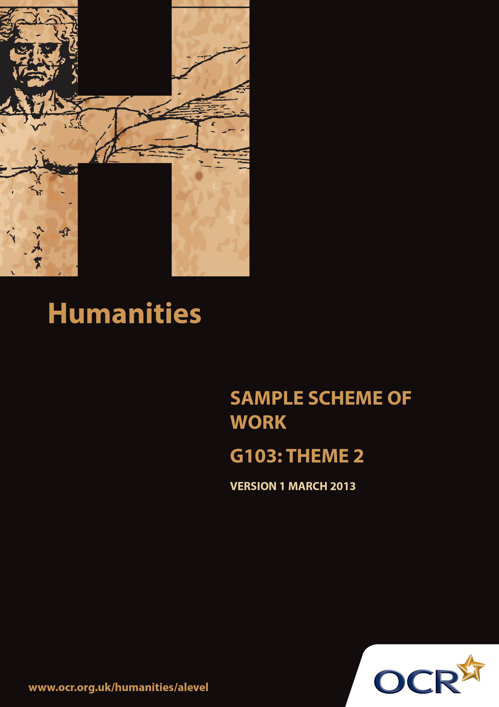
TWENTY FIRST CENTURY SCIENCE SUITE
SCHEMES OF WORK AND LESSON PLANS
B1: You and your genes
VERSION 1.1 JULY 2011
Introduction
OCR involves teachers in the development of new support materials to capture current teaching practices tailored to our new specifications. These support materials are designed to inspire teachers and facilitate different ideas and teaching practices. Each Scheme of Work is provided in Word format – so that you can use it as a foundation to build upon and amend the content to suit your teaching style and students’ needs.
The Scheme of Work provides examples of how to teach this unit and the teaching hours are suggestions only. Some or all of it may be applicable to your teaching.
The Specification is the document on which assessment is based and specifies what content and skills need to be covered in delivering the course. At all times, therefore, this Support Material booklet should be read in conjunction with the Specification. If clarification on a particular point is sought then that clarification should be found in the Specification itself.
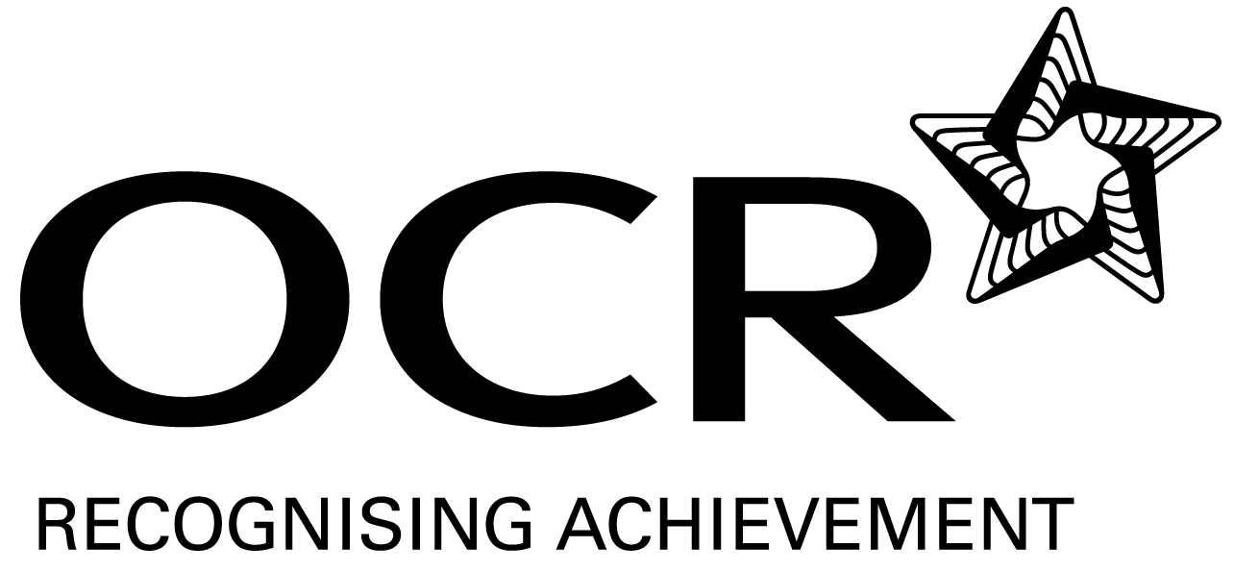
Sample Scheme of Work
GCE Humanities
G103: International and Global Controversies Theme 2: Culture, Media and Identity

Suggested Teaching Time: 15 Hours

Aims of the whole unit

This unit is about analysing the nature of recent global controversies, reviewing evidence from across a range of disciplines which challenges or supports particular views. The focus is international, with a time frame of the last 25 years.

The unit will develop:
- Candidates’ intellectual curiosity about current global issues
- The skills and attributes of working independently
- The ability to consider different sides of controversies objectively and to select and analyse relevant evidence from across a range of academic disciplines
- The ability to construct a reasoned argument and reach independent substantiated conclusions
- Essay writing skills to present arguments and findings in a clear, coherent way.

Content of this theme

This theme has at its centre one of the most important trends in the last 25 years – that of globalisation. It treats it in terms of its impact on identity, and in so doing draws on a repertoire of approaches based in cultural studies. Media representation is a natural complement to this focus, as we continue to debate the role of institutions in the modern world and their impact upon individuals.

Teaching this unit

All the topics can be studied with reference to the following key questions:
- What is the current situation?
- Why is this happening?
- What, if any, action needs to be taken?

The unit will contribute especially to the development of Skills 3, 4, 5, 6 and 7 and the written aspects of Skill 9 listed on page 7.

Sample Scheme of Work
GCE Humanities
G103: International and Global Controversies Theme 2: Culture, Media and Identity

The function of expanded content

The specification responds to the key questions, and the expanded content provides resources and prompts for the students to develop the skills of academic curiosity, independent working, objective analysis from across the range of academic disciplines, reasoned argument and essay writing using those key questions. The structure is iterative, repeating these skills for each part of the theme and across themes to give students the opportunity to absorb and retain the required knowledge, and to practice the skills through deliberately organised rehearsal using targeted feedback.

Topic outline | Suggested teaching and  homework activities | Suggested resources | Points to note
What is happening: introducing globalisation | Although a GCSE-level resource, the GCSE Bitesize video may be a good initial starting point, as it introduces some key terms and factors behind globalisation in a way that can spark an agenda for further discussion.  Another useful initial activity is for students to reflect on their own identity. How would they describe themselves? (Perhaps 10 sentences starting ‘I am…’). What groups do they explicitly identify themselves with? Who do they define themselves against – who aren’t they like? Where do their identities come from? Who has transmitted them to them? | BBC Bitesize Globalisation video:  http://www.bbc.co.uk/schools/gcsebitesize/geography/globalisation/globalisation_video.shtml | Students will already be familiar with the approach to this unit from the first theme. The key starting point here is to set up the two terms which will be in opposition for the first sub-theme: globalisation and identity. Having defined these, it will be possible to move on to more detailed readings.
Why is this happening? The globalisation and cultural identity debate. | One possible starting point is an article from The Statesman (Ghana): ‘Is Ghana a victim of cultural imperialism?’ The article can be colour coded to show the sequence of structured debate suitable to an essay, and also as practice for the effective citation of different arguments in a piece of writing. Students can build on this in an active way by role-playing the different views and evaluating their strengths and weaknesses. There is also the opportunity to research some of the more sophisticated key concepts being used, such as ‘cultural imperialism’.  Homework: students can take on one of the roles cited in the article and extend their argument, citing the opposing views and demonstrating why theirs is stronger. | ‘Is Ghana a victim of cultural imperialism?’, The Statesman: http://sociolingo.wordpress.com/2007/04/20/is-ghana-a-victim-of-cultural-imperialism/ | From the specification, the effects on minority cultures of globalisation is probably the most logical way into the topic from the introductory activities for students.
Why is this happening and what (if anything) should be done about it? Extending the globalisation and cultural identity debate | Having rehearsed the use of arguments from a single source document which can be cited to support a debate in an extended piece of writing, students can now apply this to a task which requires the repetition of individual research skills. Use the Emory University Globalisation Website as a starting point – it has a page devoted to the question: ‘Does globalisation diminish cultural diversity?’ The bullet-pointed reasons on each side of the debate could be used as prompts for an initial lesson activity, and then students (individually, in pairs or groups) could be asked to investigate the resources listed below to find and evaluate evidence and arguments which would further support those initial debates. The sources would need to be evaluated in the usual ways, looking at credibility of context, strength of argument and reliability of evidence. Students could then (perhaps as a final collective activity) reach some supported concluding judgements.  Homework: ask students to write an essay of 750 words answering that question: ‘Does globalisation diminish cultural diversity?’. They should draw on feedback from previous written work and use the concepts, arguments and evidence from the research they have undertaken. | Emory University Globalisation website: http://www.sociology.emory.edu/globalization/issues05.html
What is happening, why is it happening, what (if anything) should be done about it?  Putting the skills together as a project. | The students can be placed into pairs or larger groups and given project topics which cover the remaining sub-areas of the ‘Globalisation: Cultural Heritage and Identity’ area of controversy:  - The spread of democracy and the collapse of communism  - The spread of Western culture vs national political or economic identity (e.g.Cuba or China)  - Global commercialisation of sport vs minority or cultural heritage sports  - Professionalisation of sporting competition or the use of performance enhancing drugs vs amateur sporting achievement.  There is flexibility here to split some of these areas into further debates in order to give a range of groups/pairs in a larger class separate foci. For each however, students should follow a common progression:  - What is happening? Identify the context of the debate, key concepts and essential information. Formulate a question which summarises the debate.  - Why is it happening? Identify alternative arguments and evaluate their strengths and weaknesses by also weighing up supporting evidence.  - What (if anything) should be done about it? Based on all of this, reach their own supported conclusions.  The results of all of these steps can be presented back to the class as a poster or powerpoint. Optionally, individuals could then write up the process as an essay. | An advantage of this topic is that it focuses students on developing their own research skills and in doing so applying credibility criteria more actively to select sources. However, a number of possible starting points could be suggested for the various projects. This pair of articles would be appropriate, for example, for cemocracy vs communism:  Richard Swift, ‘The Wild East’, New Internationalist 366 (April 2004): http://newint.org/features/2004/04/01/keynote  ‘Capitalism’s Third Century’, The Washington Times, 1 November 2009:  http://www.washingtontimes.com/news/2009/nov/01/capitalisms-third-century/?page=all
Influence and activities of global media monopolies. What is happening? | A good starting point is to establish some basic awareness: bring a range of newspapers and magazines in and use to establish the key distinctions between ‘red-top’, mid-market tabloid, broadsheet, and various kinds of magazines aimed at specific markets. The different TV channels and media sources on the internet could also be shown and discussed at this point. It would be useful to draw on the framework students already have for assessing the credibility of different sources and apply it specifically to the media.  For the following lesson, a good next step would be the NATE activity on media ownership. Follow the suggested A-Level extension as homework, or for the lesson after, of researching specific media companies in groups and for students to feed back on what they have discovered.  Possible homework: contribute to a class wall-map on the media using the information which has been discovered. | NATE, Reviewing the World: Teaching Resources from Global Education – Media Ownership. http://www.nate.org.uk/globed/index.php?cat=Media&res=31
Influence and activities of global media monopolies. Why is it happening? What (if anything) should be done about it? | From here, students can move on to specific controversies, and practice the skills of analysing and evaluating different sides of the debate.  Given that these skills have now been practiced for several iterations, it would be possible to begin with a sample question, for example:  ‘The international mass media are a force for good in the world’. Discuss. (from the sample examination materials)  ‘Is media ownership too narrowly concentrated?’  ‘The mass media is an essential part of a modern democracy’. Discuss.  For each, begin by clarifying the key terms in the question and the essential context from the initial research which has been undertaken by the students. Then look at some contrasting arguments from different sources (see the suggested resources) and analyse and evaluate them against one another. Students can then use the information and ideas they have gathered to reach a supported judgement on the question.  Homework: produce an essay answering one of the questions. | Some useful background. Torin Douglas, ‘Analysis: Murdoch and media ownership in UK’, BBC News (2010): http://www.bbc.co.uk/news/uk-12062176  Leveson debate:  Norman Fowler, ‘In the post-Murdoch era, we must reform media ownership’, Guardian, 11 May 2012: http://www.guardian.co.uk/commentisfree/2012/may/11/post-murdoch-reform-media-ownership  Vicki Young, ‘Analysis: Michael Gove gets under Leveson’s Skin’, BBC News 29 May 2012: http://www.bbc.co.uk/news/uk-politics-18257958 (includes video of Gove’s defence of press freedom).  Guardian Teacher Network, ‘Learning about the Leveson report: news and resources round-up’, Dec 2012: http://www.guardian.co.uk/teacher-network/teacher-blog/2012/dec/09/leveson-report-teaching-resources (an excellent page with a wealth of links, resources and activities)
24-hour news media / Internet censorship: practicing the questions | As with the globalisation and identity sub-topic, students can be given an opportunity to conduct their own research, organise perspectives and reach conclusions following some initial stimulus material in class. The UK Parliament debate page on the 24-hour news media is a very good starting point for this. Students can then search for further sources on each side of the debate, evaluate them and reach conclusions.  Another option from the specification for this type of activity is the debate over the censorship of the internet. Here, a pair of contrasting arguments to read in class might provide an interesting starting point. The two, in the suggested resources, also provide an opportunity to discuss the complexities of context: a Chinese artist argues in favour of internet freedom whereas an American writer (albeit in China Daily) makes the case for the benefits of regulation.  Homework: write an essay in response to a question arising from one of these debates. | UK Parliament, ’24-hour media: Parliament, politics and the public’: http://www.parliament.uk/about/podcasts/theworkofparliament/24hrmedia/  Andre Vitchek, ‘Should the Internet be regulated?’, China Daily 19 September 2012: http://usa.chinadaily.com.cn/business/2012-09/19/content_15767959.htm  Ai Weiwei, ‘China’s censorship can never defeat the internet’, The Guardian 16 April 2012: http://www.guardian.co.uk/commentisfree/libertycentral/2012/apr/16/china-censorship-internet-freedom
What is happening: end of theme quiz | In preparation for the exam, and its need for recall of specifics as well as the writing of arguments, a good end-of-theme task might be to ask different groups of students to select a subtheme and construct a quiz with questions and answers based around different key concepts and other information. They could then try out their quizzes (and provide answer keys!) with the rest of the class.

