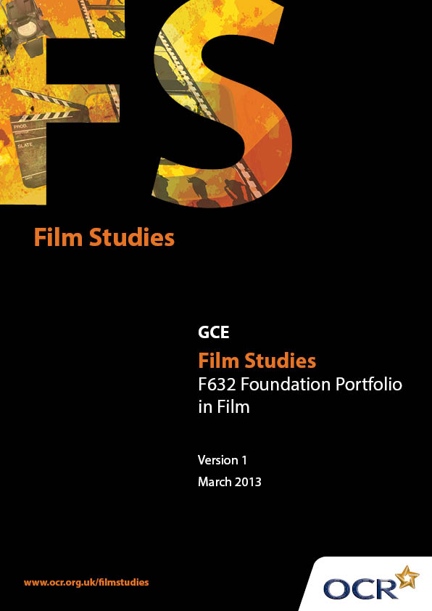
Introduction
OCR involves teachers in the development of new support materials to capture current teaching practices tailored to our new specifications. These support materials are designed to inspire teachers and facilitate different ideas and teaching practices. Each Scheme of Work and set of sample Lesson Plans is provided in Word format – so that you can use it as a foundation to build upon and amend the content to suit your teaching style and students’ needs.
The Scheme of Work and sample Lesson plans provide examples of how to teach this unit and the teaching hours are suggestions only. Some or all of it may be applicable to your teaching.
The Specification is the document on which assessment is based and specifies what content and skills need to be covered in delivering the course. At all times, therefore, this Support Material booklet should be read in conjunction with the Specification. If clarification on a particular point is sought then that clarification should be found in the Specification itself.
Introduction

Sample Scheme of Work
GCE Film Studies H067
F632: Foundation Portfolio in Film

Suggested teaching time | 36 hours | Topic | Foundation Portfolio in Film - Textual Analysis, Planning, Creative Artefact (non-filmed option), Evaluation

Topic outline | Suggested teaching and homework activities | Suggested resources | Points to note
Textual Analysis | Focus on micro elements within context of Genre and Narrative. Students will need to engage in a range of activities which help them to identify, label and understand the function of micro elements. For example:  Students to identify micro elements that "show" them that extracts are from western, horror, sci-fi etc.  Narrative card sort. Students to match cards with five parts of narrative: exposition, development, complication, climax, resolution. How do micro elements help them to understand narrative?  Students to use micro elements to identify common character traits (hero, villain, side-kick etc) from film trailers.  Genre "moodboard". Collection of images that represent a specific genre. Explanation of choices can be presented orally to rest of class or through written labels. | Short extracts from popular films eg. Star Wars, Once Upon a Time in the West, Notting Hill, Halloween.  Cards containing five parts of narrative from films such as Jaws or ET.  Film Education's Teaching Trailers dvd. (www.filmeducation.org)  Online image libraries or collections of magazines/newspapers. | Micro Elements:  Cinematography - the use of camera shots, angle, movement, composition, and lighting.  Editing - the organisation of sequences to construct meaning. This should include transition of image and sound, continuity and non-continuity systems, cutting (shot/reverse shot, eyeline match, graphic match, action match, jump cut, crosscutting, parallel editing, cutaway, insert).  Sound - diegetic and non-diegetic sound, synchronous/asynchronous sound, sound effects, sound motifs, sound bridge, dialogue, voiceover, mode of address/direct address, sound mixing, sound perspective, and soundtrack (score, incidental music, themes and stings, ambient sound).
 | Homework - choose an extract from a film and prepare a presentation to rest of class using micro elements to explain generic/narrative conventions.  Introduction of assessed task. Teacher to model - for example: a study of two romantic comedies, exploring generic conventions through an application of film language. Include exemplar essay for discussion.  Student presentations - pitch individual ideas for study. Feedback from class/teacher. | Student or centre collections of films.  Extracts from (for example): Forgetting Sarah Marshall (2008), Nicholas Stoller, Universal, USA Run Fatboy Run (2007), David Schwimmer, Beech Hill Films, UK.  Centre produced exemplar essay. | Mise-en-Scène - production design, location, studio, set design, costume and make-up, properties, colour design, casting.
 | Homework - research films, analyse films, produce essay. (This can be produced and monitored whilst the next block(s) of lessons are taking place.)

Suggested teaching time | 9 hours | Topic | Foundation Portfolio in Film - Textual Analysis, Planning, Creative Artefact (non-filmed option), Evaluation

Topic outline | Suggested teaching and homework activities | Suggested resources | Points to note
Planning | Approaches to planning - demonstration of different planning options.  Demonstration - a series of photographs with notes representing a location report - Romantic Comedy. | Centre produced exemplar material or examples from OCR support materials "Introduction to A Level Film Studies" presentation slides. | The teacher and class can explore different ways to plan for their creative artefact. The teacher can demonstrate a range of acceptable formats, including, but not limited to:  - an animatic storyboard  - a series of photographs with notes representing a location report  - a series of screen tests with notes  - a shot list with digital still photographs to illustrate
Homework - construction of planning materials.

Presentation of materials to class for peer feedback.

Suggested teaching time | 27 hours | Topic | Foundation Portfolio in Film - Textual Analysis, Planning, Creative Artefact (non-filmed option), Evaluation

Topic outline | Suggested teaching and homework activities | Suggested resources | Points to note
Creative artefact - An extract from a script with images of 9 key frames (locations and characters need to be dressed and posed as they would be in a filmed sequence, with some explanation of the shot types chosen) | Demonstration - script with nine key frames for a romantic comedy.  Construction of artefact.  Presentation of materials to class for peer feedback. | Centre produced exemplar material or examples from OCR support materials "Introducing to A Level Film Studies" presentation slides. | Monitor construction through one-to-one meetings, interim presentations, etc.

Suggested teaching time | 18 hours | Topic | Foundation Portfolio in Film - Textual Analysis, Planning, Creative Artefact (non-filmed option), Evaluation

Topic outline | Suggested teaching and homework activities | Suggested resources | Points to note
Evaluation | Students to load creative artefact to social network site (eg Pintrest linked to Facebook) ask for constructive feedback from "friends". It is important that students make aims of artefact clear to those viewing/reading. Feedback to be compiled with peer feedback in response to question 4.  Use SurveyMonkey to survey target audience about identifiable codes and conventions in artefact.  Use Prezi to illustrate relationships between textual analaysis, planning, and creative artefact.  Presentations (using outcomes from activities above) with peer feedback - discussions around 4 key questions. | www.pinterest.com  www.surveymonkey.com  www.prezi.com | The four questions that need to be addressed in the evaluation:  - what were the aims of the artefact?  - what codes and conventions identified in the textual analysis were used in the artefact?  - how were the planning materials used in the construction of the artefact?  - how successful was the artefact in achieving the aims?
 | Homework - writing up evaluation, compiling portfolio for submission.

Sample Lesson Plan
GCE Film Studies H067
F632 – Foundation Portfolio in Film

Generic Conventions
OCR recognises that the teaching of this qualification above will vary greatly from school to school and from teacher to teacher. With that in mind this lesson plan is offered as a possible approach but will be subject to modifications by the individual teacher.
Lesson length is assumed to be one hour.

Learning Objectives for the Lesson
Objective 1 | Students will be able to use prior learning to demonstrate understanding of how generic conventions are communicated.

Recap of previous experience and prior knowledge

Content
Time | Content
10 minutes | Recap prior learning - generic conventions with focus on micro elements (mise-en-scene, sound, editing, cinematography).
30 minutes | Students to create genre "moodboard" (a montage of images that represent a specific genre). This can be completed using magazine images or as an opportunity to use ICT. Depending on class size this can be an individual, paired, or group exercise.

Consolidation
Time | Content
20 minutes | Presentation of "moodboards". Oral presentation. Students to explain their image choices with focus on micro elements.

