Write a critical evaluation of the following argument. Ensure that in your answer you:
• Explicitly identify the structure of the argument. i.e. any conclusions drawn and reasons given.
• Assess the argument by giving the assumptions which must be made, and explaining the flaws in reasoning.
• Present two further arguments which challenge and/or support the conclusion.
Three marks are available for quality of written communication.
Total Marks [20]
There have been recent heated discussions in Parliament over the following issue:
Would there be a more efficient health service in Britain, if the government used private health insurance in addition to taxation as a means of funding it?
Countries such as the USA and France spend more of the GDP* on health care than the UK and have a greater percentage of this funded through private health insurance than the UK.
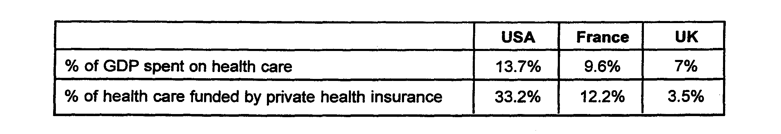
It follows that funding through private health insurance encourages greater expenditure on health care provision.
Chai Patel of the private health provider Westminster Care offers further evidence. He states that the people who are treated by his organisation get a better standard of care than NHS patients. This shows that the standards of health care throughout the NHS would rise if the private sector was more involved in the provision of care.
This superior provision is due to the fact that the private sector is in a competitive market. State- run restaurants in the Soviet Union were of a very poor quality, as there was no competition and no way they could go out of business. The introduction of the free market and such competition as McDonalds has driven down price and driven up quality. In the same way, subjecting a state monopoly of health care to competition, will drive up standards and reduce costs.
Steven Weeks of the health workers union, Unison, argues against this. He claims that more private provision will actually drive up costs, because private operators have to make profits. However, he is more interested in protecting his members’ wages and conditions from being eroded by the cost-cutting that the private sector will bring. Therefore, his arguments should be dismissed.
As seen from the above, there is an overwhelming case for overcoming the traditional prejudice that inhibits the use of the private sector in UK health care. The government should consequently proceed with the policy of increasing the involvement of the private sector at the earliest opportunity.
*GDP - Gross Domestic Product, i.e. the total value of goods produced and services provided in a country in one year.

