1. Read through the following passage on alveoli and gas exchange, then write on the dotted lines the most appropriate word or words to complete the passage.
During inspiration, air reaches the alveoli through small tubes known as
................................................ . The alveolar wall is composed of a
................................................ layer of epithelial cells which
................................................ the diffusion rate of oxygen from the alveolar air
into the ............................................ surrounding the alveoli.
(Total 4 marks)

2. The flow chart below shows the sequence in which some cells are formed during spermatogenesis in the mammalian testes.
(a) State the part of the testis where spermatogenesis occurs.
................................................................................................................................
(1)
(b) Name cells A and B.
Cell A .....................................................................................................................
Cell B .....................................................................................................................
(2)

(c) Explain the importance of meiosis in the formation of spermatozoa.
................................................................................................................................
................................................................................................................................
................................................................................................................................
................................................................................................................................
................................................................................................................................
................................................................................................................................
(3)
(Total 6 marks)

3. Explain what is meant by each of the following terms.
(a) The cardiac cycle
................................................................................................................................
................................................................................................................................
................................................................................................................................
................................................................................................................................
................................................................................................................................
................................................................................................................................
(3)
(b) Coronary circulation
................................................................................................................................
................................................................................................................................
................................................................................................................................
................................................................................................................................
................................................................................................................................
................................................................................................................................
(3)
(Total 6 marks)

4. The graph below shows oxygen dissociation curves for human haemoglobin and myoglobin.
(a) From the graph, find the partial pressures of oxygen at which myoglobin and haemoglobin are 50% saturated with oxygen.
Myoglobin ..............................................................................................................
Haemoglobin ...........................................................................................................
(1)
(b) Describe the role of myoglobin.
................................................................................................................................
................................................................................................................................
................................................................................................................................
................................................................................................................................
................................................................................................................................
................................................................................................................................
(3)
(c) On the graph, draw a curve to show the dissociation curve for fetal haemoglobin.
(2)

(d) If the partial pressure of carbon dioxide increases, the dissociation curve for haemoglobin moves to the right.
(i) What name is given to this effect?
.....................................................................................................................
(1)
(ii) Explain the importance of this effect.
.....................................................................................................................
.....................................................................................................................
.....................................................................................................................
.....................................................................................................................
.....................................................................................................................
.....................................................................................................................
(3)
(Total 10 marks)

5. The photograph below shows part of the surface of an onion leaf, as seen using a light microscope.
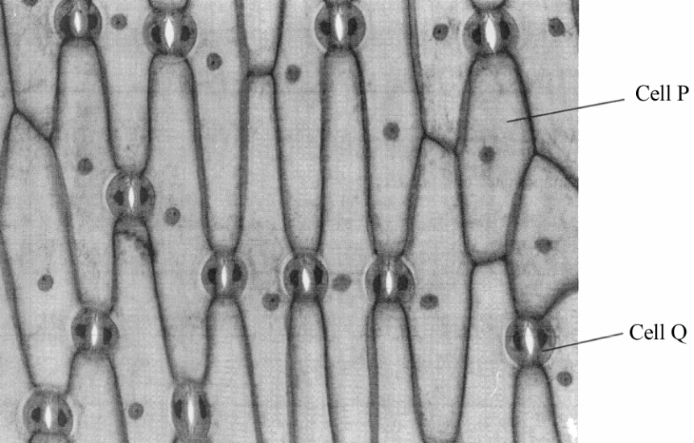
(a) Name the cells labelled P and Q.
Cell P .....................................................................................................................
Cell Q ....................................................................................................................
(2)

(b) The area shown in the photograph is 0.069 mm2. Count the number of stomata present and calculate the number per mm2. Show your working.

Answer = ...............................................
(3)
(c) In an investigation, the rate of transpiration of a plant was measured in two different conditions, still air and moving air. The results are shown in the table below. The rate of transpiration is expressed as the mass of water lost per unit leaf area, per second.
Condition | Rate of transpiration  / g × 10–6 per cm2 per second
Still air | 70.0
Moving air | 250.0
(i) Describe the effect of moving air on the rate of transpiration.
.....................................................................................................................
.....................................................................................................................
(1)
(ii) Explain why air movement has this effect on the rate of transpiration.
.....................................................................................................................
.....................................................................................................................
.....................................................................................................................
.....................................................................................................................
.....................................................................................................................
.....................................................................................................................
(3)
(Total 9 marks)

6. The diagrams below show two invertebrates found in freshwater habitats. Rat-tailed maggots are found in stagnant or slow moving water. Stonefly nymphs live in fast flowing streams.
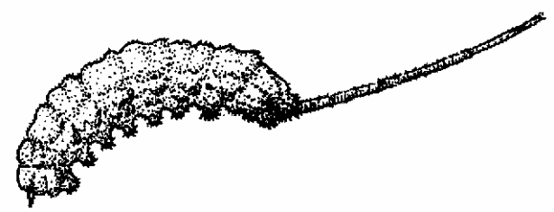 | 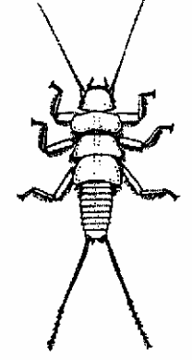
(a) Suggest how rat-tailed maggots are adapted to their habitat.
...............................................................................................................................
...............................................................................................................................
...............................................................................................................................
...............................................................................................................................
...............................................................................................................................
...............................................................................................................................
...............................................................................................................................
...............................................................................................................................
(4)
(b) Suggest what adaptations stonefly nymphs might have for living in fast flowing water.
...............................................................................................................................
...............................................................................................................................
...............................................................................................................................
...............................................................................................................................
(2)
(Total 6 marks)

7. The diagram below shows a simple respirometer, which can be used to measure the uptake of oxygen by germinating seeds.
(a) State the function of the potassium hydroxide solution.
...............................................................................................................................
...............................................................................................................................
(1)
(b) Suggest a function of the 1 cm3 syringe.
...............................................................................................................................
...............................................................................................................................
(1)

(c) In an experiment, the tube containing the seeds was placed in a water bath at 24 °C and left for five minutes with the syringe removed. The syringe was then replaced.
The level of the coloured liquid was read from the scale every two minutes for a period of ten minutes. The experiment was then repeated at 30 °C.
The results are shown in the table below.
(i) Compare the results obtained at 24 °C with the results obtained at 30 °C.
......................................................................................................................
......................................................................................................................
......................................................................................................................
......................................................................................................................
(2)
(ii) Describe how you would use this respirometer to find the rate of uptake of oxygen by these seeds.
......................................................................................................................
......................................................................................................................
......................................................................................................................
......................................................................................................................
......................................................................................................................
......................................................................................................................
(3)
(Total 7 marks)

8. An investigation was carried out into the digestion of starch in different regions of the human digestive system.
3 cm3 of 1% starch solution was placed in each of four tubes. Similar masses of the tissues shown in the table below were taken and ground up separately in 10 cm3 of distilled water.
1 cm3 of the resulting suspension was added to the tubes as shown in the table below. A control tube was set up containing 3 cm3 of the starch solution and 1 cm3 of distilled water.
After incubation at 37 °C for 15 minutes, the contents of each tube were tested for the presence of reducing sugar.
The results of the investigation are shown in the table below.
Tube number | Tissue suspension added | Presence of reducing sugar
1 | Salivary gland | Present
2 | Stomach wall | Absent
3 | Duodenum wall | Absent
4 | Pancreas | Present
5 (control) | None | Absent
(a) (i) Name the enzyme that causes the digestion of starch.
......................................................................................................................
(1)
(ii) Describe the effect of this enzyme on starch.
......................................................................................................................
......................................................................................................................
......................................................................................................................
......................................................................................................................
(2)
(b) Suggest the purpose of the control.
...............................................................................................................................
...............................................................................................................................
(1)
(c) Suggest reasons for each of the following.
(i) The absence of starch digestion in Tube 2.
......................................................................................................................
......................................................................................................................
(1)

(ii) The difference between the results for Tube 3 and Tube 4.
......................................................................................................................
......................................................................................................................
(1)
(d) Describe how the products of starch digestion are absorbed from the small intestine into the blood.
...............................................................................................................................
...............................................................................................................................
...............................................................................................................................
...............................................................................................................................
...............................................................................................................................
...............................................................................................................................
...............................................................................................................................
...............................................................................................................................
...............................................................................................................................
...............................................................................................................................
...............................................................................................................................
...............................................................................................................................
(6)
(Total 12 marks)

