1. Read through the following passage about enzymes, then write on the dotted lines the most appropriate word or words to complete the passage.
Enzymes can be described as biological .............................................. as they reduce
the .......................................... needed for a metabolic reaction to occur.
The ........................................... combines with the enzyme at a specific region of
the molecule called the ........................................ . The shape of this region can
be altered by a change in pH or ................................................ which will
............................................... the rate of the metabolic reaction.
(Total 6 marks)

2. (a) State two structural differences between the molecules of the polysaccharides cellulose and glycogen.
 | Cellulose | Glycogen
1

2

(2)
(b) State two structural differences between the molecules of the proteins collagen and insulin.
 | Collagen | Insulin
1

2

(2)
(Total 4 marks)

3. (a) A student was given two carbohydrate solutions, labelled A and B, and was told to perform two tests on each solution.
Test 1: Add Benedict’s solution and heat.
Test 2: Add hydrochloric acid and boil.
Neutralise with alkali.
Add Benedict’s solution and heat.
The table below shows the colour of each solution after testing.
Solution | Colour after Test 1 | Colour after Test 2
A | Red
B | Blue | Red
(i) Complete the table to show what colour solution A would be following Test 2.
(1)
(ii) Explain why these results indicate that solution B contained a non-reducing sugar.
.....................................................................................................................
.....................................................................................................................
.....................................................................................................................
.....................................................................................................................
(2)
(b) Describe how you would use biuret reagent to compare the concentration of proteins in two solutions.
................................................................................................................................
................................................................................................................................
................................................................................................................................
................................................................................................................................
................................................................................................................................
................................................................................................................................
(3)
(Total 6 marks)

4. The table below refers to the formula and structure of some biological molecules.
Complete the table by writing in the name, the formula or the structure of the molecule where appropriate in the empty boxes.
Name | Formula | Structure
Water | H2O
 | NH2RCHCOOH
Fatty acid

(Total 6 marks)

5. Immobilised enzymes have a wide range of commercial applications.
(a) Explain what is meant by the term enzyme immobilisation.
................................................................................................................................
................................................................................................................................
................................................................................................................................
................................................................................................................................
(2)

(b) Explain two advantages of using immobilised enzymes in industrial processes.
1. ............................................................................................................................
................................................................................................................................
................................................................................................................................
................................................................................................................................
2. ............................................................................................................................
................................................................................................................................
................................................................................................................................
................................................................................................................................
(4)
(Total 6 marks)

6. The diagram below shows the sequence of stages in the cell cycle.
(a) During the cell cycle, the DNA content of the cell changes. Identify the stage when the DNA content increases and the stage when the DNA content decreases. In each case give an explanation for your answer.
DNA increases .......................................................................................................
Explanation ............................................................................................................
...............................................................................................................................
DNA decreases ......................................................................................................
Explanation.............................................................................................................
................................................................................................................................
(4)

(b) Proteins are synthesised during interphase of the cell cycle. Protein synthesis involves transcription and translation of the genetic code.
(i) Explain what is meant by the term transcription.
......................................................................................................................
......................................................................................................................
......................................................................................................................
......................................................................................................................
(2)
(ii) The letters below show the sequence of bases in part of a gene which codes for an enzyme.
ATGGAAAAAAGC
Use the information in the table below to work out the sequence of amino acids which is coded for by this part of the gene. The names of the amino acids are shortened to their first three letters. You do not need to write down the full names of the amino acids.
Sequence of amino acids ...............................................................................
(2)
(Total 8 marks)

7. The photograph shows a cell in mitosis as viewed using a transmission electron microscope.
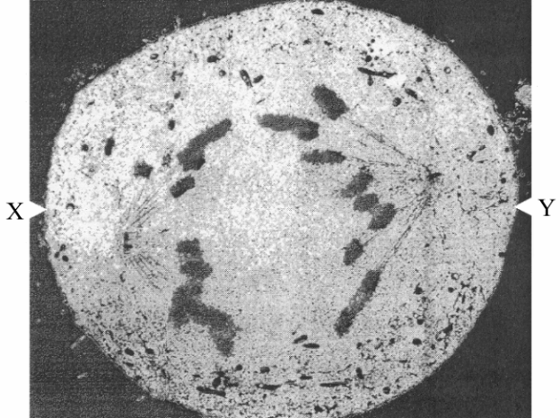
Dr D. Spector, Peter Arnold Inc./ Science Photo Library
(a) The actual diameter of the cell between points X and Y is 50 μm. Calculate the magnification of this photograph. Show your working.

Answer ................................
(3)
(b) In the space below make an accurate drawing of the cell. Label the chromosomes, spindle fibres and centrioles.

(5)
(c) State the stage of mitosis that this cell is in.
................................................................................................................................
(1)

(d) State one function of each of the following.
Spindle fibres
................................................................................................................................
................................................................................................................................
Centrioles
................................................................................................................................
................................................................................................................................
(2)
(Total 11 marks)

8. The information in the table below refers to some carbohydrates and their roles in living organisms.
Complete the table by writing the name of the carbohydrate, or one role, in each of the empty boxes.
Carbohydrate | One role in living organisms
 | Form in which carbohydrate is transported in mammals
Sucrose
 | Form in which carbohydrate is stored in mammals
Cellulose
(Total 4 marks)

