1. Auxins are plant growth substances which can cause elongation in developing plant tissues.
A student formed the hypothesis that an increase in the concentration of auxins would increase the elongation of seedling tissue. To test this idea he cut twenty 15 mm lengths from identical oat seedlings and immersed ten of them in a solution of 1 μg dm–3 auxin and ten in a solution of 10 μg dm–3 auxin.
These samples were left in controlled conditions for 12 hours, after which they were removed and their lengths re-measured.
An extract from his laboratory notebook is shown below.
(a) Prepare a table and organise the data in a suitable way so that the increase in length in each concentration can be compared.
(4)
(b) Use the data in your table to present the information in a suitable graphical form.
(3)
(c) State a suitable null hypothesis for this investigation.
(1)

(d) The student applied a t-test to his data to test his hypothesis.
He calculated the value of t to be 3.68.
The table below shows the critical value of t with 18 degrees of freedom for various significance levels.
Significance level (%) | 20 | 10 | 5 | 2 | 1
Critical value of t | 1.33 | 1.73 | 2.10 | 2.55 | 2.80
What conclusions can be drawn from this investigation? Use the information provided to explain your answer.
(3)
(Total 11 marks)

2. Froghoppers, such as the one shown below, are small insects that feed on soft-stemmed plants.
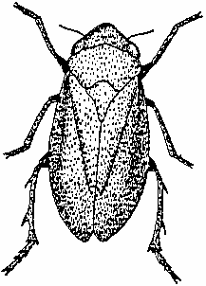
Froghopper (3–11 mm)
Plan an investigation, which you personally could carry out, to test the hypothesis that coppicing (cutting down trees to leave a stump) of a woodland increases the number of froghoppers.
Your answer should be given under the following headings,
(a) Plan of the investigation to be carried out.
(10)
(b) Recording of raw data measurements, presentation of results and methods of data analysis.
(6)
(c) Limitations of your method and an indication of further work that could be undertaken.
(5)
(Total 21 marks)

