1. Carbohydrates in the human diet are important sources of energy. Much of the carbohydrate is supplied in the form of starch. It is now known that the type of starch present in potatoes, bread and some breakfast cereals is more rapidly digested than the starch found in beans, peas and lentils, pasta and wholegrain cereals. The latter is referred to as ‘slow release’ starch.
(a) Explain one way in which the structure of a starch molecule is related to its function of storage.
……………………………………………….………………………………………
……………………………………………….………………………………………
……………………………………………….………………………………………
……………………………………………….………………………………………
(2)
(b) Complete the table below by writing in the names of the two enzymes involved in the complete digestion of starch in the human gut, and their sources.
Name of enzyme | Source of enzyme
(2)
(c) An investigation was carried out into the changes in blood glucose levels that occur after eating meals containing different types of starch. The blood glucose levels of two groups of volunteers, Group A and Group B, were measured and recorded immediately before eating a meal and then at 30 minute intervals for 240 minutes afterwards. None of the volunteers had diabetes.
The meal eaten by Group A contained cornflakes and white bread toast.
The meal eaten by Group B contained pasta and beans.

The mean blood glucose levels, in mmol dm–3, for each group were calculated and the results are shown on the graph below. The normal level of glucose in the blood is about 5.0 to 5.5 mmol dm–3.
(i) Compare the changes in the blood glucose levels of Group A with those of
Group B throughout the period of the investigation.
……….……………………………….………………………………………
……….……………………………….………………………………………
……….……………………………….………………………………………
……….……………………………….………………………………………
……….……………………………….………………………………………
……….……………………………….………………………………………
(3)
(ii) Suggest explanations for the differences in the blood glucose levels of the two groups.
……….……………………………….………………………………………
……….……………………………….………………………………………
……….……………………………….………………………………………
……….……………………………….………………………………………
……….……………………………….………………………………………
……….……………………………….………………………………………
(3)

(d) Suggest one reason why the starch stored in wholegrain cereals and beans may not be digested as readily as the starch in bread and potatoes.
……………………………………………….………………………………………
……………………………………………….………………………………………
(1)
(Total 11 marks)

2. Daphnia are small invertebrates, which are found commonly in freshwater habitats such as ponds and lakes, where they feed mainly on microscopic algae (phytoplankton).
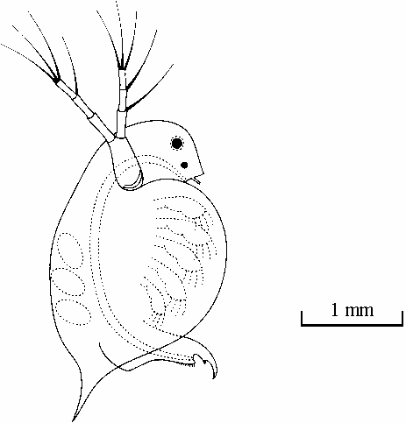
Daphnia
Daphnia are sensitive to pollutants such as pesticide residues and metal ions. An investigation was carried out to determine the effects of aluminium ions and lead ions on the survival of Daphnia. Cultures of Daphnia were set up in synthetic pond water containing phytoplankton. Each culture was aerated (air was bubbled through it using an aquarium pump).
The cultures were maintained at 15°C under fluorescent lights and left for 24 hours. Solutions containing different concentrations of aluminium nitrate or lead nitrate were then added to the cultures. Four replicates were set up, at each concentration of metal ion solution.

The percentage survival of Daphnia in the cultures was assessed 5 hours after adding the solutions of metal ions. The results are shown in the tables below.
(a) Suggest reasons for each of the following.
(i) The cultures were maintained at a constant temperature.
……….……………………………….………………………………………
……….……………………………….………………………………………
……….……………………………….………………………………………
……….……………………………….………………………………………
(2)
(ii) The cultures were aerated.
……….……………………………….………………………………………
……….……………………………….………………………………………
……….……………………………….………………………………………
……….……………………………….………………………………………
(2)
(b) Compare the effect of aluminium nitrate with the effect of lead nitrate on the percentage survival of Daphnia.
……………………………………………….………………………………………
……………………………………………….………………………………………
……………………………………………….………………………………………
……………………………………………….………………………………………
……………………………………………….………………………………………
……………………………………………….………………………………………
(3)
(c) Suggest why ions of heavy metals, such as lead, have a toxic effect on, Daphnia.
……………………………………………….………………………………………
……………………………………………….………………………………………
……………………………………………….………………………………………
……………………………………………….………………………………………
(2)
(d) Suggest what effect pollution with aluminium ions or lead ions would have on a freshwater food chain.
……………………………………………….………………………………………
……………………………………………….………………………………………
……………………………………………….………………………………………
……………………………………………….………………………………………
……………………………………………….………………………………………
……………………………………………….………………………………………
(3)
(Total 12 marks)

3. Write an essay on the following topic.
Protein synthesis and the genetic modification of cells to produce new proteins
Marks will be awarded for scientific content, coverage of the topic, and the quality of written communication. You should include in your answers any relevant information from the whole of your course. You may include diagrams if you wish, but make sure that they are relevant to your essay and add extra information to it.
(Total 15 marks)

4. Write an essay on the following topic.
The roles of pigments in living organisms
Marks will be awarded for scientific content, coverage of the topic, and the quality of written communication. You should include in your answers any relevant information from the whole of your course. You may include diagrams if you wish, but make sure that they are relevant to your essay and add extra information to it.
(Total 15 marks)

5. Write an essay on the following topic.
The evidence for human evolution
Marks will be awarded for scientific content, coverage of the topic, and the quality of written communication. You should include in your answers any relevant information from the whole of your course. You may include diagrams if you wish, but make sure that they are relevant to your essay and add extra information to it.
(Total 15 marks)

