1. The diagram below shows part of the adult stage of the tapeworm, Taenia, which is an endoparasite of mammals.
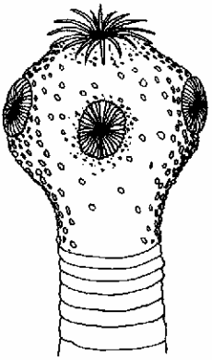
(a) State where the adult stage of Taenia would be found in the body of the host mammal.
...............................................................................................................................
(1)
(b) Explain how the hooks and suckers shown in the diagram enable Taenia to be a successful endoparasite.
...............................................................................................................................
...............................................................................................................................
...............................................................................................................................
...............................................................................................................................
(2)
(c) Give two features of Taenia, other than those shown in the diagram, that are adaptations to the parasitic mode of nutrition.
...............................................................................................................................
...............................................................................................................................
(2)

(d) Explain how the mode of nutrition shown by a parasite, such as Taenia, differs from that shown by a fungus, such as Rhizopus.
...............................................................................................................................
...............................................................................................................................
...............................................................................................................................
...............................................................................................................................
...............................................................................................................................
...............................................................................................................................
(3)
(Total 8 marks)

2. Weasels and stoats are small carnivorous mammals found in Britain. They are able to prey upon many of the small herbivorous mammals found in the countryside. Their diet includes mammals such as mice, voles, rabbits and hares and also worms and other invertebrates. On country estates they are considered to be pests because they eat the eggs and chicks of the game birds that are bred for shooting.
A weasel
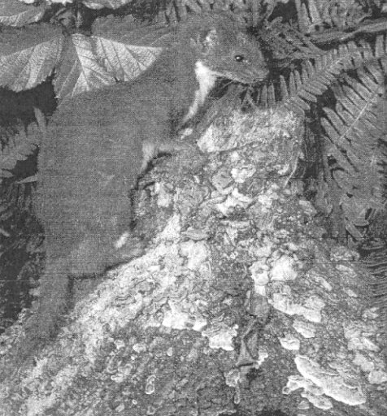
Ecoscene / Robin Redfern
Although their quick reactions and long, slender bodies enable them to have some chance of escape, many weasels and stoats become the prey of larger carnivores, such as foxes and cats.
Figure 1, Figure 2 and Figure 3 show data concerning the weasel and stoat populations in Britain.

Figure 1 - Analysis of the prey eaten by weasels and stoats on game estates in Britain
Figure 2 - An estimate of the numbers of individuals and biomass
for weasels and stoats in Britain
Species | Number | Biomass / kg × 103
Weasels | 450 000 | 34
Stoats | 462 000 | 116
Figure 3 - Mean number of weasels and stoats trapped per hectare on game estates in Britain
Figures 1 and 3 – adapted from Biologist Vol 17 Num 3 June 2000
Figure 2 – adapted from Biological Sciences Review Vol 12 Num 4 March 2000

(a) Name the trophic level in a pyramid of biomass that would include weasels and stoats. Explain your answer.
...............................................................................................................................
...............................................................................................................................
...............................................................................................................................
...............................................................................................................................
...............................................................................................................................
(3)
(b) Explain what the data in Figure 2 indicate about the relative size of weasels and stoats.
...............................................................................................................................
...............................................................................................................................
...............................................................................................................................
...............................................................................................................................
(2)
(c) With reference to Figure 1, suggest why it is better to record the prey animals eaten as percentage of diet by biomass rather than as numbers eaten.
...............................................................................................................................
...............................................................................................................................
...............................................................................................................................
...............................................................................................................................
(2)
(d) Compare the diet of the weasels with that of the stoats.
...............................................................................................................................
...............................................................................................................................
...............................................................................................................................
...............................................................................................................................
(2)

(e) With reference to Figure 3, describe the trend in the populations of weasels and stoats since 1975. Suggest what the effects of this trend might be on the other animals within the ecosystem.
...............................................................................................................................
...............................................................................................................................
...............................................................................................................................
...............................................................................................................................
...............................................................................................................................
...............................................................................................................................
(3)
(Total 12 marks)

3. The seas around Britain consist of tidal waters fed by the estuaries of many rivers. These waters are generally shallow, in comparison to open seas, and are often relatively close to towns and industries.
Figure I illustrates the water circulation pattern within an estuary. The natural recycling of nutrients and detritus within these waters means that there is a great capacity for high productivity.
Figure 1 – Movement of plankton, detritus and nutrients in an estuary
The convenience of having relatively large bodies of water close to towns and industries has meant that the seas and estuaries around Britain have long been used for waste disposal. Much of this waste is the biodegradable components of sewage from domestic and industrial sources. However, some of the discharges may contain non-biodegradable and toxic compounds.
In addition to this, many of the estuaries receive the drainage from agricultural land that may contain the residues of fertilisers and pesticides.
Figure 2 shows the effects of biodegradable wastes on the numbers of individual organisms, and on the numbers of species, living on the sea bed at different distances from the point of discharge.

Figure 2 – Effect of discharge of biodegradable waste on organisms living on the
bed of an estuary
Figures 1 and 2 adapted from Biological Sciences Review Vol 2 Num 1 Sept 1989
(a) Explain what is meant by the term productivity.
...............................................................................................................................
...............................................................................................................................
...............................................................................................................................
...............................................................................................................................
(2)
(b) Explain why there is a great capacity for high productivity in the water in estuaries.
...............................................................................................................................
...............................................................................................................................
...............................................................................................................................
...............................................................................................................................
(2)
(c) With reference to Figure 1, suggest why water in estuaries may be particularly affected by the residues of fertilisers and pesticides from agricultural land.
...............................................................................................................................
...............................................................................................................................
...............................................................................................................................
...............................................................................................................................
...............................................................................................................................
...............................................................................................................................
(3)

(d) Explain what is meant by the term biodegradable.
...............................................................................................................................
...............................................................................................................................
...............................................................................................................................
...............................................................................................................................
(2)
(e) Using the information in Figure 2, describe the effects of the discharge of biodegradable waste upon the organisms living on the bed of the estuary.
...............................................................................................................................
...............................................................................................................................
...............................................................................................................................
...............................................................................................................................
...............................................................................................................................
...............................................................................................................................
(3)
(f) Explain these effects.
...............................................................................................................................
...............................................................................................................................
...............................................................................................................................
...............................................................................................................................
...............................................................................................................................
...............................................................................................................................
(3)

(g) Explain why releasing raw sewage into the waters of estuaries can pose a threat to human health.
...............................................................................................................................
...............................................................................................................................
...............................................................................................................................
...............................................................................................................................
...............................................................................................................................
...............................................................................................................................
(3)
(Total 18 marks)

