1. The table below lists some enzymes associated with carbohydrate digestion in humans, their site of secretion and product(s) of their action.
Complete the table by filling in the blank spaces.
Enzyme | Site of secretion | Product(s)
Amylase
 | Lining (mucosa) of ileum | Glucose and galactose
Sucrase |  | Glucose and fructose
(Total 4 marks)

2. (a) Cardiac muscle contracts myogenically. Explain what is meant by the term myogenic.
……………………………………………….………………………………………
……………………………………………….………………………………………
……………………………………………….………………………………………
……………………………………………….………………………………………
(2)
(b) The diagram below shows structures in the heart which are concerned with the coordination of contraction.
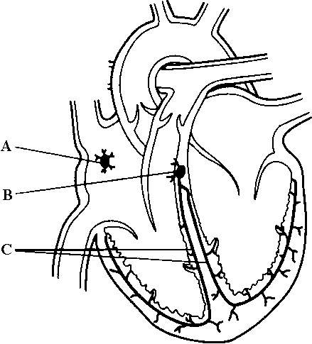

(i) Name parts A, B and C.
A ………………………………………………………………………………
B ………………………………………………………………………………
C ………………………………………………………………………………
(3)
(ii) Explain how the structures shown in the diagram coordinate the contraction of the heart.
…………………………………………………………………………………
…………………………………………………………………………………
…………………………………………………………………………………
…………………………………………………………………………………
…………………………………………………………………………………
…………………………………………………………………………………
(3)
(Total 8 marks)

3. The diagram below shows the formation of tissue fluid from part of a capillary.
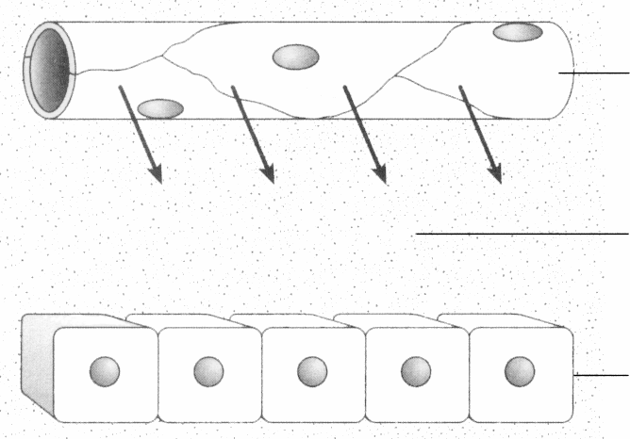

(a) Describe how tissue fluid is formed.
……………………………………………….………………………………………
……………………………………………….………………………………………
……………………………………………….………………………………………
……………………………………………….………………………………………
(2)
(b) The table below shows the concentration of some solutes in blood plasma and tissue fluid.
Solute | Concentration in  blood plasma  /mmol dm–3 | Concentration in  tissue fluid  /mmol dm–3
Potassium ions | 4.0 | 4.0
Sulphate ions | 0.5 | 0.5
Protein | 2.0 | Less than 0. 1
(i) Compare the concentrations of these solutes in blood plasma and tissue fluid.
…………………………………………………………………………………
…………………………………………………………………………………
…………………………………………………………………………………
…………………………………………………………………………………
(2)
(ii) Suggest explanations for the difference in the concentration of these solutes in blood plasma and tissue fluid.
…………………………………………………………………………………
…………………………………………………………………………………
…………………………………………………………………………………
…………………………………………………………………………………
…………………………………………………………………………………
…………………………………………………………………………………
(3)
(Total 7 marks)

4. (a) Explain what is meant by implantation in relation to human reproduction.
……………………………………………….………………………………………
……………………………………………….………………………………………
……………………………………………….………………………………………
……………………………………………….………………………………………
(2)
(b) The diagram below shows the structure of part of a human placenta and umbilical cord.
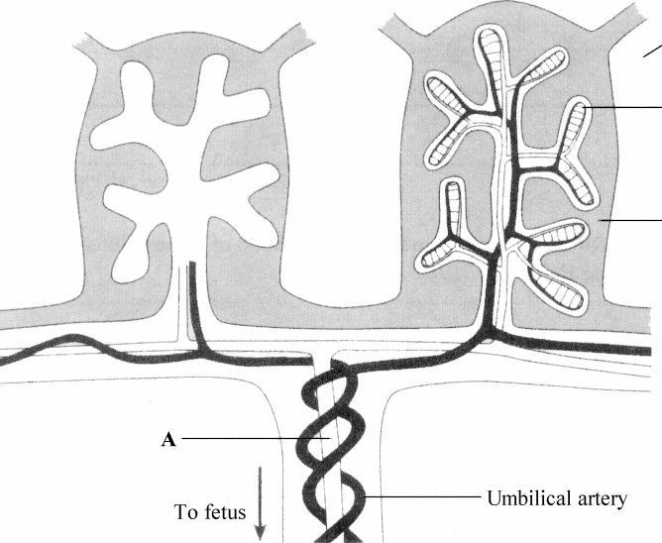
(i) Name the part labelled A.
A ….………………………………….………………………………………
(1)
(ii) Name two substances which would be present in a higher concentration in the umbilical artery than in the mother’s blood.
1 ….………………………………….………………………………………
2 ….………………………………….………………………………………
(2)

(iii) With reference to the diagram, suggest how the structure of the placenta enhances the transfer of substances between the blood of the fetus and the blood of the mother.
…….………………………………….………………………………………
…….………………………………….………………………………………
…….………………………………….………………………………………
…….………………………………….………………………………………
…….………………………………….………………………………………
…….………………………………….………………………………………
(3)
(iv) Shortly after the birth of the baby, the placenta leaves the uterus as the afterbirth, as a result of continued contraction of the uterine muscles. Name the hormone that causes this contraction.
…….………………………………….………………………………………
(1)
(Total 9 marks)’

5. Explain what is meant by each of the following terms.
(a) Pollination
……………………………………………….………………………………………
……………………………………………….………………………………………
……………………………………………….………………………………………
……………………………………………….………………………………………
……………………………………………….………………………………………
……………………………………………….………………………………………
(3)
(b) Protandry
……………………………………………….………………………………………
……………………………………………….………………………………………
……………………………………………….………………………………………
……………………………………………….………………………………………
(2)
(Total 5 marks)

6. The photograph below shows a transverse section of part of a root, as seen using a light microscope.
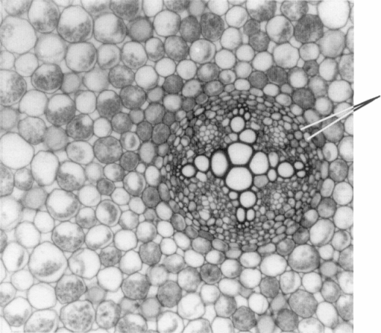
(a) On the photograph, label a xylem vessel.
(1)
(b) Describe the role of the endodermis.
……………………………………………….………………………………………
……………………………………………….………………………………………
……………………………………………….………………………………………
……………………………………………….………………………………………
……………………………………………….………………………………………
……………………………………………….………………………………………
(3)

(c) In an investigation, the rate of uptake of water by a sunflower was measured at intervals of two hours from 08.00 hours until 06.00 hours on the next day. The results are shown in the table below.
Time  (24 hour clock) | Rate of uptake of water  / g per 2 hours
08.00  10.00  12.00  14.00  16.00  18.00  20.00  22.00  24.00  02.00  04.00  06.00 | 3  12  29  38  39  40  12  9  8  5  2  2
(i) Describe the changes in the uptake of water which occurred during this investigation.
…….………………………………….………………………………………
…….………………………………….………………………………………
…….………………………………….………………………………………
…….………………………………….………………………………………
(2)
(ii) Suggest an explanation for the change in the uptake of water which occurred between 08.00 hours and 14.00 hours.
…….………………………………….………………………………………
…….………………………………….………………………………………
…….………………………………….………………………………………
…….………………………………….………………………………………
(2)
(Total 8 marks)

7. The photograph below shows part of a transverse section of a leaf, as seen using a light microscope.
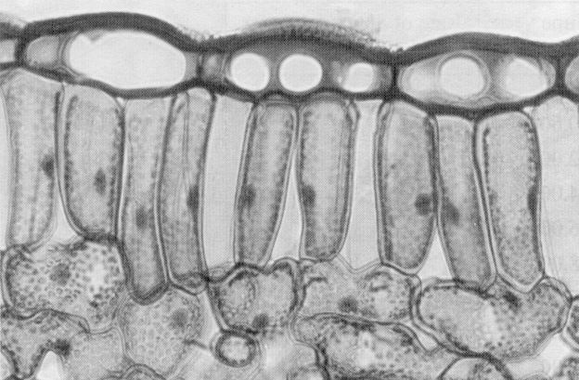
(a) Name the tissues labelled A and B.
A ............................................................................................................................….
B .............................................................................................................................…
(2)
(b) Explain how the tissue labelled B is adapted for the function of gas exchange.
……………………………………………….………………………………………
……………………………………………….………………………………………
……………………………………………….………………………………………
……………………………………………….………………………………………
……………………………………………….………………………………………
……………………………………………….………………………………………
(3)
(c) In an investigation into gas exchange in leaves, a maize leaf was placed in a dark chamber, and the mass of carbon dioxide released from the leaf in one hour was determined. The surface area of the leaf was also measured.
The results are shown in the table below.
Mass of carbon dioxide produced per hour  /mg | Surface area of leaf  /cm2
4.076 | 29

(i) Calculate the mass of carbon dioxide released in one hour per unit area of leaf. Show your working.

Answer .........................….
(2)
(ii) Suggest how the results would have differed if the leaf had been illuminated
…………………………………………………………………………………
…………………………………………………………………………………
…………………………………………………………………………………
…………………………………………………………………………………
(2)
(Total 9 marks)

8. The graph below shows the oxygen dissociation curves for the haemoglobin from two species of fish, a toadfish and a mackerel. One of the species is relatively inactive and lives in still water. The other is very active and fast-swimming.

(a) From the graph, find the partial pressure of oxygen at which the haemoglobin of each species of fish is 50% saturated with oxygen.
Toadfish ....................................................................................................................
Mackerel ...................................................................................................................
(2)
(b) Suggest which species of fish is adapted to living in still water. Give an explanation for your answer.
Species ………………………………………………………………………………
Explanation ………………………………………………………………………….
……………………………………………….………………………………………
……………………………………………….………………………………………
……………………………………………….………………………………………
……………………………………………….………………………………………
……………………………………………….………………………………………
……………………………………………….………………………………………
……………………………………………….………………………………………
(4)
(c) (i) On the graph, sketch a curve to show the effect of an increase in the partial pressure of carbon dioxide (the Bohr effect) on the dissociation curve of mackerel haemoglobin.
(2)
(ii) Explain the importance of this effect.
…………………………………………………………………………………
…………………………………………………………………………………
…………………………………………………………………………………
…………………………………………………………………………………
(2)
(Total 10 marks)

