GAUTENG DEPARTMENT OF EDUCATION
SENIOR CERTIFICATE EXAMINATION

TYPING SG
(Second Paper)

TIME: 3 hours

MARKS: 300

INSTRUCTIONS TO CANDIDATES:

READ THE FOLLOWING INSTRUCTIONS CAREFULLY BEFORE YOU START WITH THE PAPER.

- Type your examination number at the top of every sheet of paper used in answering the questions.
- Begin each question on a separate sheet of paper.
- Arrange your answers in the examination cover provided, in the correct numerical order.
- If you answer the timed accuracy test in English you are to answer Questions 2, 3, 4, 5, 6, 7 and 8 in English as well.
- Please read through your typed answers carefully.
- The invigilators will give you instructions about Question 1.
- You are to complete Question 1 and hand it in before answering the other questions.

INSTRUCTIONS TO INVIGILATORS:

1. Place at least eighteen sheets of A4 paper (80 g) in the examination cover prior to the examination.
2. The typing teacher is to ensure that the typewriters are in perfect working order.
3. Neither carbon ribbon nor correcting ribbons may be used during the examination.
4. It is essential that a typing teacher be one of the invigilators for the duration of the examination to assist with malfunctioning typewriters.
5. Candidates are to report to the typing centre at least 15 minutes before the examination commences.
6. Candidates should be given approximately 10 minutes to read through the examination paper before beginning Question 1. They may rule lines and underline words.
7. Both invigilators are to use stopwatches for time control. The timed accuracy test is to be timed by the typing teacher. Invigilators may not move among candidates during this test.
8. 8.1 Before the candidates start with this paper, they should be instructed to type their examination numbers in the top RIGHT HAND CORNER of the paper used for the timed accuracy test. After all the candidates have done this, the signal may be given to begin the test.
8.2 After the time allowed for the accuracy test has expired, the invigilator is to collect all the tests and initial them after the LAST WORD TYPED ON EVERY SHEET USED FOR THE SPEED TEST. All the sheets used by a candidate to answer Question 1 are to be stapled together. ONLY THE ANSWER SHEETS TO QUESTION 1 ARE TO BE STAPLED TOGETHER.
8.3 It is an invigilator’s responsibility to place the accuracy test correctly in each candidate’s examination cover on completion of the examination.
- During the rest of the paper, moving among candidates is to be restricted to handing out additional paper, assisting with faulty typewriters, etc.

QUESTION 1  TIMED ACCURACY TEST | [60]

The timed accuracy test is to be typed in double line or 1½ line spacing on one side of the paper only. Use margins of 10º. A minimum of 35 w.p.m. is expected and the limits are indicated by (…..).

TIME: 10 MINUTES

The business world directs economic matters in countries that operate in a capitalist
system, although sometimes its interests are not solely economic. It is a complex
system comprising many kinds of business organisations, large and small, which
interdependently mobilise the resources of a country to satisfy the needs of its
inhabitants. Therefore the needs and wants of the community determine the complexity
of its business life. In Western countries business is the primary source of products,
services, employment and income for the community. The business world acts as a
catalyst for economic growth, and successful business results in general welfare. The
high standard of living in Western countries is also attributable to business. It also
serves the community indirectly through technological innovation, and scientific
research, and by giving financial and other support to universities, museums, places of
historic importance, the arts, and other activities and institutions characteristic of an
advanced civilisation. We could say that the business world represents the culture of
society. In the South African context the business world is a valuable promoter of
sports, particularly in the attracting of touring teams from abroad to South Africa,
isolated as it was in the world of sports.

Therefore, the business world and the society in which it operates co-exists in a state of
mutual dependence and mutual influence. The entrepreneur, in his pursuit of profit, is
constantly searching for new ideas, new products and improved methods. In doing this
he moves the community in the direction of innovation and change. As a pivot of the
capitalist system the businessman’s decisions ………………………………………….. 35 w.p.m.
on investment, production, and employment influence not only the state of the
economy, but also the prosperity of the community as a whole. Conversely the
community exerts its influence on business in many …………………………….……… 40 w.p.m.
ways. If business organisations act negatively or socially irresponsibly, for example by
causing pollution or through deceitful or monopolistic practices, the community reacts

by means of legislation or other measures. Moreover, the attitude of ……….……….. 45 w.p.m.
society towards the business world is by no means consistent.

The reason for this is that in a changing environment the community has different
expectations of the business world at different times. If the business world fails to
respond to its ……………………………………………………………………………..…. 50 w.p.m.
expectations, the attitude of society will change. Up to and throughout the 1930s the
business world was regarded as a valuable social institution because it helped to realise
society’s aims concerning material welfare and a rising standard of living. ….……… 55 w.p.m.

QUESTION 2  Type the following tabulation according to the block method on ONE sheet of A4 paper, LANDSCAPE. All manuscript instructions should be executed. Horizontal lines must be typed with the typewriter. All vertical lines in ink or with the typewriter.  TIME: 20 MINUTES | [30]

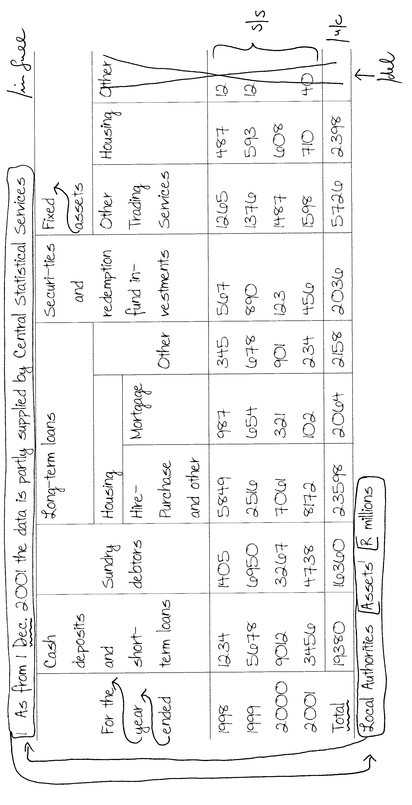

QUESTION 3  Type the following income statement correctly.  TIME: 20 MINUTES | [30]
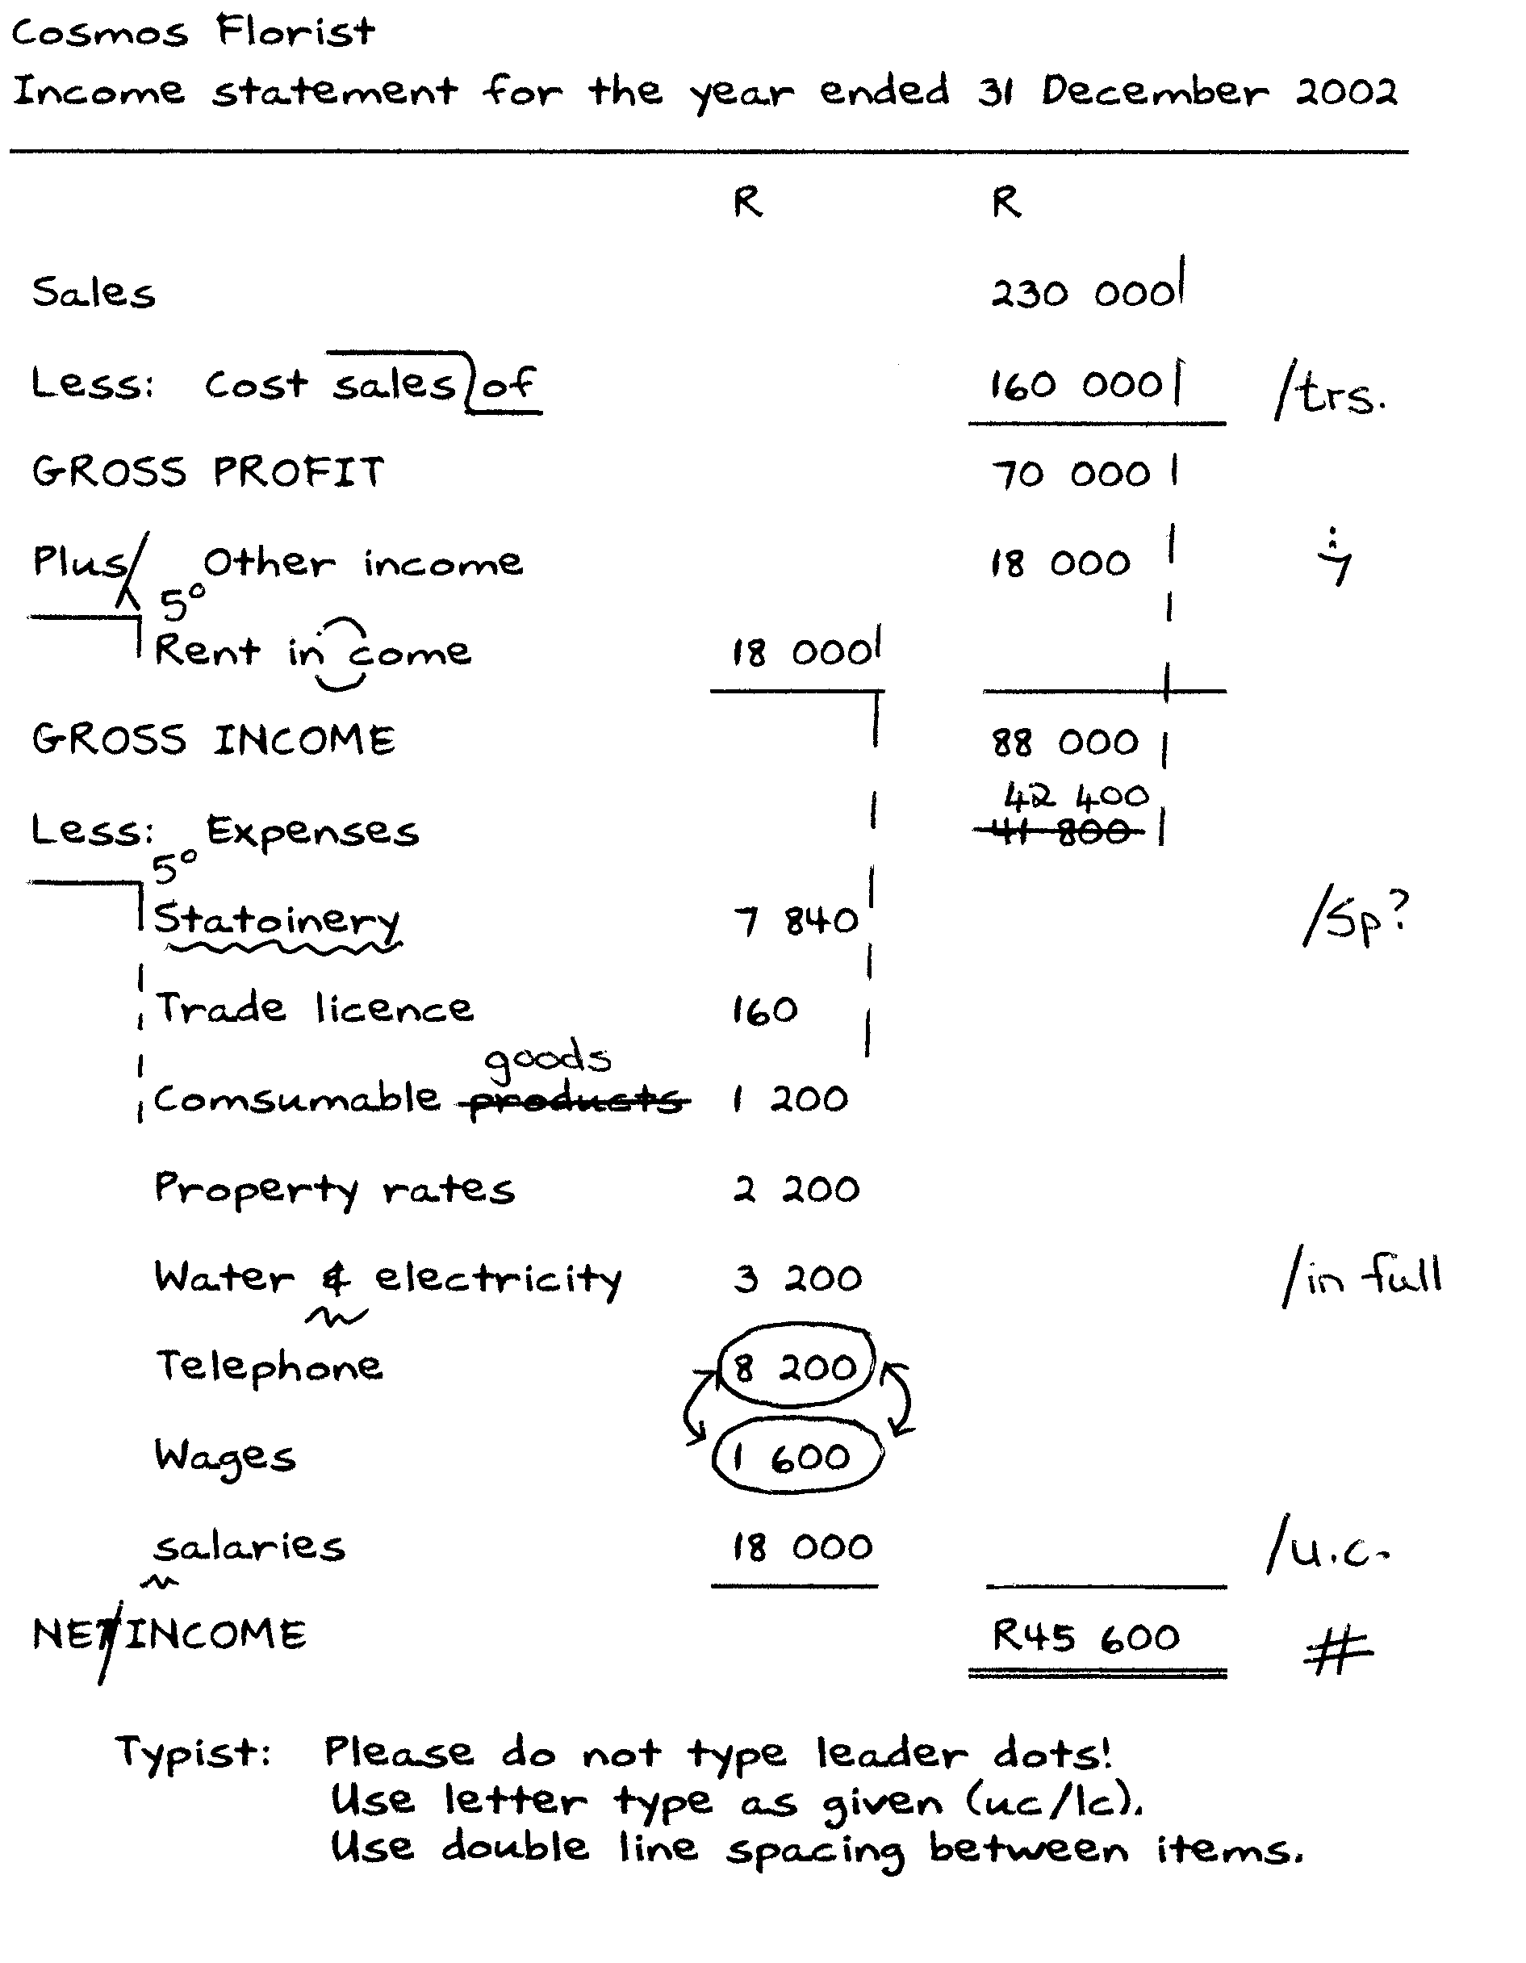

QUESTION 4  Type the following circular correctly on the letterhead on page 17. Detach it from the paper, do the question and place it in examination cover with the other answers.  TIME: 35 MINUTES | [50]

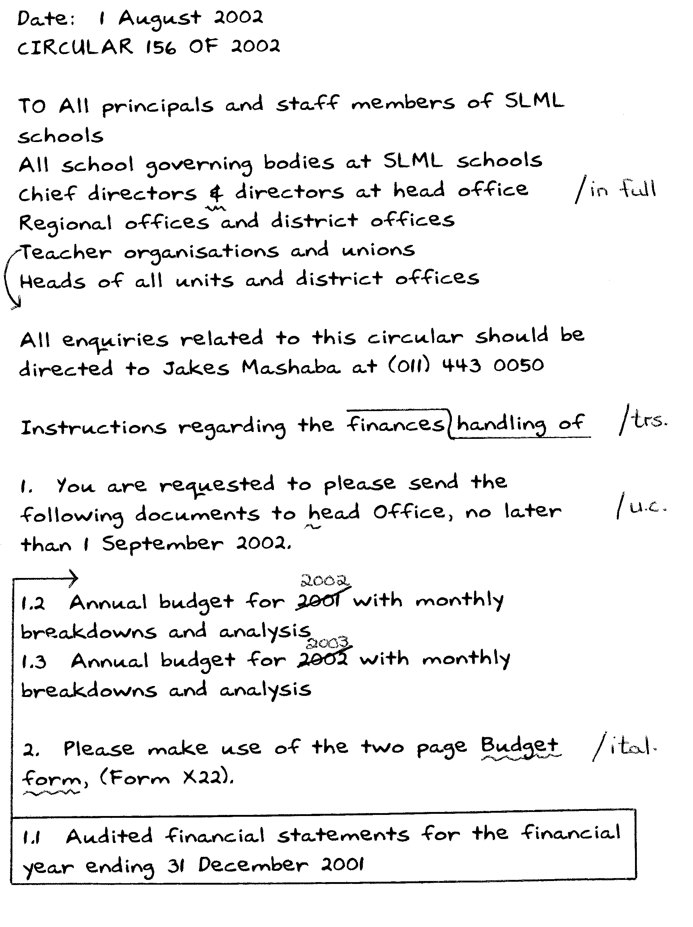

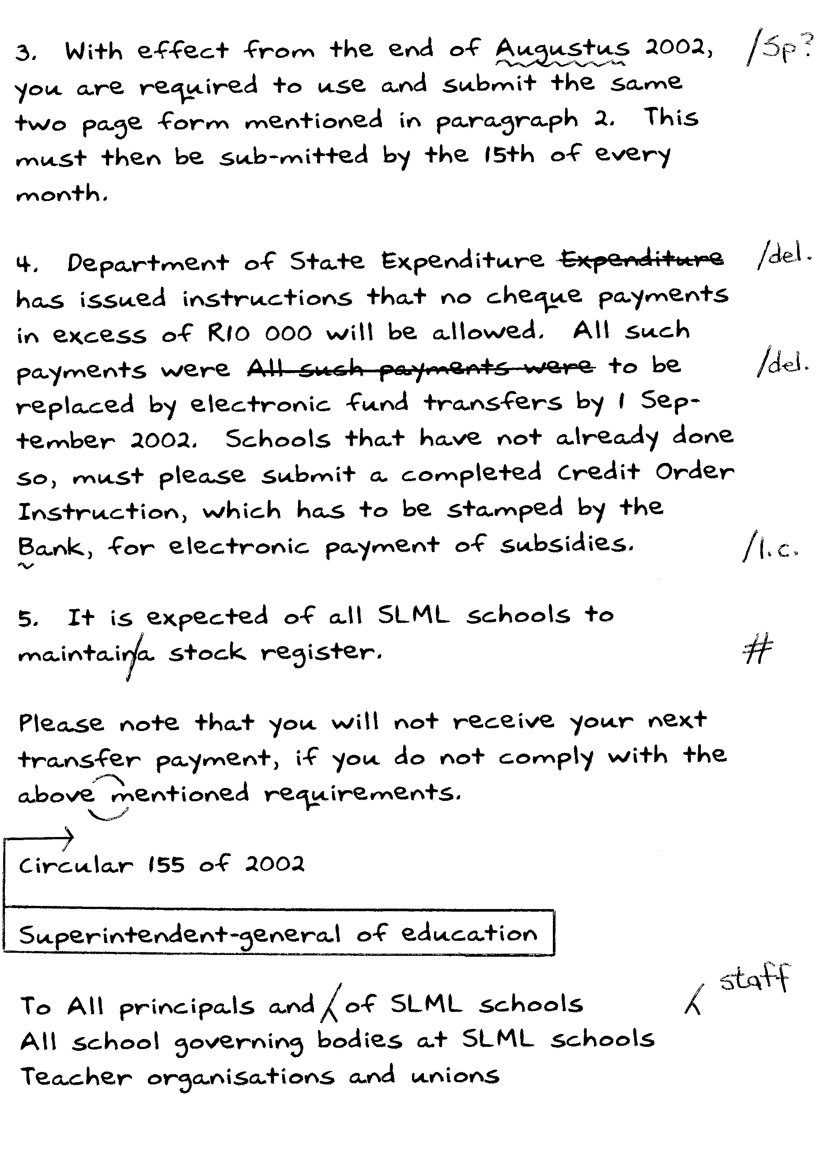

QUESTION 5  Type the following meeting of shareholders.  TIME: 20 MINUTES | [30]

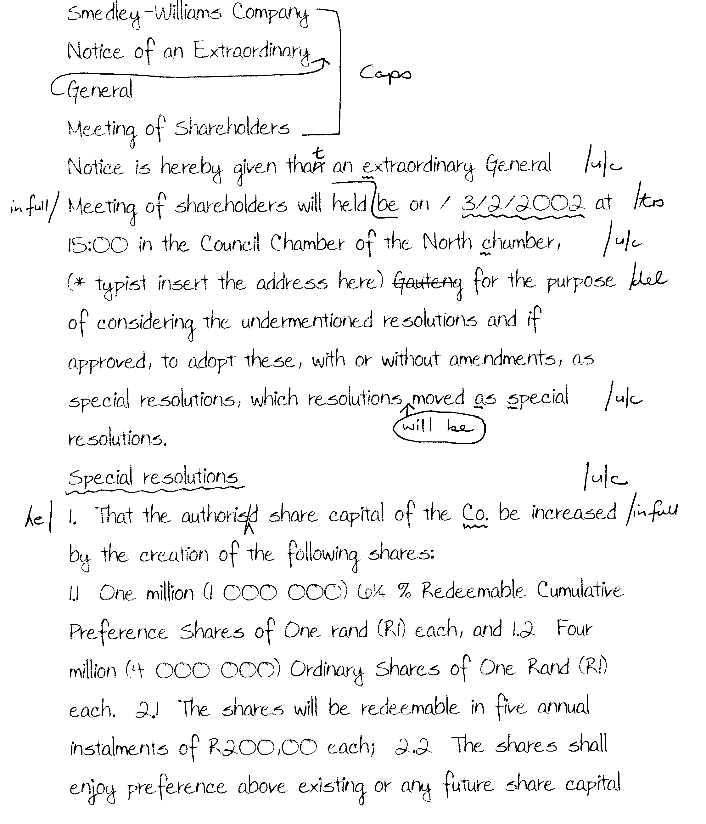

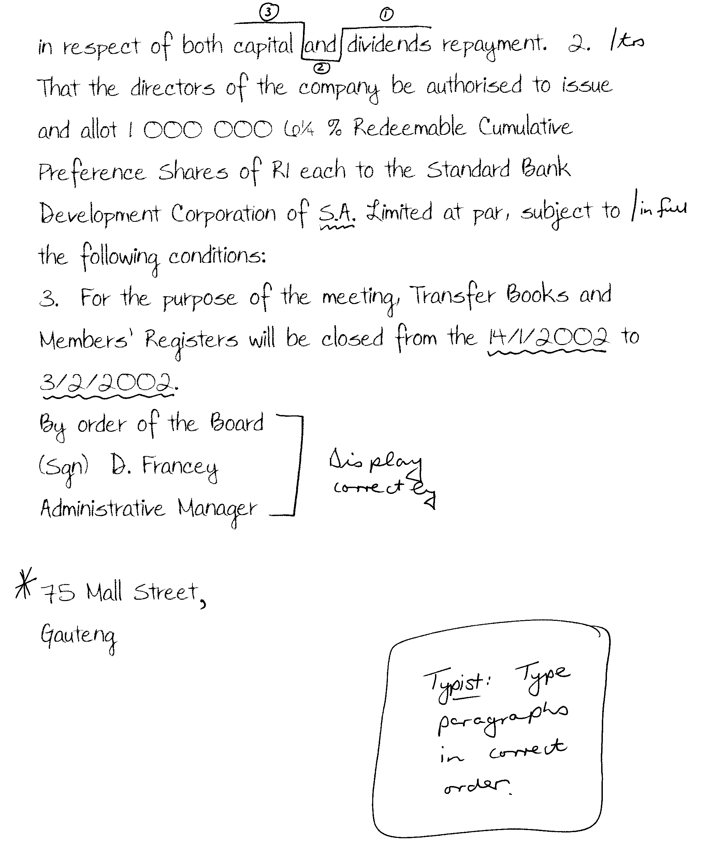

QUESTION 6  Type the following last will and testament.  TIME: 20 MINUTES | [30]

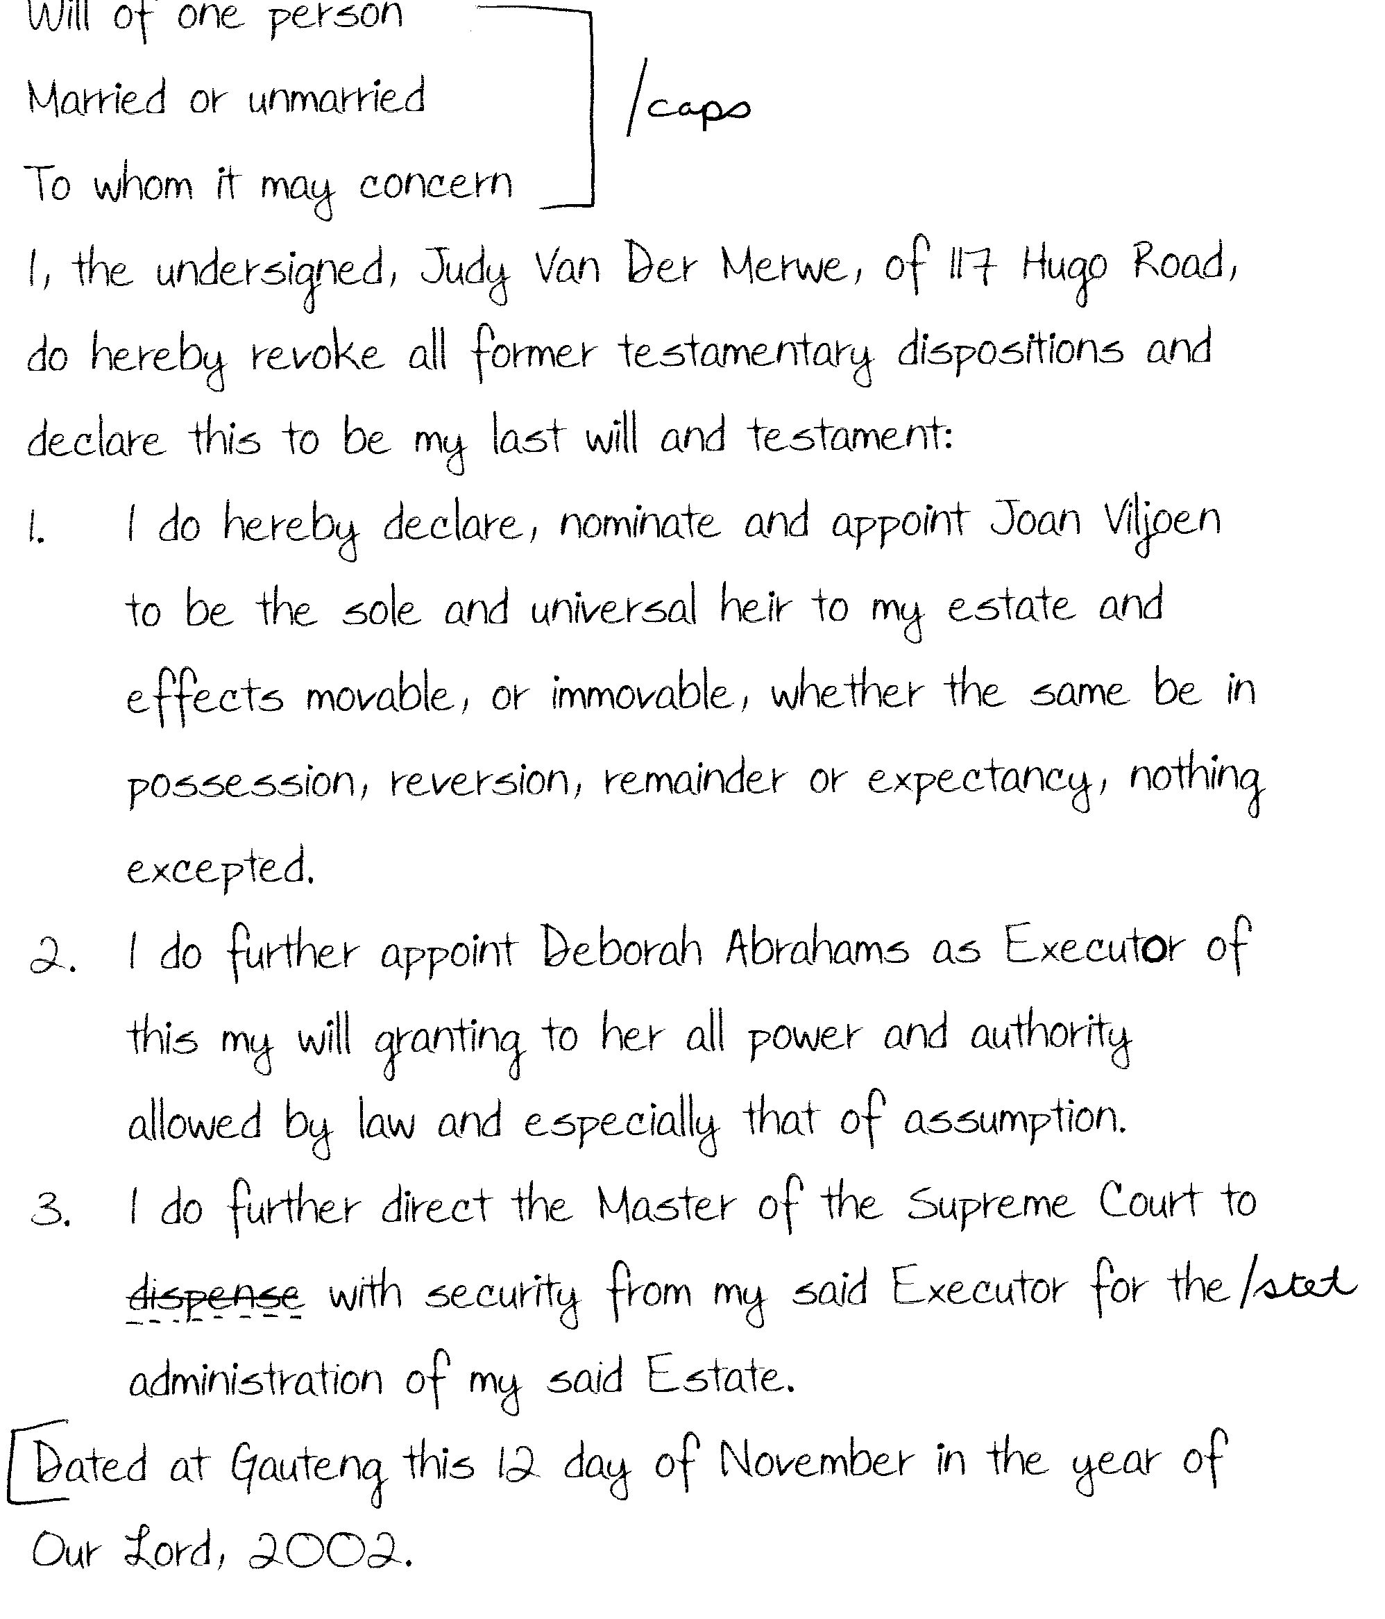

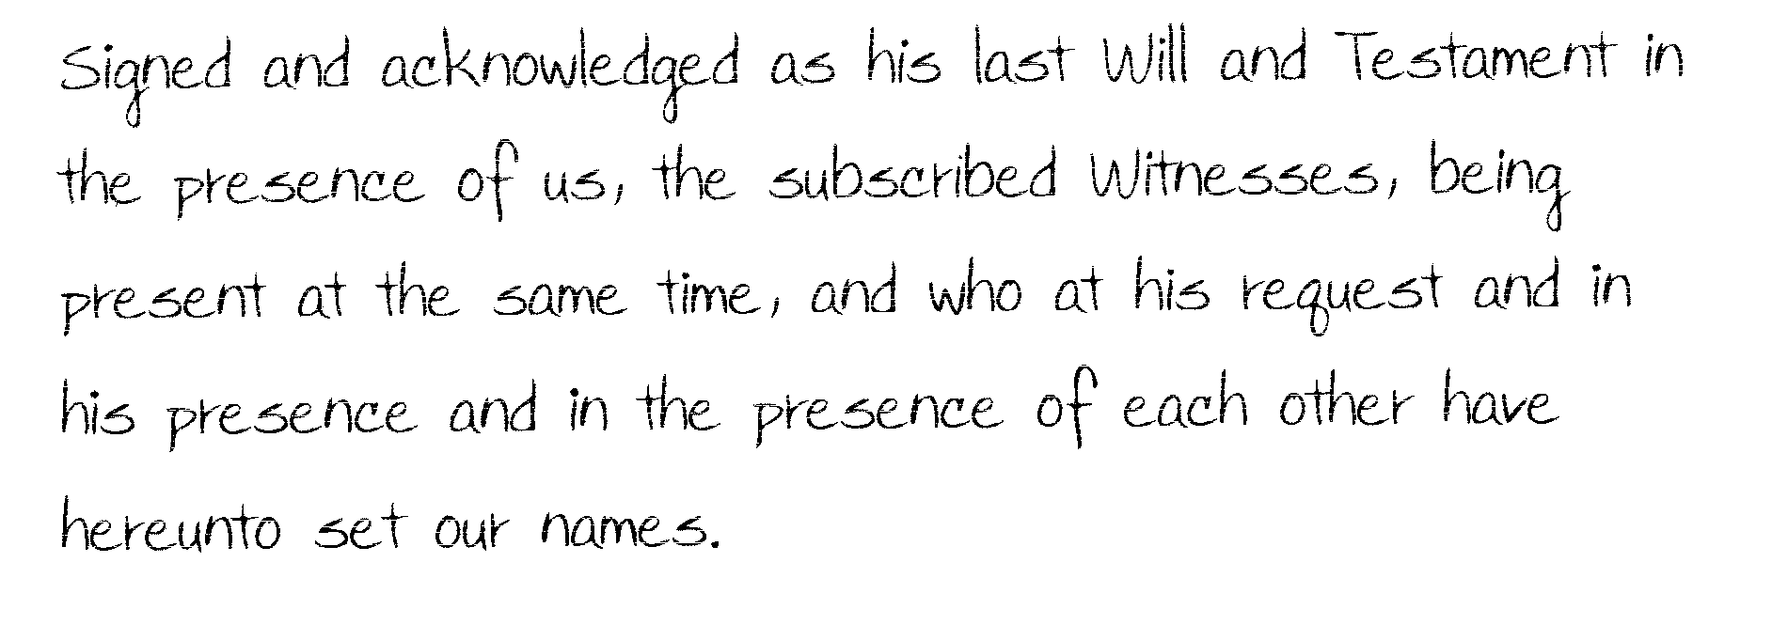

QUESTION 7  Type the following report correctly.  TIME: 23 MINUTES | [36]

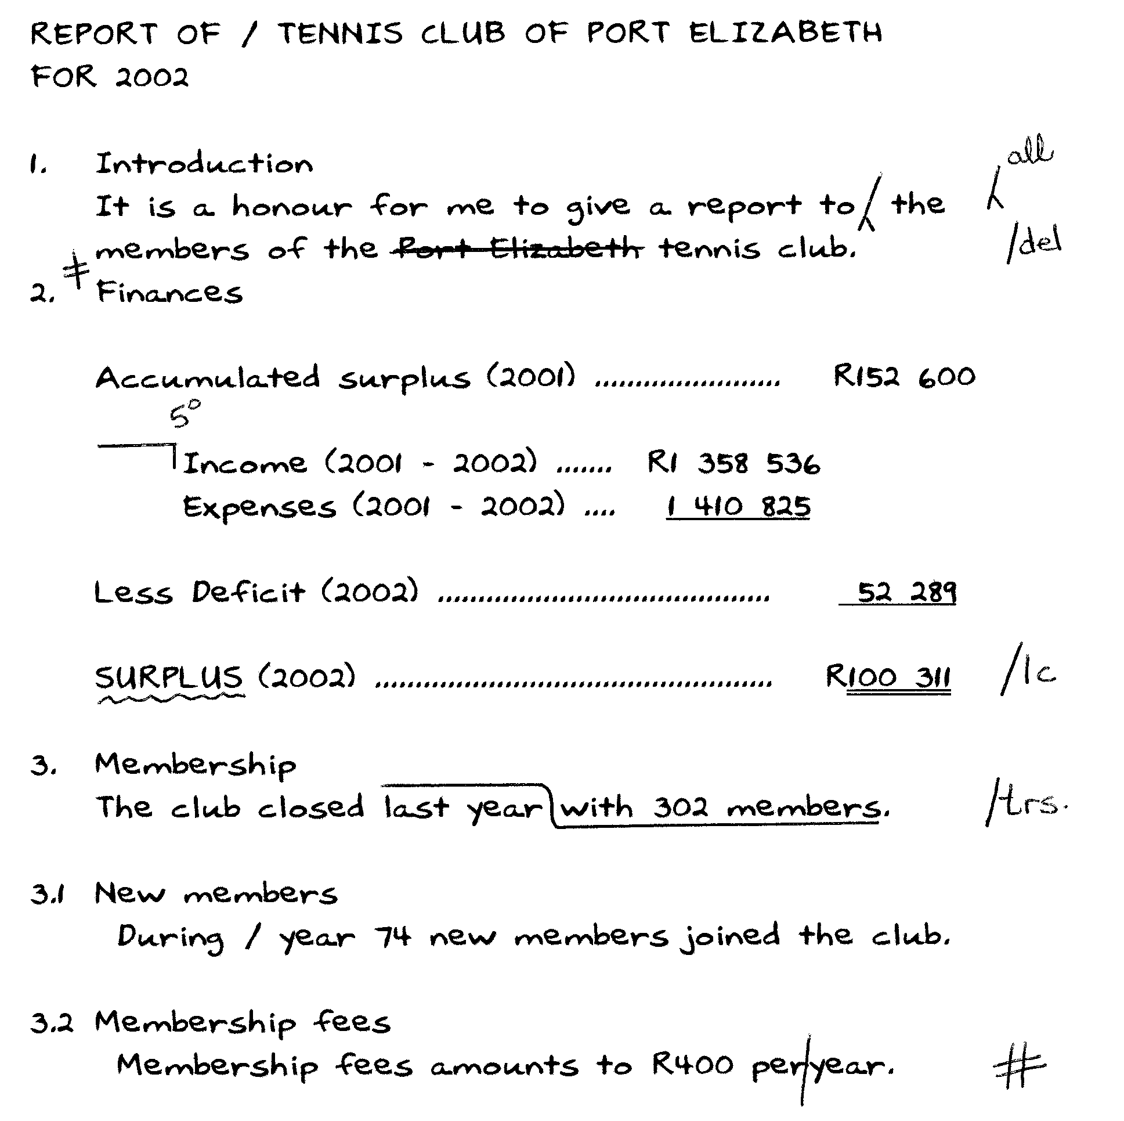

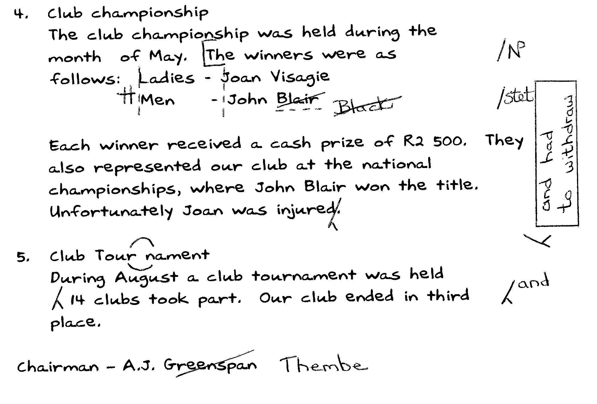

QUESTION 8  Type the following testimonial correctly.  TIME: 22 MINUTES | [34]

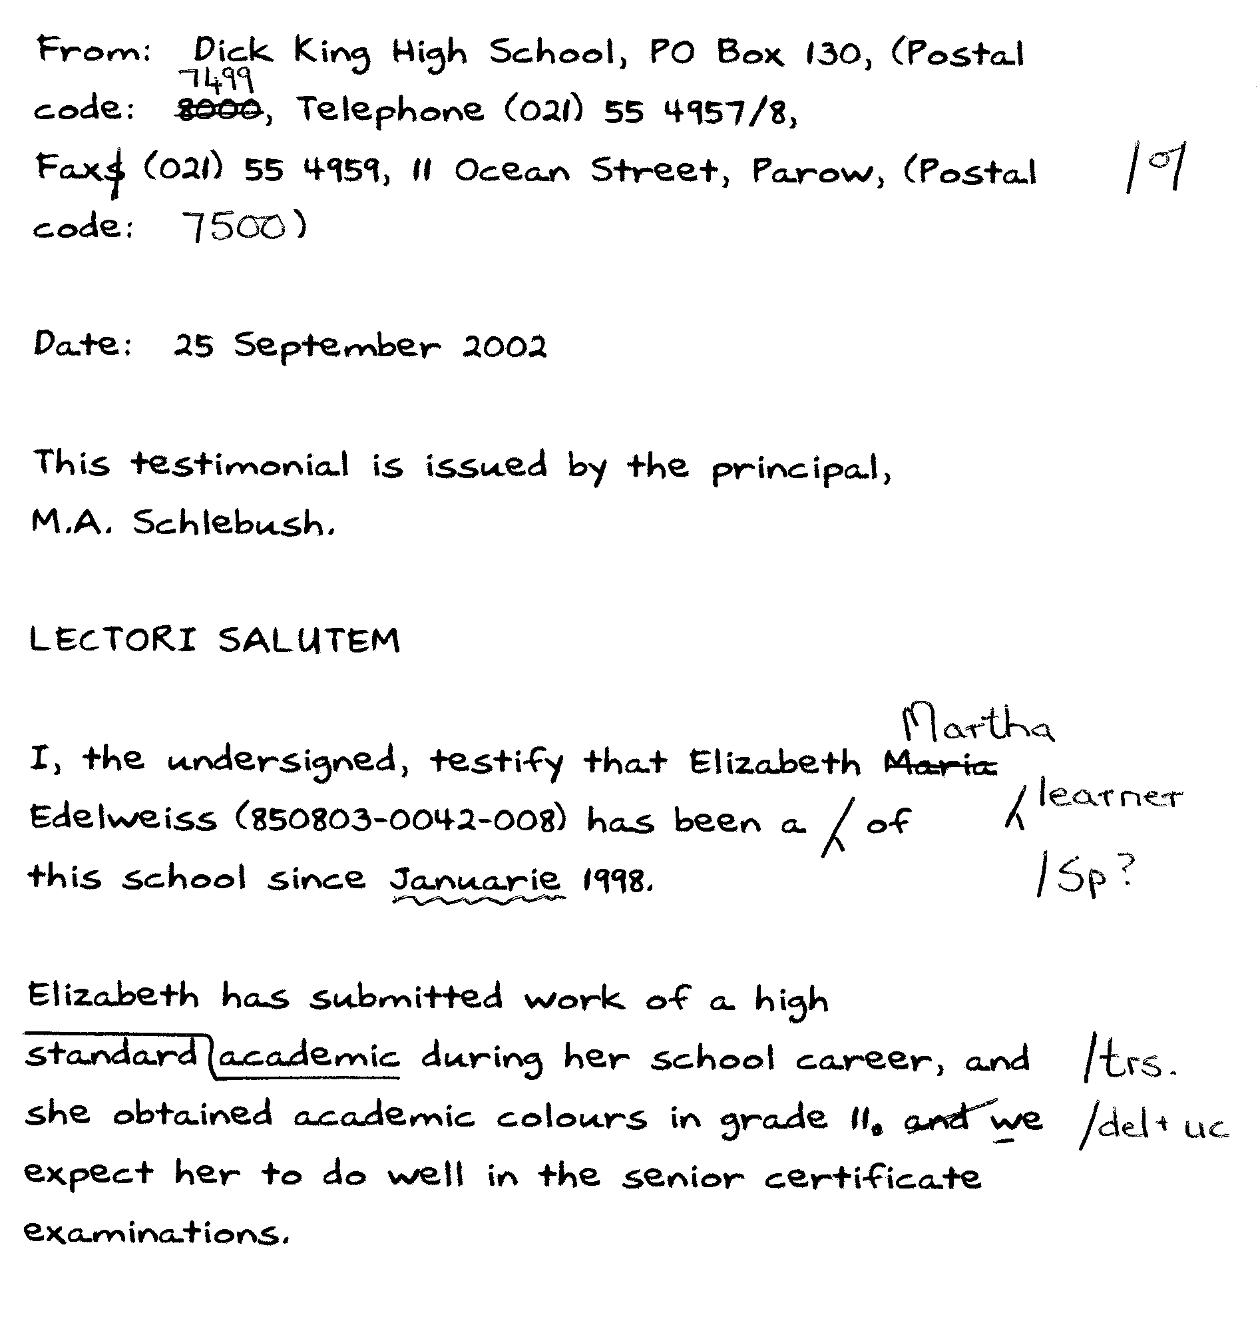

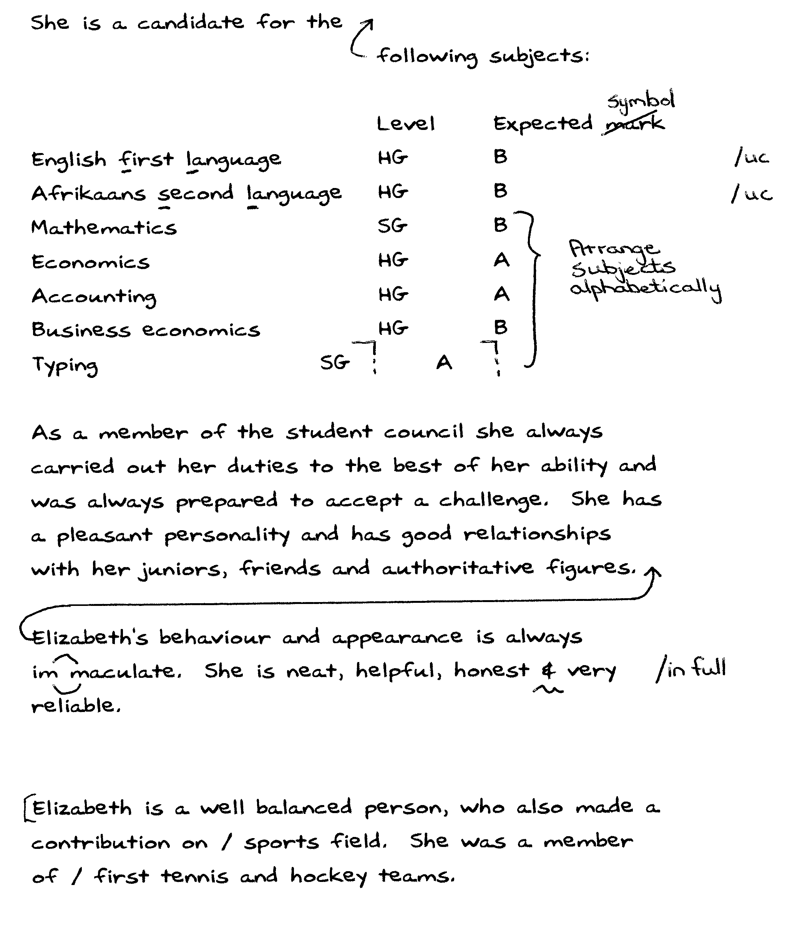
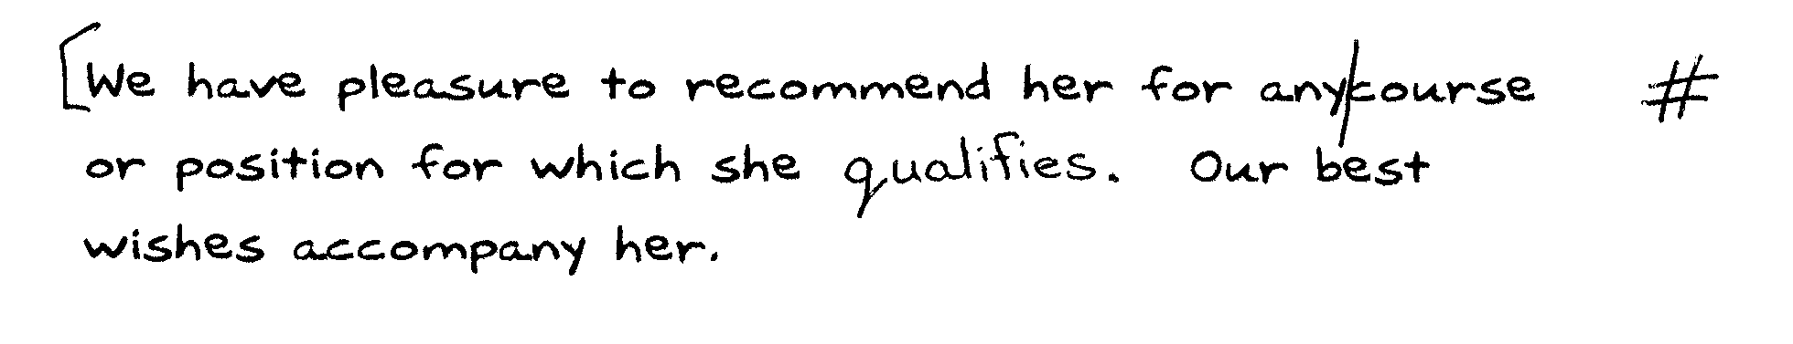

TOTAL: 300

QUESTION 4

