GAUTENG DEPARTMENT OF EDUCATION

SENIOR CERTIFICATE EXAMINATION

MUSIC HG
(First paper: Harmony and Composition)

TIME: 3 hours

MARKS: 100
INSTRUCTIONS TO THE INVIGILATOR:

- Each candidate must be supplied with 3 sheets of music manuscript paper.

- Each candidate must have access to a piano for the full duration of the examination.

- No candidate may, however, disturb another candidate nor share the use of a piano at any particular time.

INSTRUCTIONS TO THE CANDIDATE:

- This question paper is also the answer book.

- Enter your examination number in the space provided.

- Ensure that your notation is neat and unambiguous.

- Answer Question 1 OR Question 2 AND ALL other questions.

Answer Question 1 OR Question 2.  QUESTION 1  Set ONE of the following poems to music. Choose a suitable voice, key and metre. Neatly write the text below the melodic line. | [20]

SpaghettI!  Spaghetti! Spaghetti!  You’re wonderful stuff,  I love you, Spaghetti,  I can’t get enough.  You’re covered with sauce  And you’re sprinkled with cheese,  Spaghetti! Spaghetti!  Oh, give me some please.  [J Prelutsky] | OR | Die storie-uur  Saans as die winterwind so waai  En lekker brand die vuur,  Dan kom ons saam by Oupa sit –  Dit is die storie-uur  Hy skraap sy keel, sy hande vou,  Ons lag en gril, kry hoendervel  En dan kan ons ’n uurtjie lank  Saam lugkastele bou.  [Kleinjan]

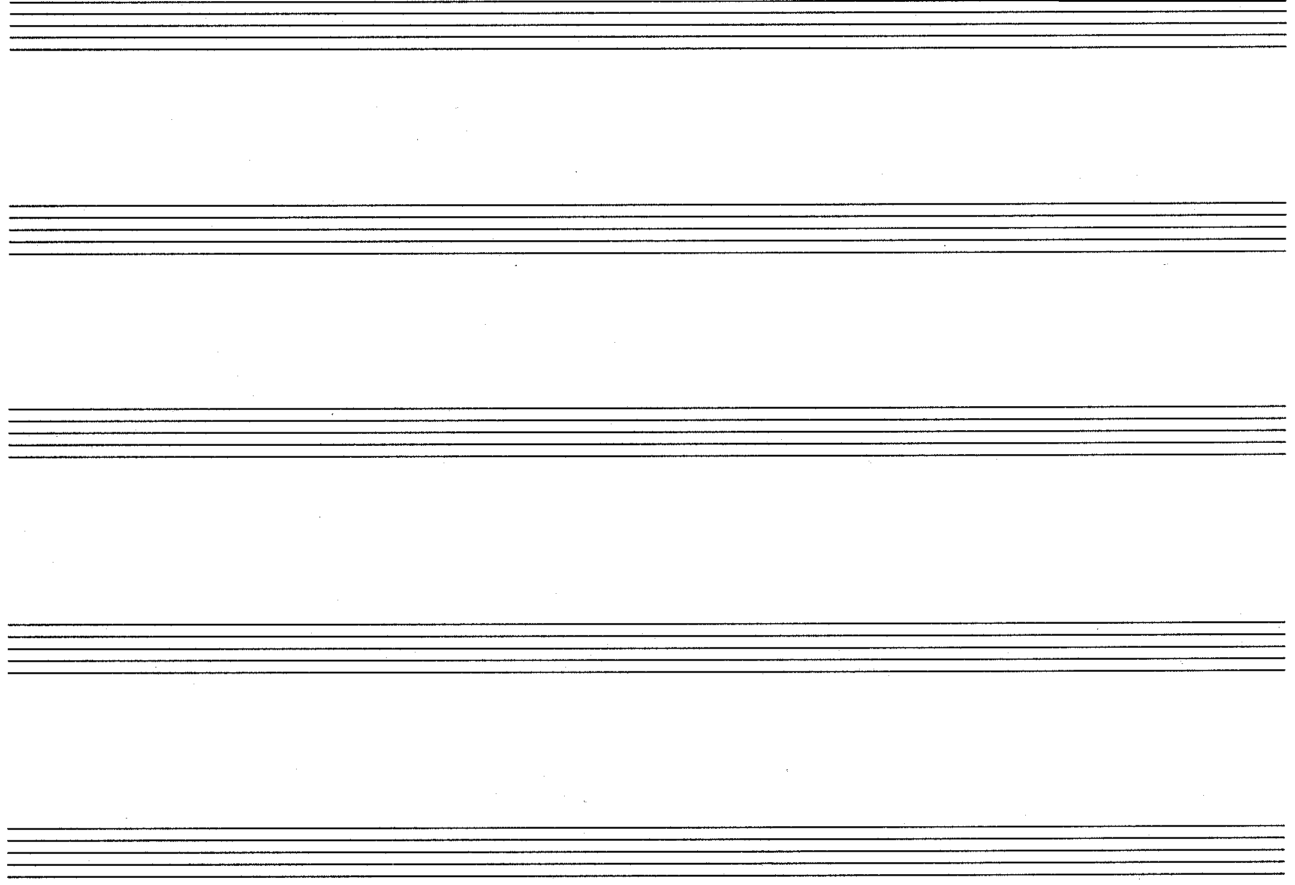

OR

QUESTION 2  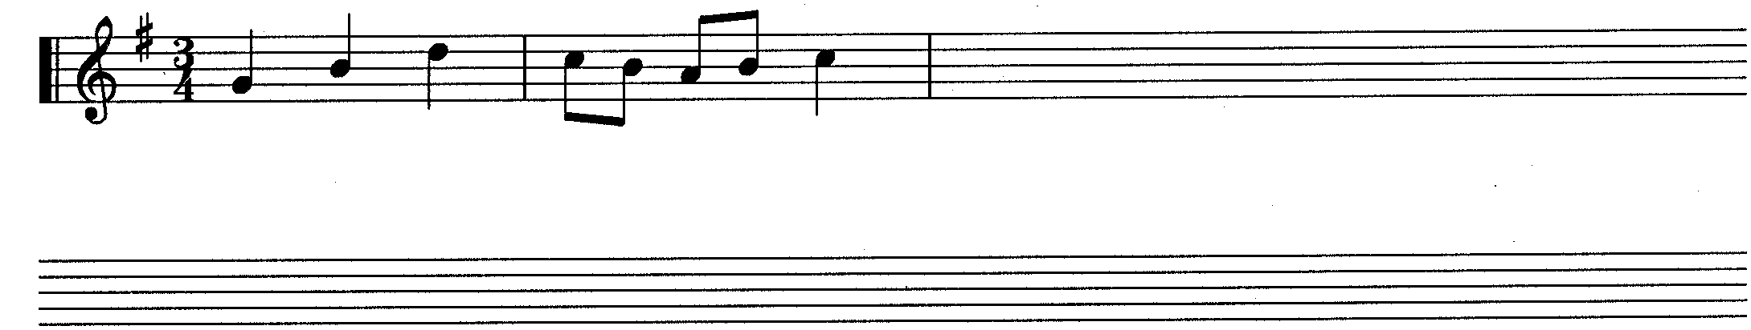  - Write TWO sequences to the following two-bar melodic fragment. | [20]  (5)

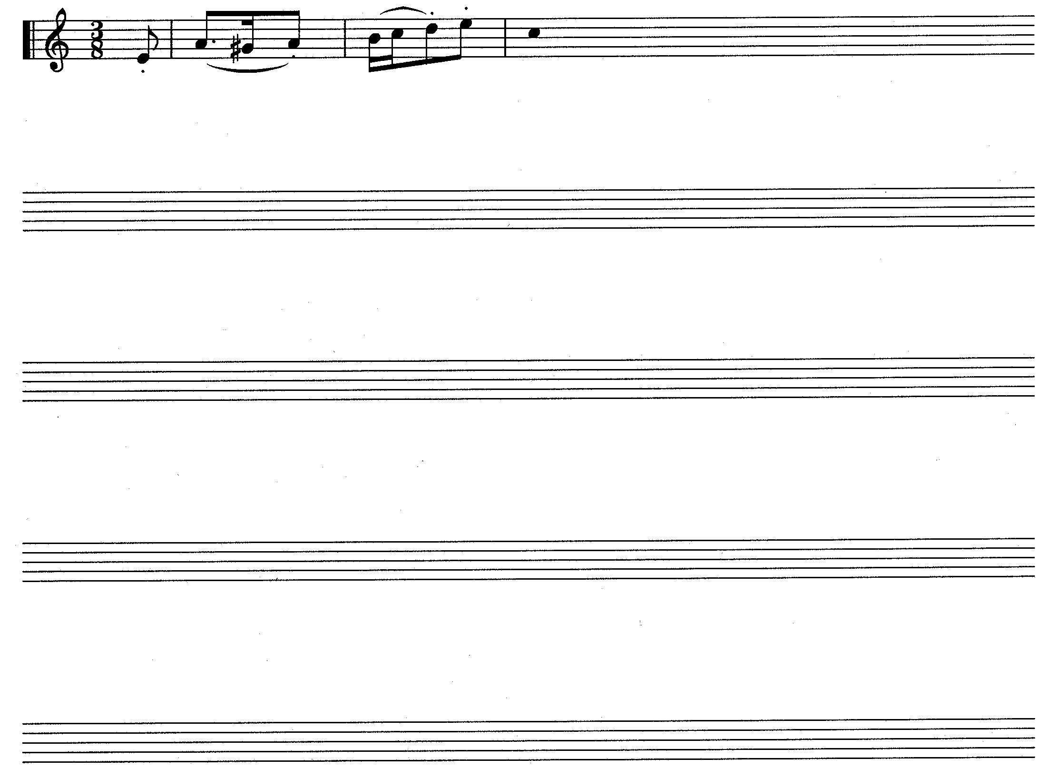  - Extend the given opening to a symmetrical melody consisting of 12 bars in ternary form. Modulate to a related key and end in the original key. Indicate for which voice or instrument the melody is intended.  Allegretto simpatico | (15)

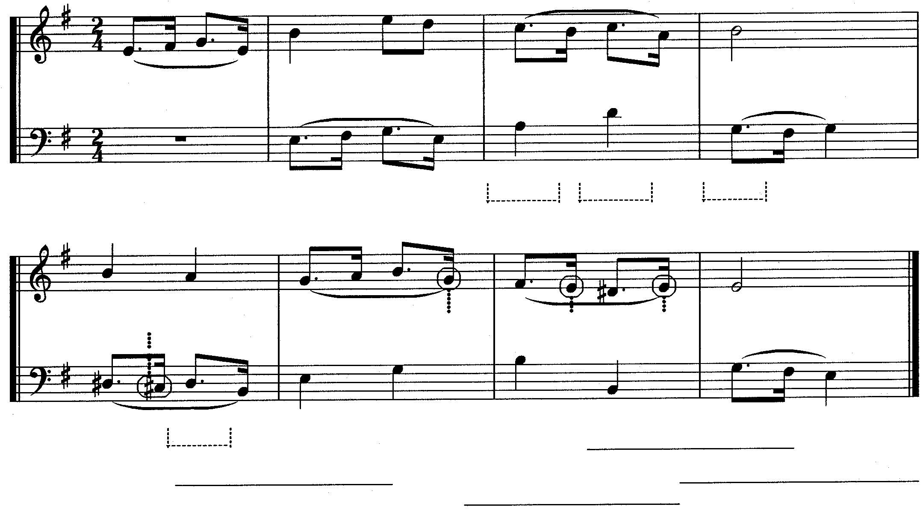  QUESTION 3  1  (a)  (b)  (c)  (h)  (g)  (f)  (e)  (d)  (e)  (f)  (g)  (h)  5  - Study the given extract and answer the questions that follow.  - Provide harmonic analysis at (a) – (d). Indicate the key, chord and inversion in each case.  - What contrapuntal technique is used in bars 1 – 2?  _______________________________________  - Name (e) – (h) the non- harmonic notes or harmonic notes. | [25]  (4)  (2)  (4)

Complete the following passage in two-part counterpoint by adding the missing part. Continue in the style suggested by the given material.  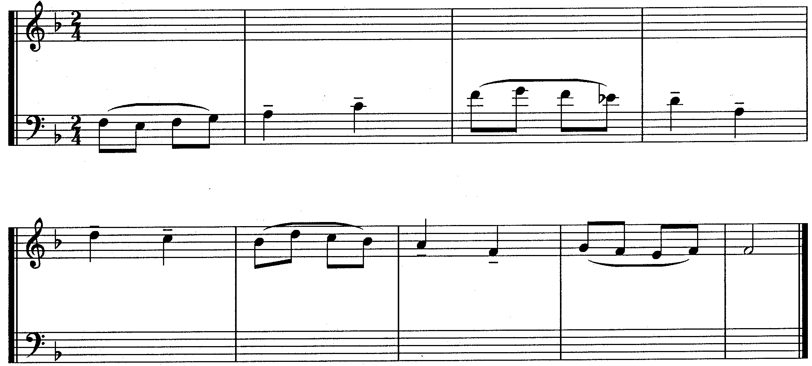 | (15)

QUESTION 4  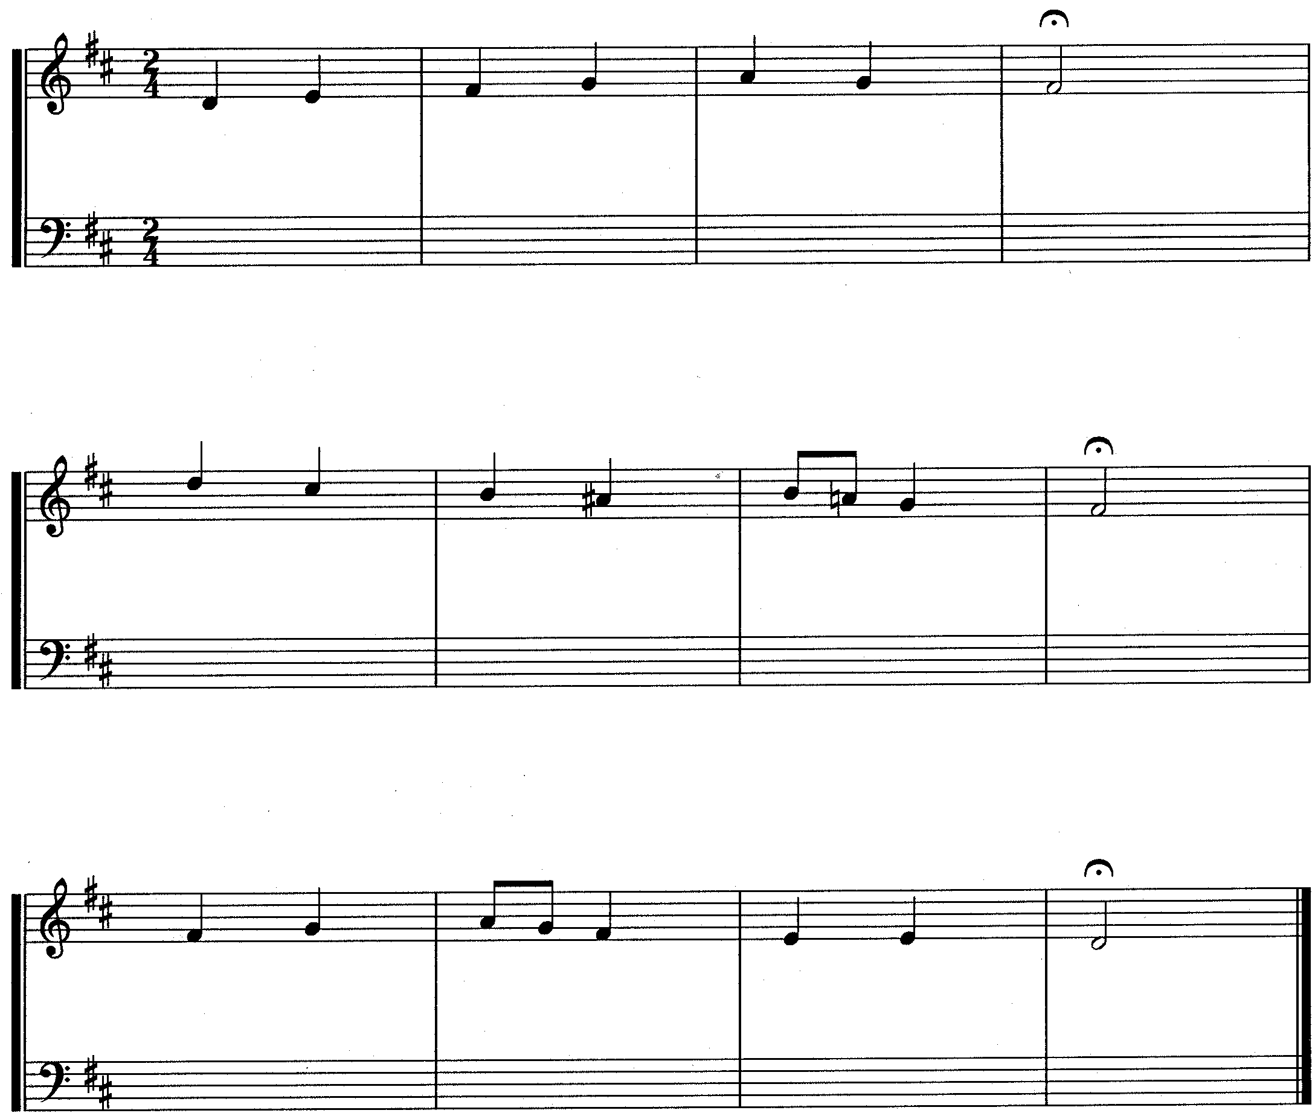  Harmonize the given soprano part for mixed choir (SATB) and use harmonic devices with which you are familiar. | [20]

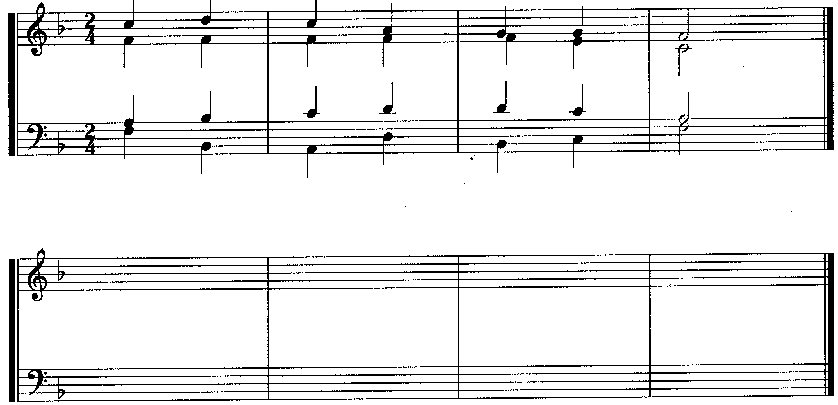  QUESTION 5  Fragment  Answer  Rewrite the given harmonic fragment and insert the following harmonic features at suitable places:  5.1 Two passing notes  5.2 A suspension  5.3 Two auxiliary notes (neighbouring note)  5.4 An interrupted cadence  5.5 A secondary dominant in first inversion before the dominant | [10]  (2)  (2)  (2)  (2)  (2)

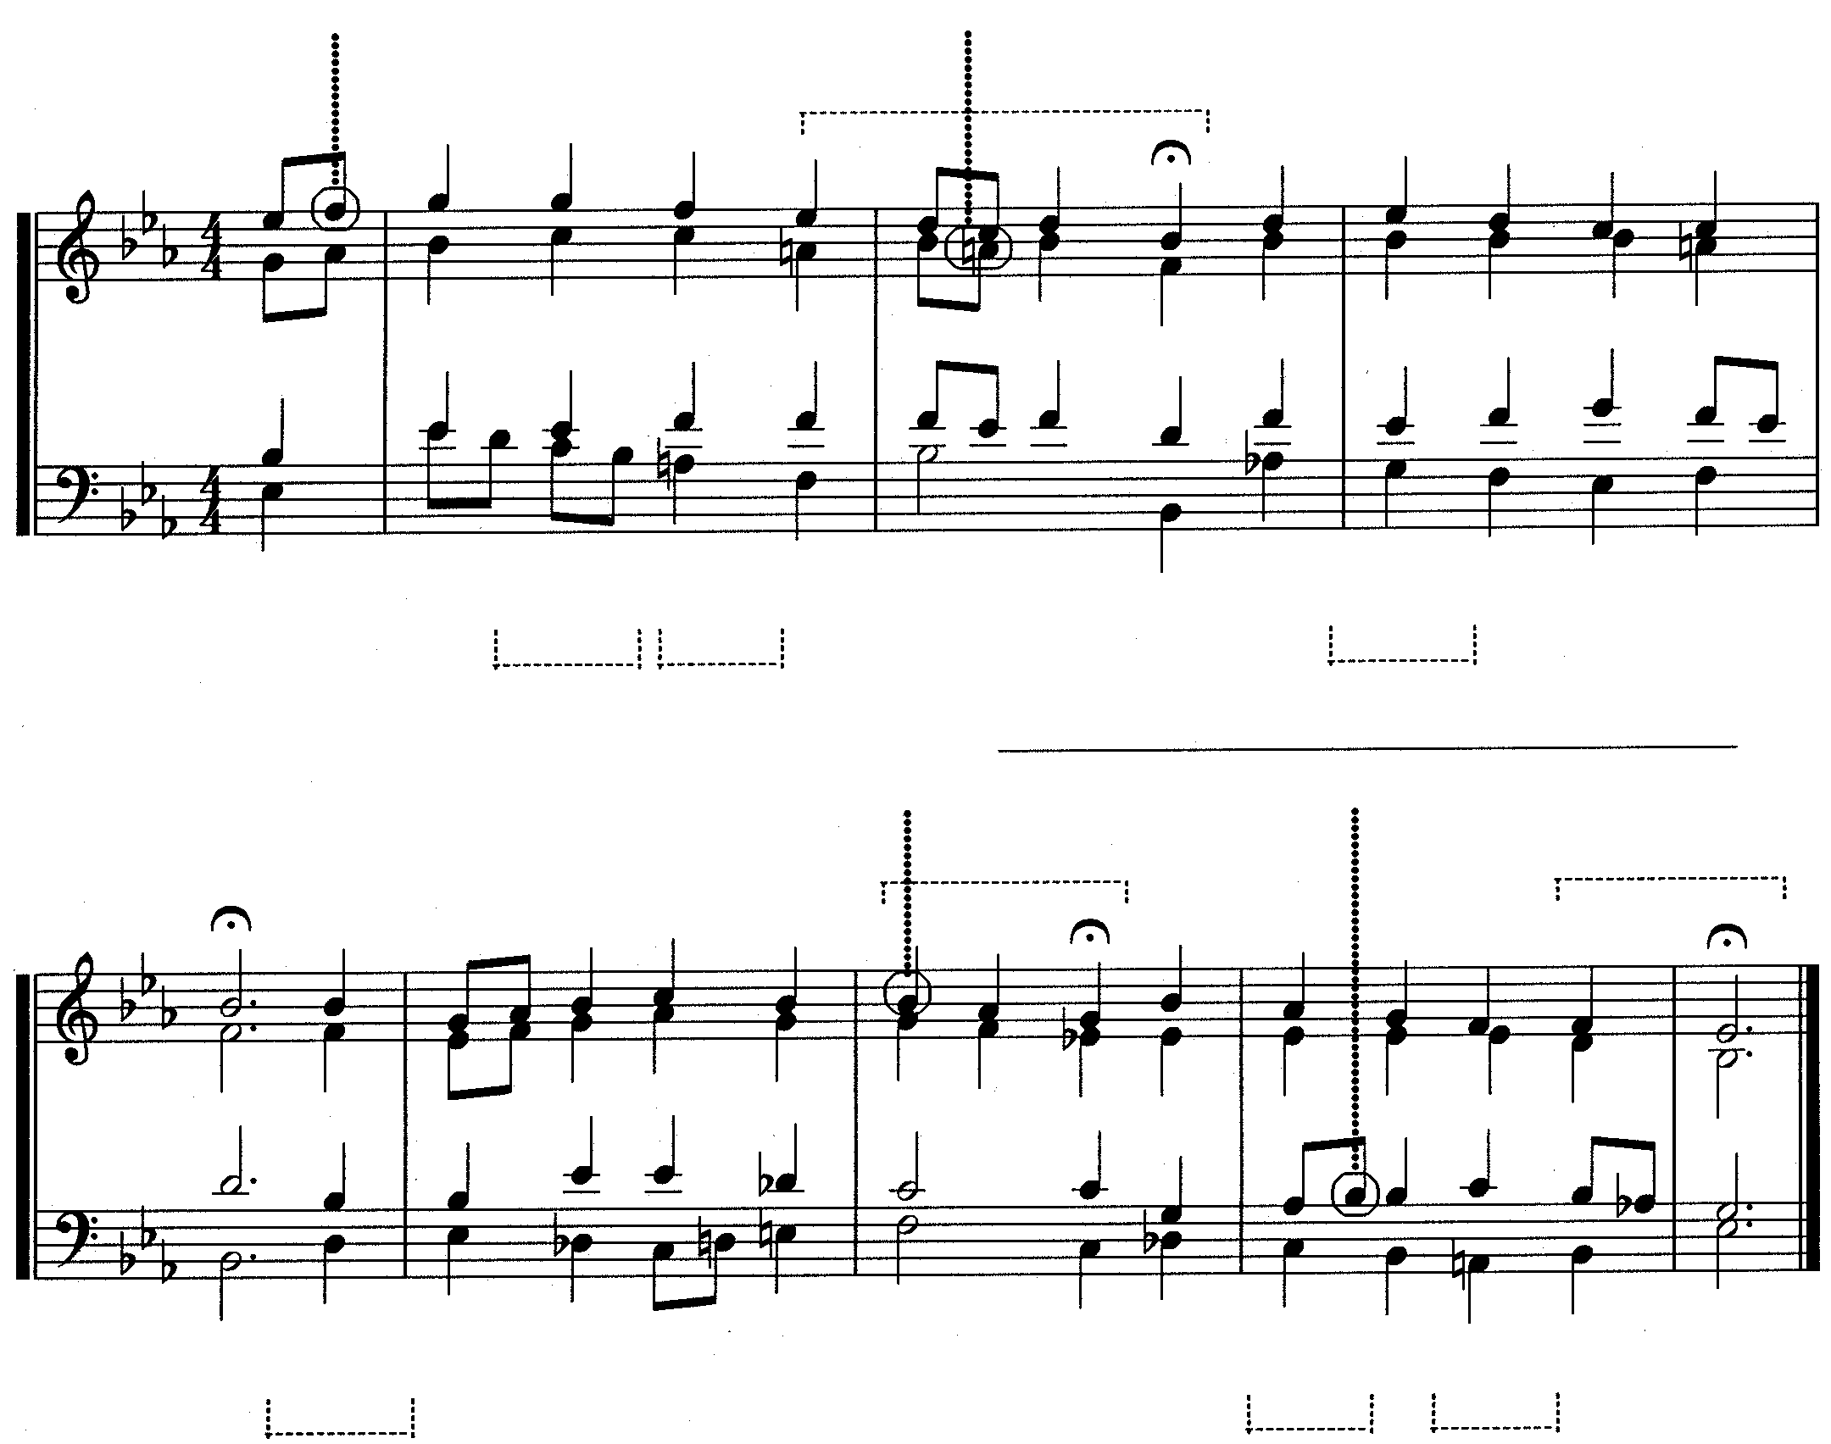  QUESTION 6  (j)  (k)  (g)  (b)  (a)  (c)  (m)  (l)  (h)  Cadence (g)  (i)  (e)  (f)  (d)  Study the given excerpt from a chorale and carry out the following instructions:  - Figure the harmonies (a) – (f). Indicate the key, chord and inversion for each.  - Name the cadences (g) – (i). Indicate the key and chord progression for each.  - Name the non-harmonic notes (j) – (m).  Cadence (h) ________________________________ Cadence (i) | [25]  (12)  (9)  (4)

Non-harmonic notes: | (j)
 | (k)
 | (l)
 | (m)

TOTAL: | 100

